'Fortunate to be alive': Girl, 7, contracts bubonic plague at Colorado campground
By NBC News staff and wire reports
DENVER -- A seven-year-old girl is recovering at a Denver hospital from a rare case of bubonic plague she likely contracted from fleas feeding on a dead squirrel at a southwestern Colorado campground, hospital officials said on Wednesday.
Sierra Jane Downing is "fortunate to be alive," but is on the road to recovery after her near-fatal bout with the disease, the Rocky Mountain Hospital for Children said in a statement.
It marked the first confirmed case of bubonic plague in Colorado since 2006, the hospital said.
Sierra's father Sean Downing described how his daughter had a seizure and stopped breathing for a couple of minutes.
"I thought she died, and I was just running for the ER," he said.
Advertise | AdChoices
Read the story on local NBC station 9NEWS.com
At first, Sierra's parents -- and even Sierra herself -- thought the illness was a flu. "She told me, 'Mommy, this is just the flu. Can't we go home?'" Darcy Downing said.

Jack Dempsey / AP
Seven-year-old Sierra Jane Downing watches while her father Sean Downing and mother Darcy Downing talk about her recovery from the bubonic plague at the Presbyterian/St. Luke's Rocky Mountain Hospital for Children on Wednesday. It is believed Downing caught the bubonic plague from a dead squirrel.
Bacteria that cause bubonic plague are carried by rodents and can be transmitted to humans through parasitic fleas or the handling of infected animals.
The plague is believed to have killed 25 million Europeans during the Middle Ages, when it was known as the Black Death.
Today, the disease is treated with antibiotics, and seven U.S. cases a year are reported on average, most of them in the western states, according to the U.S. Centers for Disease Control and Prevention in Atlanta.
Tried to bury dead squirrel
Sierra was at an outing with her family in Pagosa Springs, Colorado, last month when she came across a dead squirrel that she tried to bury, hospital spokeswoman Angie Anania said.
Follow @NBCNewsUS
"She never touched the squirrel, but laid her jacket next to the dead squirrel, and the fleas looking for a new host might have jumped onto the jacket," Anania told Reuters.
The girl tied the jacket around her waist, and doctors discovered insect bites on her torso, which led them to believe the plague came from the squirrel encounter, Anania said.
Sierra was taken by her parents to a Pagosa Springs hospital on Aug. 24 suffering from a high fever and seizures. She was later flown to the Rocky Mountain Hospital for Children, which has facilities and pediatric specialists better equipped to care for gravely ill children.
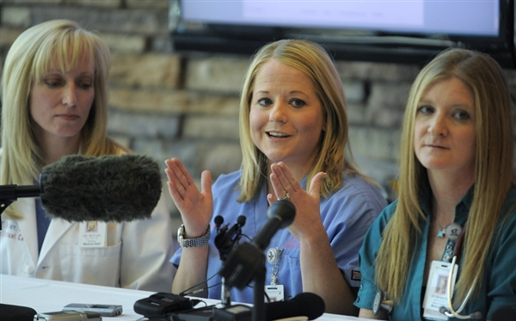
Jack Dempsey / AP
Jennifer Snow, MD, pediatric intensivist in the pediatric intensive care unit talks to media about seven-year-old Sierra Jane Downing's recovery from the bubonic plague at the Presbyterian/St. Luke's Rocky Mountain Hospital for Children on Wednesday.
The girl's temperature reached 107 degrees Fahrenheit, and doctors detected swollen lymph nodes in her groin after she complained of severe leg pain, said Dr. Jennifer Snow, the pediatrician who treated her in Denver.
Once the diagnosis was made, Sierra was placed on a special antibiotic regimen. She may be discharged in a week, the hospital said.

Follow US News from NBCNews.com on Twitter and Facebook

5 commentsJoin the discussion
Explore related topics: featured, colorado, denver, plague, black-death, bubonic-plague, sierra-

