

Search this site

- Products
- How to Order - We Sell Direct!
- About Us
- Education Center
- Anaerobic Chamber FAQ
- The Benefits of PRAS
- Links
 | Save The Date!  Bacteriology Workshops  October 23rd, 2012  North Arkansas College  Harrison, AR  October 24th, 2012  Conway Regional  Health System  Conway, AR  Chamber Training  and  Advanced Anaerobe Bacteriology Courses  January 9-11, 2013  April 10-12, 2013  Morgan Hill, CA  For More Information  or To Register Call:  1.800.443.3108  The Anaerobic Bacteriology Workshop Will Come To You!  Would you like to set up a workshop in your area?  It's fast, easy, and FREE!  For More Information on Hosting Click Here  Or Call Us At: 1.800.443.3108 | Education Center‎ > ‎  Anaerobe Educator  Comments  You have no permission to add comments.
  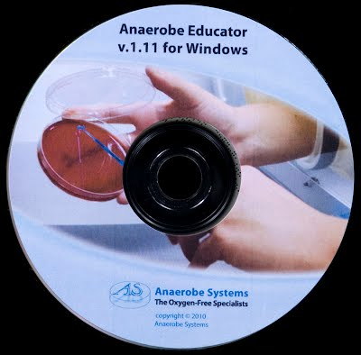
  An Interactive Computer Learning System for Anaerobic Identification.
  - In depth profiles of 19 commonly encountered clinical anaerobes.
  - Color pictures of organism colonies on Brucella blood agar, PEA, EYA, BBE/LKV and CCFA media.
  - Text and graphic representations of all test required for the identification of the selected organism.
  - Zoom feature allows close-up view of organism colonies and cells.
  - Text descriptions of colony and cell morphology and of special traits of each organism. Simulated lab practical teaches presumptive identification methods.
  - Students are asked to identify organisms through logical step by step methods.
  - On-line flowcharts can be made available during exams.
  - Records of tests requested during exams are kept for later evaluation.
  - Exams can be taken in two modes.
  - Practice Mode gives feedback to the students after each organism.
  - Exam Mode records student answers without feedback.
  - Thoroughly and efficiently prepares students for “wet” lab training. Integrated approach combines computer based and textbook learning
  - Color photographs and text description of media, tests and observations.
  - Explanations of basic concepts in anaerobic bacteriology and references for further reading.
  - Online help and glossary features.
  - The program is designed to be used with and augment two of the foremost anaerobe bacteriology texts.
  - The program engages the student through interactive nonlinear learning, heightening interest and curiosity
  - Extensive exam setup options and automatic exam reports
  - Allow or disallow genus abbreviations.
  - Have random or predetermined test sets.
  - Have test sets alternate between users.
  - Log, save, and print all student answers and tests chosen During exams for later evaluation and grading.
  - Edit exam logs from any word processor.
  - Limit access to log records and setup options with a password.
  View the full product insert: Anaerobe Educator Software.PDF
  Anaerobe Educator Software
  Item # | Description | Size | Price
  AS-5002 | Anaerobe Educator | 1 each | $19.99

