Christian Character
Survey Results
For curiosity’s sake, I took the survey twice, a week apart, and my scores were fairly consistent. The highest scores belonged to compassion and faithfulness and the lowest scores to patience and forgiveness. Surprisingly to myself, I scored high in aspects of love and kindness, traits which I feel I struggle with occasionally. I have been praying for greater love in my heart for others, which I believe God has been answering.
One of the strongest impacts on my teaching is that these scores are reflective of my personal values as well as my Christian character, the values I uphold to the students and attempt to teach them. I strongly value faithfulness to God and the teachings of His Word. Being faithful to what I believe is Truth is extremely important to me as a person and a Christian. Being faithful includes responsibility in our everyday tasks such as completing work, doing one’s best, and often means practicing self-denial to do so. These are areas which I emphasize to students on a daily basis because they are valuable to me.
Scoring low in patience is apparent in my struggles to slow down in the hectic pace of life which I seem to live. I know I am often impatient and rush, which is something I need to work on in class with my students. I also need to be patient when they are not showing faithfulness in their tasks which is something I value. Being aware of my struggles will help me to focus on what needs to be improved as I work with children daily, and most importantly, to pray for God’s grace for growth in this area.

Fruits of the Spirit
After reading Zigarelli’s books on the importance of gratitude, I have chosen to focus on the character trait of “joy”. I have discovered in my own Christian walk, my attitude was not always on the positive but would tend toward the negative. Controlling my thoughts to be more positive and not allowing negativity to creep in has been an intentional act over the past year. As Zigarelli states in his book, “The mind of the high-virtue Christian, it seems, is a disciplined mind, a pure and godly mind, a mind that is adept at immediately clearing away sinful thoughts.” (Zigarelli, 2005, p. 29). To counteract negative thoughts which arise in my mind, I find that if I stop myself and think of the positive, it refocuses my thought. By doing so, I find I am less stressed and happier- have more joy, in daily tasks.
Since gratitude is so closely linked with joy, I have chosen to focus in class this week on gratitude as our “character trait” of the week. I introduced the trait on Monday and had students write 5 things they were grateful for. Students seemed to enjoy sharing their lists with the class. We also include gratitude in our daily prayers. I remind students we don’t want to only ask God to grant requests, but we want to thank Him for His many blessings.
Another aspect of joy is to look at things with a positive perspective or view point. We spend time examining this and I read a picture book to students along those lines. The picture book poses examples of having a positive outlook even when situations are not ideal (waiting in line, a friend doesn’t play with you, etc.). The students share how they can think positively about these type of situations in our discussion time. It is my intention that with practice students will develop a habit of looking at the positive. “It is this habit—a habit of keeping perspective—that transports them to the next level of gratitude and of character.”
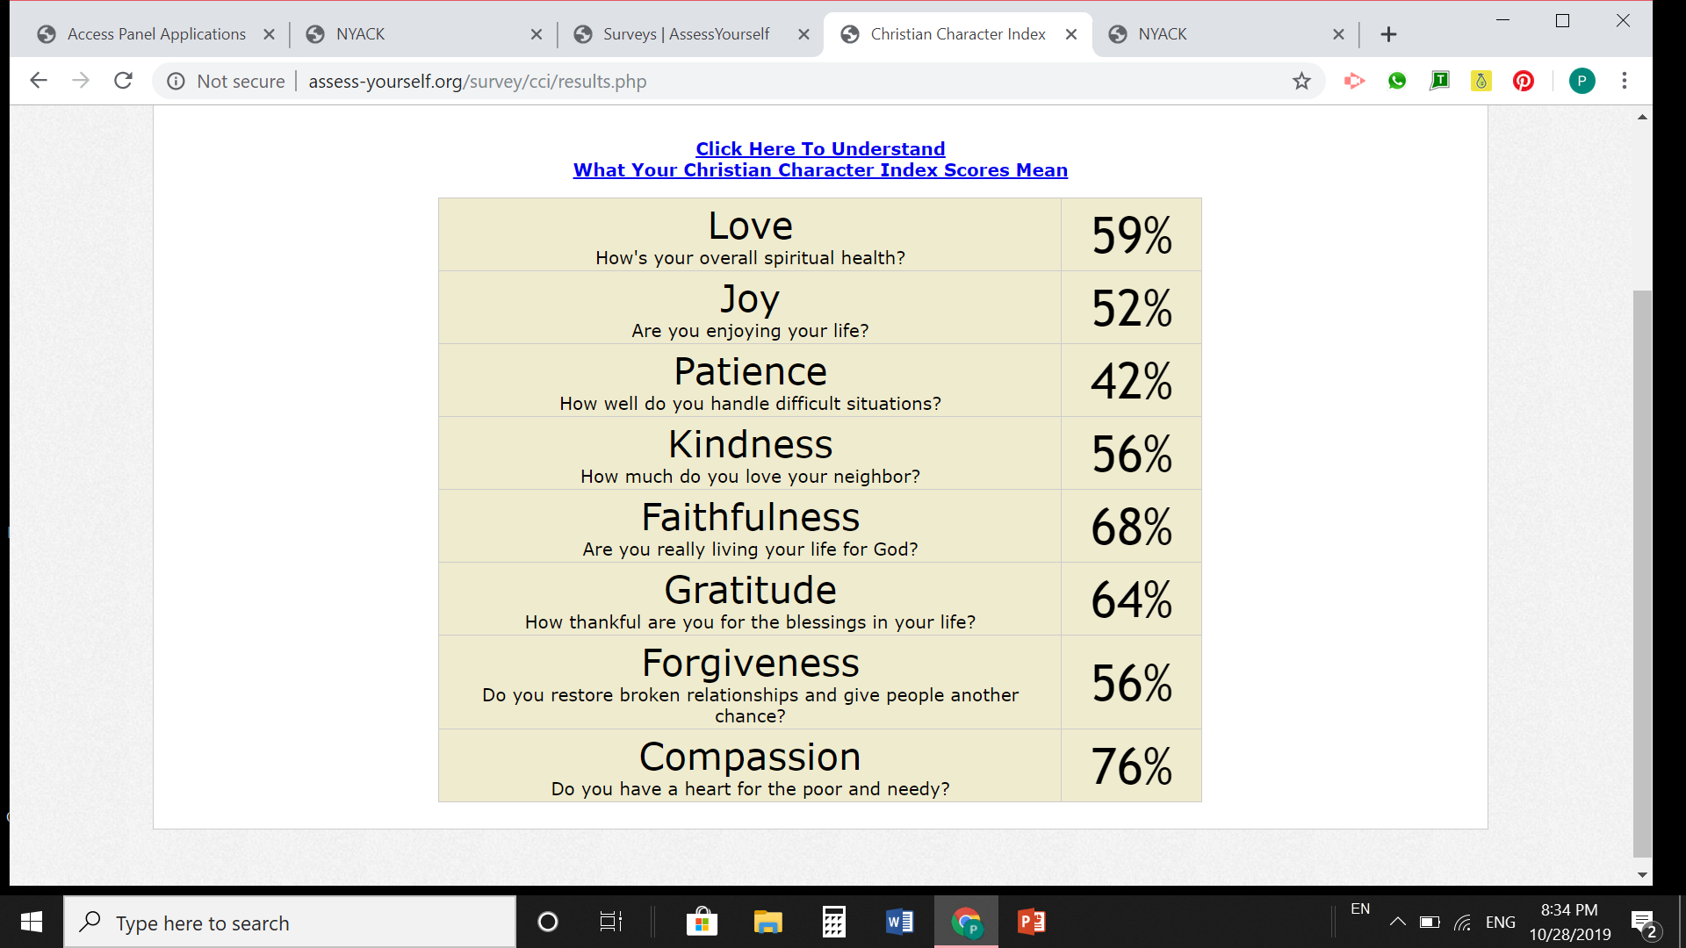
Bibliography
Zigarelli, M. A. (2005). Cultivating Christian character: how to become the person God wants you to be
and how to help others do the same. Colorado Springs, CO: Purposeful Design Publications.

