Faith and the Public Schools
Morals and Faith Commonalities
Faith is a basic and necessary aspect of every person’s life. Faith at its most basic is “complete trust or faith in something,” (Lexico, 2019). There are universals to faith. Every culture has a belief system based on faith. Even those who claim no faith in a religion, have faith principles in Science and moral principles of right and wrong. Understanding another’s faith and their foundational beliefs help to understand their perspecitives of the world. This is true also of Christian beliefs and the stories that are part of the faith of those who believe in the Bible. At its heart, Christianity is about loving God and others and living a moral life, morals which are held in common with the values that “transcend cultural, religious, and socioeconomic differences,” (Hunter, 2000, p. 117).
The core values of Christianity are embedded throughout the historical records of the Old and New Testaments. The rewards and conseqences of choosng to live in accordance to the values or rebelling against them, are laid out in the lives of the people who make them. This is true also of the values secular society desires to teach through the principles of the Psychologiacal Regime strategies. “Values…are integrated into a cost-benefit analysis of personal and social consequences,” (Hunter, 2000, p. 105). Therefore, the stories of the Bible as historical records, could be used to set forth clear principles of right and wrong choices and provide opportunities to discuss the outcomes of those decsions.
The Christian Roots of Western Culture
As 21st century Americans, we tend to look at our values and beliefs in the current trends of society. However, there are many layers of culture and history on which are values are founded. Examine for example, the introduction of the Declaration of Independence. “We hold these truths to be self-evident, that all men are created equal, that they are endowed by their Creator with certain unalienable Rights, that among these are Life, Liberty and the pursuit of Happiness.” (Declaration of Independence). To fully understand this statement, we need to acknowledge and explore our roots in Christianity. Why are all men considered equal? It is not through Science or evolution which we arrive at this conclusion. In fact, the Holocaust had roots in evolution. “Leading Nazis, and early 1900 influential German biologists, revealed in their writings that Darwin’s theory and publications had a major influence upon Nazi race policies.” (Bergman, 1999, p. 101).
However, democracy has at its foundation the values of Biblical Christianity. It is acknowledged fact by historians that the Protestant Reformation was the beginning of democracy. “Protestants asserted not the right to choose their rulers, but the duty to challenge them.” (Ryrie, 2017). To ignore the factors which led to our form of government and additionally laid the foundation for many of the values and truths we hold to be “self-evident” gives us only a partial understanding of who we are as a nation and why we believe the way we do.
Conclusion
As a Christian teacher who believes in the Bible as a literal and powerful guide to life, I firmly believe we can present logical reasons for including Biblical narratives in a secular curriculum without sacrificing the integrity of Truth. Two such methods are to use the stories with common morals as historical examples of cost-benefit analysis of choices and to examine society’s values in the light of the historical roots of Christianity. Although it is important to have “better communication between the two groups,” (Noddings, 1997, p. 245) I don’t believe we should compromise truth to do so.
References

Bergman, J. (1999, November). Darwinism and the Nazi Race Holocaust. Journal of
Creation, 13(2), 101–111.
Hunter, J. D. (2000). The death of character moral education in an age without good or evil.
New York, NY: Basic.
Faith: Definition of Faith by Lexico. (n.d.). Retrieved October 30, 2019, from
https://www.lexico.com/en/definition/faith.
Noddings, N. (1997). Dialogue Between Believers and Unbelievers. Religous Education, 92(2).
Ryrie, A. (2017, October 29). Three surprising ways the Protestant Reformation shaped our
world. Retrieved October 31, 2019, from

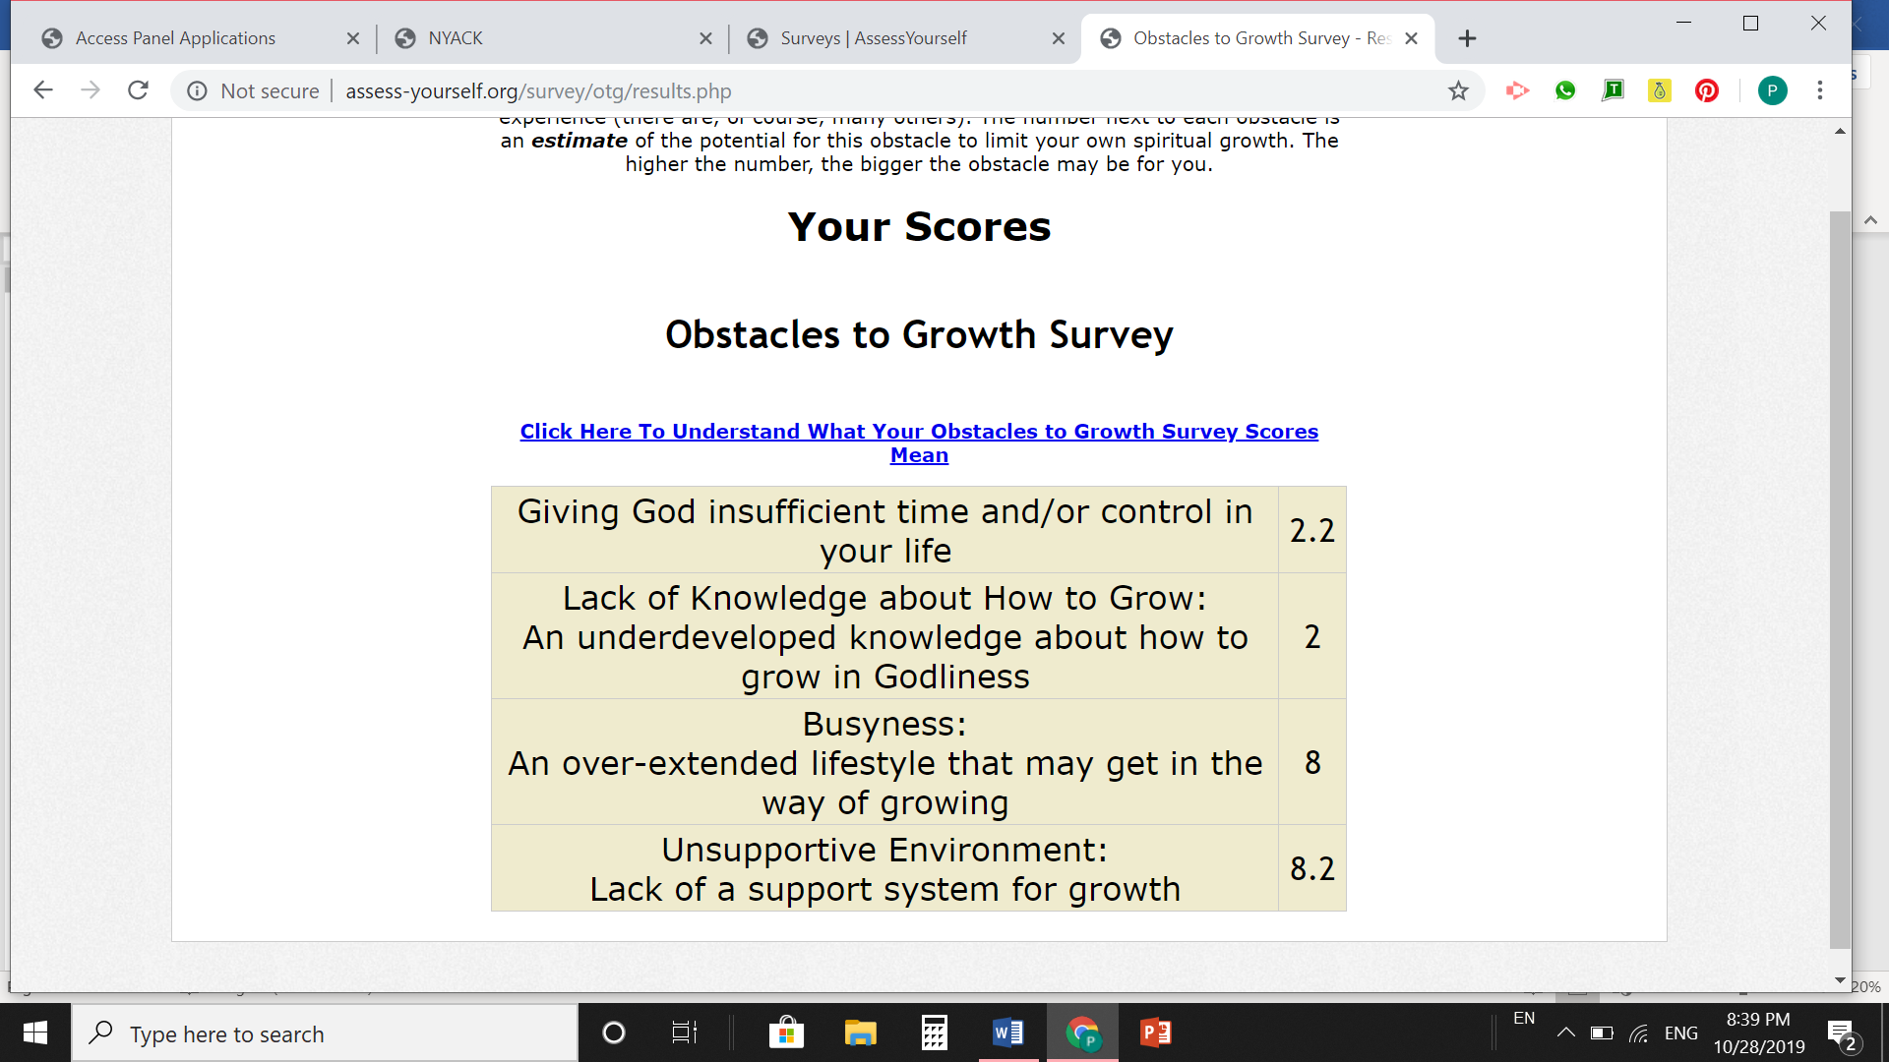
https://edition.cnn.com/2017/10/29/world/reformation-world-change/index.html.

