1.
According to the textbook emotions can be defined as, “A feeling, or effect, that occurs when people are engaged in an interaction that is important to them,especially one that influences their well-being.” I believe that emotions are important to a child’s developmental stage because during this time period the child is learning how to recognize their feelings. It also happens to be that their emotions also intends to be greatly influenced by the way they think.During this time period they are becoming more aware of their own feelings and learning how to cope with them,and they also become better at recognizing and understanding other people's emotions as well. A way of how adults can help their child would be by verbalizing other children’s thoughts and emotions when there is a conflict.

3.
Emotional development plays an important role in parent child relationships by first understanding that the key roles in early childhood would be to help children understand feelings and teach them to take turns on building healthy relationships with those among them. There are many different ways that a parent can help support their child on their social and emotional development. . Some Ways could be to love your child and show your affection for them so I encourage the child to try new things to give your child opportunities to play with other children their age to show their feelings to establish daily routines and to also acknowledge your child’s feelings when they are hurt when they’re sad when they’re happy when they’re anxious when they’re scared. A parent role is so important to a child’s development because they intend to help the child exhibit optimistic and confident social behaviors this can also help lay the foundation for a better social and academic skills for the child long-term. And example of a time where my parents played an active role in helping me build my emotional development would be whenever are used to get bullied as a kid my mom was sent me down and she would pay close attention and she would ask me what’s wrong why are you crying and she will ask me what did I do about it and what do I want for her to do, . I was simply tell her that I don’t want her to go to school and have to talk to the principal all the girls parents because it would only make the problem worse because then it was as if I am weak and she is stronger than me because I went into an adult and I didn’t confront her like she expected me to. From that moment on my mind as a child she stop this not too long ago but as a child she will often ask me how was your day how did your day go did you have any problems was there any part of your date that was difficult for you to do solve that problem did you have a productive day she would constantly ask me how I’m feeling and then what I would do if I had unproductive day.

7.
Stress can be defined as a feeling of strain and pressure. Stress can also be viewed as a type of psychological pain as well. The small stress we deal with on a day to day basis can be viewed as desired, beneficial, and even be considered to be healthy. Positive stress can be considered to be helpful in improving athletic performance. This also helps play a role in becoming a person’s motivation, adaptation to a situation, and can also be viewed as a reaction to the environment. And example when I dealt with stress in my life would be just the other day I had to take my citizenship test and I was stressed because I knew I have studied and I was waiting for the date to come to finally take the exam. I was stressed because history is not my best subject and I have dealt with situations in my past where I have struggled to take in history exams or finals or state test more than twice. I was scared because I just do not like the feeling of failure knowing that I had put in the work for it to hopefully get a good grade. I felt good afterwards knowing that I have passed.

5.
The three types of infant cries would be basic cry, anger cry, pain cry. Basic cry is a rhythmic pattern usually consisting of a cry, a briefer silence,a shorter inspiratory whistle that is higher pitched than the main cry, and then a brief rest before the next cry. A parent would react to this crying by trying to determine if it is an anger cry or a pain cry. It is not good to spoil a young infant every time he or she cries for a little attention to be picked up. Anger cry can be defined as a cry similar to basic cry but with more air forced through the vocal cords. The best way to go amongst your child when he or she is dealing with this type of cry is to again not spoil them but to try to calm them down and figure out through their form of communication why they are crying while they are angry, it could be that something is bothering them or they are not getting enough attention, or the baby can just be simply hungry. The final cry is pain cry. This cry can be defined as a sudden appearance of loud crying without preliminary moaning, and a long initial cry followed by an extended period of breath holding. A parent ought to respond to this type of cry is to try to figure out what pain their child is expressing and try to remove the pain with a rub or a pain pill if it is okay with the child’s doctor for them to take, to also pick their child up and rub their backs to let the child know it’s safe and that the pain will soon go away.

10.
An easy child can be defined as being generally in a positive mood,quickly establishes regular routines in infancy, and adapts easily to new experiences. A difficult child can be defined as a child that reacts negatively and cries frequently,engages in irregular daily routines, and is slow to accept change. The slow-to warm-up child can be defined as a low activity level, is somewhat negative, and displays a low intensity of mood.
As a child my mom would definitely describe me as an easy child because I wasn’t that child that always seeked my moms attention. I would be to distracted playing with the other children in the park or in my backyard. I have worked with a daycare a few years back and I had an incident where I had to take care of the younger aged children 6 months old to a 2 year old. There were these two kids you could not put together because they would fight on who gets to play with this doll. I could considered the 2 babies to be a difficult child because they would both cry until you took the toy away from the other child to give to the other one, then the other child would cry because we had to take the doll away to give it to the other baby to play with.

12.
Attachment can be defined as a close emotional bond between two people. Bowlby was the creator of the ethnological theory. This theory was created to recognize infants emotional tie to the caregiver as an evolved response that promotes survival. John intended to apply this idea or thought to the infant-caregiver bond. He intended to discard the psychoanalyst idea that the quality of attachment to the caregiver had profound implications for a child’s security and capacity to inform trusting relationships. He then went on and stated that “FEEDING IS NOT THE BASIS FOR ATTACHMENT”. The overall message of the attachment theory is to explain that mothers who are available and responsive to their infant needs kid and Stabley should a Social Security and their children. The infant will know that the caregiver is dependable, which intends to create a secure base for the child to then explore the world. Feeding was seen to be a central context in which the caregiver and babies seemed to develop an attachment.

15.
If I were a parent and I had to decide which a door would be considered the right to stay at home with my children it would be myself because as a mother I believe that is a certain type of attachment that happens and it would be considered a different type of attachment then a father to son of a father daughter attachment. I have a bias answer to this question because I believe that as a mother since I had the child grown in me for nine months and I gave birth to my child, I believe that no other person would know my child better than me. I would have a set schedule on when they’re able to eat when they’re able to watch TV when they’re able to play when it’s time for bottle feed for a diaper change for a bath I will have my job on the strictly scheduled arrangement. Case that I would not be able to make it the only other person I would have to take care of this responsibility would be my child’s father and my child’s father would have to know their schedule we have to know my child as well as I know my child they will have to know what every crime means that we have to have a certain attachment to my child then will also need to have an understanding of the different needs than my child may want and then we need to understand that my child can be around does anybody because of the influences that an adult may have won a child positive and negative.

21.
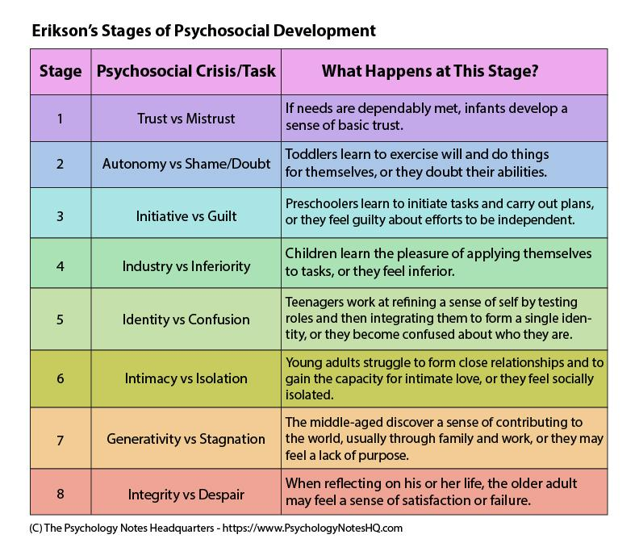
The overall concept of this theory would be to understand that within each stage a crisis must be resolved. The types of crisis you come across with intends to be seen as a major developmental issue that later on becomes important during a specific time period in a person’s life. The only way to be successful at solving the crisis, the person must be able to balance positive and comparable negative trait. The person must also understand that how they intend to meet the challenge cam intend to affect their personality trait. A main point that Erickson made in his psychosocial stage theory would be that ego identity is seen as a conscious sense of self that people develop through social interaction, which intends to change due to the new experiences and info we acquire on a daily basis.

23.

Families are taught to influence identity formation by having a positive or a negative effect on how the child would react to thin families are taught to influence identity formation by having a positive or negative effect on how the child would react to this. A positive way of how families are thought to influence identity formation would be to help the child grow on the positive path telling them or informing the child on good decision making on having good self-esteem understanding that although everybody is different culture wise they look different shapes sizes and forms that they are all the same with him and that they are capable of pursuing anything and everything they put their minds to.. A negative way of how families are taught to influence identity information would be family speaking on a child because they’re not the skinniest a family choosing to pick one a job because of the eating disorder they may have or putting a child down because of the way he or she thinks of the silly comments they may make or how they are mine processes information differently from theirs

