Lukas De Candido
Wise Wandering Map
Nyack College AGSC

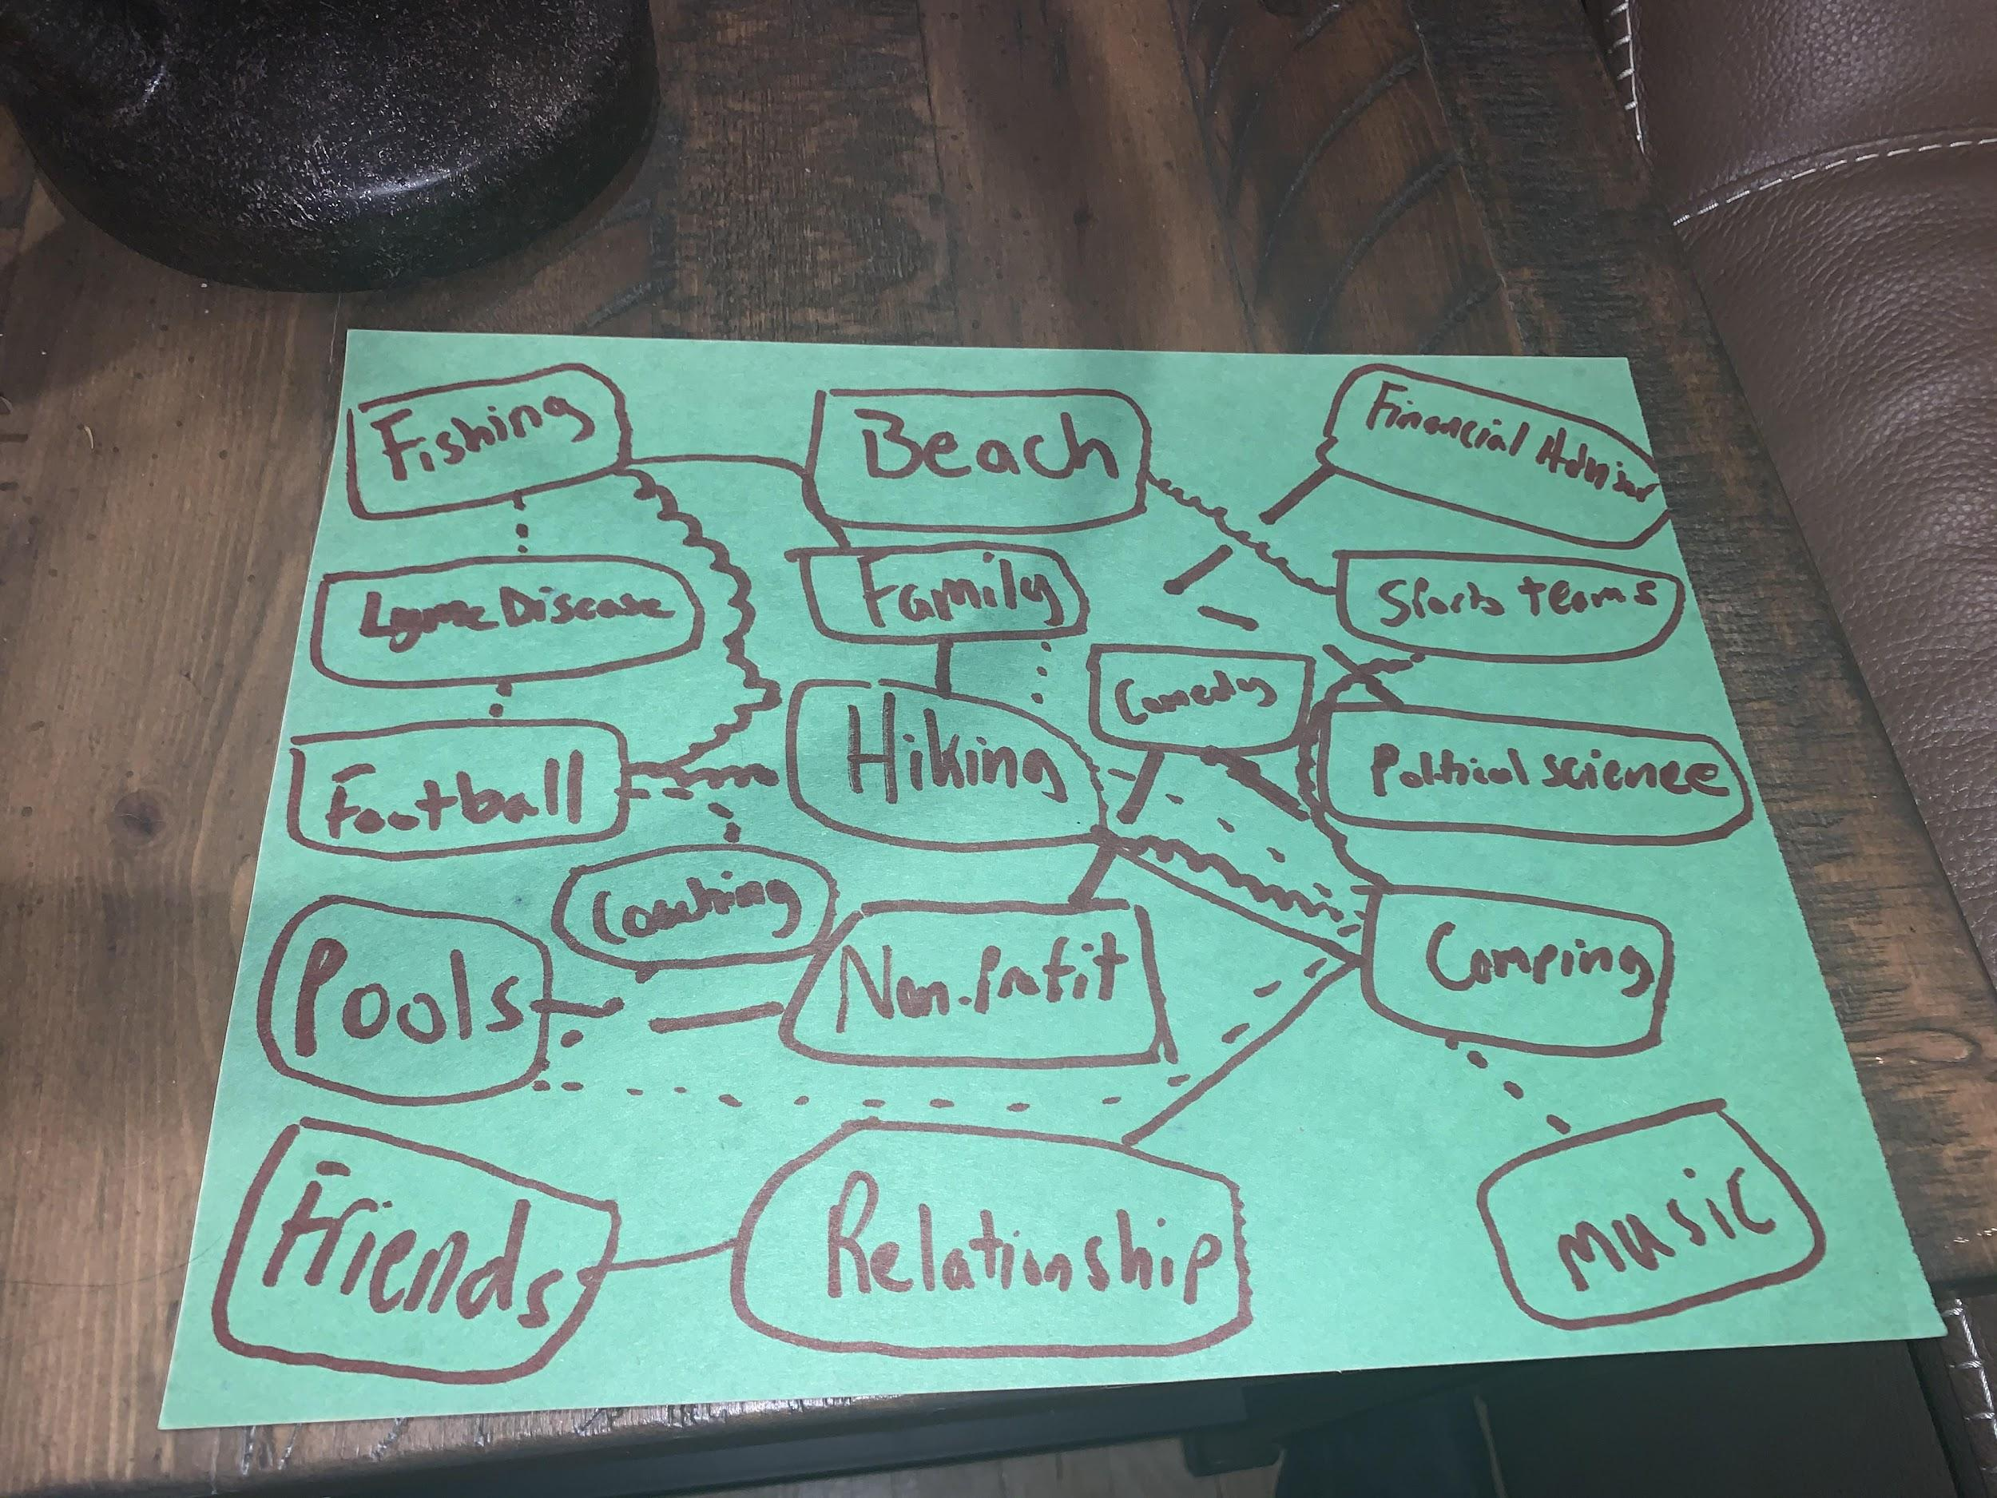
Wandering Map words:
Fishing- A hobby the client has had since they were a kid and shared with their entire family. Fishing was something that connected their family on weekends down at their shore house in Long Beach Island.
Lyme Disease- The client went through two years of life battling Lyme Disease in which they thought would at the time take their life. Through the tough trials and tribulations they grew and survived thanks to their family and friends, hobbies, and faith.
Football- Football has always been their favorite sport. They played from Kindergarten through Undergraduate college. Football served as a stress reliever and was and still is one of their biggest passions.
Pools- They have always been a water bug and in the summer you can find them in the pool at any given time. Along with enjoying swimming the client has worked on pools as a job for five years.
Friends- The client has had the same group of friends for nearly my entire life. They have experienced so many of life's milestones together and plan to experience so many more together. They have been the clients rock for a substantial amount of time.
Beach- In being blessed with a summer home at the beach the client had plenty of time in the sun swimming and building sand castles as a child.
Family- The most important thing in my clients life is and always will be their family and loved ones. Whether it was holidays, birthdays, or any occasion their family always came together. The client stated they can truly lean on one another and know at the end of the day they always have each other. “We have done this life together and having such a loving family has made life even at its toughest times and biggest storms so much better. My family is my lighthouse and I am the fisherman.”
Hiking- They have enjoyed hiking and being outdoors when they need to relieve themselves of stress or simply am just looking for a workout.
Coaching- The Client has found a new passion in coaching/volunteering and training young athletes who play football. “I feel giving back the knowledge and skill set I have developed would be beneficial to athletes looking to further their career in football.”
Non-Profit- They had started a non-profit that gave backpacks filled with everyday essentials to the homeless in the United States called “Got Your Back”
Relationship- The client stated “I have learned the true meaning of love due to my girlfriend Jessica and what it means to be in a healthy relationship.”
Comedy- “I have always been the class clown, funny friends, and comedian wherever I am. I earned ‘funniest’ in high school and will be trying out for America’s Got Talent. Since I was a young child I have truly believed God uses me best when I am healing others through laughter.”
Financial Advisor- The first job/position the client received after graduating from Fairleigh Dickinson University.
Sports teams- They enjoy watching sports just as much as they enjoy playing them. Their love for the Philadelphia eagles never wavers and they are a true “die-hard fan.”
Political Science- They received a degree in Political Science in 2018 from Fairleigh Dickinson University
Camping- Something they have enjoyed taking part in since they were a child with family and friends.
Music- “Although I don't have a great singing voice, I listen to music regularly and it has helped me get through many trying times in my life.”
After reviewing the clients wandering map, it was apparent that there were many themes that were interconnected in themselves. One of the first themes picked up on was the clients desire to be outdoors and involved in physically demanding activities in the clients life. Whether it be sports, outdoor hobbies, or vacationing the client has been active and often in the outdoors. The client has spent a great deal of their time outside and appreciating what the great outdoors has to offer. Along with that, the client was a football player for most of their life. Being tall in stature standing at six feet three inches tall and weighing 225lbs the client is fit for many physically demanding activities.
It was also apparent that they had a theme in relations to the importance of family and friends. Not only did they have the words “family and friends” actually present on their map, many of the different words they had listed involve those same exact people. Their friends and family have gone through life with them. The importance of those relationships holds to be unbreakable and a lifelong bond has been created. They have always considered themselves to be a family man, by that they mean that not only do they consider blood to be family, but the individuals they constantly come in contact with are family as well whether that be; friends, teammates, colleagues, etc. To them, family means being there for one another whenever that call comes, no matter the circumstance.
I also found a recurring theme of activeness. By activeness, I mean that the client is physically active through many different activities, but they are also active in the sense of being relentless in their efforts. Since my client was a child to this day they still participate in physically demanding activities because it fulfills a pleasure principle of their own which is to challenge themselves to be their best, and to fulfill their competitive nature. Also, they said there is a theme of activeness because no matter what life may throw their way they are actively doing what they can to make their situation better or even overcome an obstacle. My client believes being an active person who attacks obstacles with all their heart makes them more versatile and ambitious. Having beat Lyme Disease, recovered from nearly 15 sports related injuries, and having their back against the wall in many other situations they have found that the best reaction to any situation is to be active and to not let a cloud of negativity overcome them. The client explained that they are always active in bettering themselves.
The theory best fit for this client's wandering map is Person-Environment Correspondence theory. This theory holds the importance of the clients needs in correspondence with the needs of the career. As stated “work adjustment is the process of achieving and maintaining correspondence. Work adjustment is indicated by the satisfaction of the individual with the work environment, and by the satisfaction of the work environment with the individual” (Dawis & Lofquist, 1984). My client has stressed the importance of working in an environment that fits their values and needs. The client left their last position as a financial advisor solely on the fact that sitting behind a desk was not his ideal work environment and it left the client feeling mentally drained. Likewise, in the PEC theory the work environment is searching for individuals with the correct set of capabilities qualifying them for the position in which the individual can fit all requirements. It is important that both the individual and the environment have congruence. It is also clear that my client, having played sports and taken part in many goal oriented tasks have some sort of rewards found in their career to satisfy my clients values. When employee and workplace satisfaction are high the result is a long path in the career.
In Zunker’s Text “Career Counseling: A Holistic Approach.” Dawis’s and Lofquist’s theory states that the following four key points must be followed in order to benefit the client
(1) Work personality and work environment should be amenable
(2) individual needs are most important in determining an individual’s fit into the work environment,
(3) individual needs and the reinforcer system that characterizes the work setting are important aspects of stability and tenure
(4) job placement is best accomplished through a match of worker traits with the requirements of a work
It is important to follow these four key points in order to put the client in the best position for tenure.
What I know about my client is that they are extremely active and love the outdoors. I cannot picture my client being stuck behind a desk all day long and they even stated they left a prior job for that reason. Having noted the clients desire to have goals, be active, be outdoors, and have a rewarding position, I found that a good career choice could be a fish and game warden. My client is from Maine, and has a background in being outdoors, fishing, sports, and more. This career is extremely rewarding and a goal oriented career. Having already graduated from school, the individual can step aside and join the police academy to provide them with proper training in order to become a fish and game warden. The client is somebody who loves the outdoors and I cannot picture them anywhere else and neither can they.
Next Steps:
- Have the client review their wandering map with me
- Have them point out the recurring themes within the map
- Speak about why they left past job positions
- Ask what they would want in a new career?
- Incorporate the Person-Environment Correspondence Theory
- Mention possible career paths and choices such as Fish and Game warden, Police officer, etc.
- Weigh in the benefits of both the individual and the environment
- Will it be beneficial?
- Find next steps in pursuing the intended career path
In relation to PEC Zunker states “job satisfaction is an indicator of the individual’s perception of work and the work environment and is highly related to tenure in a work situation.” (Zunker P. 24). In order to set our client up for a successful career we must assure that the client is in congruence with the demands of the work environment. Setting the client up with a goal oriented, outdoor, challenging career sets up a successful standard in which both the employee and the work environment flourish off of one another.

Work Cited
U. (2020, February 23). Theory of Work Adjustment. Retrieved June 22, 2020, from http://vpr.psych.umn.edu/theory-work-adjustment
Zunker, V. G. (2016). Career counseling: A holistic approach. Australia: Cengage Learning.

