Social Work Practice Evaluation Plan
Valerie St.Vil
SWK 628: Social Work Program and Practice Evaluation
Nyack College

Table of Contents

Title Page and Title | 1
Table of Contents | 2
DESCRIBING THE CLIENT & PROBLEM | 3
Client Background | 3
Client Problem(s) | 4
Client Intervention(s) | 5
Intervention Hypothesis | 6
CLIENT GOALS & OBJECTIVES | 6
Client Problem Areas & Target Problems | 7
Intervention Goals & Objectives | 7
RESEARCH DESIGN | 8
MEASUREMENT | 10
Quantitative Measurements | 10
Qualitative Measurements | 12
DATA ANALYSIS | 12
Quantitative Data | 12
Qualitative Data | 13
RESULTS & DISCUSSION | 14
Quantitative Results | 14
Qualitative Results | 16
Findings & Implications | 16
REFERENCES | 17

Describing the Client Problems
Client Background
Twenty-Six year old Hispanic female, Ms. L, was referred to Sheltering Arms Children & Family Preventative Services. She is a single mother of two children, I.M (6 years old) & K.M (1 year old). She currently lives with her mother, and her two sisters in a three bedroom apartment in South Ozone, in Queens, NY. She is currently unemployed and seeking an overnight job, so that she can still be able to watch take care of her 1 year old during in the morning, while her 6 year old daughter attends schools. Although she lives with her mother, and her mother often assists her with taking care of her two daughters, she reports that they struggle to maintain a healthy relationship.
She reports that they engage in numerous verbal altercations, however reports that it doesn’t escalate past that. She reports that their unhealthy relationship stems from her childhood. She reports that as a child, she witnessed her parents engage in verbal and physical altercations. Ms. L, reported that as a child, she witnessed her parents, whom at the time, were married fight many days and nights. She reports that her father struggled with alcoholism & substance use disorder. She also states that her father also struggled with mental health, and that she believes that it is genetics, that connects her with her struggle with substances & mental health.
At 15 years old, her parents divorced each other. She reports that at 18 years old, she moved to Orlando, Florida and met her eldest daughter’s father. The relationship lasted approximately 3 years until, he became violent. She then met her youngest daughter’s father, whom she reports she met through his mother, whom she worked with at a local health center. The demise of their relationship was contributed from his ongoing infidelity, which caused her to contract a chronic medical illness, whom she reports, caused her clinical depression, and increase in substance and alcoholism. She reports that it was then, when her mother encouraged her to move back to NYC for family support. When member moved back to NYC, she eventually reunited with an old acquaintance, whom she is currently in a relationship with.
Client Problems - Epidemiology and Etiology
Presenting problems of this family: Case initiated after it was reported that L.N stays days at a time at an unknown address in the Bronx with her children. She reports that unknown location is with her boyfriend, whom her mother does not like, due to her and boyfriends history of verbal altercations. Ms. L.N had a prior indicated case from 2018, after she left 1 year old daughter K.M at maternal grandmother’s home and disappeared to Florida without notice. She states that she went to Florida, to see her ex-boyfriend, whom she was having ongoing verbal interactions with. Ms. L.N was previously engaged in PPRS with Sheltering Arms, she engaged in parenting skills, and her service case was closed on 7/31/19. L.N was referred for mental health services during her most recent ACS, case due to a traumatic event and due to the fact that she is currently not engaged in mental health services, and out of compliance with her psychotropic medications. L.N admits understanding that she needs to be adherent to her mental health treatment and also admits that she smokes marijuana & drinks regularly when stressed. During this investigation, L.N experienced a domestic violence incident with her current boyfriend. At first she reported that it was not physical, although, it was later revealed, that not only did the incident occur in front of her two young children, but it took place in her residence, after inviting him to sleep over. This event took place as a result of her violating a full stay away Order of Protection, that she placed against him, resulting in her risking the safety of her and her children.
L.N was referred to receive Preventative Services from Sheltering Arms by ACS and consented on 9/25/2019. Since the referral L.N has agreed to meet for a minimum of 6 monthly contacts L.N expressed that she is interested in finding an apartment with her two daughters when her lease is up.
Client Interventions
The interventions set in place for L.N’s first goal of being a survivor domestic violence is for member to receive trauma-focused cognitive behavioral therapy. Cognitive behavioral therapy is an intervention that is common used with individuals suffering from mental health issues such as depression, stress and post-traumatic stress disorder. Implementing trauma-based CBT among survivors, who are also mother due to the intensity of the effects caused by violence. The goal of implementing trauma-focused CBT, is to assist with the trauma that is caused from individuals who have witnessed and have experience IPV. PTSD can be developed as a contributing factor for intimate-partner violence. The technique that is used is trauma-based cognitive behavioral therapy for children of veterans. “TF-CBT is an evidence-based treatment aimed at addressing these symptoms, among others, for children and adolescents ages 3 to 17 exposed to a range of traumatic events including abuse or neglect, witnessing IPV, traumatic grief, and natural disasters (Cohen, Mannarino, & Deblinger, 2010). The second intervention is relapse prevention & harm reduction counseling through Motivational Interviewing with an onsite CASAC. “MI is a brief intervention. The substance abuser and the MI counselor will typically meet from one to four times, for about 1 hour each session. The settings of delivery can vary and consist of aftercare/outpatient clinics, inpatient facilities, correctional facilities, halfway houses, and other community-based settings. MI incorporates four basic principles into treatment: 1) expressing empathy, 2) developing discrepancy, 3) rolling with resistance, and 4) developing self-efficacy.” (Smedslund, 2011)
Client Goals & Objectives
Client Problem Areas & Target Problems
The first problem & target areas focuses on the client’s history with domestic violence, and substance use disorder in DSM-5. The client has children who witnessed the domestic violence incident, creating a child safety risk. The traumatic event can affect her children’s, by creating negative schemas on violent. The second problem is her struggle with substance use, which member identified as alcohol & marijuana.
Interventions Goals & Objectives
CLIENT PROBLEMS, GOALS, OBJECTIVES, & INTERVENTIONS
PROBLEM AREAS AND TARGET PROBLEMS | CLIENT GOALS | CLIENT OBJECTIVES | INTERVENTIONS
Domestic Violence incident with Boyfriend. | 1 weekly attendance to DV Women’s Empowerment Group | The client will receive DV counseling for 20 minutes for weeks. | Women’s Support Group with DV specialist &  Trauma-Focused Cognitive Behavioral Therapy.
Substance & Abuse. | Relapse Prevention/ Increase Harm Reduction. | The client will receive 45 minutes of Substance & Abuse Counseling with CASAC-T for 20 weeks | Substance & Abuse Counseling through Motivational Interviewing.

Intervention Hypothesis
- The first Hypothesis is that receiving 20 weeks of Trauma-Focused Cognitive Behavioral Therapy will improve the effects on her mental health& will decrease her depression scale scores by at least 30%.
- The second Hypothesis is that receiving 16 weeks of Relapse Prevention Counseling & Motivational interviewing will increase harm reduction from smoking marijuana and drinking alcohol daily to at least 2-3 times a week.

Research Design
The design that has been selected to observe the clients problems & interventions implemented to measure changes made, will be the basic single systems: A-B design. The A-B design can clearly indicate whether any changes in problematic behaviors occurred. (Bloom, 2009) The A phase of the A-B design focuses on the baseline phase for each problem. The B phase of the A-B design focuses on the interventions that will be used for the client. According to Bloom, the single systems design is theory independent, in the sense that any intervention may be evaluated within the working of single-systems designs. Bloom, also emphasizes the importance of identifying a specific intervention for the target, to ensure that the evaluation process makes sense. For example the client has two target problems, which will result in implementing two individual A-B designs. The first design will be A= (Domestic Violence) B = (Trauma-Focused Cognitive Behavioral Therapy). The second design will be A= (Substance Abuse), B= Substance Abuse Counseling, using Motivational Interviewing.
The rationale for using the A-B design is that implementing it can observe whether there is a change in the target population, since the design is only observing the problem, and implementing the intervention. Therefore, its design can suggest that any changes made in the behavior can contributed specifically because of the intervention. Another rationale for using this design, is that it is a simple design, which provides the client and the practitioner to focus on outcomes, which is relative to the focus of the program in which the client is receiving the services from. A threat to internal validity of this single system design is history. For example this client has a target problem of domestic violence. The intervention that is being used to help this client is cognitive behavioral therapy, but the client who has left her spouse can choose to go back to that relationship, which can threaten the progress from CBT. Another example is this client struggles also with another target problem, which is substance abuse. Her struggle with addiction can overshadow the domestic violence. Single systems design by definition extend overtime, there is ample opportunity for extraneous events to occur. (Bloom, 2009)
A threat to external validity is difference in clients. Every client has their own background, which includes their age, their gender, and their economic status, which can cause the lack of success in a single system design being used because every client is different. Attempting to use a general design based that has previously worked with other clients, does not necessarily equate success on a new client. Each client is their own subject expert. And while the intent is to help the client, most clients are recommended services without client’s opinion of what they believe is best, which can cause the intervention to not work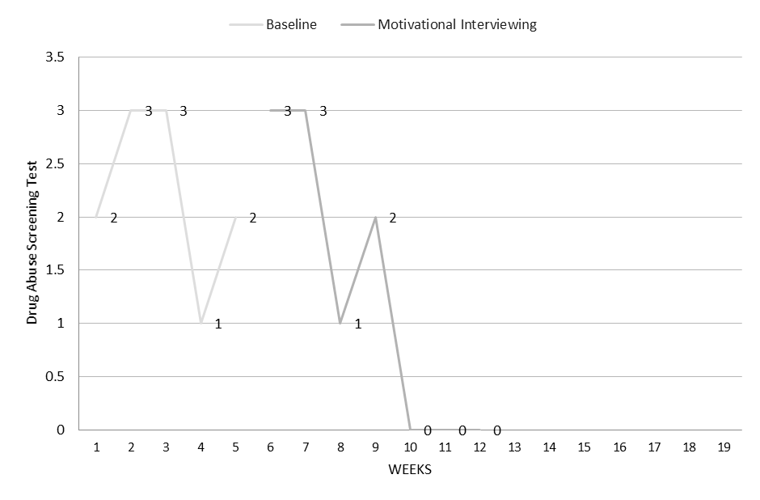Figure 1.1
Figure 1.2

References

Bloom, Martin, et al (2009). Evaluating Practice: Guidelines for the Accountable Professional.
Pearson/Allyn and Bacon. Print.

Deblinger, Esther, et al. “Trauma-Focused Cognitive Behavioral Therapy for Children: Impact of the Trauma Narrative and Treatment Length.” Depression and Anxiety, vol. 28, no. 1, 2010, pp. 67–75., doi:10.1002/da.20744.

Smedslund, Geir. “Motivational Interviewing for Substance Abuse.” Practice: Motivational Interviewing for Substance Abuse, National Institute of Justice, CrimeSolutions.gov, 2011, www.crimesolutions.gov/PracticeDetails.aspx?ID=31.

