1. Enzymes are
a) DNA.
b) lipids.
c) carbohydrates.
*d) proteins.
e) amino acids.

2. Which of the following statements does NOT agree with the cell theory?
a) Insects are composed of cells.
b) Paramecium comes from Paramecium.
c) The smallest living organisms are single cells.
*d) A balanced diet is important for good health.
e) Spontaneous generation of cells cannot occur

3. The sum total of all the chemical reactions in a living structure is called its
a) energetics.
b) locomotion.
c) digestive power.
d) entropy.
*e) metabolism.

4. Plants need which of the following to carry out photosynthesis?
a) Only H₂O
b) Only CO₂
c) Glucose and O₂
d) Both CO₂ and O₂
*e) Both CO₂ and H₂O

5. Ribosomes are the structures in which
a) chemical energy is stored in the form of ATP.
b) cell division is controlled.
*c) genetic information is used to make proteins.
d) sunlight energy is converted into chemical energy.
e) new organelles are made.

6. When ATP releases its energy, it forms
a) Only AMP
b) Only ADP
c) Only phosphate (Pi)
d) Both AMP and Pi
*e) Both ADP and Pi

7. The products of the light dependent reactions of photosynthesis
a) are complex carbohydrates.
b) are not used in the light independent reactions.
*c) include ATP, NADPH and O₂.
d) are glucose molecules.
e) include ATP and complex carbohydrates.

8. Refer to the accompanying figure. In which condition does trypsin function best?
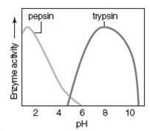
*a) high pH, such as in the intestine
b) low pH, such as in the intestine
c) high pH, such as in the stomach
d) low pH, such as in the stomach
e) neutral pH, such as in most interstitial fluid.

9. One difference between plant and animal cells is that
a) only animal cells have mitochondria.
b) only plant cells contain plastids.
*c) plant cells have a cell wall, whereas animal cells have a plasma membrane.
d) plant cells lack a cytoskeleton.
e) only plant cells have a Golgi apparatus.

10. Mitochondria are common in animal cells but not in plant cells.
a) T
*b) F

11. Which statement is true?
a) A cell placed in an isotonic solution will swell.
*b) A cell place in a hypotonic solution will swell.
c) A cell placed in a hypotonic solution will shrink.
d) A cell placed in a hypertonic solution will remain the same size.
e) A cell placed in a hypertonic solution will swell.

12. Prokaryotic cells do NOT have
a) nucleoid regions
*b) membrane bound nuclei.
c) cytoplasm.
d) a plasma membrane.
e) DNA.

13. Phospholipids have a hydrophobic head and hydrophilic tail.
a) T
*b) F

14. Phospholipids are found in cell membranes.
*a) T
b) F

15. Openings in leaves through which gases enter and exit are called
a) Rubisco
*b) stomata
c) veins

16. Energy_________
*a) cannot be created or destroyed
b) can change from one form to another
c) tends to disperse spontaneously
d) all of the above

17. Which of the following is the smallest?
a) Eukaryotic cell
b) Prokaryotic cell
*c) Mitochondrion
d) Virus

18. The Krebs cycle (also called Citric Acid Cycle) does not require oxygen to function.
*a) T
b) F

19. Enzymatic reactions can be affected by salinity.
a) T
*b) F

20. Chloroplasts and central vacuoles are common in plants but not in animal cells.
*a) T
b) F

21. Which color is not absorbed by chlorophyll?
a) red
b) orange
*c) green
d) blue
e) purple

22. The Domain Eukarya includes all of the following except
*a) Bacteria.
b) Kingdom Plantae.
c) Kingdom Fungi.
d) Protists.

23. Although it is too simple an explanation, the concept of a key fitting into a lock is descriptive of the
a) inhibition of enzymes by small molecules
b) fit if coenzymes to enzymes.
*c) matching of enzyme with substrate.
d) regeneration of ATP from ADP.

24. ____________ is the primary source of energy for autotrophs on this planet
a) food
*b) sunlight
c) ATP

25. A mutant plant cell with no chloroplasts would appear green in color.
a) T
*b) F

26. During photosynthesis, sugars are built
a) on the outer chloroplast membrane
b) inside the mitochondria
*c) in the stroma of chloroplast
d) in the thylakoids

27. Which organelle is most abundant in cardiac muscle cells?
*a) Mitochondria
b) Lysosomes
c) Golgi complexes
d) Smooth ER
e) Plastids

28. Enzymes increase the rate of a given reaction by lowering what kind of energy?
a) combination
*b) activation
c) thermal
d) electrical
e) solar

29. Choose the correct pathway of information flow in the cell.
a) RNA → DNA → protein
*b) DNA → RNA → protein
c) ER → DNA → RNA → protein
d) ER → DNA → Golgi → protein

30. The light-dependent reactions of photosynthesis occurs in
a) stroma of chloroplast
*b) thylakoid of chloroplast
c) lysosome
d) mitochondrion
e) nucleus

31. These organelles are sometimes referred to as rough or smooth, depending on the structure.
a) Golgi bodies
b) ribosomes
c) mitochondria
d) lysosomes
*e) endoplasmic reticula

32. Cells that primarily produce steroid hormones, such as testosterone and estrogen, have large quantities of smooth endoplasmic reticulum.
*a) T
b) F

33. Four of the five answers listed below are portions of the cell theory. Select the exception.
a) Cells are the structural and functional components of living things.
b) Cells arise from preexisting cells.
c) All organisms are composed of cells.
d) Cells are the basic living unit or organization of living things.
*e) All cells have a nucleus.

34. The oxygen released in photosynthesis comes from
a) carbon dioxide.
b) glucose.
c) rubisco.
*d) water.
e) atmospheric oxygen.

35. Recognition proteins are most important for
a) facilitated diffusion of molecules.
b) active transport of molecules.
c) maintaining membrane integrity.
d) maintaining membrane fluidity.
*e) distinguishing foreign cells from "self" cells.

36. Photosynthesis is an exothermic reaction.
*a) T
b) F

37. These organelles contain enzymes used in the breakdown of glucose and generation of ATP.
a) Golgi bodies
*b) ribosomes
c) mitochondria
d) lysosomes
e) endoplasmic reticula

38. Cell membranes do all of the following EXCEPT
a) isolate the cell's contents from the external environment.
b) allow communication between cells.
c) regulate the movement of substances between the cytoplasm of the cell and the extracellular fluid.
d) provide attachments between cells.
*e) provide an energy source for the cell.

39. Which of the following is(are) not components of all cells?
a) plasma membrane
b) DNA
c) cytoplasm
d) ribosomes
*e) nucleus

40. The net movement of molecules from a high concentration to a low concentration is best described by which of the following?
*a) Passive transport
b) Active transport
c) Osmosis
d) Endocytosis
e) Exocytosis

41. Which of the following is an energy-requiring mode of transport that brings substances into a cell?
a) Facilitated diffusion
b) Osmosis
*c) Active transport
d) Simple diffusion

42. The diffusion of water molecules across a selectively permeable membrane is called
a) facilitated diffusion.
b) hydrolysis.
c) active transport.
d) exocytosis.
*e) osmosis.

43. Which of the following occurs as an enzyme produced by a cell is secreted from the cell?
a) Endocytosis
b) Phagocytosis
c) Pinocytosis
*d) Receptor-mediated endocytosis
e) Exocytosis

44. The light-independent reactions of photosynthesis
*a) fix carbon dioxide into a stable organic compound.
b) involve the liberation of oxygen.
c) cannot occur in the light.
d) occur in the mitochondrion

45. Movement of a molecule against a concentration gradient occurs in
a) simple diffusion
b) facilitated diffusion
c) osmosis
*d) active transport
e) passive transport

46. Carbon dioxide absorption is an appropriate indicator of photosynthesis because
*a) CO₂ is needed to produce sugars in the Calvin cycle
b) CO₂ is needed to complete the light reactions
c) plants produce oxygen gas by splitting CO₂
d) the energy in CO₂ is used to produce ATP and NADPH

47. Based on your knowledge of photosynthesis, a plant placed under red light would probably
a) absorb no CO₂
b) absorb the same amount of CO₂ as plants under both green light and normal sunlight
c) absorb less CO₂ than the plants under green light
*d) absorb more CO₂ than the plants under green light

48. A single-celled freshwater organism, such as a protistan, is transferred to salt water. Which of the following is likely to happen?
a) The cell bursts.
b) Salt is pumped out of the cell.
*c) The cell shrinks.
d) Enzymes flow out of the cell.
e) All of these.

49. Which of the following statements concerning cell walls is NOT true?
a) The cell wall is located outside the plasma membrane.
*b) Water cannot move through a cell wall.
c) The cell wall is more rigid than the plasma membrane.
d) Cell walls can form connections to one another.
e) Pectin and cellulose are found in plant cell walls.

50. All cells have:
a) a nucleus, but not necessarily DNA
b) a plasma membrane, but not necessarily DNA
c) cytoplasm, but not necessarily a plasma membrane
d) cytoplasm and a plasma membrane, but not necessarily DNA
*e) cytoplasm, a plasma membrane, and DNA

51. Which letter identifies this cell’s nucleus?
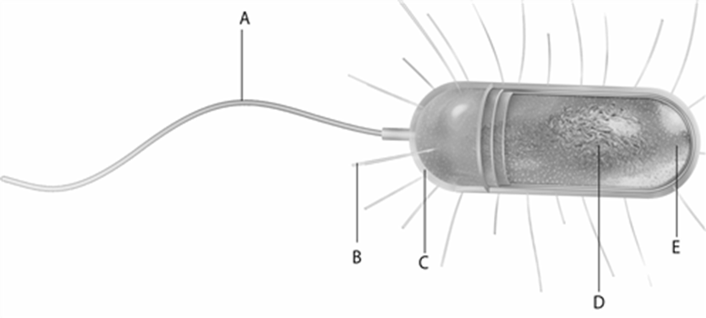

a) A
b) B
c) C
d) D
*e) There is no nucleus.

52. How does a high pH affect an enzyme’s activity?
a) It deceases it.
b) It increases it.
c) It changes the shape of all enzymes.
d) It does not affect the enzyme but it lowers the availability of substrate.
*e) It varies with different enzymes; some work well at a high pH, others do not.

53. What is a key difference between autotrophs and heterotrophs?
*a) Autotrophs harvest energy directly from the environment.
b) Autotrophs do not require carbon.
c) Autotrophs mainly break down organic compounds.
d) Autotrophs harvest energy from decomposing organisms
e) Autotrophs are consumers.

54. This figure shows the metabolism of glucose and oxygen to CO₂ and H₂O. The carbon in CO₂ comes from oxygen.
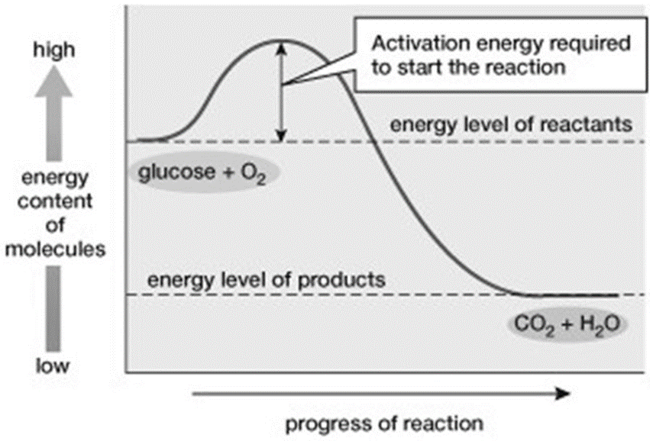
A) T
*b) F

55. Energy is released in this reaction.
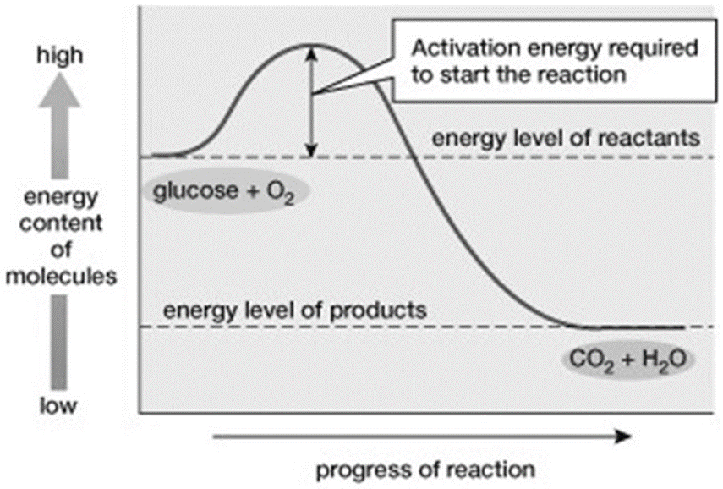
*a) T
b) F

