HOW TO PRINT ALL DETAIL INVOICES FROM REYNOLDS & REYNOLDS

Prior to making changes - Please read through all instructions beginning to end. Check with your Service Manager, if you already receive an ALL DETAIL ACCOUNTING COPY (SAMPLE BELOW) - you can skip to the 3659 instruction highlighted at the end to print your copies.
If you don’t, you need to make changes to 3639 as outlined below. Prior to printing any copies -Reynolds & Reynolds Helpdesk will need to direct these copies to your printer. This will print an extra copy each time something is closed. Specify no additional changes should be made to current hard copies, and invoice print settings.

Select 3639 From Service
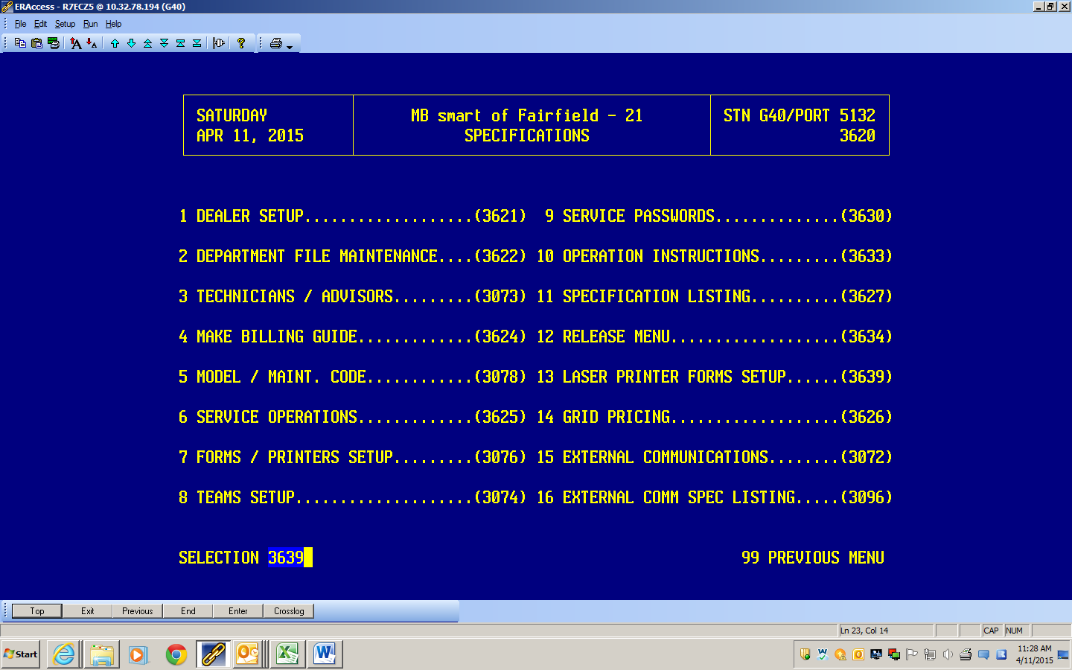

On the next screen choose 9 (to display)
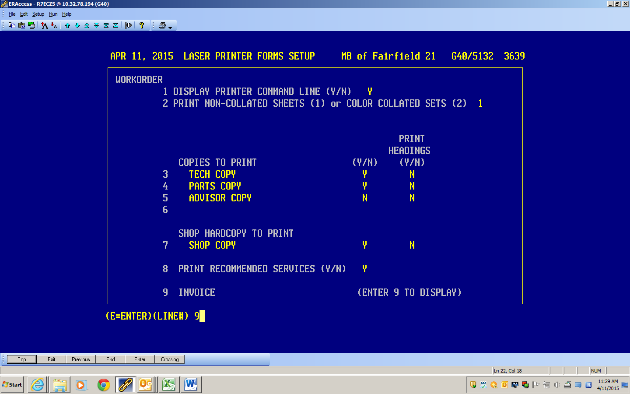

On the next screen choose F
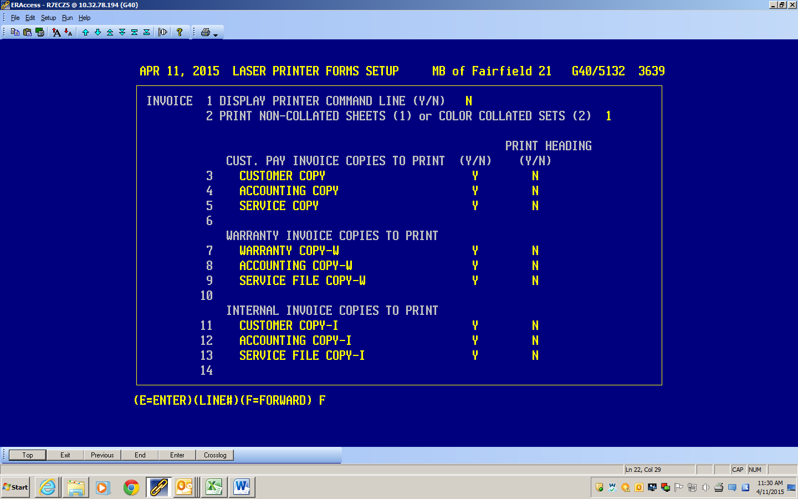

On next screen you will see ALL DETAIL INVOICE COPIES TO PRINT YOU NEED TO GO TO LINE 1 –
Name the copy (I chose Accounting Copy-A) and SELECT Y for the print choice. 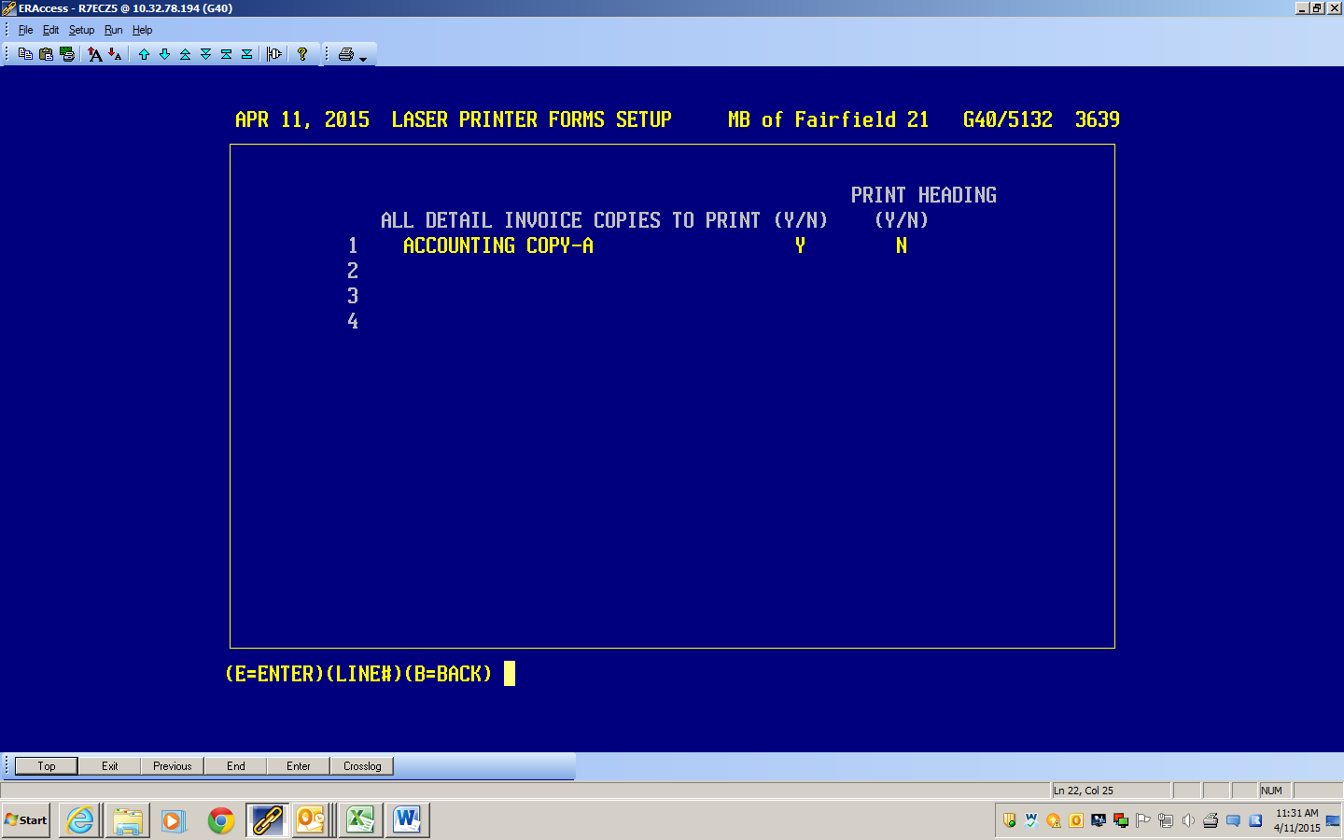
*Once the changes are made you can print a run of 200 RO’s easily in 3659 (selecting print by invoice number) – Please see final instructions below in yellow highlight. Return to 3639 and turn off the print feature, or contact R&R to delete it so you no longer get an extra copy, unless you want to keep it.
Print 1 and verify the following information is visible before running 50 copies. 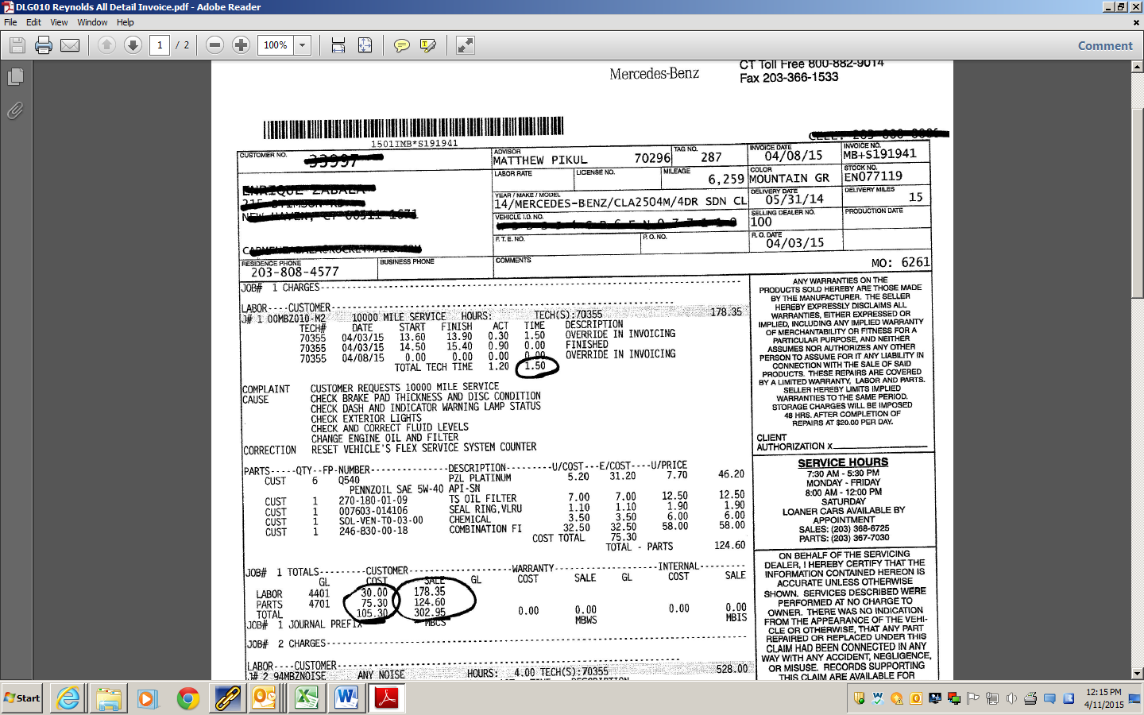
* FINAL INSTRUCTIONS TO PRINT A RUN OF 50 RO’s
SELECT 3659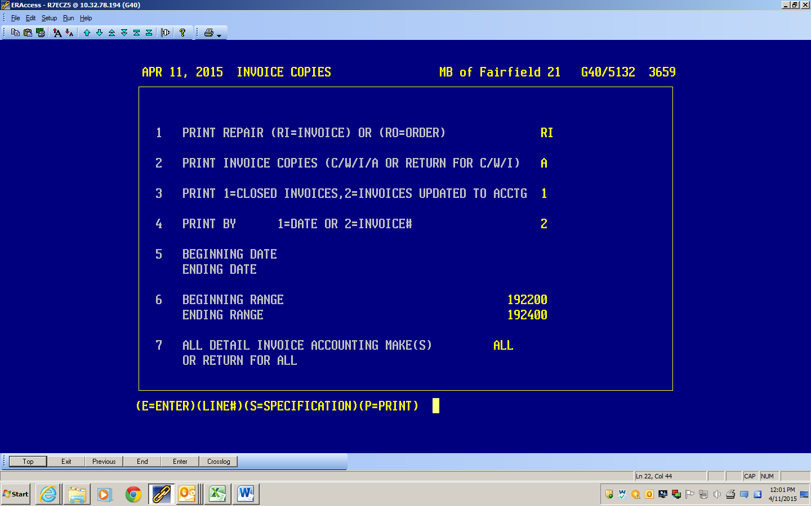
Choose the following for fields 1-7
1 – RI / 2 – A / 3 – 1 / 4 – 2 and then in 6 the Invoice number range you want to run/ 7-ALL and P to Print

