
NADA 063016
General Information

Location: NADA Academy
3rd Floor Classroom # 1
8400 Westpark Drive
Tysons, VA 22102
www.nada.org/academy/login

Instructors: Heather Westman Jeff Breeland
(703) 827-7406 (703) 988-1099
hwestman@nada.org jbreeland@nada.org

Any questions regarding the class syllabus please contact your instructors

Arrival: A Hotel List can be found on your NADA Academy class website with special rates. Arrive by the Sunday before the first day of class. Class begins on Monday at 8:00 am and typically ends by 5:00 pm each day (except Friday).

Departure: Class concludes by 1 pm on Friday. Please do not schedule flights before 4:30 pm.
The closest airports are Dulles (IAD), and Reagan National (DCA).

PLEASE NOTE: Websites utilized for the Financial Management class:
- NADA Academy – Class site / Pre-Work Exam www.nada.org/academy/login
- NADA 20 Group Composite – ElectronicCompositehttp://www.nada20Group.org/20Group_Elearn/

Pre-Class Work

To be fully prepared and to gain the most from your class experience, you MUST complete the following Pre-Class work prior to attending the class: You will receive over 1/4 of the benefit of the class right now by completing the pre-course assignments.

DEADLINE FOR COMPLETION OF PRE-CLASS WORK:

All items must be completed 2 weeks BEFORE you arrive for class on Monday.
Pre-Class Work & Materials/Documents Required for Class

- The Financial Management Four Pre-Class Online Learning Modules must be taken BEFORE CLASS BEGINS:
- Go to your class site www.nada.org/academy/login and log in with your credentials.
- Click “Courses” at the top.
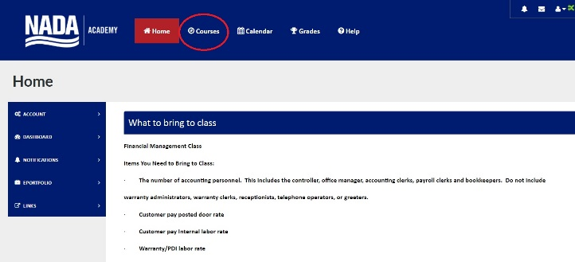

- Click on your Financial Management Course.
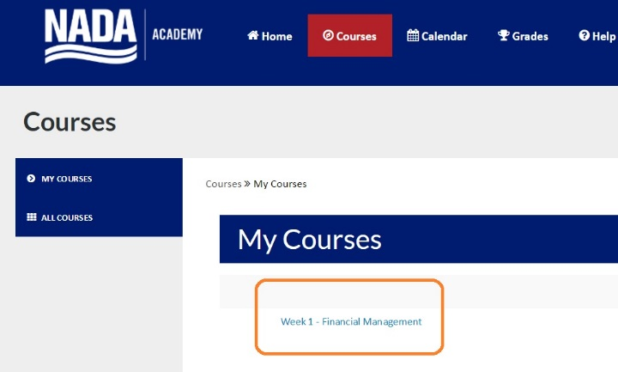

- Click on “Units” on the left side tool bar
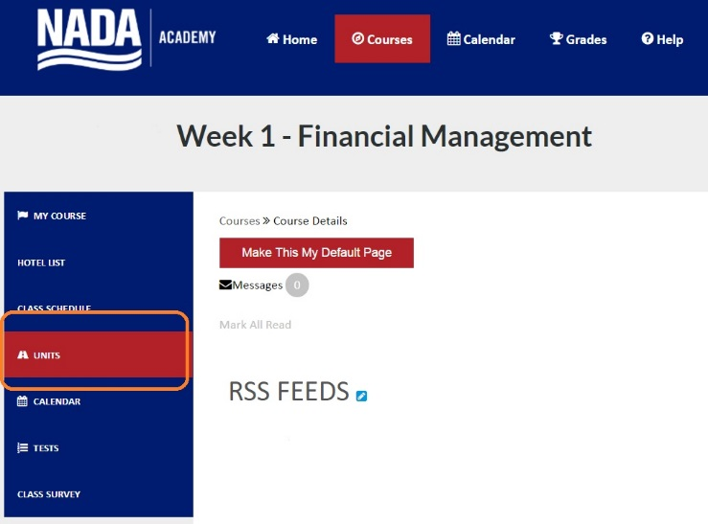

- Click on “Pre-Class Modules” and follow the directions exactly as they appear on screen, being sure to check mark each task before continuing to the next one.
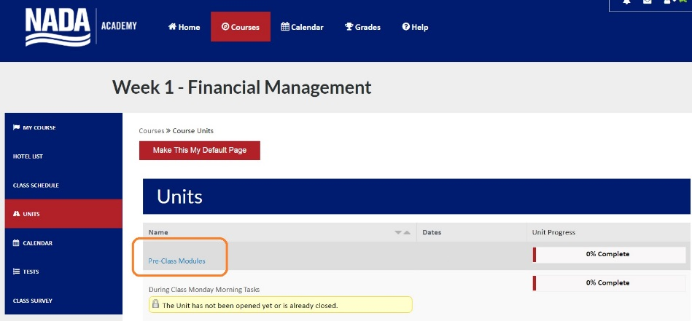

- Submit an Excel copy of your October financial statement along with the supplemental sheet information to dcastatements@nada.org this is critically important and failure to do so will result in your exclusion from the class composite. The statement may also be a PDF file.

- The NADA 20 Group Composite tutorial must be taken BEFORE CLASS BEGINS and can be found under “Units” on your Financial Management Class site.

- Each month once you have completed your financial statement, log onto the composite site http://www.nada20Group.org/20Group_Elearn/ , click the link near the top right: Supplemental Input Sheet. Once here you will manually enter additional data needed for your composite. We recommend you print a blank copy, fill in the blanks, then go back in and enter the data all at once. Once finished hit submit.

- Bring a printed and stapled original copy of your manufacturer’s October Financial Statement. An electronic file is not sufficient for class.

Technology Requirement for Class

YOU MUST HAVE THE LATEST TECHNOLOGY (BOTH HARDWARE AND SOFTWARE) IN ORDER TO GET THE MOST OUT OF THE CLASS!

- Laptop Computer: Students are required to bring a capable/current P.C. or Mac laptop with wireless access to class as it will enable them to complete templates and assignments that evaluate critical aspects of the dealership’s performance. An iPad or tablet will not meet the technology requirements of the class websites.

- Software: The Academy currently distributes templates and applications compatible with the Microsoft Office Suite, including Word, Excel, and Power Point. The software must be fully installed and registered to utilize the templates provided by the Instructors. We strongly recommend students have a basic working knowledge of Excel prior to arriving for the seminar. All Mac users must have Office Suite for Mac (Word, Excel, and Power Point) installed on their Mac computer prior to coming to the seminar.

- WE RECOMMEND THAT YOU USE THE CHROME BROWSER FOR IMPROVED ACCESS!

- Wireless Internet Access: Wireless internet access points are available in the classroom. The SSID and access codes are posted for student use on the first day of class. The Instructors distribute materials via the Internet during the class.

Keys to Success
- Enter into the learning process with enthusiasm and the inquisitive drive to learn.

- Ask questions if you do not understand something. During the entire period of your training, please be assured that there are no stupid questions. Don’t assume anything ‒ find out!

- Develop empathy for your classmates and their viewpoints. Constantly challenge the views of others, but always respect them.

- We will provide the most current learning techniques available to make this education the most meaningful, and we congratulate you and look forward to working with you!

