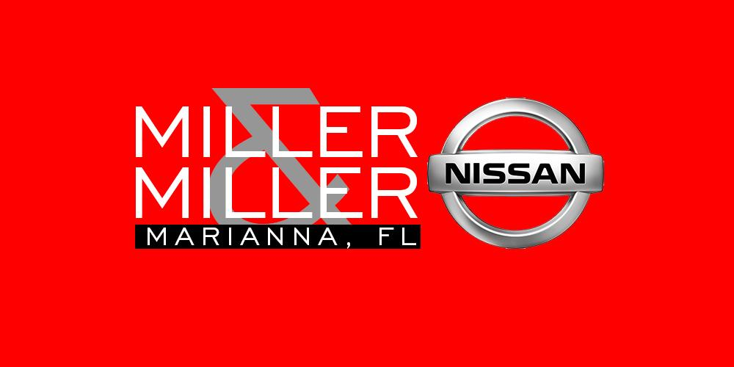

By

Dustin Miller N327-26

And

Michael John Mitchell N327-27

Advertising




Marketing

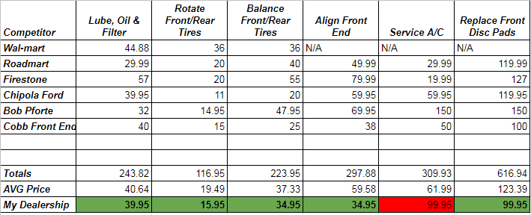

After calling around town, it actually appears that our competitive rate pricing is better than or comparable to our local competition. We are getting consistently beat in pricing for A/C service, though.
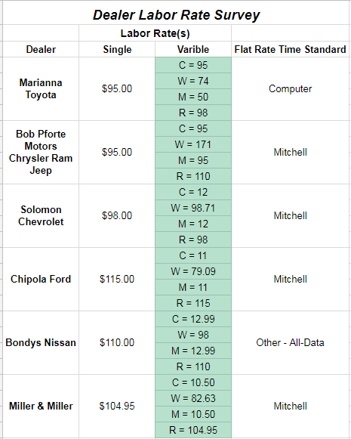

Our Labor rate was around middle of the pack of the dealerships we surveyed. It is something we will continuously audit and adjust to ensure that our service department is a s competitive as it can be.
Facility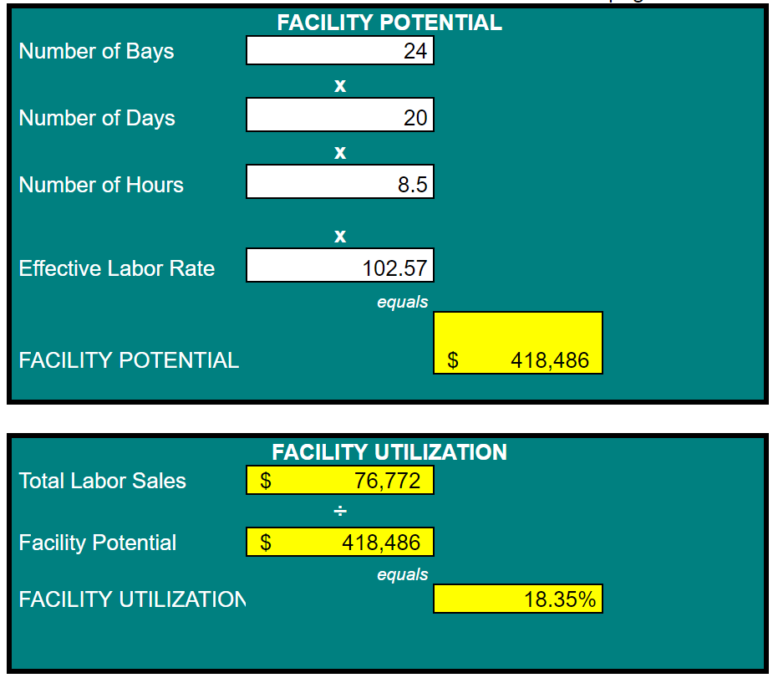

This was a very bad month in fixed for us. But even during a good month, we are not using our facility to the full potential. Not even close. One big reason is we have a full line GM store and a Nissan store all under one roof currently. Our service department stays extremely busy, to the point that our service advisors are order takers, not order makers. We have put an emphasis on MPVIs and upsells, but there have been some growing pains. Overall, I see this getting much better once the two stores are separated (April 2018.)

Productivity

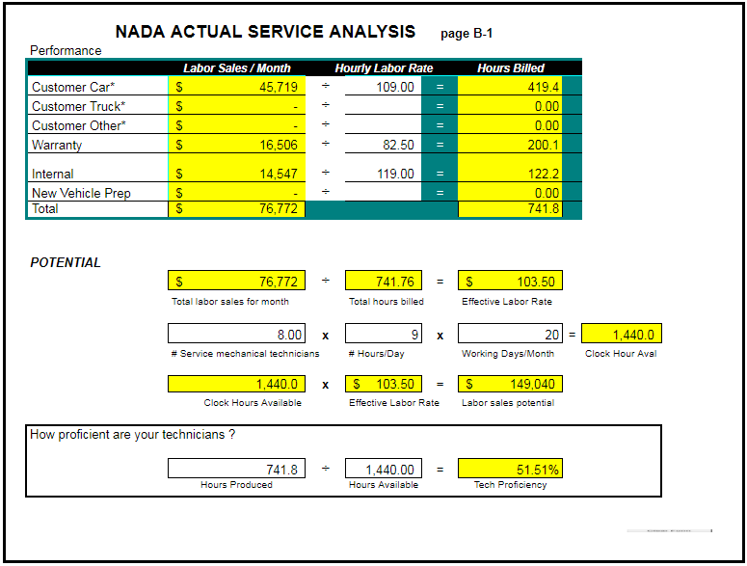

Since our Fixed Ops 2 class, we have instituted service meetings like we talked about. We have begun to give bonuses to techs at that meeting who had the most upsells, and we are beginning to track hours turned by tech during the week. Even though we have begun to upsell more per R.O., our hours are still not where we want them (and, in turn, our productivity is low.) This is a problem we are focused on fixing, because NADA guide is 120% t4ech proficiency. We are greatly underachieving that goal.

Production Method

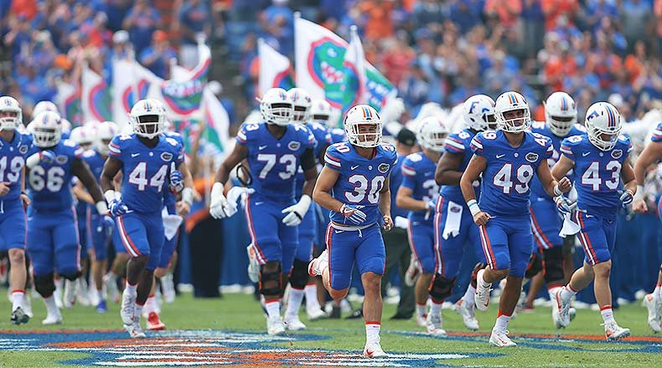

v



We do not use teams in our service department. It is something that we are considering, but we haven’t decided anything on that front yet.

Analyze Cost of Labor

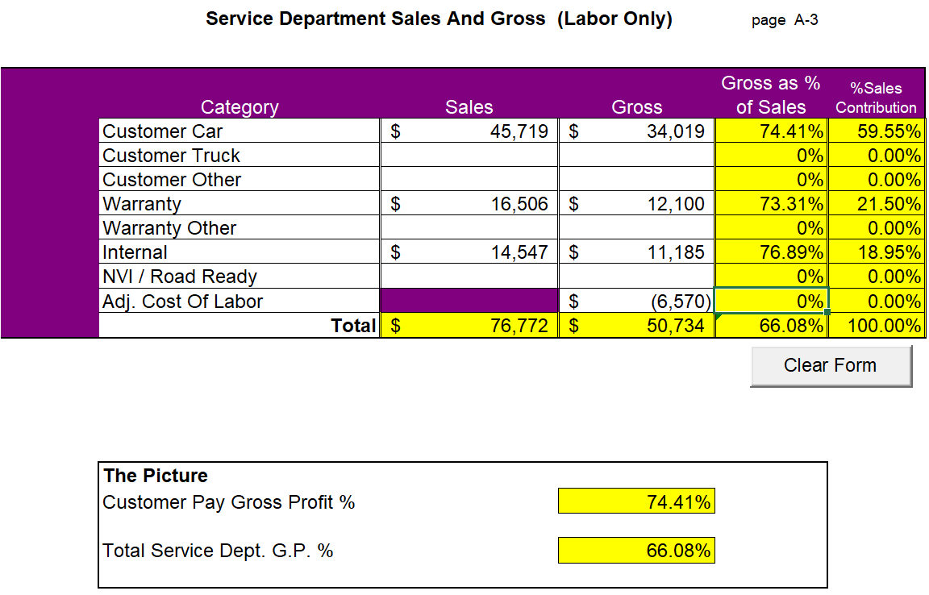

Our GP as a percent of sales is lower than NADA guide. NADA guide says it should be around 78%, and ours is 66%. This is a problem that we are working on, by only allowing the service manager to issue a discount. We have begun treating service jobs like the sales department. Every job that is declined has to have a manager T/O. It is only at this point that the manager can issue a discount to try to earn the customer’s business. Although, it is obviously not as big of a problem for us as our tech proficiency.
Changes in Expense Structure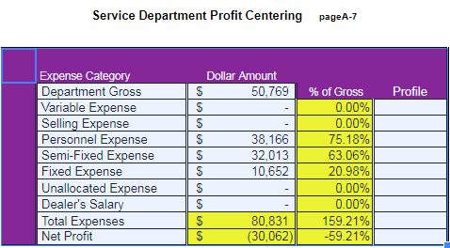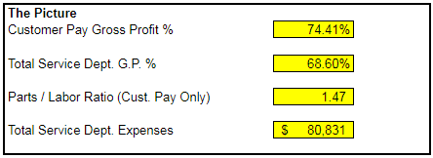

We don’t actually know how it is possible that our service department shows a loss. There is nothing that we can do at this time until our GM and Nissan store is separated, and Michael John and I have control of the accounting of the Nissan store. We are only given a DOC daily, and that is pretty much all the financials that our Sponsor will discuss with us openly. We are constantly told that fixed, especially service, is the bell cow for the dealership. It was upon pouring over the FInancial Statement that we learned that our service department actually has a negative operating profit. I’m not sure what expenses are allocated to the service department to cause such a discrepancy between what we are told and what is on paper.

Pay Plans

Service Manager
1. $675.00 WEEKLY SALARY
2. 0-49,999 PAYS 3%
50,0000-59,999 PAYS 4%
60,000+ PAYS 5%
75,000 + PAYS 6% or PAGE 4 LINE 2 of GM STATEMENT
3. PAYS 15% OF DEPT. NET PAGE 4 LINE 61
4. PAYS 1% OF DEALERSHIP NET
5. DEMO

Service Advisor 1
- $500 a week
- Weekly Flat Rate hours Bonus
  - 325 hrs = $200.00
  - 350 hrs = $250.00
  - 375 hrs = $500.00
Monthly Commission $1000.00 -$1500.00 according to the monthly gross

Service Advisor 2
- $950 a week
- Weekly Flat Rate hours Bonus
- 325 hrs = $200.00
- 350 hrs = $250.00
- 375 hrs = $500.00

Service Advisor 3
- $500 a week
- Weekly Flat Rate hours Bonus
- 325 hrs = $200.00
- 350 hrs = $250.00
- 375 hrs = $500.00
Monthly Commission $1000.00 -$1500.00 according to the monthly gross

Service Technicians
Techs Paid by RO Hours | Techs Paid by Clock Hours
Tech 1 - $25.00 | Tech 6 - $10.00
Tech 2 - $26.00 | Tech 7 - $10.00
Tech 3 - $26.00 (Part Time) | Tech 8 - $10.00
Tech 4 - $25.00 | Tech 9 - $9.00 (Part Time)
Tech 5 - $900 weekly | Tech 10 - $10.00 (Part Time)
Level Of Current Training

Nissan
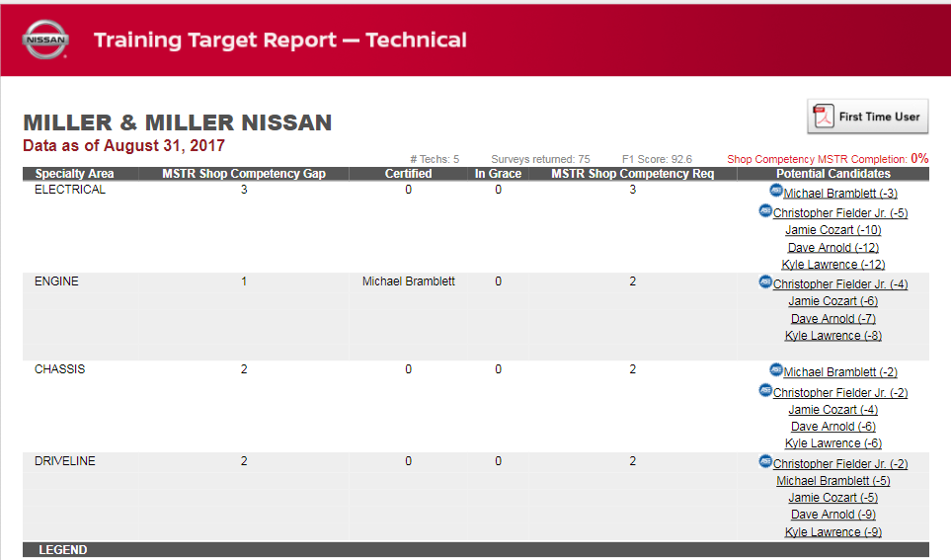

General Motors
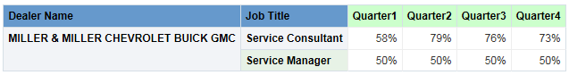

Special Tools

This is our current Special Tools Situation. Unfortunately, it will not change until be open the new Nissan Facility across town and our GM store is remodeled. Expected date on new Nissan Facility is April, 2018. Basically, we are told that techs come up to the special tools room, get the part they need for a particular job, leave the boxing for that tool on the floor of the special tools room, and then leave the room without a second thought. This is the first time we, Michael John or Dustin, has seen this room.

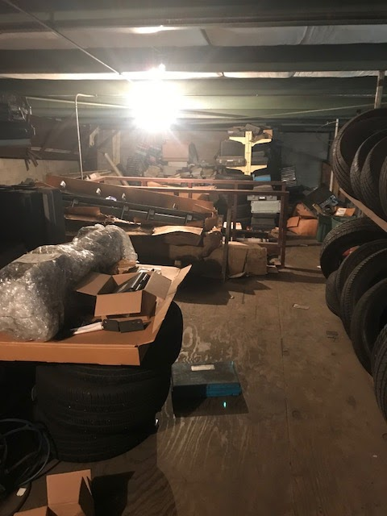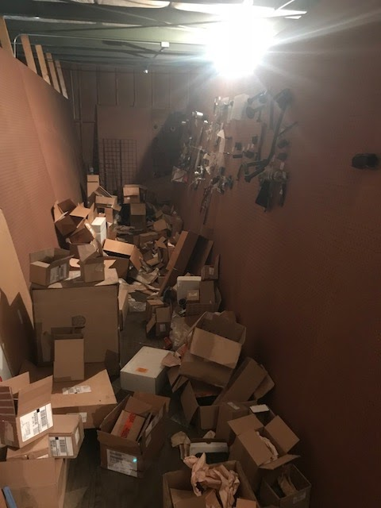

100 Repair Order Analysis

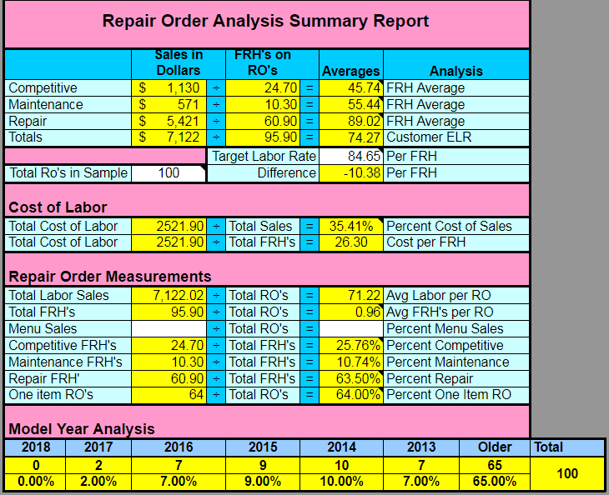

Complete Qualitative SWOT Analysis

Strengths  - Individually Owned  - Very Busy  - Certified Techs  - Treat Customers Like Family  - We have ability to draw from neighboring counties  - Hiring local knowledgeable Personnel  - Dependable business  - Customer Retention  - Great ASE certified techs  - Strong Service Manager | How to Bolster Strengths  - Continue train techs  - Continue treating customers like family  - Advertise more in surrounding counties
Opportunities  - Upscale MPI  - Opportunity for Employees  - Vehicle needs of agricultural and industrial areas coming to area  - More advertisement digitally  - Better communication between staff  - Upsales  - Meet new car buyers to establish relationship  - Increase labor rate  - Control the workflow  - No Quick Lube  - Larger Tech repairs need quality control from Manager | How to Improve  - Establish a more thorough process for customer using electronic MPI through service such as Service1 or through Reynolds & Reynolds  - Start weekly service meetings  - Train service advisors  - Establish a consistent Sales to Service handoff
Weaknesses  - Poor Communication from sales to service  - Parts Not in Stock  - Misdiagnosis or Comebacks  - Sales too Demanding  - Poor Training  - Laziness  - Shop needs to be cleaner  - Location near highway  - Personnel Benefits  - Not enough committed employees  - No thorough inspections and upsales  - Not up to date with technology  - Takes too long to get parts from parts department  - We are reactive rather than proactive in selling  - Appt booked out too far | How to Improve  - Sales staff must go through sales management when issues arise  - Conduct bi-weekly fill rate analysis to ensure fill rate gets above 80%
Threats  - Hot in Shop  - Location  - Parking  - Tight spaces causing perception of unorganization and confusion  - Population decrease  - Overpricing work  - More independant shops opening  - Repairs takes too long | How to Improve  - Possibly install Big Ass Fans  - Parking will improve once new Nissan facility opens across town.

