  
    - Service Advisor Training
    - Service
    - Walk-a-Round Process
    - er 18
Where customer satisfaction is our #1 goal! |  | MARCH 2018
Service Advisor Role:
- Initiation of services & repairs by ascertain vehicle performance & service requests

- Liaison between customer and technician

- Proper documentation of jobs performed, recommendation and information for future visits.

- Build rapport with each customer with the goal to grow your individual owner base.

- Updates on timing, recommendations, findings, and any other impertinent information the customer needs to be told while visiting or in the future.

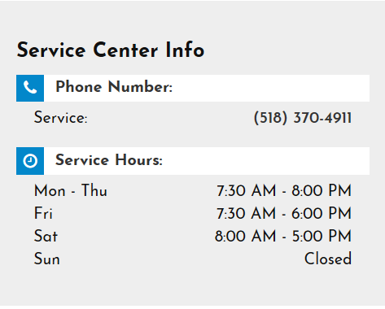

OUR SERVICE ADVISOR TEAM:
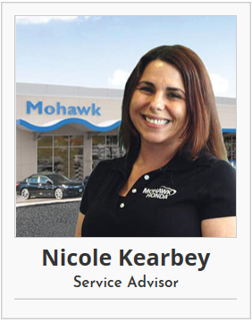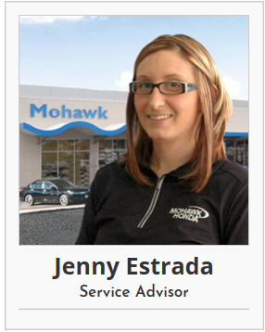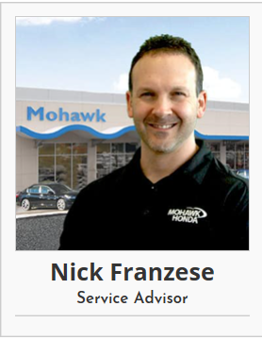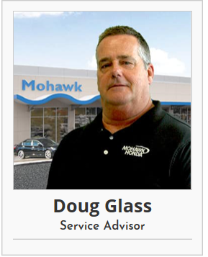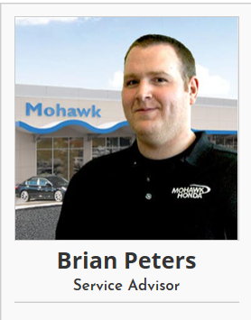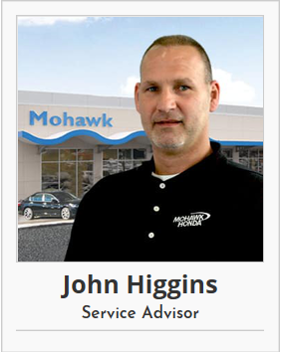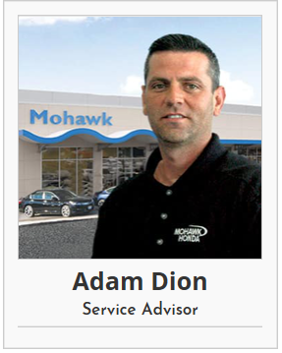
100% CUSTOMER SATISFACTION!
THE JOB OF A MOHAWK HONDA
SERVICE ADVISOR:
- Responsible for initiating the automotive service and repairs by ascertaining vehicle performance problems and service requests.

- Present a friendly, professional greeting to customer; proper meet and greet.
- Develop estimates, write repair orders, maintain customer records as detailed as possible.

- Must verify warranty and service contract coverage

- Service as the communicator and liaison between the customer and the technician; ensuring the customer’s needs are understood by the technician and the needed and recommended services/ repairs are understood by the customer.

- Develop estimates by costing materials, supplies, and labor; calculating customer’s payment including deductibles, rental frees and tow bills.

- Prepare repair orders by describing symptoms, problems and causes discovered, as well as repairs and services required. **OBTAINING approval signature.

- Communicate additional repairs and services needed to the customer based on vehicle inspection.

- Administer the manufacture warranty for qualifying vehicles.

- Consult with customers on applicable service specials and keeping customer informed on completion times and service expense.

- Review and explain the multi-point inspection; communicate what is involved in our process and create the value in the inspection.
NADA Survey says:
What Do Customers
Want and Expect?
- Relationship with the service advisor at the dealership.

- Early warning of vehicle maintenance and repair needs.

- Options for oil changes, brakes, and tires.

- One-stop shopping that meets all customer needs in a timely manner.

- Repairs explained in simple language.

- Competitively priced and value-added services.

- Concern for safety for themselves and their family.

.
.

WHY SERVICE WITH US?

- Our #1 goal is 100% customer satisfation!

- Market based, competitive pricing!

- Service you can trust! Family owned and operated for 99 years!

- Our Certified Honda trained technicians!

- We service all makes & models!

- We perform a complimentary multi-point inspection on every vehicle to ensure your safety on the road! (Valued at $49.95 & its FREE!)

- Our friendly & professional staff

- Large rental fleet availbily to our customers

- Complimentary shuttle service

- We always go out of our way to please our customers!

“What sets us apart from other Honda dealers is the care and quality we’re able to offer every customer. Regardless of year, make and model every vehicle gets the same level of excellent service whether it’s the first oil change or a 105k mile tune-up. Mohawk Honda has invested both time and money to ensure the service experience here is above and beyond anything comparable to ensure customer retention. These are the reasons why I am proud to work for Mohawk Honda and look forward to my day-to-day operations knowing I work for a company that stands for and by their product.”

SERVICE DEPARTMENT CUSTOMER
EXPERIENCE PROCESS:

1.) Scheduling an appointment: It starts on the phone
2.) The Meet & Greet: Checking in our guests (see page 4).
3.) Walk Around: Taking pictures of vehicle, get customer involved. Note all damage and offer a free estimate. (View this as your first up-selling opportunity).
4.) Alignment Check: Service Advisor to explain our alignment check system at check-in Service drive team to check each vehicle in the drive. Service advisors’ responsibility to sell it.
5.) Write-up: Review all repairs/ maintenance items being done to vehicle while in our procession today. Price quotes are given at this time & all work is authorized by customer with a signature.
6.) Dispatch: Mike & his team will bring vehicle to respected shop & give to Rick Moore to be distributed in the shop.
7.) Upsell Labor & Accessories: Use MPI to upsell technician recommendations
8.) Advisor/ Customer communication: Update promises, text to drive responses- Keep our customers involved
9.) Prepare invoices/ final repair order for customer check out.
10.) Order special order parts
11.) Active delivery: collect payment/ MPI/ Ask for the survey review
12.) Set up Next appointment
13.) The farewell Greeting: Always say thank you & offer to pull vehicle around for customer.

THE MEET AND GREET: 8 Simple steps for SUCCESS.

- Welcome to Mohawk Honda! My name is_______________, and yours is?

- Have you serviced with us before?

YES Great, Welcome back Mr./Mrs. Customer, I will be your personal service advisor today. Our goal is 100% customer satisfaction, so if you have any questions throughout your visit or in the future, I am here to help! Let’s get you checked in.

No Welcome to Mohawk Honda Mr./Mrs. Customer, thank you for choosing Mohawk Honda for your repair facility today. I will be your personal service advisor today. Our goal is 100% customer satisfaction, so if you have any questions throughout your visit or in the future, I am here to help! I am going to start by updating your account.

- **VERIFY PHONE NUMBER, ADDRESS & EMAIL ADDRESS IS UP TO DATE BEFORE WRITTING UP ANY WORK NEEDING TO BE DONE TODAY***

- What brings you in today?
- Customer states “My wrench light is on”: Explain what is on their maintenance minder system. What each code means and how long the repair will take and how much it will cost.

- Customer states “Oil Change”: make sure to check codes and explain if there is anything other than an A displayed.

- Customer state: Noise, Vibration, etc.: get as much information as possible from the customer. Be as detailed as possible!!!

- THE WALK AROUND: Include your customer in the process!! Walk around the car with them!
Tell them the WHY: I am taking picture of your vehicle today to ensure the car is returned to you in the same condition you brought in.
- **EXPLAIN OUR IN-DRIVE ALIGNMENT PROCESS & WHY PROPER ALIGNMENT IS IMPORTANT TO THE WEAR ON YOUR TIRES **

- ***Important each customer not only authorizes the work being done but is quoted the price prior to starting the work*** Create a realistic time frame.

- Customers who have never been here before need to be walked out by their service advisor or a service employee who is available and given a VERY quick tour of what we offer at MH
Things to cover: Complimentary coffee station, kids room, high top tables, lounge, bathrooms & WIFI password.

When answering an incoming call:

“Thank you for choosing Mohawk Honda Service, this is______________. How may I assist you?

Always greet every customer with a warm and sincere smile, whether you are available to help them or NOT. Acknowledgement goes a long way with our customers and it is important to remember this…
FOR EXAMPLE:
“Hi! How are you today? Someone will be right over to assist you.”
“Thank you for your patience, one of my fellow advisors will be right with you to start your check-in process...”
ALWAYS REMEMBER: “The 10-Foot Rule” whenever an employee comes within 10 feet of a customer, the employee greets the person with a cheerful hello, or simply makes eye contact, smiles and nods his or her head.

INSTEAD OF SAYING NO…
“Don't say no when you don't have to! & Say it in the best way possible when you do!”

“I will do my very best…”
“I will try…”
“Let me check on that…”
Come up with an alternative solution.
Offer what you can do, if you can’t accomplish their request…
Explain WHY

WHENEVER POSSIBLE, ADDRESS THE CUSTOMER BY THEIR NAME.
ABSOLUTELY
THAT WOULD BE MY PLEASURE

***ALWAYS PERSONALIZE WHEN POSSBILE: LEARN & USE CUSTOMERS NAME WHENEVER POSSBILE***

Reviewing the Multi-point section:
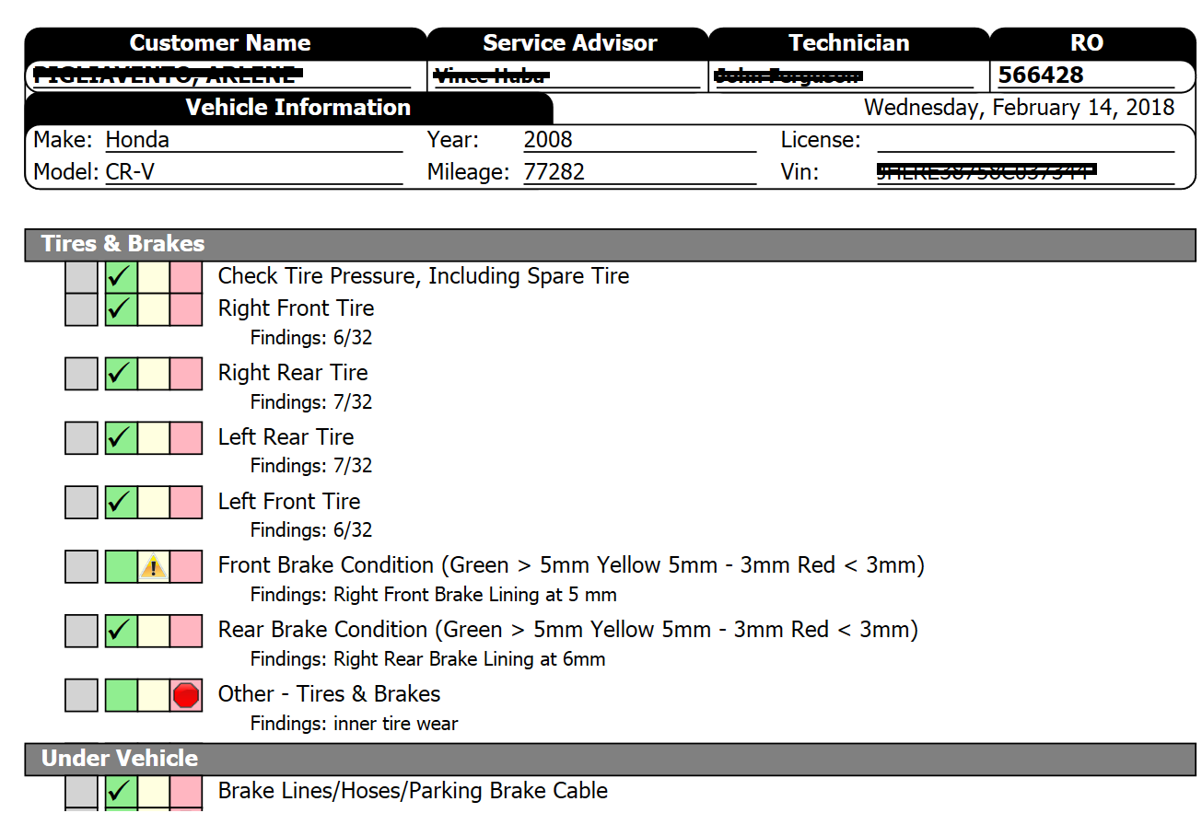
USE IT TO SELL! YOU DON’T HAVE TO WAIT TILL THE CUSTOMER IS LEAVING TO REVIEW THE MPI. USE IT FOR UP-SELLING!
Always ask if you may review the finds of the multi-point section with the customer, prior to reviewing the information.

Review GREEN items first, compliment the customer for the great job they have done maintaining their vehicle.

Review the YELLOW items, things they should consider for next visit & estimates provided on repair order.

Go over the RED items with the customer. These items they should consider fixing today. They could be a safety concern and should be reviewed with the customer in detail, with cost and time associated with the vehicle.

**Always be sure to end your MPI conversations with asking the customer if they understand everything that you just went over with them**
**USE term “MULTI-POINT INSPECTION” as many times as possible **

EMPLOYEE PRICING GUIDE:

Lindsey, Lisa or Travis are to write up all employee cars unless otherwise directed by managers.

*PLEASE ADVISE: IF CASHING OUT AN EMPLOYEE: MUST pay same day that work is completed or all discounts will be removed from repair order* *SET PRICING- No Coupons on Employee pricing*

HOURLY RATE | $57.50
HONDA OIL CHANGE | $44.00
TIRE ROTATION | $24.95
INSPECTIONS | $21/ $10
CABIN AIRFILTER/ HVAC | $109.95
TRANSMISSION DRAIN/FILL | $99.95-229.95
ENGINE COOLANT | $99.95
REAR DIFFERENTIAL FLUID | $89.95- $99.95
BRAKE FLUID | $109.95
TIRES | $10 PLUS COST
MOUNT & BALANCE 4 TIRES | $60.00
ALIGNMENT | $79.95
RENTALS | $25/DAY

**NON- HONDA OIL CHANGES** $18.00 LABOR + FILTER & OIL USED **
EMPLOYEE DETAIL PRICING:
INTERIOR | $69.00
MP3 ONLY | $79.00
IN/OUT NO MP3 | $99.00
IN/OUT WITH MP3 | $125.00

ACCESSORY PRICING:
10% OVER COST FOR ALL PARTS PLUS $57.50/ HOUR INSTALL
For all car starters please see a service manager for discount.

DETAIL SERVICES & PRICING GUIDE:
**ALWAYS RECOMMEND A DROP OFF FOR ANY DETAIL SERVICE**

We now have our own personal detailer. Sammy is responsible for all detail service written up for customer pay that come in to the service drive.
- Any vehicle in for additional service to a detail MUST be written up as a waiter.
- Service in main shop is to be complete prior to sending the vehicle to detail.
- Service advisor is responsible for communicating with Sammy and bringing vehicle around to him when ready.
- Service advisor is responsible for time coordination and setting the expectation to customer; which is to include updates throughout the day.

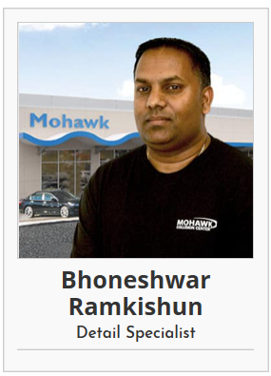

Exterior ONLY (3 hours) $139.95
LABOR “OP”EXT
- Exterior wash
- Tar removal (as best as we can)
- Clean wheels and Removal of brake dust (as best as we can)
- Car polish / Wax performed by Sammy
- Tire shine

Complete Detail Special
(5 hours) includes both above Specials $225.00 includes MP3
labor “op” is DETAIL

MP3 Special (2.5 hours) $118.00
LABOR “OP” AB
- Exterior wash
- Clean wheels
- Clean Windows
- Tire shine
- MP3

Interior Detail Special :(3 hours) $139.95
LABOR “OP” INT
- Vacuum /Shampoo upholstery carpets and seats
- Clean dashboard door jams and leather areas.
- Clean windows
- Wash exterior of vehicle and tire shine



All Simo Claims will be a 2- step process. We must first get it approved by SIMO prior to completing the work. Simo does reserve the right to send out a representative to look at the customers vehicle.

- Go to: https://www.simoniz.com/claims-submission/ to fill out customer & vehicle info.

- Questions to ask customer: What stained the interior? Did you try to clean it?
- Take pictures of stains to be submitted to SIMO

- Make a copy of customers warranty: ask if they have it with them first. If customer does not have contract with them, lean on managers to get you the information you need.(Lisa & Lindsey).
- Open Repair order for interior detail $79.95; Simo will approve an hourly rate of $55/hr
Use your discretion when estimating.
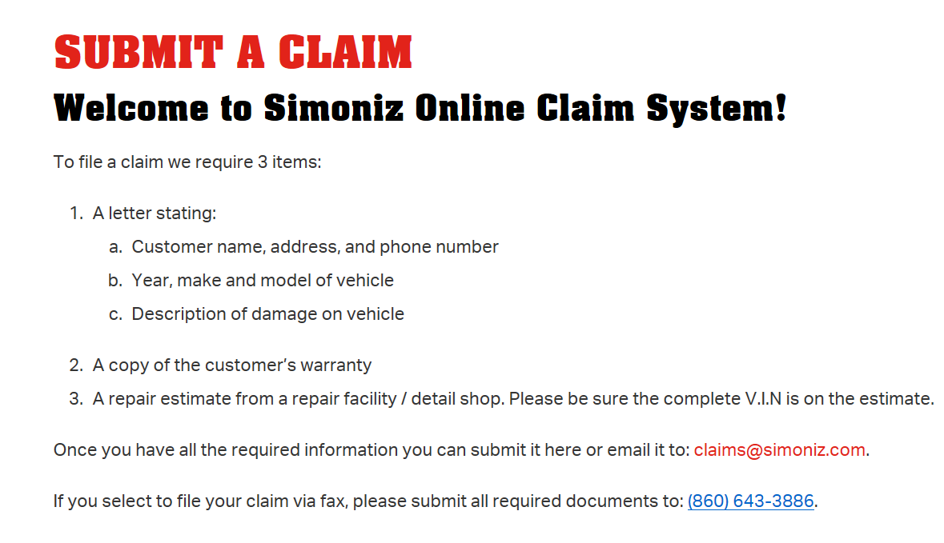

DISCOUNTING IN THE SERVICE DRIVE:
NICK B must authorize any employee pricing for ALL customers. Many customers may come in here and mention they know Nick, Jeff, or anyone else…this is sometimes a way of receiving services at a discount or even no cost.
Lindsey, Lisa and Travis have authorization to sign off as well. Service manager must approve a discount BEFORE it is even offered to a customer.
It is NEVER to be the case that an Advisor gives employee pricing without a signature. There may be noted accounts, but they still need a signature.
Coupon MUST be present at time of check in or check out. All must be attached to repair orders. (No expired coupons accepted).
Any & all policy for a pre-owned customer back with a concern MUST be reviewed by a Service and Sales Manager before any diagnosis is completed.
**We are NO LONGER MATCHING ALL competitive coupons. Please see Travis for special circumstances with this. **
WE OWES: Need to be attached to RO & closed out to the appropriate schedule.
If maintenance is promised to customer, needs a signature.
CREATE THE VALUE!!!
SELL YOURSELF!
WHY DO YOU COME TO WORK EVERYDAY?
WE SHOP OUR COMPETITION! LOWEST IN THE AREA!
MULTI-POINT INSPECTION IS FREE! $49.94 VALUE
HONDA FACTORY TECHNICIANS
KNOWLEDGABLE, WELL TRAINED & FRIENDLY STAFF!

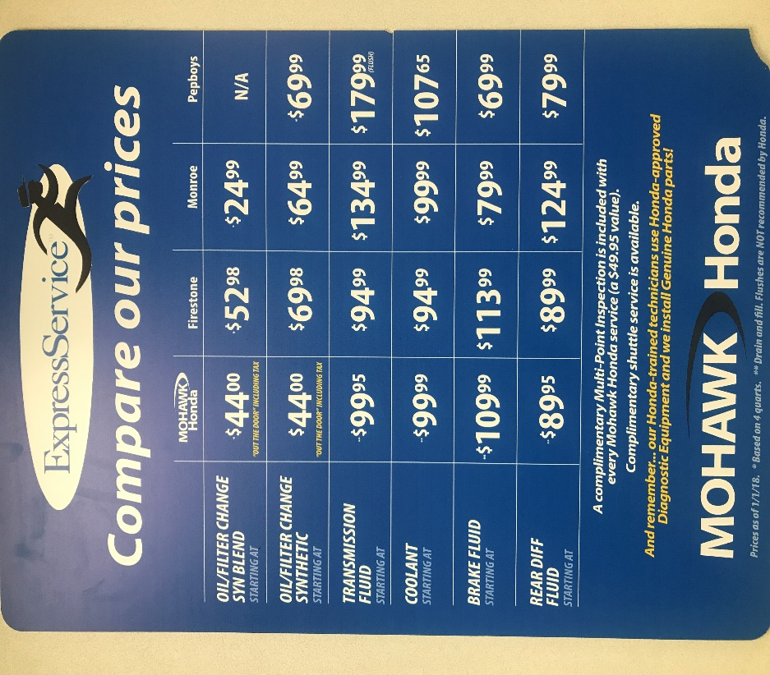

Saying Goodbye:
The last interaction you have with you customer is just impactful as your first impression…
- Expedite the pull in of the customers vehicle, ask your fellow SA, shuttle drives, MXP to help.

- Go over each repair/ maintenance item done to the customers vehicle with them.

- Explain the multi-point inspection & what our technician found or did not find.
“The multi-point is like your report car for your car, today you got an A+, you are all in the green, which means our technicians don’t have any recommendations for you or your vehicle…”
- Go over any additional recommendations that were not on the MPI, if any

- SOR/ RETURN APTS: EVERY CUSTOMER MUST SCHEDULE AN APT BEFORE LEAVING. NO EXCEPTIONS.
WHY:
- Customer are getting upset when they must wait an additional week to have the repair done on their vehicle.
- This will cut down on SOR calls
- Parts will be installed quicker
- Customer can always CXL!

- Collect payment: make sure all charges are clearly explained to customer at this time. Coupons must be present at time of sale.

- Ask customer if they have any additional questions about their multi-point inspection or any of the information provided to them today.

- Review Honda Survey that may come to them. Ask them to please fill it out. Remind them 100% customer satisfaction is our #1 Goal! Ask for dealer rater reviews.

- Final greeting: “Thank you for servicing with us today! I hope your enjoy the rest of your day/ night” <<<<HAND SHAKE>>>>>

