Variable 2
Pre Class Assignment

Joel Dalbo
jdalbo@nada.org
949-829-7017

- Latest Financial Statement

- Other income and deductions.
  - Investigate the new vehicle sources and deductions to this account
    - DOC Fees
    - Factory incentives and programs
    - Distributor payments
  - Total all additions to income attributable to new vehicle sales ____________________

- What is your dealerships ideal months’ supply of new vehicles? Prepare to defend this number. ____________________________________________________________________

- New Vehicle Inventory sorted by age (Bring Copy to Class)

Run right before class… does not need to match with the statement)
  - -Subtotal in following age buckets (calculate units and dollars for each bucket)
0-30 days
31-45 days
46-60 days
61-90 days
91-120 days
Over 120 days

- Investigate your dealerships floorplan financing interest rate: ___________ %
  - Does the dealership earn incentives based on retail contract penetration?
_____________________________________________________________________

Briefly describe your New Vehicle floorplan assistance program:
_________________________________________________________________________________________________________________________________________________________________________________________________________________________________

- Print and bring your New Car Area of Responsibility Map (available from your manufacturer).

- Bring sales effectiveness report card from your manufacturer, including pump in and pump out information, owner loyalty/customer retention and units in operation. (5, 7, 10 year)

- What is the size of your active unique owner base? _______________________________ (number of active customers you still do business with from all departments)

- Bring a copy of a ‘worksheet’ / ‘buyers order’ / ‘computer printout’ utilized in the sales department when working a deal with a customer. Prepare to share the process and overcoming customer objections with the class

- Copies of Pay Plans and job descriptions sales person, f&I and service advisor.

- On class site Discussions then doc sharing to upload required files.

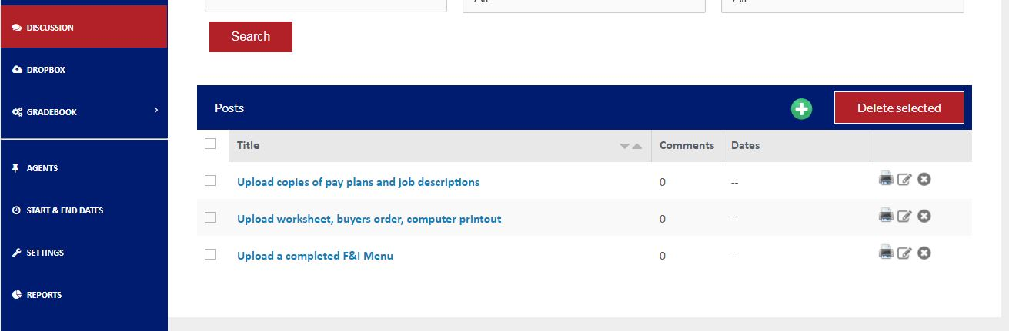

- What is the total number of employees that left dealership employment during the previous 12 months? ______________________ How many left voluntarily? ______________________

- What is the total percentage of ‘mini’s’ or ‘flats’ paid to the sales force on new car sales for the last 12 months _________

- Bring current phone call guide used by Sales Consultant when taking incoming sales calls and for placing outbound internet and phone communications

- How much time does it take to purchase a vehicle at your store? ______________________

- Bring a completed F & I Menu (if you are using one and I hope you are!) If you are using DocuPad please take a screen shot and bring with you.

- Have your F & I Manager complete attached F & I performance data form.

- Does every retail customer go through the F & I office at time of sale?__________________ If not, what percentage do? _________________

- What are the goals of the F & I office in your dealership, financial and otherwise? ______________________________________________________________________________________________________________________________________________________

- Review and observe the following during your next sales, service and management meetings at your dealership: content, effectiveness and level of participant satisfaction. __________________________________________________________________________________________________________________________________________________________________________________________________________________________

To be provided by F & I Manager/ Retail Sales

Please use YTD total for month ending __ _______________
 | A | B | C | D | E
Year To Date Production
Total Units
________
__________________________________________________ Total Income
_______
________________________________________

Total Chargeback

_________________________________________________
 | Units | Non Lease New Vehicle | New Vehicle Lease | CPO-OEM | Non CPO Used
1 | Units Delivered
2 | Finance or Lease Contracts
3 | Service Contracts
4 | Pre-Paid Maintenance
5 | GAP
6 | Theft Deterrent
7 | Paint Sealant & Appearance
8 | Tire/Wheel
9 | Lease Care
10 | Other______________
 |  | Year To Date Income
 | Incomes | Non Lease New Vehicle | New Vehicle Lease | CPO-OEM | Non CPO Used
11 | Finance or Lease Reserve
12 | Service Contracts
13 | Pre-Paid maintenance
14 | GAP
15 | Theft Deterrent
16 | Paint Sealant & Appearance
17 | Tire/Wheel
18 | Lease Care
19 | Other______________
 |  | Year To Date Charge backs
 | Charge backs | Non Lease New Vehicle | New Vehicle Lease | CPO-OEM | Non CPO Used
20 | Finance or Lease Reserve
21 | Service Contracts
22 | Pre-paid Maintenance
23 | GAP
24 | Theft Deterrent
25 | Paint Sealant & Appearance
26 | Tire/Wheel
27 | Lease Care
28 | Other______________

