RETAIL DEALERS
THE DATA'S VERDICT

Sales-effectiveness ratings can kill a franchise
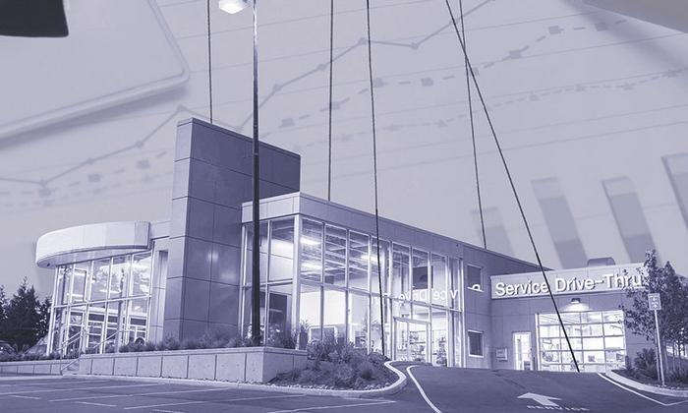
Related Stories
- Meet the man behind your sales report card
Lindsay Chappell
Automotive News
April 4, 2016 - 12:01 am ET
A Kia dealer in central Ohio is fighting for his survival right now because he has not met his factory's sales expectations. His market requires him to sell Kias to Honda employees and their families, thousands of whom live in his area.
A Chevrolet dealer in metro New York nearly lost his franchise last year after the factory said he was not meeting its sales expectations there. His market requires him to sell Chevys in a metropolitan area renowned for its import preference.
A Honda dealer in upstate New York lost his franchise for failing to meet that manufacturer's sales expectations. His market required him to sell Hondas in a small, economically distressed market of loyal domestic-brand buyers -- some of whom the factory assumed would drive 65 miles to shop with him.
What those auto retailers -- and many more like them -- have been confronting is the jagged edge of a factory business analytic known as "retail sales effectiveness."
The metric goes by different names at different manufacturers, and some brands are hotter on its enforcement than others. But it is all the same math -- calculated by a single Detroit company, Urban Science.
For many retailers, sales effectiveness is just a cog in the clockworks of being a car dealer -- a sales report card from the factory that affirms how well they are beating the average at selling new vehicles in their market.
But dealers who are struggling say retail sales effectiveness is a cold metric that will not listen to reason.
"I corresponded with Volkswagen about this for years, both me and my attorneys," says Russell Atamian, whose family had operated Atamian Volkswagen in Tewksbury, Mass., since 1962. "They told me I wasn't sales-effective. I told them that to sell enough cars to make myself sales-effective, I would need a lot more inventory from them. But I could never get more inventory because I wasn't selling enough to earn them."
Pros and cons
Urban Science, developer of sales-effectiveness ratings, says these factors govern the sale of vehicles.

- Having the correct number of dealerships in a market

- Having them in the correct locations

- Having the correct selection of models to satisfy the market

- Effective dealer operations

Critics of the performance measurement raise these exceptions.

- A manufacturer might suffer from a reputation for poor quality.

- A competitor brand could be pouring large amounts of advertising dollars into one city in a given state but not into another city across the state.

- A dealer might be aggressively undercutting his fellow dealers of the same brand.

- A given market area might suffer a long-term economic blow, such as the closing of a major employer or a hurricane.

 | Atamian: Sold VW business
Build or sell out?
Atamian, who is still a Honda dealer in his market, 24 miles outside Boston, claims he was told by his Volkswagen representatives that more inventory would come to him if he agreed to build a new VW showroom.
Instead, last December, feeling uneasy about his relationship with Volkswagen, Atamian chose to sell the VW business. Even though it was small by factory expectations, it reliably turned a strong profit every year, he says.
"Our family has been in the car business since my grandfather," Atamian says. "It's not like we don't know what we're doing."
A spokeswoman for Volkswagen Group of America declined to discuss the Atamian story or comment about the sales-effectiveness metric in general.
Retailers who are at odds with the sales-effectiveness metric do not challenge manufacturers' right to use it but say they believe the metric is sometimes misused.
"I don't think anybody has a problem with the basic idea of measuring a dealer's performance," says Christopher DeVito, an attorney with Morganstern, MacAdams & DeVito in Cleveland. "The problem comes when you do so without taking unique local market situations into consideration."
DeVito has handled a number of dealers' protests against manufacturers in recent years in which a factory has cited a low retail sales-effectiveness score as proof that a dealer was operating poorly.
“Every local market isn't created equally.”
Zach Doran,
president-elect of the Ohio Automobile Dealers Association
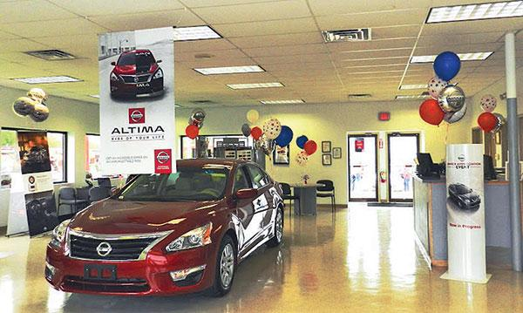
Sims Nissan’s proximity to GM’s Lordstown, Ohio, assembly plant was an issue in a court battle.
6-year battle
One of those cases concerned Sims Nissan in Warren, Ohio.
Nissan North America served dealer Bill Sims with a franchise-termination notice in 2009, pointing out that he was the lowest-performing dealer in sales effectiveness in his region.
In the six years that followed, Sims protested that move to the Ohio Motor Vehicle Dealers Board, filed a lawsuit against Nissan in Ohio's Franklin County Court of Common Pleas and since then has fought various appeals from the factory -- all with one argument.
Sims, also a Buick-GMC dealer, pointed out that he has a lower-than-normal sales outlook because he is selling Nissans from a store that is about 9 miles from General Motors' Lordstown Assembly plant. Lordstown employed 4,500 people at the time of the dealer protest, and over the decades of its operations has generated thousands of local retirees, as well as employee family members, suppliers' employees and others. All of those people can receive manufacturer discounts when buying GM vehicles.
Moreover, Lordstown has for decades had a reputation for fierce UAW loyalty -- compared with Nissan's reputation as a nonunion automaker.
Sims' argument? On paper, his local market of responsibility might very well indicate that "X" number of vehicles could be sold in any given year. But missing from that number was any recognition that the local residents are less inclined to buy a Nissan than a GM vehicle.
DeVito presented evidence in the Sims case that Chevrolet's local market share was twice the Ohio average, while Toyota, Nissan and Honda's local results hovered at about half of the state's average.
Sims prevailed and is still a Nissan dealer.
Zach Doran, president-elect of the Ohio Automobile Dealers Association, representing 835 franchised dealers in the state, says the Ohio landscape is a good example of why this is a problem issue for dealers in general.
"We have a big Jeep plant in Toledo," Doran says. "We have the GM Lordstown plant. We have Ford operations in Lima, and Honda has a lot of operations here. Every local market isn't created equally."
Doran declines to reveal exactly what is being discussed but says the association is now trying to bring new clarifications to Ohio vehicle franchise law to address how sales effectiveness is used in the state.
"It's one thing when the factory tells you that your bogey is to sell 80 cars a month," Doran says. "It's another when that starts to threaten your business."
 | Doran: There are lots of big auto plants in Ohio.
Who makes the rules?
Who makes the rules for determining effectiveness? Nearly 40 years ago, that job fell to Jim Anderson, the founder and CEO of Urban Science. (See story, Page 36.)
Since the late 1970s, Anderson's ever-growing analytics company has become one of the industry's most powerful authorities. Not only did Anderson and Urban Science create the mathematics of judging how a given retailer in a given location is performing; the company also effectively serves as the monitor of each retailer's results in each market. (See story, right).
"This business is data rich and lends itself to analytics," Anderson says. "We put the numbers there not just for dealers who may not be performing as well as the opportunity would suggest but also for dealers who are overperforming."
Market representation is a second part of Urban Science's insight into local performance. A store that routinely far exceeds the state average might flag an opportunity for a manufacturer to insert another dealership into the area.
Factories also rely on Urban Science to determine whether existing stores are poorly located within a market or shopping patterns are evolving enough to warrant changes. The changes might also mean re-drawing a dealer's area of primary responsibility to incorporate more households.
Urban Science does not have the power to make changes or factory policy. That is the manufacturer's call. Urban Science is the source of the data for factories to come to their own decisions about what needs to happen locally.
Anderson acknowledges that the numbers can make some dealers squirm by spotlighting those performing under the market's potential. But he maintains that the math accounts for quirks in the market.
Just four factors govern the sale of vehicles, Anderson contends:
1. Having the correct number of dealerships in a market.
2. Having them in the correct locations.
3. Having the correct selection of models to satisfy the market.
4. Effective dealer operations.
"When you are below average," Anderson says, "there is clearly opportunity to improve to the above-average list."
 | Rosen: Dealers, Nissan talking
The counterarguments
Some dealers and their attorneys would beg to differ.
Among the exceptions they raise:
• A given manufacturer might suffer from a reputation for poor quality.
• A competitor brand could be pouring large amounts of advertising dollars into one city in a given state but not into another city across the state.
• One dealer might be aggressively undercutting his fellow dealers of the same brand by selling vehicles below established sale prices.
• A given market area might suffer a long-term economic blow, such as the closing of a major employer or a hurricane.
Nissan North America, which some dealers say has been particularly aggressive in monitoring sales effectiveness to press retailers toward its corporate goal of increasing U.S. market share, may be considering some adjustments.
Jeff Rosen, owner of Rosen Nissan in Milwaukee and chairman of the Nissan National Dealer Advisory Board, says Nissan and its dealer board have been discussing ways to keep its sales metrics flexible. The issue is doubly important to Nissan dealers at the moment because of its dealer sales incentives program, which rewards retailers for reaching sales targets.
"Nissan looks at extenuating circumstances," Rosen says. "We saw bad snow in the Northeast, and it was an extreme change in the market for them because they lost an entire weekend. So we looked at that and made a few changes to help the dealers there.
"Throughout the United States there are always going to be issues," he says of the larger issue of analytics. "The dealer board and the OEM really have to work together to make sure those different inefficiencies are taken care off."
Nissan North America declined to comment about its retail sales-effectiveness practices.
 | Scott DeMasso: Retail sales effectiveness is a fair measure.
Giving up Kia store
Last year, Clarksville, Tenn., dealer Gary Mathews gave up his Kia franchise during a courtroom fight with the manufacturer. Kia had faulted Mathews for operating well below his sales effectiveness target in the town, which includes in its territory the Fort Campbell U.S. Army base, home of the 101st Airborne Division.
Mathews urged the factory to consider who lived in his market: 32,000 personnel from the 101st, as well as family members and other people in the community whose livelihoods also benefit from the base. But, he pointed out, the 101st was deployed to active duty in the Middle East in 2013. It was deployed in 2012 and in 2010.
In court documents relating to Mathews' franchise situation, he reasoned that as a result the Clarksville market itself was not operating under normal circumstances. And therefore, he argued, his sales-effectiveness performance was skewed.
That case was resolved out of court last year. Mathews is no longer a Kia dealer.
Kia Motors America says the sales-effectiveness metric has been upheld repeatedly by courts and agencies as a fair and reasonable way to evaluate dealer performance.
In a statement released to Automotive News, Kia wrote: "While we cannot comment on pending litigation, KMA only issues a cure notice to a dealer when performance has been substantially below average for an extended period of time. If a Kia dealer claims there are unique circumstances in its market that prevent improvement, KMA investigates and, if justified, adjusts for any such circumstance."
How Urban Science's math works
Urban Science founder and CEO Jim Anderson created the mathematics of judging how a given retailer in a given location is performing. The company also effectively monitors each retailer's results in each market.
In a simplified description of a complex calculus, Urban Science's data work this way:

- Every local market is measured for its size, the number of vehicles that are registered there and the buying patterns of its population -- how many consumers buy pickups, how many buy sedans and so forth.

- The equation then looks at all the dealers in a specific measurement area -- a state, for example, or a region involving parts of states -- to calculate how many vehicles they are all selling.

- From that, Urban Science arrives at an average number of sales per store. Dealerships that sell less than that amount are operating below their retail sales effectiveness. Those that sell more are above average, and those that sell the statistical average are at 100 percent of their retail sales effectiveness.

There are nuances to the complex math, and dealer-factory beefs sometimes arise from them. New vehicles are purchased in one town but registered in another.
A specific model is in hot demand, but inventories are unavailable in a certain region. Or a competing brand is big in one town but not the other.

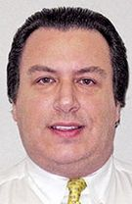 | Russell Geller: A five-year fight
Peril of low score
Russell Geller, who co-owns Beck Chevrolet in Yonkers, N.Y., outside New York City, with his father, Leon Geller, says: "It's an unfair and arbitrary system. But we challenged it, and we prevailed."
In 2009, GM canceled the Gellers' Chevrolet franchise because they were far below GM's version of sales effectiveness, called the "retail sales index," or RSI. The Gellers spent the next five years fighting GM's logic in various legal venues.
According to GM's calculations, Beck Chevrolet's sales were below the New York state average. But the Gellers countered that New York is effectively two distinct states where domestic-brand sales are concerned. In upstate New York, their attorneys argued, GM maintains more than a 20 percent market share. In the import-dominated metro market of Greater New York, where Beck operates, it is closer to 4 percent.
Measuring the Gellers' sales results against those of dealers elsewhere in the state is not valid, the courts concluded. In October 2014, the New York State Department of Motor Vehicles overruled GM's revocation, ruling that "for the New York City metropolitan area, the RSI standard of GM is unreasonable as it does not realistically reflect the Chevrolet sales challenges that Beck and other New York metropolitan dealers face ... and thus GM lacks due cause to terminate Beck's franchise."
"I'm a loyal Chevy dealer," Russell Geller says. "My father has been associated with this store since 1964. I grew up with Chevrolet. But they had to be challenged on this math."
Bill Hartley, a Buick-GMC dealer in Jamestown, N.Y., on the state's far western side, faced a different kind of market challenge. Until the end of 2012, Hartley also was a low-volume Honda dealer there and had been since 1975. He says the Honda business was "extremely profitable" for him right up to the end. But because he was unable to reach what the factory said was his sales-effectiveness level, he lost the franchise in court. He was unable to procure more inventory to increase sales, and, as a result, he was unable to satisfy Honda's desire for a larger store.
Before canceling Hartley's franchise, Honda warned him repeatedly that he was at the bottom of the chart on sales-effectiveness scores.
"I was literally the lowest-scoring Honda dealer in my region," Hartley says. "But guess what? Some of the other Honda dealers around here were only doing one-tenth of a point better than me.
"We're in a tough area. The economy here is bad, and there is a strong preference for domestic brands."
According to Hartley, Honda altered his geographical market area, expanding it from Jamestown, with a population of about 30,000, to a broad area that encompassed 100,000 people.
But that only exacerbated his poor statistics. The enlargement meant that he would be graded against how well he attracted customers to drive up to 65 miles to come to his store.
"Consumers often drive from a small town to a bigger city to shop for a new car," he says. "People don't leave a big city where there are lots of dealerships to drive to a dealer in a small town with a small inventory."
Search for inventory
Small inventories often trip up a dealer who needs to improve a sales-effectiveness score.
"They told me to go out and acquire more cars from other dealers," Hartley says of Honda. "Well, where? Nobody around here is going to let go of inventory -- especially of the models that were so hot, like the CR-V.
"I managed to find a dealership across the state line in Ohio who agreed to sell me cars -- but that created a problem for the factory because it meant inventory would be leaving one sales region for another. So it didn't happen."
A spokesman for American Honda Motor Co. declined to discuss the details of the Hartley case. Hartley acknowledges that the end was inevitable for him when GM told him he could no longer run the Honda operation out of his Buick-GMC store. That meant he eventually would have to construct a Honda showroom -- a prospect that was uninviting, considering his inability to hit Honda's targets.
But more problematic, it would have to be a Honda store sized to accommodate not the sales volume Hartley was accustomed to but a volume that matched what the manufacturer said should be his improved sales-effectiveness volume.
Hartley refused, and Honda terminated him.
"Don't accept average'
Far away in Florida, a different Honda retailer expresses sympathy for dealers who are struggling. But that doesn't mean there is a flaw with the retail sales-effectiveness model, says Scott DeMasso, CEO of Space Coast Honda in Cocoa, Fla.
"Some dealers do have an extenuating circumstance," DeMasso says. "But you have to believe the factory will take that into consideration. A manufacturer has to have some way to measure results."
DeMasso's dealership is among the thousands of stores that are doing well by the metric. Space Coast is operating at 53 percent above average for its market. The store has consistently run 45 to 50 percent above his retail sales-effectiveness target.
"I don't accept average," he says. "Some dealers are just very comfortable in how they're operating.
"But the manufacturers aren't too comfortable these days. They all want to increase market share. And retail sales effectiveness is a fair way to see who's delivering for them."

