- Go to: www.nada.org/academy/login
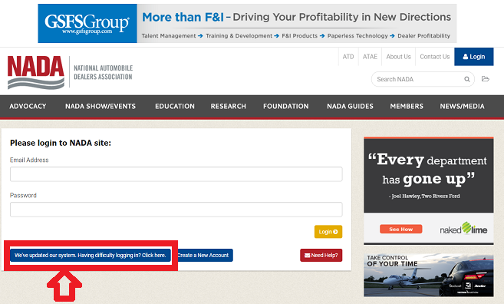
- Click on the “We’ve updated our system. Having difficulty logging in? Click Here.”

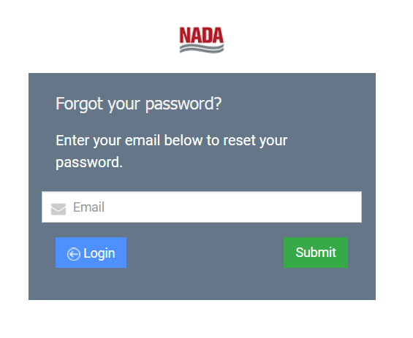
- Enter your email address, and wait for the confirmation email to arrive in order to create your password.
- Once your password is created, go back to www.nada.org/academy/login to enter your class site

