Fixed Operations 2 Service Homework

- Advertising-------Emails, Mailers: keeping your dealership name in front of your customer. – We do weekly email blasts through our advertising agency along with Honda mailers from the manufacturer.

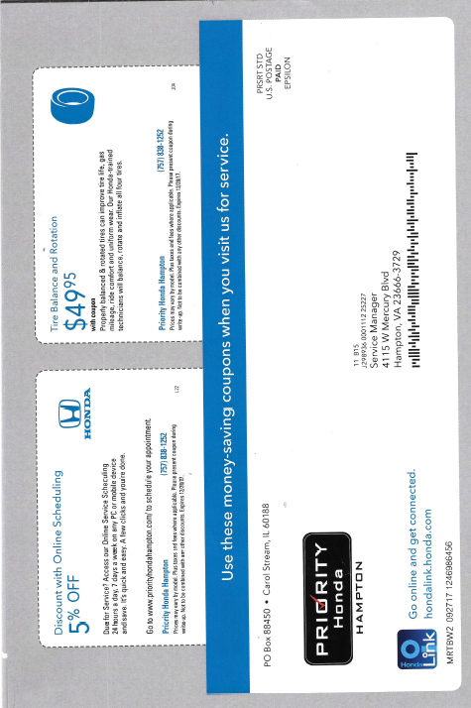

- Marketing--------Non-dealer survey -

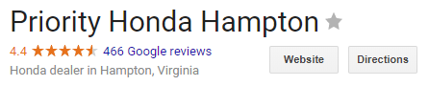

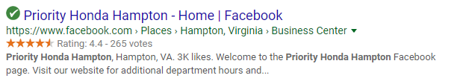

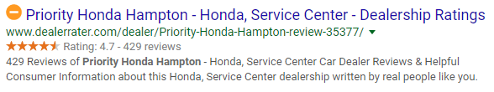

- Facility------------Capacity, Utilization (“B” Tab---second calculation) –

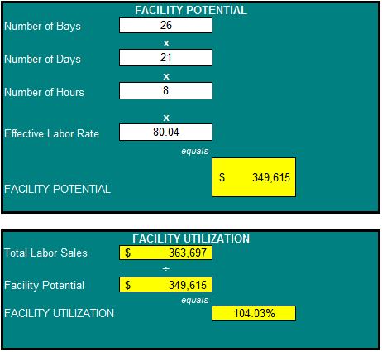

- Productivity-----Tech Proficiency (“B” Tab---first calculation) –
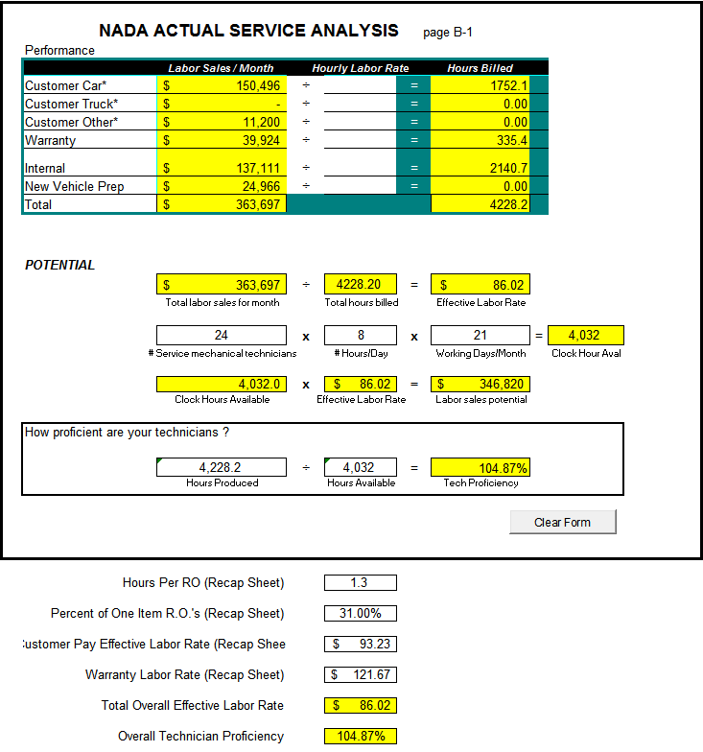
- Production Method----Conventional, Work Group, or Team –
Conventional

- Analyze Cost of Labor—(“A” Tab—first calculation) –
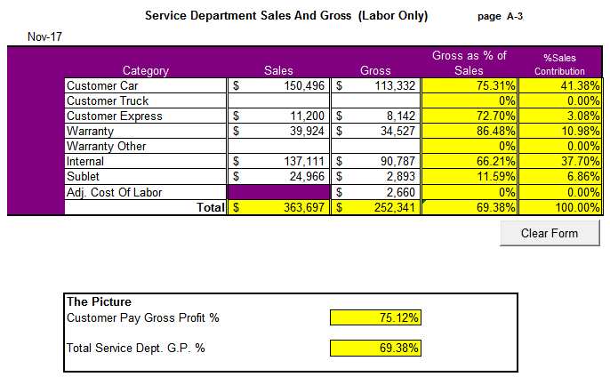
- Changes in Expense Structure—(“A” Tab---third calculation) – 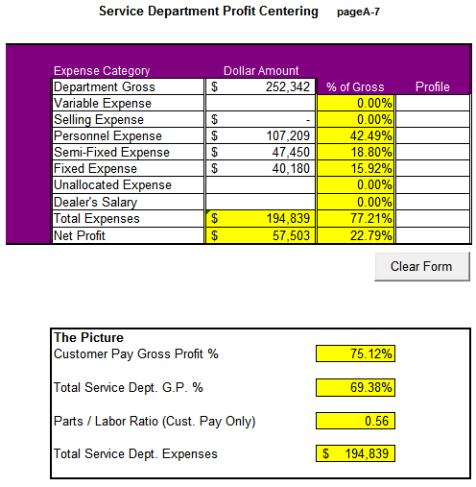

- Pay Plans – ASM and Express Pay Plan -

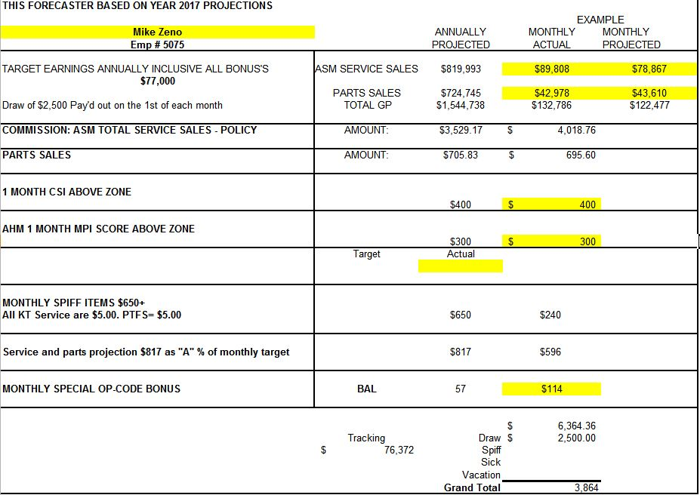

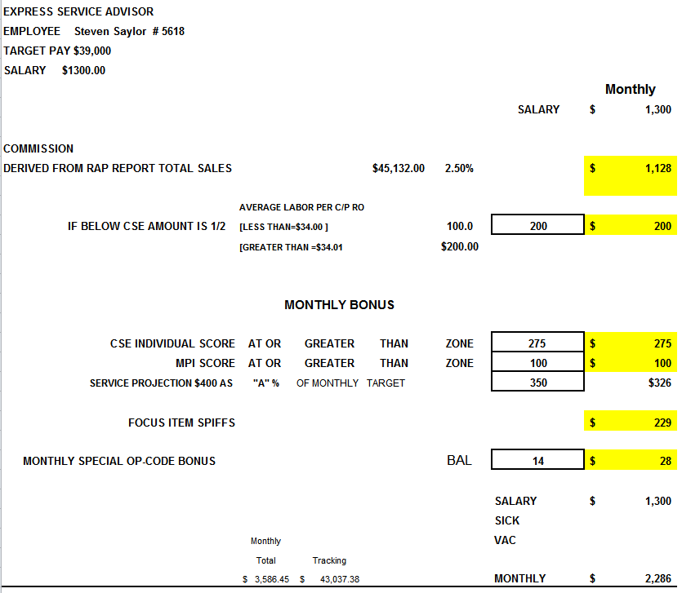

- Detail performance programs—objectives, tracking, communication –
Daily, we go over everyone’s current status and tracking to ensure they will accomplish the goals each month. We also go over new incentives and any new ideas that are presented that make sense.

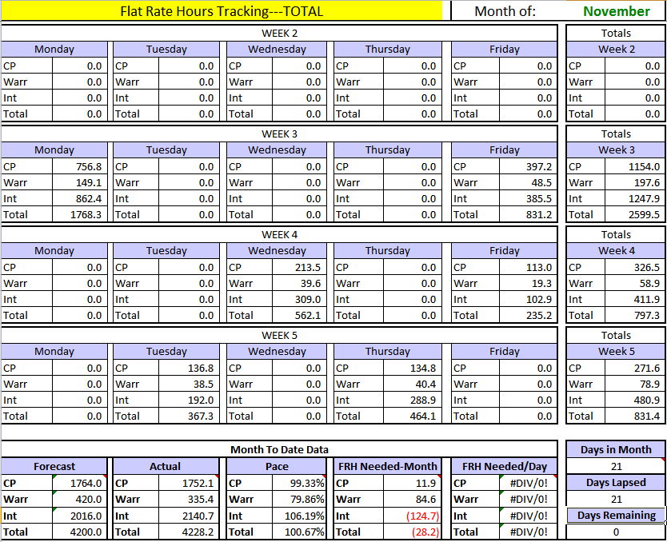

- Level of current training—Manufacturer website, minimum training standard – Training is expected and required – Always Changing
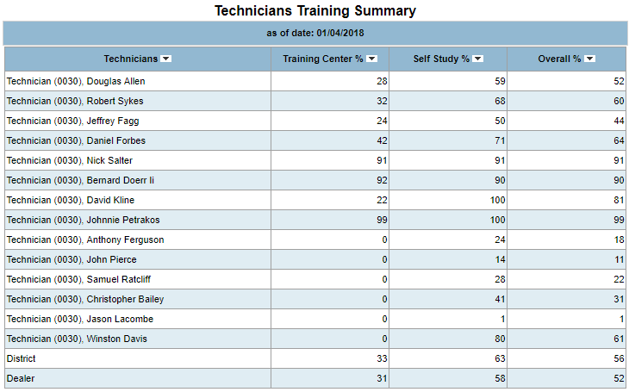
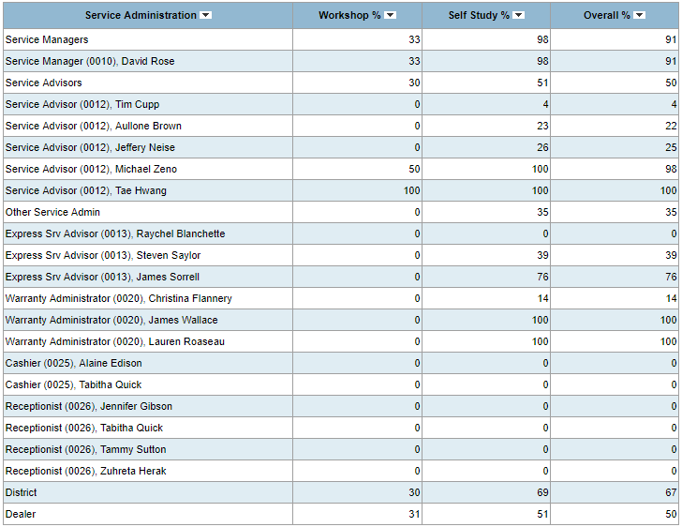
- Special tools---neat and organized, or a rats nest – Somewhat organized, not a rats nest. We have ordered a template from the manufacturer of all special tools on how they should be kept.
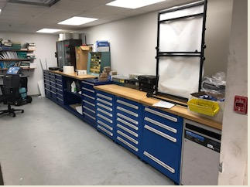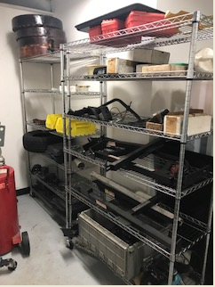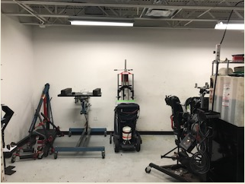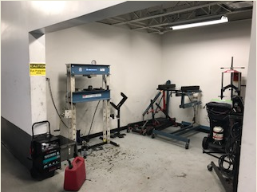

- 100 Repair Order Analysis----evaluate summary (recap) sheet –

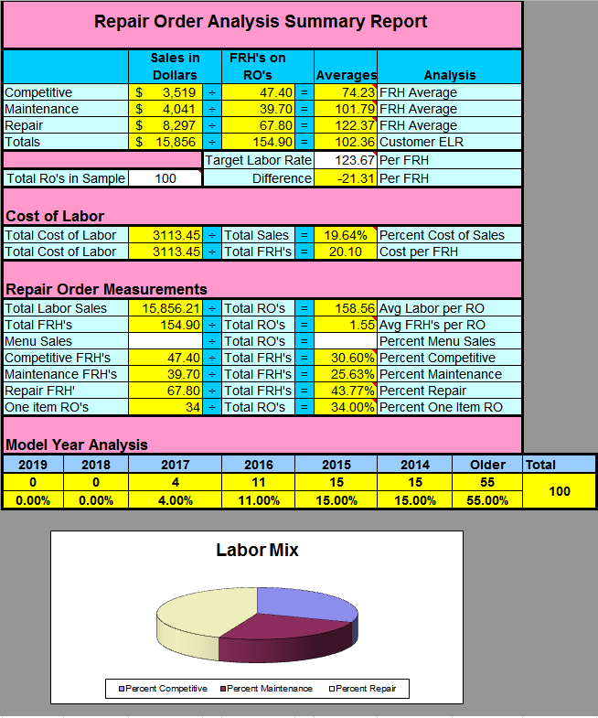

- Complete Qualitative SWOT Analysis (pages 133 – 142 in class book).
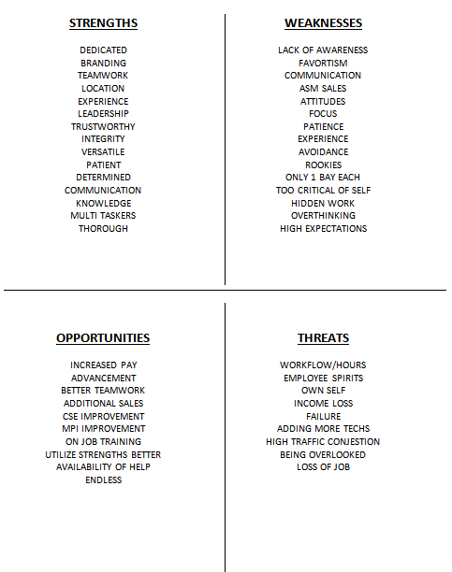

Strengths
- Large loyal customer base. The service department benefits from this store being the very first Honda dealership in the state of VA. Even though it has changed names twice, we are very blessed.

- Our Units in Operation continue to grow at a decent pace without outgrowing our service department.

- The Service Retention is currently at 31.21% and has had a slight decline YOY, but still a very healthy growth.

- We can sell more work due to our current shop capacity.

- Our Technicians are diverse in experience, and job time. We work well together and help each other for the better goal.

- Being a Honda dealership, we have great name recognition and again, loyal customer base.

- We have a great Shop Foreman who is just learning the position. He has been an ASM for many years and has chosen to take on this role. This is all a work in progress with nothing but good coming from it.

Weaknesses

1. Service hours do not match the hours of the Sales department

2. Motivation seems to be the problem with some of the technicians

3. Negativity surfaces when technicians who work a slower pace watch other technicians who are more motivated to work and turn more hours.

4. Most of our problems come from stinkin-thinkin. We are our worst enemy when things are not going the way they are expecting it to.

5. Blame is thrown at others for ability to sell larger tickets.

6. Most of the ASM’s have worked under the previous Service Director for several years. They are slow to change from the past.

Opportunities

1. We live in a very transient area with 3 military bases surrounding us. This allows us to increase our UIO and increase income potential.

2. Education on new technology is available and will put us ahead of others with less experience and ability to repair todays vehicles.

3. Additional one on one’s can create a better understanding of why things appear as they do. And that the same opportunities are available to everyone with the same equivalence of training and knowledge.

4. We added an additional alignment rack to a stall that was unproductive and costing sales.

5. Our CSE can improve with additional training and following the process we have in place. The MPI is not being disclosed 100% which I believe stems from most of our current problems.

Threats

1. Assuming that the customers will always continue to come back, regardless of how they are treated. Having a hook, or a program that affords the customer with benefits of free service work will not always guarantee a repeat customer.

2. We have dealers that were not competitive in the past who have now put their hat in the ring and have copied our benefits. One sleeper dealer, or so we thought, has one up’d us with their benefits.

3. Independent shops are open later at night than we are and are taking that some of our business.

4. The big name parts stores have now begun offering diagnostics for free and shedding a bad light on our business. Worst part is that we purchase from them and keep them in business of taking our customers.

5. If we do not perfect our process, we will prevent our service department from maximizing earnings potential for both the dealership and employees.

Objectives

1. Improve gross on customer pay repair orders for both Parts and Labor sales.

2. Improve training on a daily basis to maximize potential for all Technicians.

3. Educate all departments on why the process is what it is.

4. Educate each employee how to maximize their daily efficiency and productivity.

5. Update the Service drive with the latest technology for a better experience for the customer.

6. Continue to increase UIO with continued campaigns and increased sales through Variable.

Strategies

1. Work with the new Shop Foreman on a proper work flow and accountability of all internal repair orders.

2. Continue to embrace the changes in hours for express by maximizing the appointments for evening work.

3. Discuss lost sales tracking with Service Director and Parts Manager and create a plan to minimize loss.

4. Create a dedicated internal technician and detailer to handle the volume of work.

5. Utilize the technology that we are fully situated for. All iPads are in house and now we need to have the training and demand 100% utilization of the new process.

6. Housekeeping needs to be addressed in express, as it is not presentable and they are putting us in violation of privacy laws.

Tactics

1. Have weekly meetings with Service Manager, Shop Foreman, and Parts Manager.

2. Keep a daily log of current tracking in all departments for all employees to see.

3. Adjust the nightly service janitors duties to accomplish the needs of the shop.

4. Restructure a pay plan that makes the Shop Foreman more engaged and aware of all pending work. Base it on the success rate of time and volume.

5. Continue to advertise, as what we are doing is working.

6. Work on the process, inspect what we expect.

Action Plan

Task By Whom Completion Date

Adjust Shop Foremans Pay Plan based on GM/Serv. Dir. Jan 15th, 2018
hitting target objectives - Internal

Weekly Service & Parts Mgr meetings Service Director Daily

Have company come in to implement the Service Director Feb 1st, 2018
new technology to use iPads

Adjust janitors nightly tasks Service Director Jan 8th, 2018

Send out weekly advertisements Service Director Jan 12th, 2018

Incentivize the Service receptionists on fulfillment GM/Serv. Dir. Jan 15th, 2018
of nightly express appointments

Create the internal technician position Service Director Feb 1st, 2018

Hire an additional detailer for internal recon Service Director Feb 1st, 2018

Meet with Express Tech’s to discuss the Service Mgr/Dir Jan 12th, 2018
Importance of the privacy laws and process

Create a flow chart that will guide the Shop GM/Serv. Dir. Feb 1st, 2018
Forman on a fluid process

Implement a training deadline for all departments Service Manager Feb 1st, 2018

Hold Service Director accountable for all changes GM Feb 1st, 2018
made and for the success of changes

Synopsis
We definitely need to come to the realization of the changing conditions of our industry and the people we serve. With the changes in technology and the expectations of today’s customers, we need to come to the realization that we are not the only company that can support their needs. Competition in pricing and the technology that provides the wow factor is taking center stage and that is what the customers are wanting. We need to give the customers what they want, but that does not mean we have to give everything away to do that.

If we can educate our employees on the importance of customer satisfaction and the return it brings, we can all make a great living for a few more years or more. By wowing the customer with our knowledge, technology, and friendliness, we can continue to justify our pricing and have the customer satisfied all around. We cannot do it in a few departments, it must be in all departments and with total happiness. To accomplish that task, it will mean a lot of hands on training and extra effort from the GM and Service Director to hold everyone accountable.

When we get the process down with everyone smiling and completing each task with total fulfillment, we can maximize gross earnings in every department. That being said, that is basically the front half of the Service Department. Once the front half is flowing, the process cannot get bottlenecked up in the bays. A flow chart must be created to ensure a steady flow of work and emergency contingency plans in the event of the unknowns. We cannot have a happy paying customer if we cannot deliver on our promise. We can pay all the money in the world to wow the customer with balloons and glitter, but it will be forgotten once our promise is not delivered.

We focus on customer satisfaction so much that we forget who our best customer is. Internal sales provide us a consistent flow of profit to the bottom line. The Used Car Manager is no different than the customers we work in the lane, only better. The Used Car Manager wants his car reconditioned as fast as possible and for the best price possible. If we can get the vehicles through service in the recommended timeline of 3 days consistently, he will pay more and like it. If he feels as if he has to seek other sources or ways of cheating the system, then the process we have is broken. If we can promise a turnaround time of 3 days, he will pay more internally for the benefits of maximizing his bottom line. They understand that if we have to hire an outside service to come in and recondition the vehicle in detail, he will be paying more and that usually means the vehicle is depreciating every day it is not on display for sale. This is a huge part of profit for the dealership and is why this has got to be a priority focus item.

The process of educating all employees on the why and how it affects everything is a good thing. As children growing up, we have always been told to do and that you don’t need to know why. It didn’t feel good then and it still doesn’t, which is why we get reluctant support at times. Knowledge is king, and I want everyone to have as much knowledge as possible. Sure it creates better employee’s that you will lose because of their growth as people, but for the most part, it will pay off for you in the long run. The long term effects of training and supporting employees will create a better bonded family of employees and loyalty.

This will be a great year of change for me and this dealership. I am looking forward to seeing the success from all the changes. I know that I will have to put additional effort into making all of this work, but I didn’t get to this position without the motivation and drive I possess.

Matthew Davis N326 15

Use whatever time frame is best for you. You may use “Word” or PowerPoint. Please submit a single document and NOT 3 individual forms. Please email it to me, or if it too large, upload it to the DropBox, Homework section. Email me that it has been uploaded, so I may grade the assignment.

