Appointment Boarding Pass | <{CustFirstName}> <{CustLastName}>
  Your booking is confirmed. Please print/retain this page for your records. We thank you for choosing LaFontaine Cadillac Buick GMC and look forward to welcoming you onboard.  Reservation code | TFD052017 | 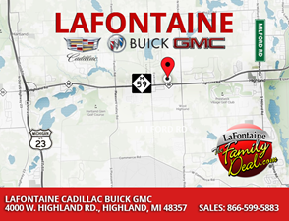
   |  | 

Date | Specialist | To | Flight | Status

<{NextSalesApptDate}> @ <{NextSalesApptTime}> | Please ask for  General Sales Manager  Paul Jordan  upon arrival | 4000 W. Highland Rd., Highland, MI 48357 | CBG 4000 | Confirmed

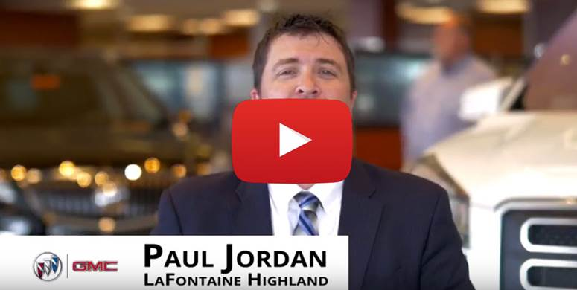

Where to park when you arrive :)
Important Information:
Please review this Appointment Boarding Pass and, should you have any inquiries please contact LaFontaine Cadillac Buick GMC at 866-690-1592 or email us.

 | Kim Seets  Business Development Manager  LaFontaine Automotive Group  Direct: 248-714-1142  Main: 248-887-4747  Social Links:  kseets@lafontaine.com | www.LaFontaineCadillacBuickGMC.com  OUR MISSION:  To build life long relationships that connect families, strengthen communities and personalize the automotive experience!

