Departmental Action Plan
Student Name: Ali Khan
Class: N319
Academy Week: Variable II

Current situation or challenge you want to address based on the Jennifer Suzuki Outline: (must be quantifiable)
The current situation for the Orange
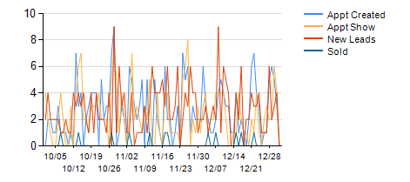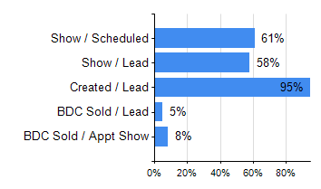

Overall Objective and Specific Desired Results:
Our overall objectives for the new CRM and appointments are: Our overall objectives for our staff and new CRM appointments is to increase the number of appointments made out of leads (70% opportunity) and increase out BDC sold from 12% to 15% by end of third quarter.
Describe your action plan in detail (be specific and include before and after measurements)
Timeline: Describe specific short term and long term checkpoints to monitor progress
Short Term: I will have the three members of the BDC team sit through Jennifer’s training online and doing the quiz. I will have the BDC manager role play with them Every Monday morning to check for understanding and to provide feedback. “Inspect what you expect” on a weekly basis.
Long Term: Long term is a different situation we need to continue to focus on training, development and empowering of all employees. We will make bonuses and incentives based on a monthly basis and focused on raising the bar to a minimum of 15% sold of all shown appointments. The reaffirmation of offering the customers two tentative times and clarification on what we will do for them and the steps of the process seem to be very effective and setting up the customer for a smooth transaction.
Please see the results for the month of June with some minor adjustments and some initial focus and training. Appointments shown increased by 1% and BCD sold leads increased form 12% to 16% (+4%). The key is and will continue to be growing the sold units and the making the most out of every lead that is available to us.

Meeting with Stakeholders (dealership personnel)
Describe what behavior change is needed to support desired goal. Address required coaching, training and/or consequences (PINO, Gain, Pain). Include timelines / Accountability / Monitoring process
Who: Ali , Mahdi (BDC Manager), BDC team members and sales staff.
What: Training will start on a weekly basis between the BDC staff and Mahdi. Role playing will continue to be key in creating a smooth flow in the conversation process. Building report with the customer and prioritizing their time and needs will be the focus. Mystery shops have been schedule to start in August and carry over into September.
By When: Training has started and will be ongoing every Monday with no completion date in mind. Training will be the focus until we achieve the desired results and it becomes more of a culture and less of a shore.
How: Training, development, and accountability will key to getting the results we are looking for. The mystery shops will get us third party results and will be based on key metrics that we will provide the BDC feedback for.
Dealer agreement:
I spoke with my VP and is onboard with the plan. I will have to update him monthly on results and any changes that we have to make as we continue on the process.

