Dealer Labor Rate Survey

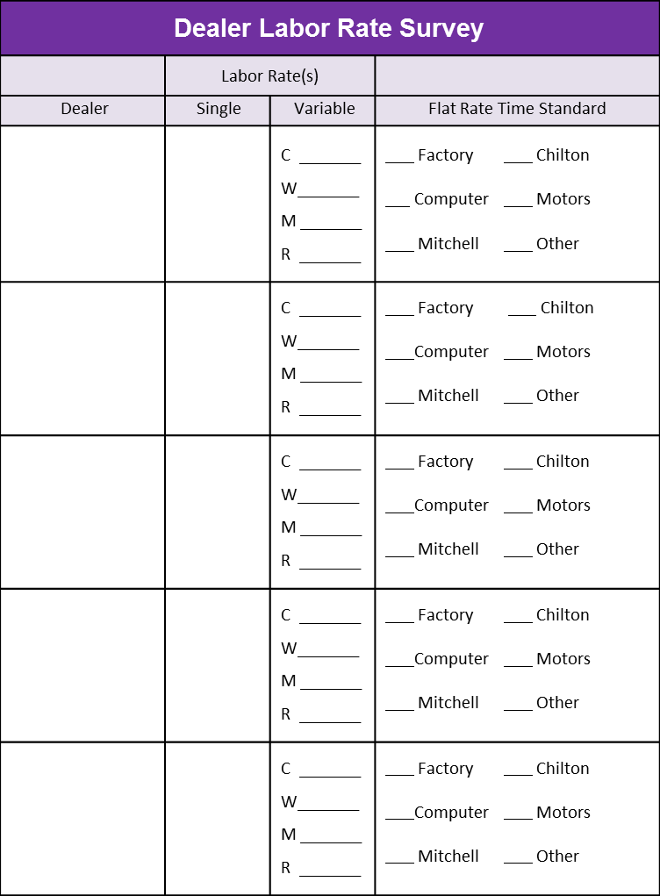

Variable Rate Code(s):
C = Lowest, Most Competitive (i.e., L.O.F., etc.)
W = Warranty
M = Maintenance Rate (Normal Factory Maintenance)
R = Highest, Repair Rate

