NADA Service Homework
Roy Karr Class #421

Marketing
Current Practices:
- We are currently using CSSR for most of our service marketing. An example of the summary is below.

- It sends out emails and mail flyers for us. Letting people know about service deals and routine maintenance reminders.
- We also use a program called Service Smart that identifies customers that have not been in for 6 months and then at 12 months so we can contact them to see if there is anything we can do for them.
- We currently send out coupons to customers that have declined repair. Those offer 10% off or sometimes $20.00 off trying to entice them into coming in to get the service they declined.
- We also rely on the GM national program advertising.
- CDN magazine mailers are also used.
Goals for improvement:
- The service manager would definitely like to see the percentage of people who decline service shrink.
- Even though our competitive to repair ratio is not bad he would like to be able to take away business from independent shops increasing our competitive ratio allowing his staff to have more up sales.
- He would also like to see more older model vehicles non – warranty come through the door.
Plans to achieve goals:
- Start calling customers that have not been in service lately at the 3 month mark instead of 6 month. Trying to get them in quicker.
- Start advertising directly our prices compared to independents in town and the value they receive using us. Similar to below.
- 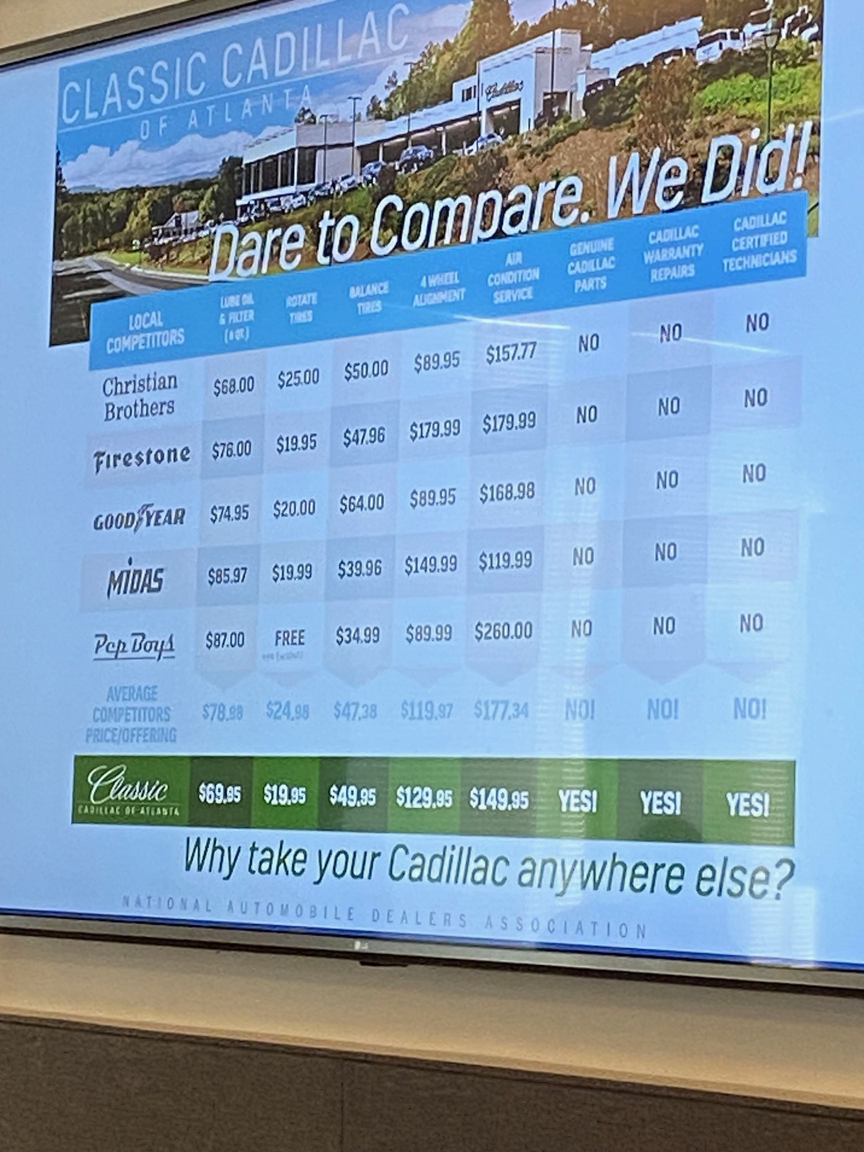
- Give the advisors some sales training. So, they can know how to actually sale the repairs. Develop a training program where they actually learn to sell just like the front-end guys.
- Start trying to implement videos from the techs of what is wrong with the car. So, they have proof instead of just taking the advisors word for it.
- Also add a value to the MPI on the RO so the customer can see what they are receiving for free and might be more willing to spend on the repair if they are getting something for free.
Plans to evaluate your changes:
- Start making these marketing changes in January of 24, implementing training for the advisors the month before. Let them run for the quarter and see what has changed in March at the end of the quarter. Compare sales from the quarter before to see if any difference in sales has occurred. Evaluate if things need to be tweaked or improved on.

Analyze Cost of Labor

These numbers are based on the July 2023 Financial statement. Our techs are paid on a Flat Rate that is not a sliding scale. The flat rate manual we use is All Data. Flat rate paying method allows gross profit to be controlled easier than other methods. The customer does not get penalized if the tech is not as fast as he should be. Our average Tech pay is $38.00 an hour. As you can see our over all gross as a percentage of sales is 76.3%. The NADA guide is 76% for all categories so we are close for the month of July. We are definitely right at the edge of guide. We need to look and make sure there is no discounting going on and stop it. Also look our internal rate to make sure it is in line with the other categories. We also need to make sure that our service advisors are trained to properly sale the repairs. Once the training is has been done will monitor the advisors sales daily.

Changes in Expense Structure

Service Department Profit Centering
 | Expense Category | Dollar Amount
 | Department Gross | $ 173,251 | % of Gross
 | Variable Expense |  | 0.00%
 | Selling Expense |  | 0.00%
 | Personnel Expense | $ 101,098 | 58.35%
 | Semi-Fixed Expense | $ 22,306 | 12.87%
 | Fixed Expense | $ 25,996 | 15.00%
 | Unallocated Expense |  | 0.00%
 | Dealer's Salary |  | 0.00%
 | Total Expenses | $ 149,400 | 86.23%
 | Net Profit | $ 23,851 | 13.77%
For the month of July, we turned a net profit of $23,851 but our overall personnel expense was 58.53%. Guide is 45-50% of gross. Yes, we did turn a profit with the help of our other expenses being kept in check well below guide. I do not for see us changing any personnel so we will have to concentrate on producing more Gross. We definitely need to look at maximizing our selling hours. We currently close at 1:00 on Saturday and do not run a full crew that day. The cost to the dealership for extra hours would be minimal since the techs are paid on what they produce not hourly. So, I am going to propose that we open until 6:00 just like sales and run a full crew. The extra work should allow us to push our Gross higher getting us closer to the NADA guide for personnel expense. Also going to look at our shop supplies and uniform cost. If we can cut those cost anywhere that will help our over all Gross. Then finally I am going to check to make sure our policy work is priced at retail. This would be done starting at the beginning of October and evaluate in December.

Productivity

As you can see from the above table, we are at 85.05% proficiency for the month of July. The NADA guide is 87.5% I know there are numerous things that we could do better to increase that percentage towards the guide.
Current practices include:
- No parts runner
- To many emergency purchases
- No parking lot organization, cars parked all over the place
- Wi Fi Updates take way to long
- Do not track lost sales adequately
- No system for technician to request common part

Goals to increase proficiency:
- Establish a parts runner or parts runners from current employees
- Work with parts manage on controlling the number of emergency purchases and work to increase RO fill rate.
- Make sure we are stocking the most 100 most frequently used parts.
- Start tracking lost sales correctly
- Develop a better way to park the cars efficiently
- Look at creating a proficiency bonus for the techs
- Look at third party to help with updates on cars
Get with service manager and parts manager tell them we are starting these changes the first of next quarter. Look at the proficiency % each month at the end of December look at how well or bad the techs number is and change as needed.

Facility
We definitely are not using our facilities to its maximum ability. We need to be at 70% Utilization and we are at 35.44% for the month of July.
Currently – we use the Conventional shop structure style. We have 24 total bays. We have 7 techs and 4 lube techs. 4 of the 24 bays are used by our lube techs. We have 4 service advisors and 2 oil change advisors. In the traditional Conventional structure, you have 1.5 bays per technician. We have nearly 3 bays per tech. We also have almost 2 techs per advisor. Which is off from guide that is 4 to 1.
Our goal is to get to at least 70%. We have to make sure that the work is being distributed correctly between the techs and make sure one tech doesn’t have more bays for some reason. Also, we need to look at hiring a few new techs and another oil tech to help us get more in line with the NADA guide lines and of course produce more gross in the end. The plan to Increase our utilization is to go ahead and hire at least one new tech. Once that tech has been here for a few months we will look at our Utilization again and decide if we could use another one.

Repair Order Analysis
- The 100 RO sample was from 8/7/23-8/14/23
- Repair Labor Rate is lower than our posted door rate which is $170.00. Need to make sure the advisors are charging the customer the right amounts.
- Our target labor rate is 156.27 which is exactly $2.00 over our warranty rate of 154.27.
- Cost of sales % at 25.31% is higher than guide which is 24%. Which could be affected by discounting.
- Our average per RO in this sample was 1.19 which is very low. The fact that this sample had over 60 Competitive ROs could contribute to this since the guide needs 2.2 to 2.5 for non-high line.
- I believe our numbers are a little off between Competitive, Maintenance, and Repair. There were 64 Competitive and Maintenance Ros in the sample due to the way we pay our lube techs. We pay them by the hour not the flat rate. They get paid flat rate on anything that is not a standard oil change. We pay one tenth on tire rotation.
- One-line R0s were at 32% and it needs to be 15%. My service manager does not see to mind the one-line ROs because we have a large number of returning business and we are number one in our zone for up sales.

SWOT Analysis
Analysis based on answers from 21 fixed op employees.
Strengths:
- Strong customer base that is loyal
- Customers have a high level of trust in our facility
- We have techs with high skill levels
- Employees that care about helping each other
- Everyone gets along with each other is a great work environment
- Ability to schedule and fulfill appointments in a timely manner
- Very low turn over of employees/ customers like dealing with familiar faces.
- Great and fast oil lube lane
- Great organization to work for
- Everybody works well together
- Great heavy line business
- Able to do all mechanical repairs and have multiple tasks
- Oil changes are out in a timely manner
- All advisors communicate well and are nice to customers
- Try to fix an issue in a timely manner

Weaknesses:
- Some of the techs need to be better in major electrical repair
- Construction of the highway in front of building going on a year now. Customers have a hard time getting into dealership
- Need more lube techs, scheduling a week out right now
- Online booking system not working properly allowing overbooking
- Could use more quality control
- More room in shop
- Need more maintenance repair work
- Having to wait for filters longer than we should sometimes
- Cross training could be improved
- Land locked and not much room for growth
- Communication is sometimes lacking
- Advisors not pulling customers vehicle around to go over service with them
- Cashier is a little rude
- To many techs touching vehicle to complete repair
- Prices being cut for so called friends

Opportunities:

- Make customer vehicle parking more organized
- Chance for further advancement in career and training
- Building relationships with good people
- Make life long customers and great customer relationships
- More up sales on MPI
- Create a quality control manager position
- Seek methods to maximize the money value of each repair order
- Training in different areas of job
- Better communication
- Improved patience with customers
- Increase efficiency

Threats:
- EV cars
- Heat
- Running to the service manager with every little problem between employees
- Finding quality employees
- Highway Construction
- Quick lube oil change shops

Objectives:
- Make it easier for customers to get to the dealership
- A seamless online booking system
- Make it easier for techs to get parts Ex: no waiting on filters
- Keep customers from waiting a week for an oil change
- Have all techs be able to perform all repairs
- Create a more comfortable working environment form the heat
- More up sales from MPI
- Get maximum money out of the ROs
- Make sure Quality Control is front and center
- Maximize communication between manager and techs

Strategies:
- Offer more shuttle runs to pick up and drop off cars to customers who are nervous about driving through the construction.
- Make sure our scheduling system is working the way it is supposed to and if it cannot find a new scheduling company.
- Start using parts runners to take the parts to the techs and make sure we are stocking all makes of filters for oil changes
- Hire another oil tech or two to handle demand
- Cross train all technicians
- Invest in more portable cooling units and purchase a commercial ice machine.
- Sales training for service advisors to help them sell all repairs
- No more discounting unless through service manager.
- Create a quality control position
- Develop an open communication policy

Tactics:

- The service manager will get with used car manager to decide on a car to use as a second shuttle car. Service manager will designate from our current employees an employee or employees to act as shuttle drivers.
- Service manager will get with the operations manager and they will bring in the vendor in charge of our on-line scheduling program. That vendor will get the kinks out or the operations manager will look for another vendor.
- Service manager will talk to parts manager and tell him that counter employees will start running parts to techs when possible.
- Will start interviewing applicants to hire a new oil tech.
- Service manager will set up certification and technical training so Techs can be cross trained in different repair applications.
- Operations manager with the service manager will decide how many more rolling AC the shop needs. The operations manager will arrange for the commercial ice machine to be put in the shop.
- Specific sales training will be set up for the service advisors.
- All discounting will go through the service manager.
- As part of the shop foreman’s job, he will also be in charge of quality control.
- Daily Clear communication meetings will be set up so everybody is on the same page.

Action Plan

Task Role Completion Date

Designate shuttle drivers Service Mgr. Oct. 1st
Fix on line scheduling Operations Mgr. Now
Parts employees as runners Parts MGR Now
Hiring new oil tech Service Mgr. Oct. 1st
Cross training Service Mgr. Oct. 1st
Fight the Heat Operations Mgr. Now
Sales Training for Advisors Operation Mgr. Oct. 1st
Stop Discounting Service Mgr. Now
Quality Control Shop Forman/ Ser. Mgr. Oct. 1st
Update Meetings Service Mgr. Oct. 1st
Quick Lube Pricing Match Service Mgr. Oct. 1st

Synopsis

When I first started looking at our fixed ops department, I wasn’t sure what I was going to find out. Looking from the outside things seemed to look pretty good but you never know until you start crunching the numbers. We are lucky that our service department has very little turnover. Our advisors have all been there 15 years plus. All of our techs have been there at least six years and our service manager has been with us 22 years. It is great to have seasoned employees but sometimes it hard to teach old dogs new tricks. I do have to say that my service manager was very open to hearing my ideas and he was always wanting to analyze the numbers. We have had many long talks about the information I brought back from school so much that a few times he went and changed some stuff right when I mentioned it. Example of that was the fact that our personnel expense was higher than guide he went and started looking at the hourly employees to see if any of them were milking the clock.

Our cost of labor for the month of July was not out of whack compared to guide since we were at 76.3%. We definitely need to make sure that we stay there or better. We need to make sure there is no discounting going on. Also believe our advisors need to be trained on how to actually sale the repair. The guys we have believe they know how to sell but I believe they could use a tune up for sure.

An area we definitely need to look at more closely was our expenses. We made a profit in the month of July but we were over guide for our personnel at 58%. The service manager was going to check our hourly employees from parts to our lube guys to make sure they were punching the right hours. I believe the biggest way to affect the number would be to increase our gross. I am going to suggest staying open longer on Saturdays and running a full crew instead of skeleton like we have been. Also look at running more hours during the week.

We are going to start stocking the right parts needed to keep our techs wait time down. Also look at using part runners and having better parking lot organization so our guys are not wasting their time which in turn waste the dealerships profit. We want our tech proficiency to be higher than where it is now at 85%. Will start looking at this on a monthly basis also instituting a proficiency bonus for the techs should help also.

Our facility potential is definitely an area that needs attention. At 35.44% we are definitely missing out on sales. Its not if we are going to hire more techs but when. We will need more than the current 7 we have now to reach maximum potential. We have allot of room to grow in this area and need to.

In our RO analysis we had 64 Comparative and Maintenance to 36 Repair ROs so our ratio is pretty good. We had way too many one-line ROs at 32% which is above guide. The sales training that we are going to start for the advisors and oil change advisors should help us get that number down.

The Swot Analysis survey was very productive. We are going to look at making sure all our techs are cross trained in every repair scenario. We are going to make sure our service scheduler is working right and have designated a Quality Control person and develop better communication between managers and employees.

Luckily our service shop is not in to bad a shape. Our employees said it was a great place to work and a place they can advance their career which was great to hear. If we can fine tune the areas in this report and get them closer to guide than our service department will definitely doing its part for the over all success of the dealership and with its absorption rate can take care the dealership when other areas fail.

