Welcome to Oakland, Illinois
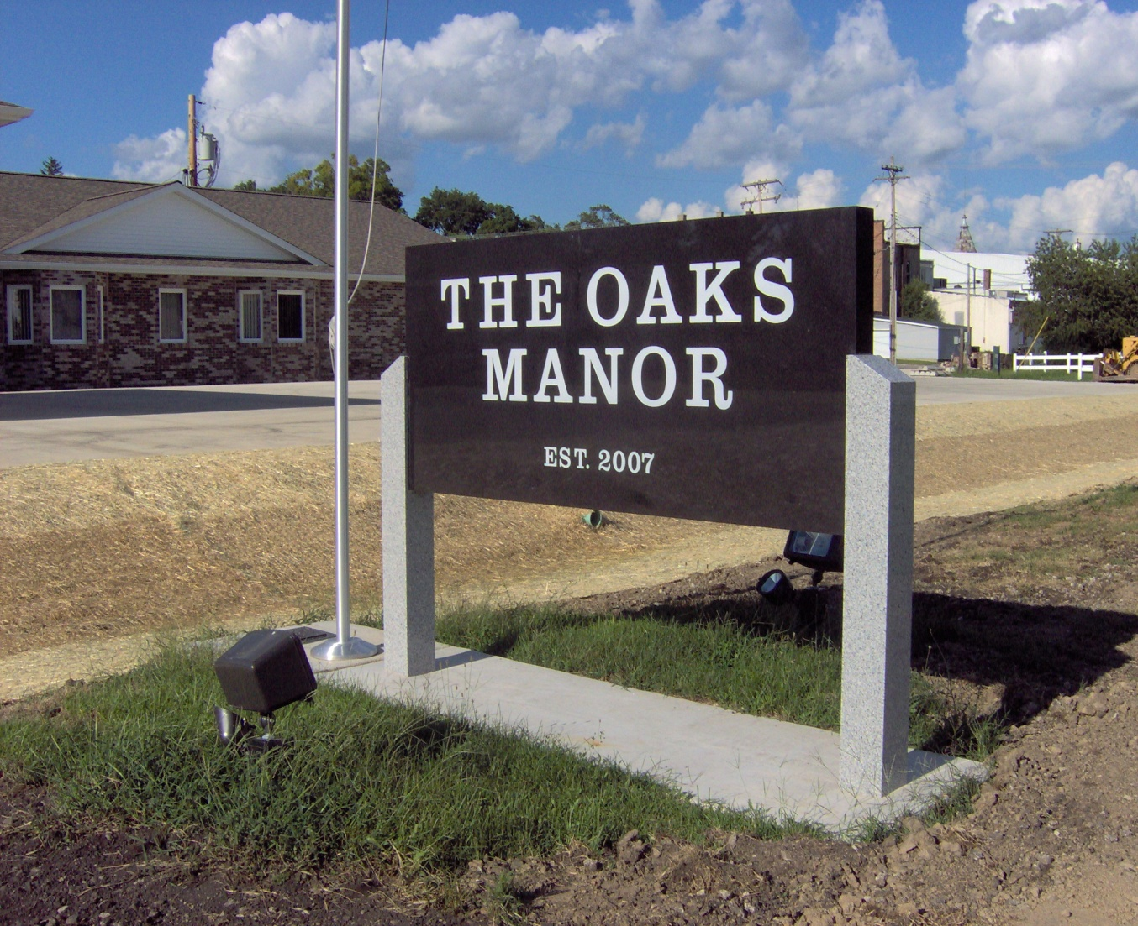
Community Assessment Project
Tenika McMillan, RN
Alicia Northen, RN
Sheila Roth, RN
Lori Turner, RN

