Week 8c Practice

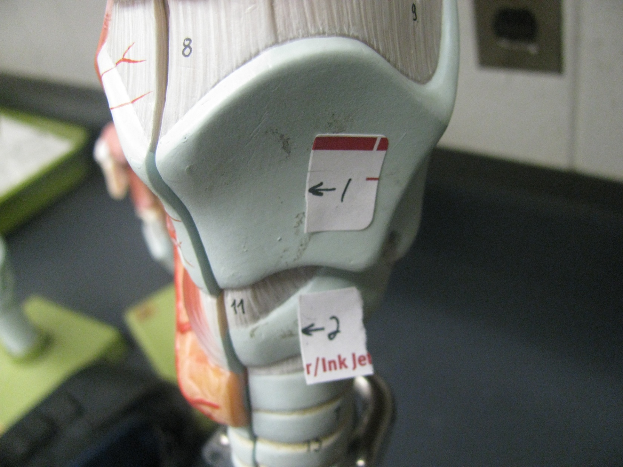

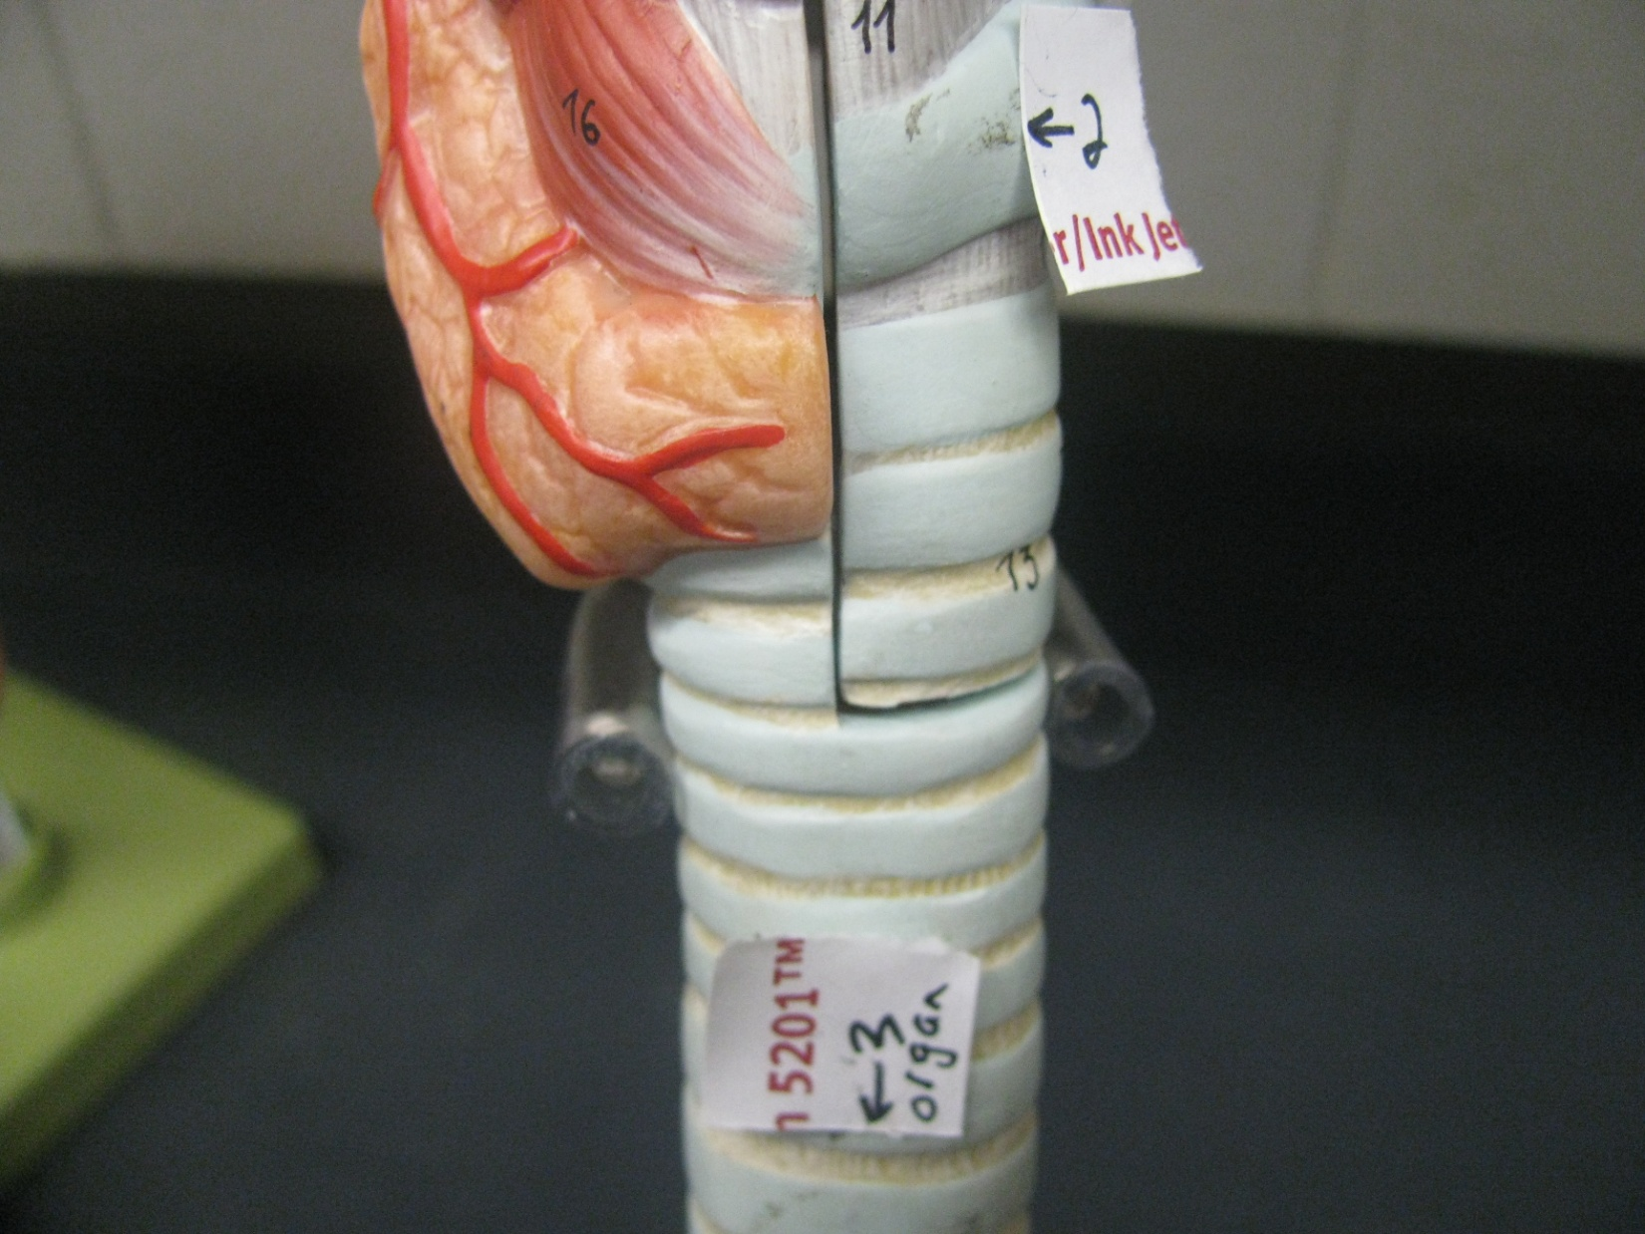

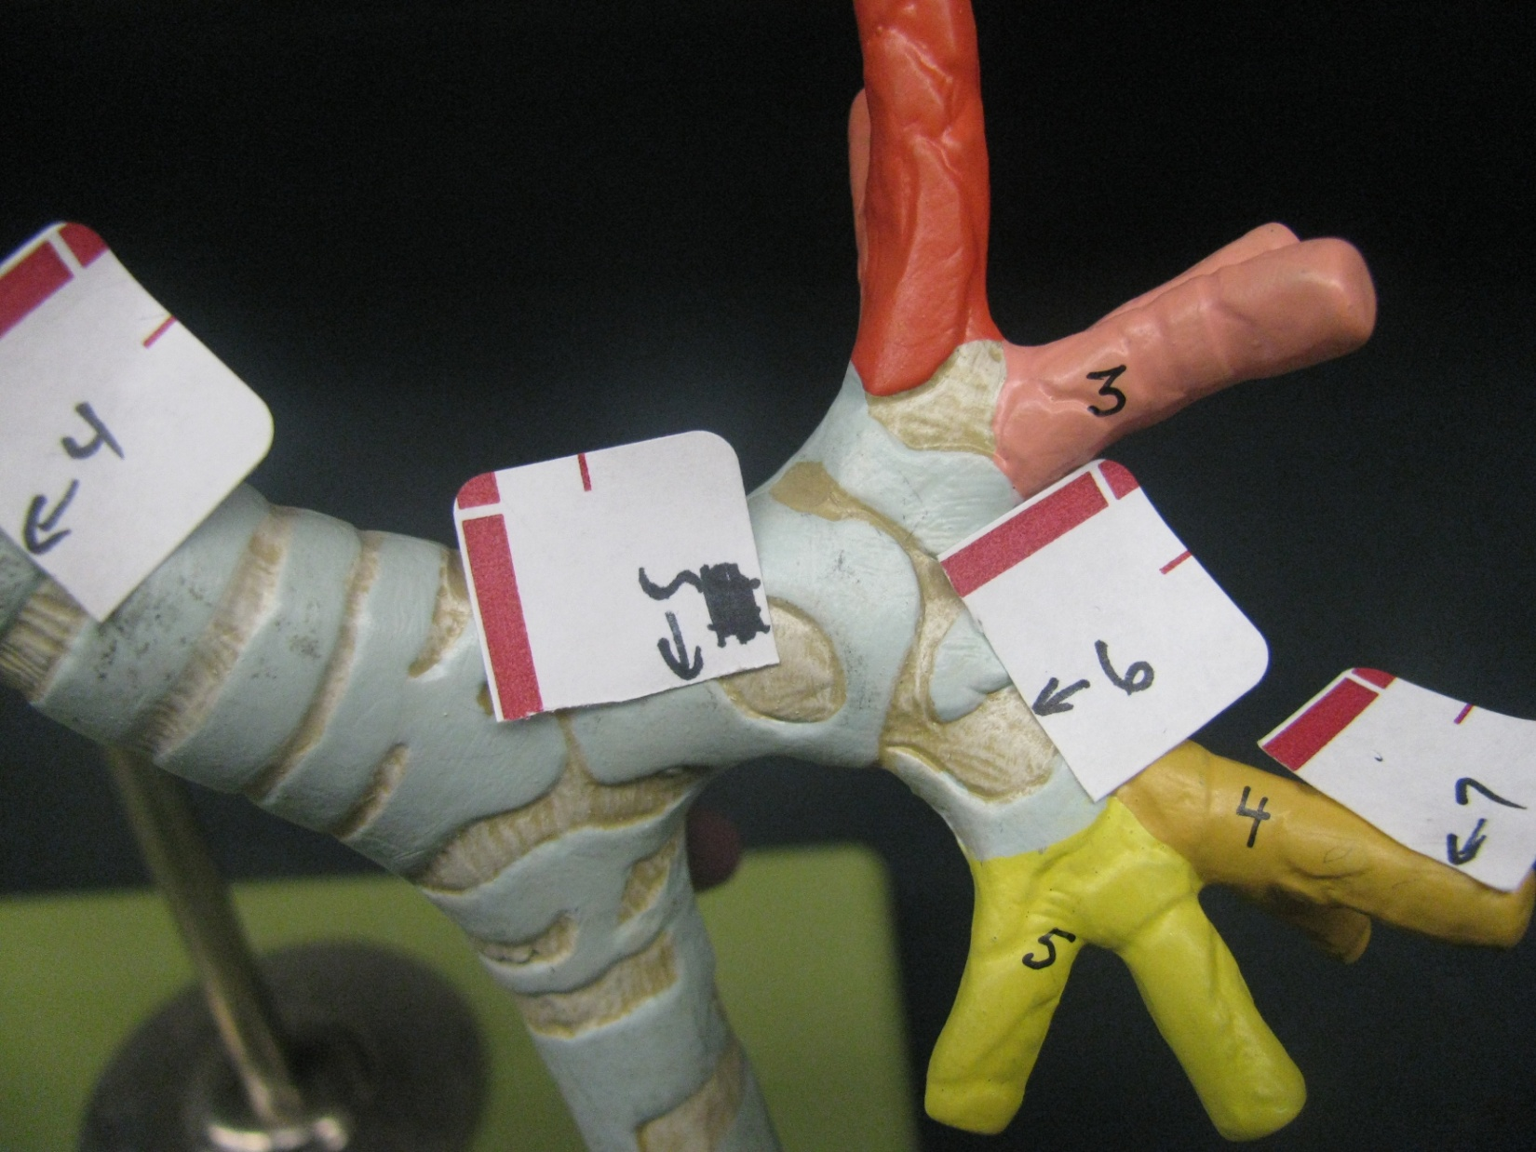

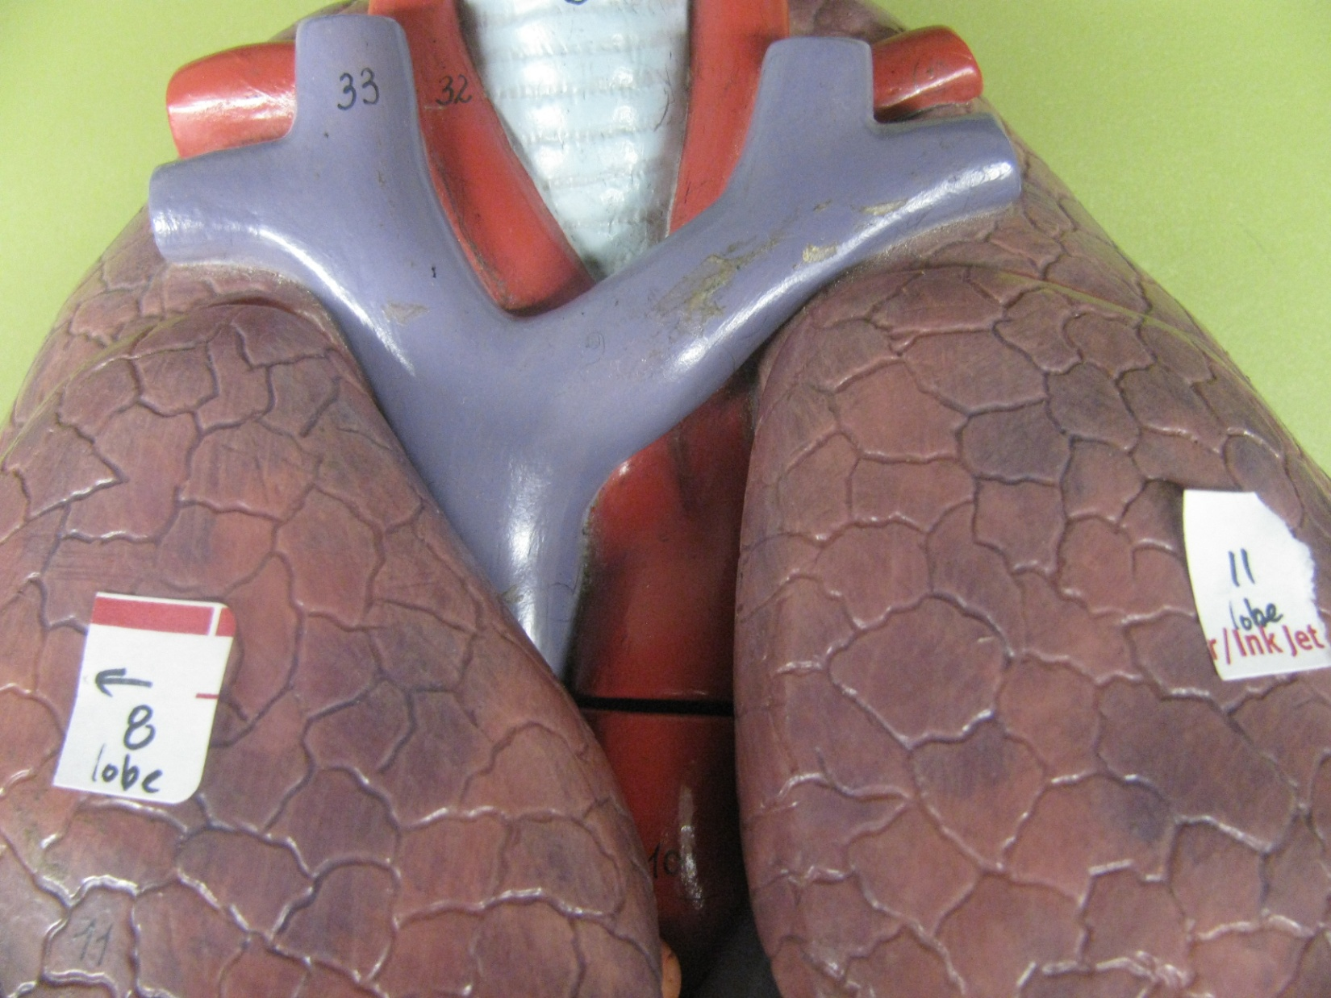

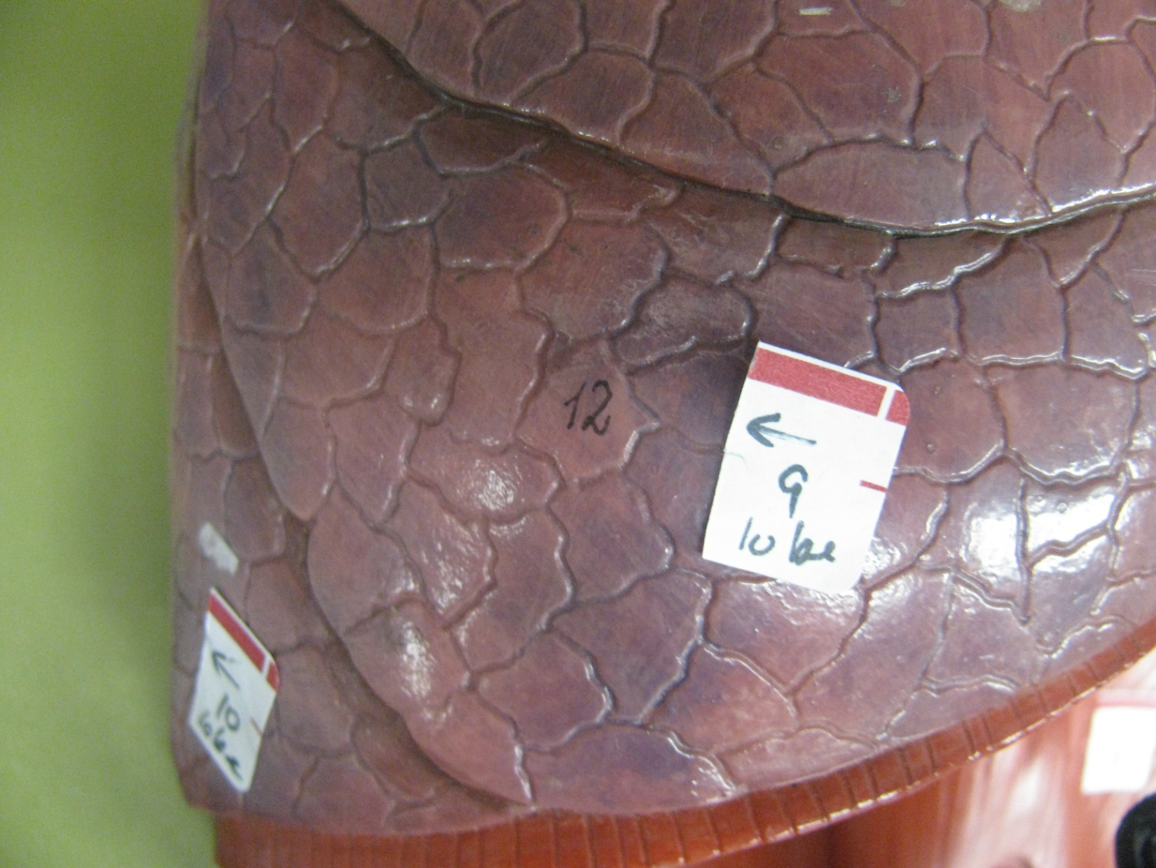

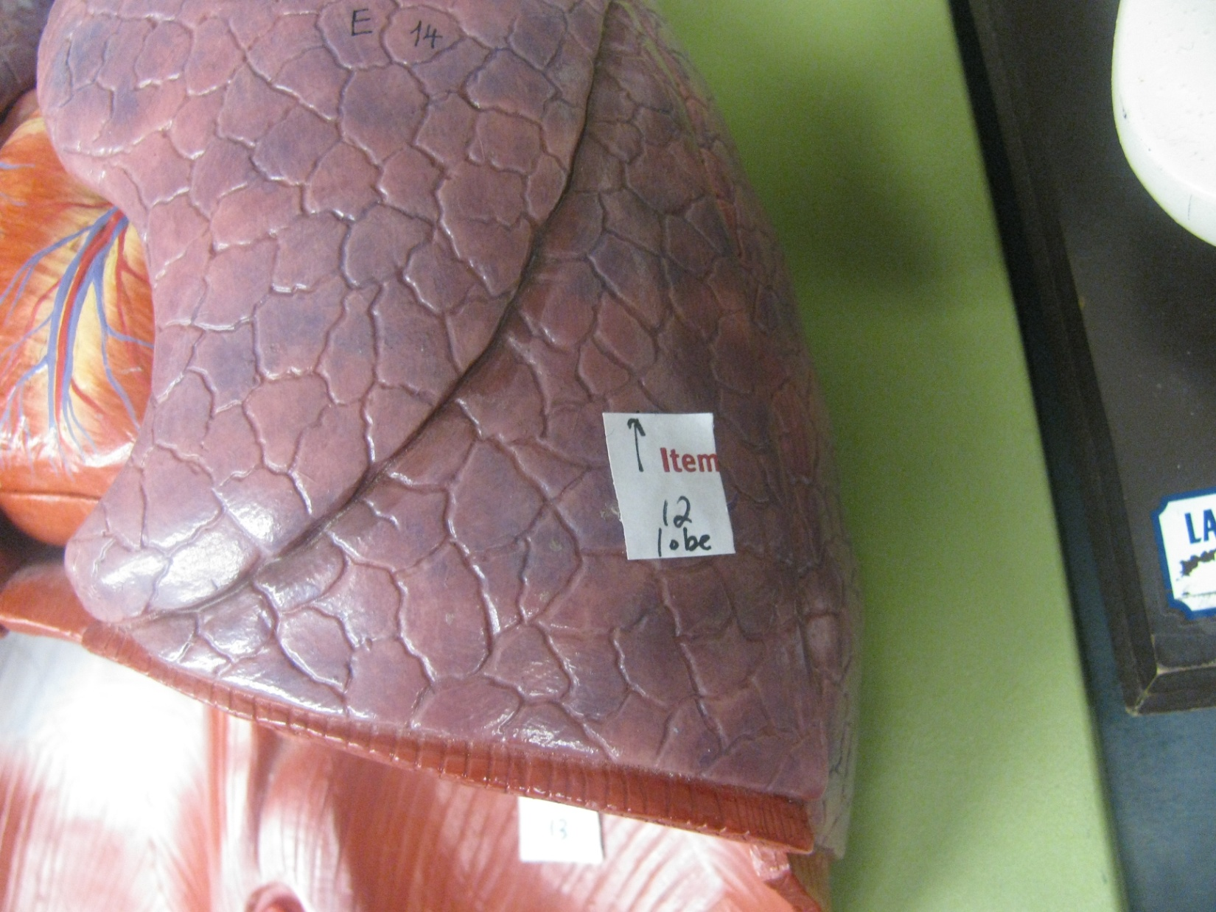

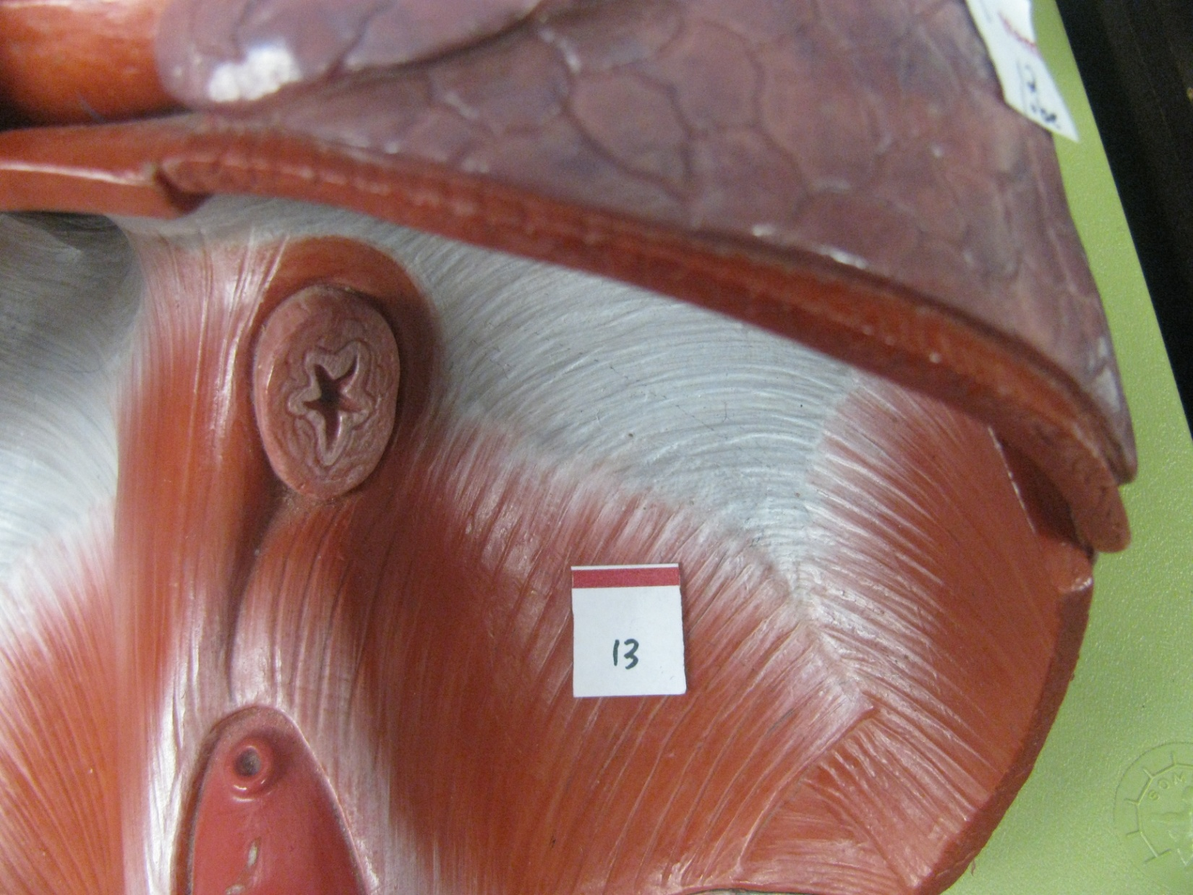

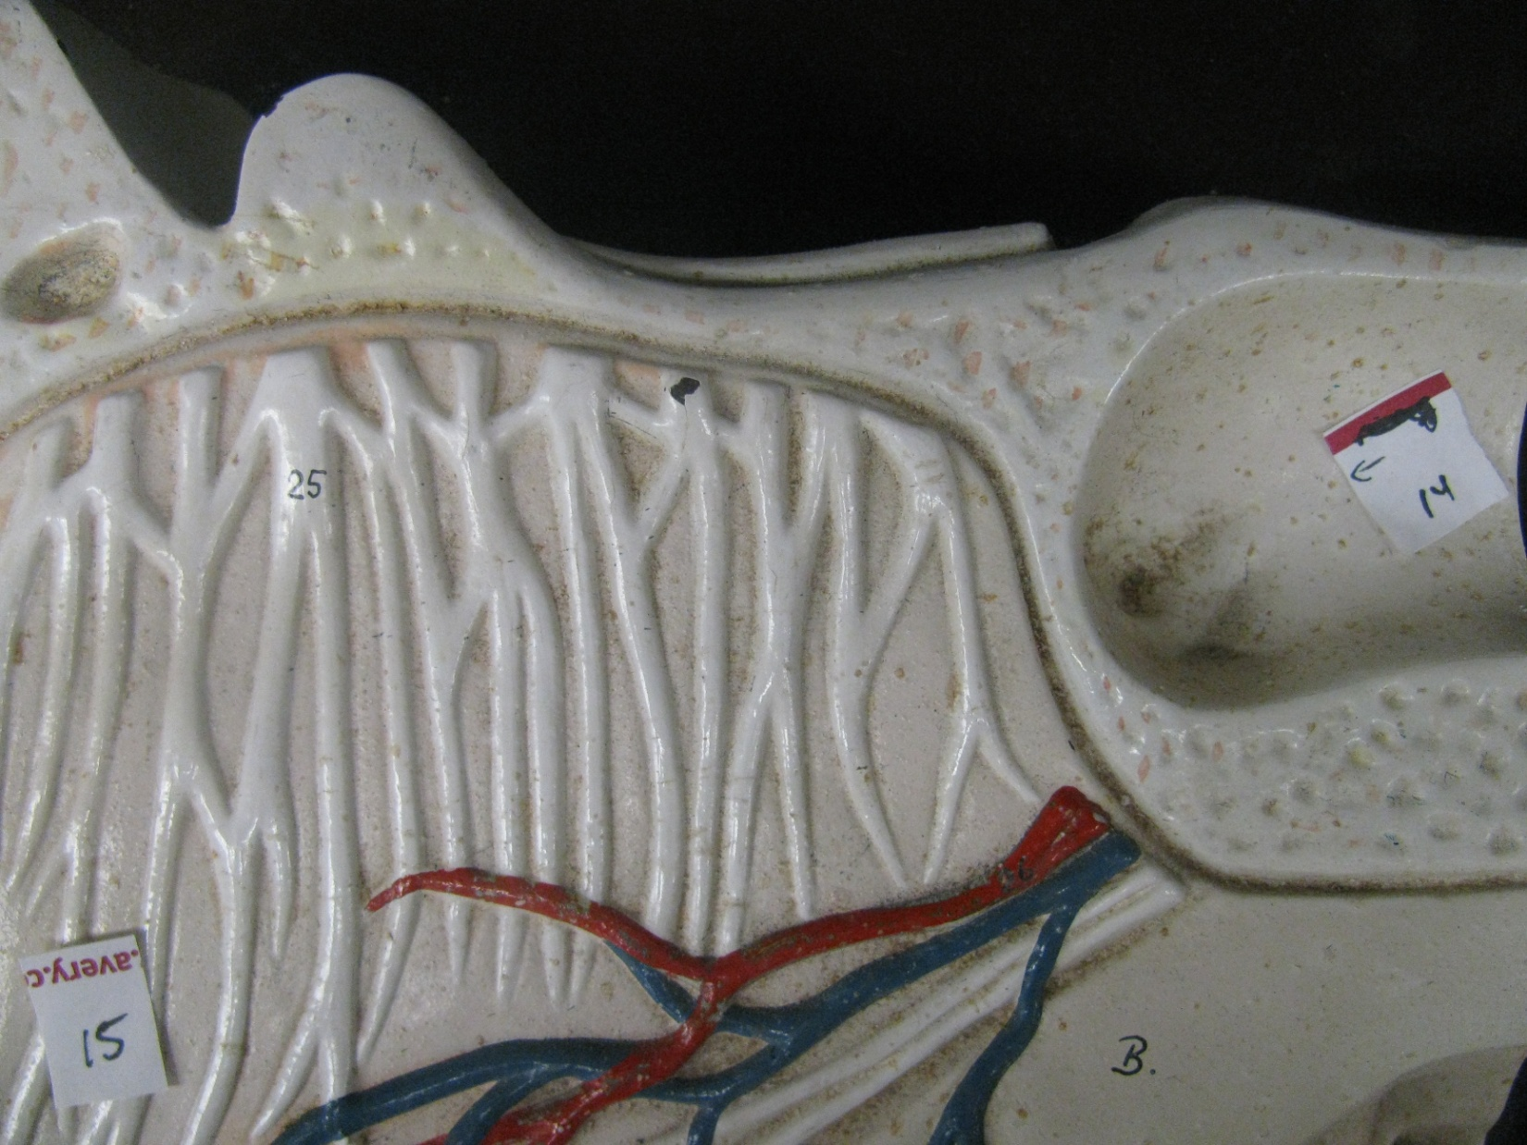

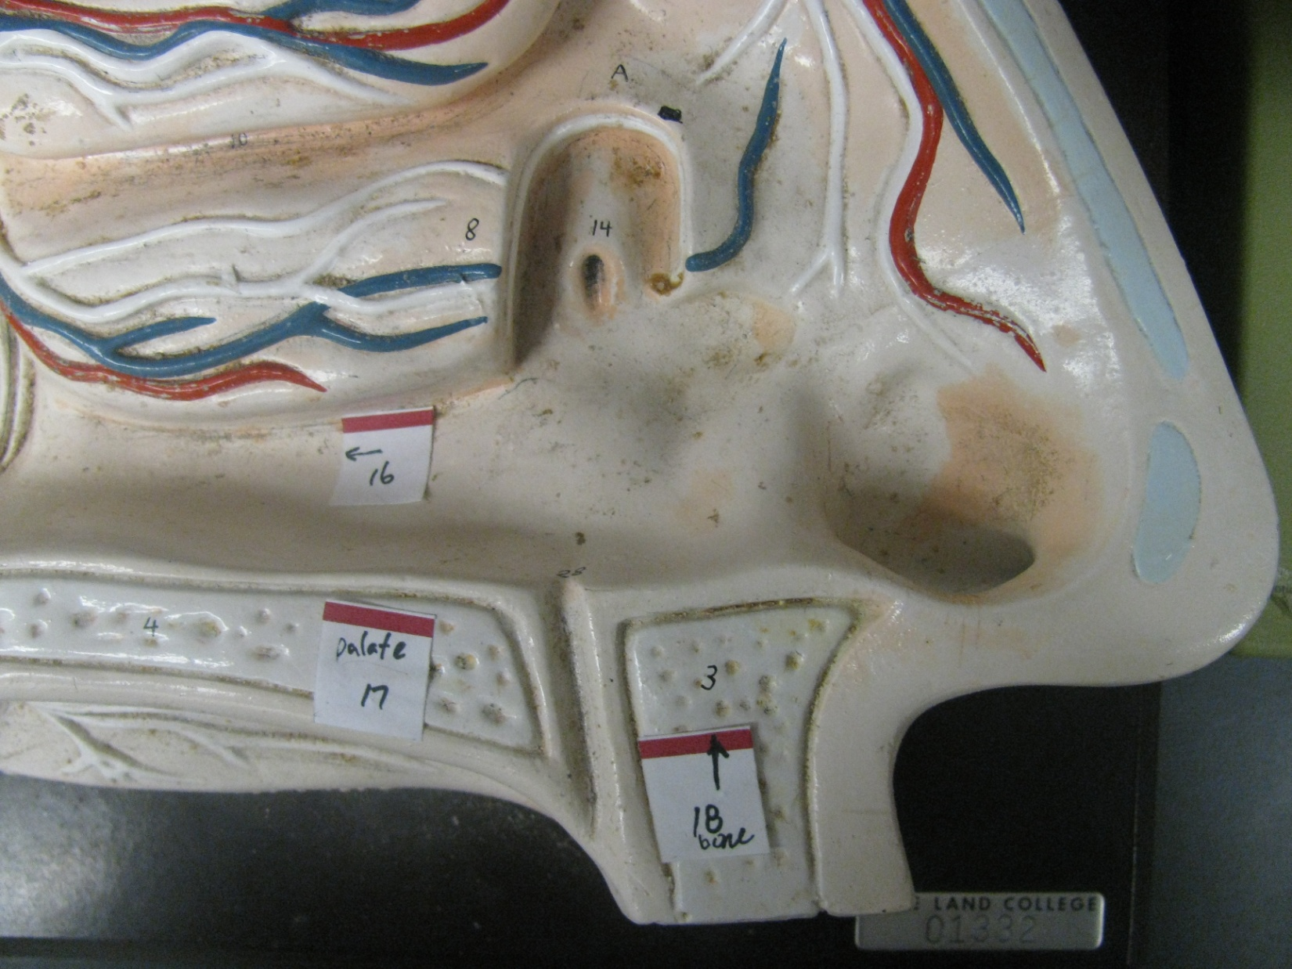

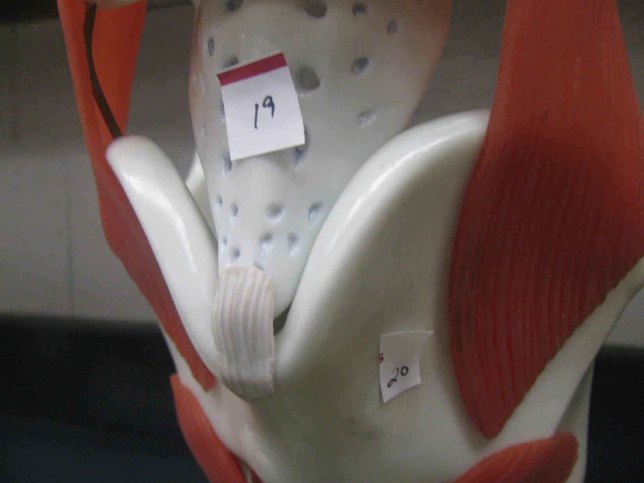

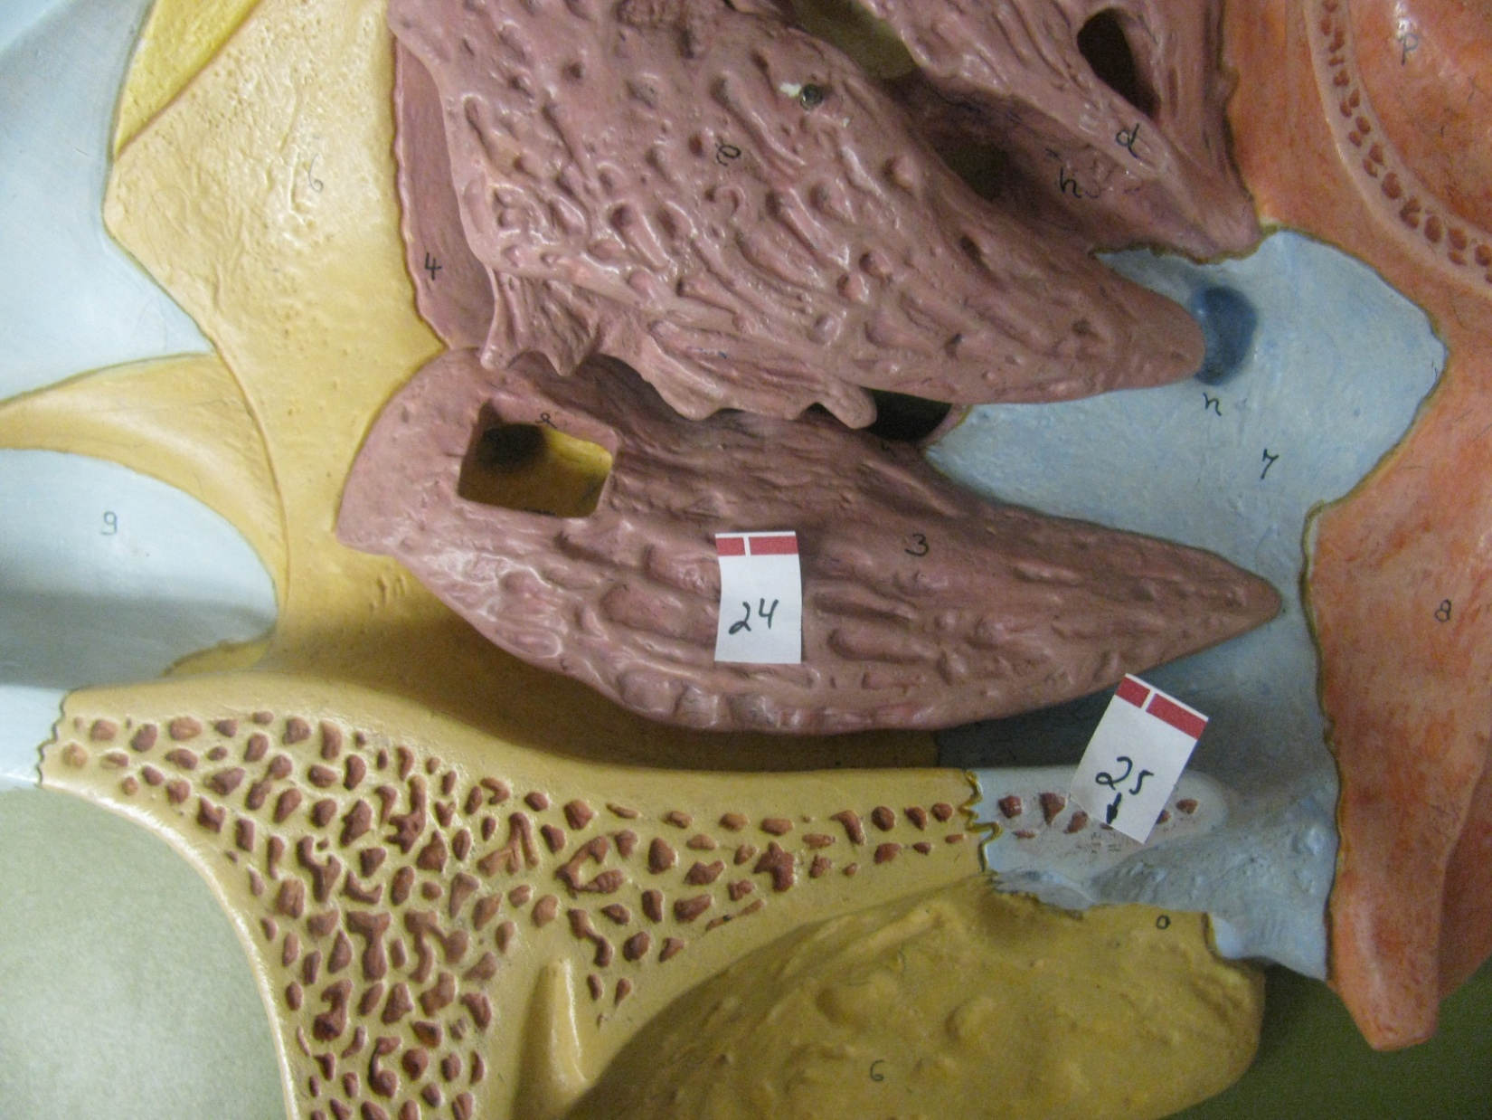

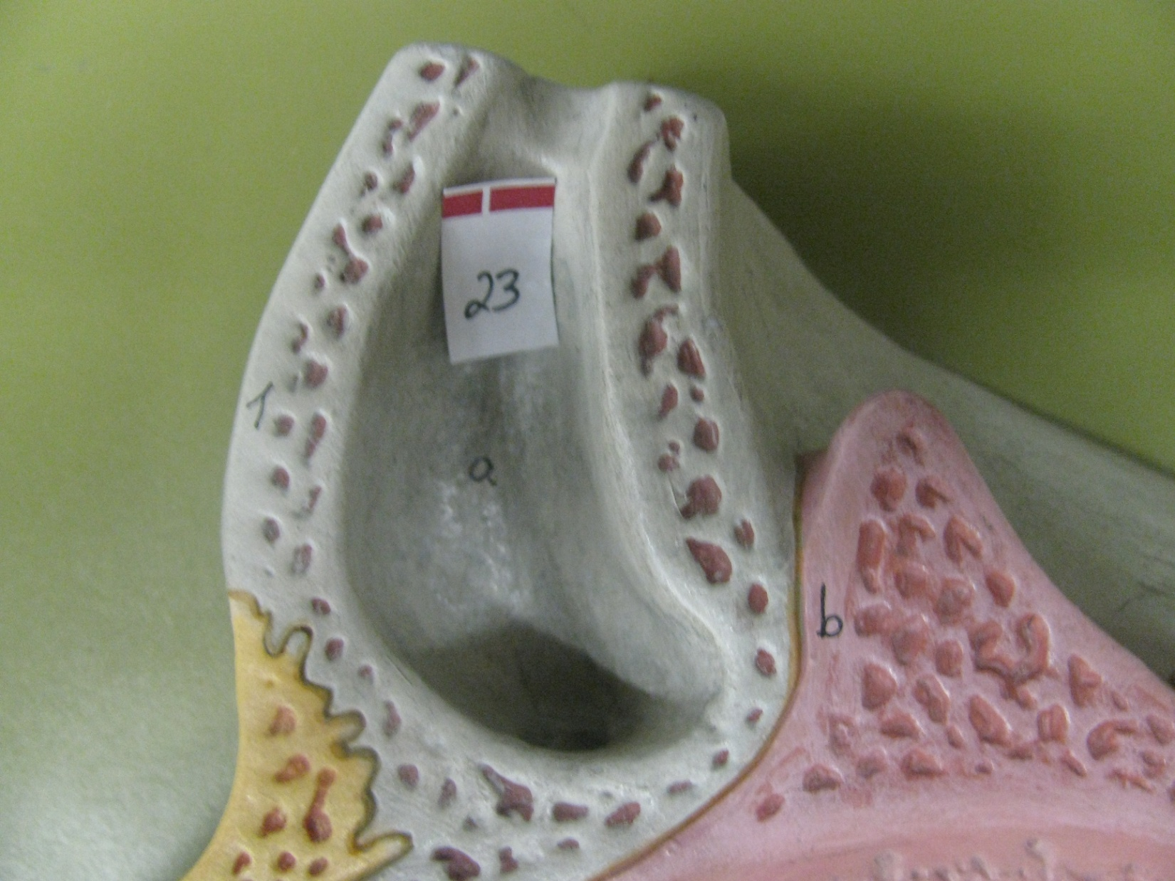

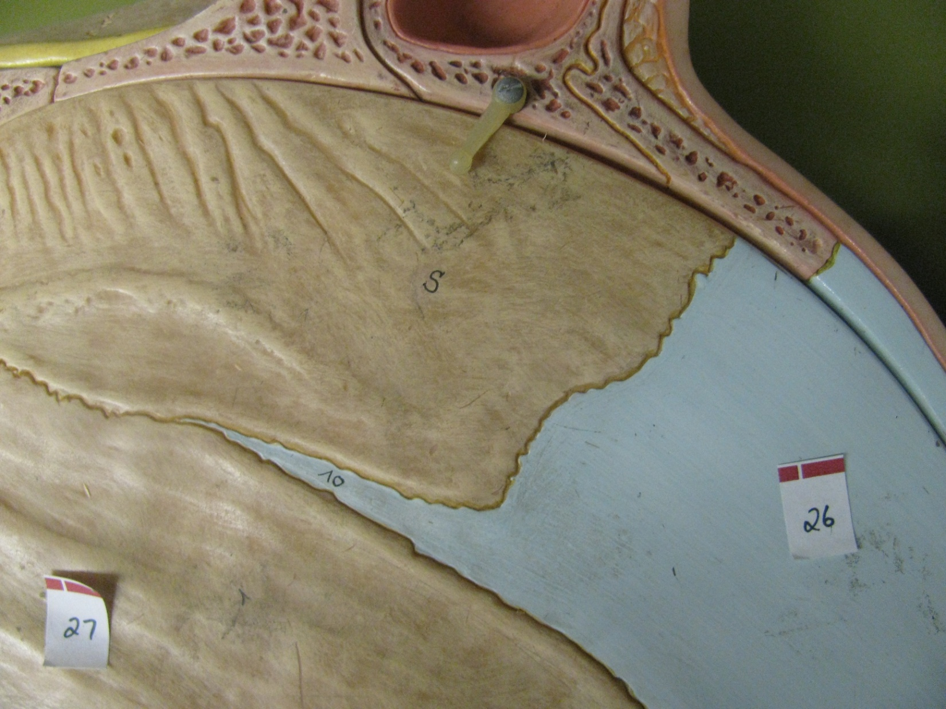

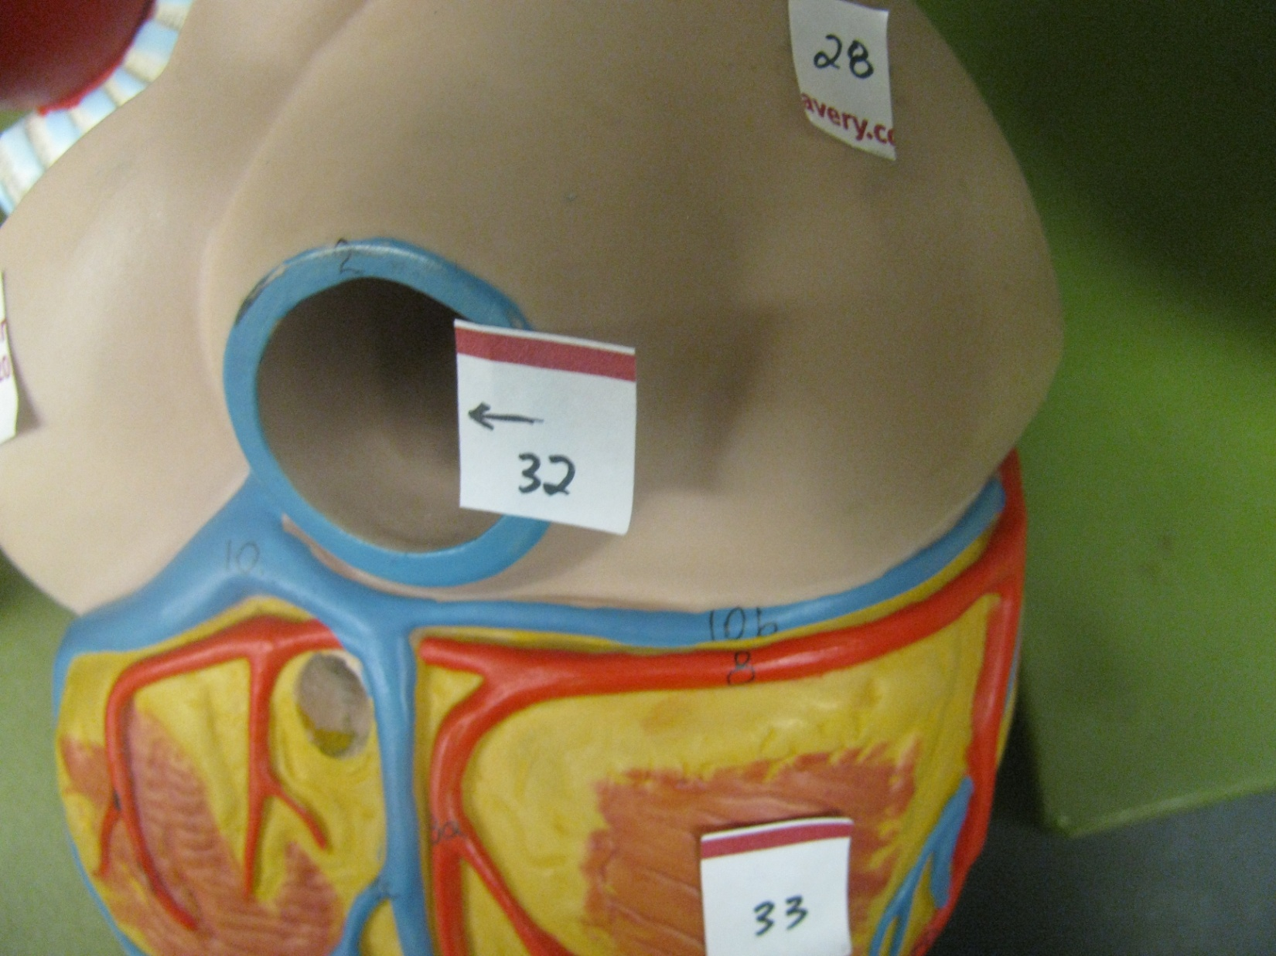

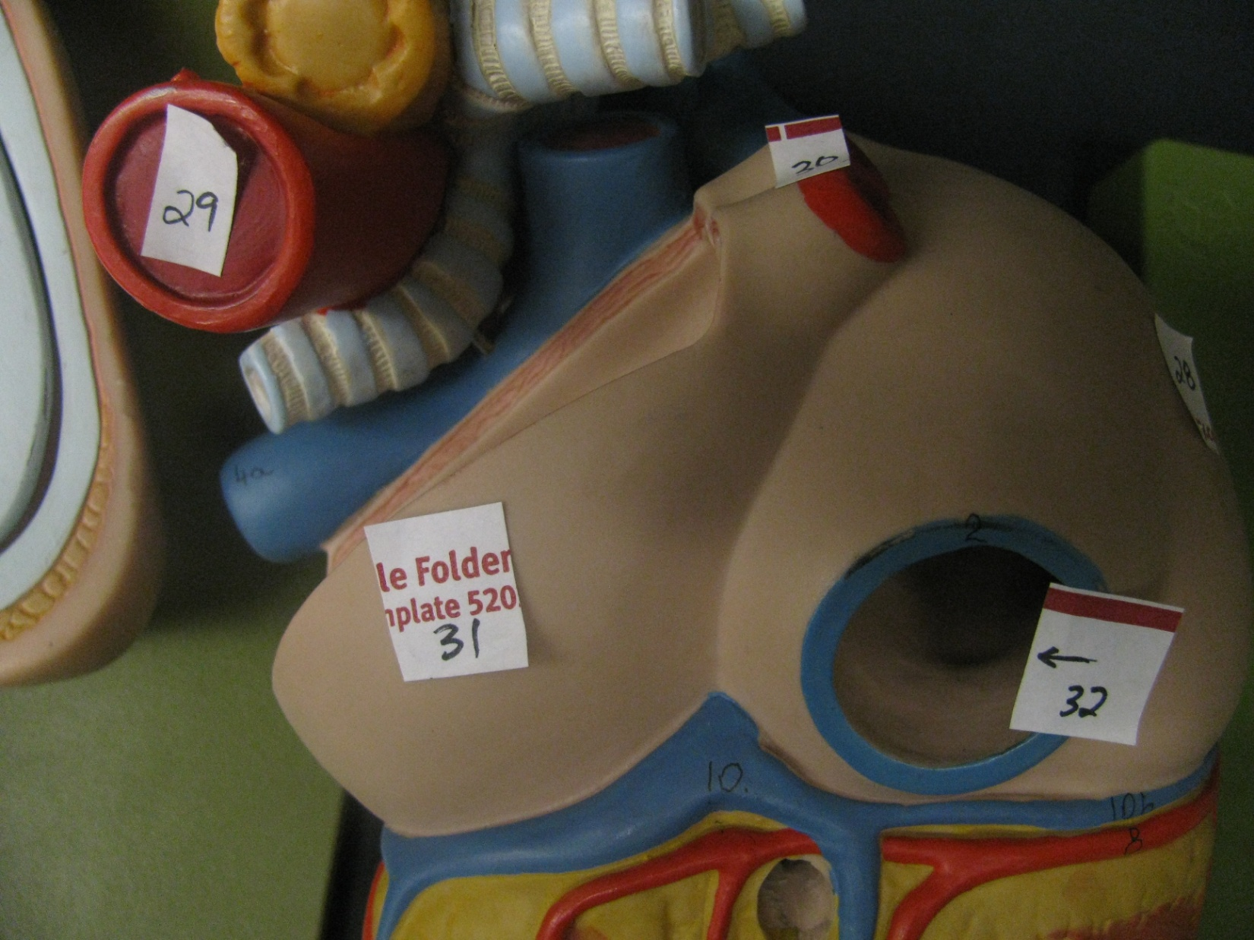

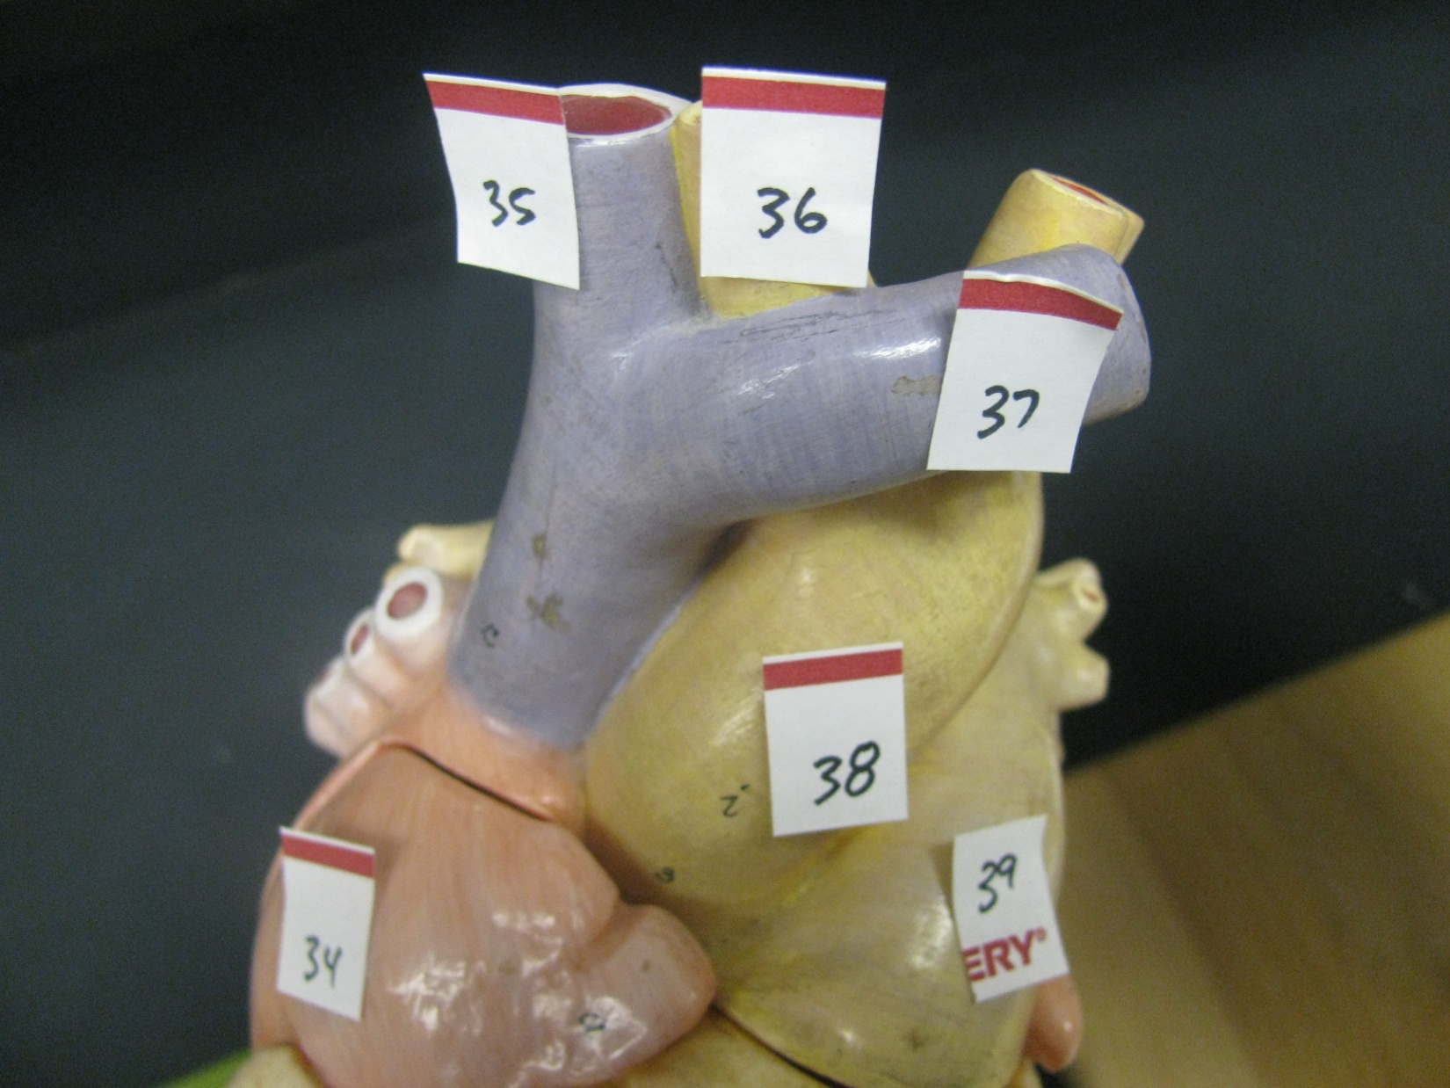

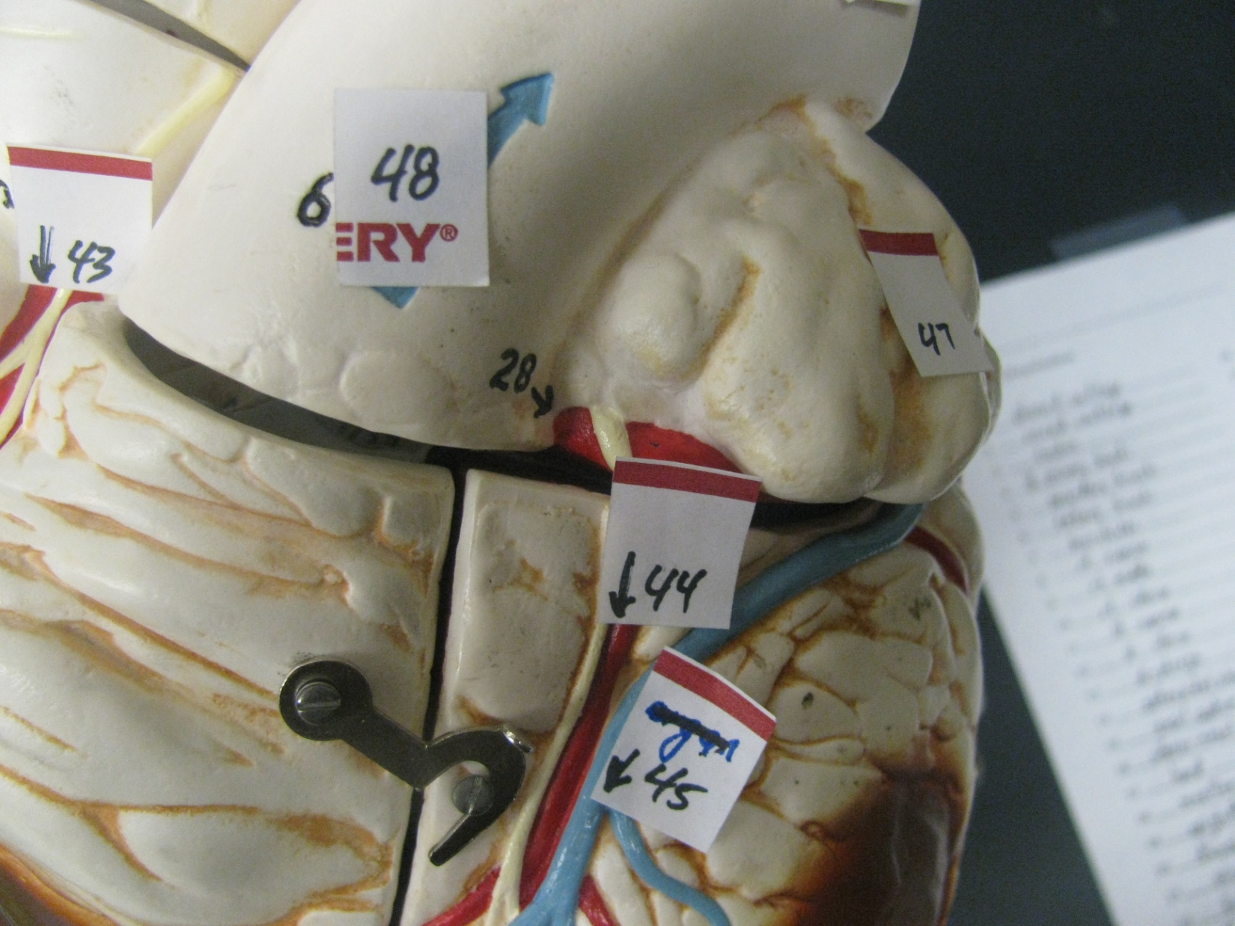

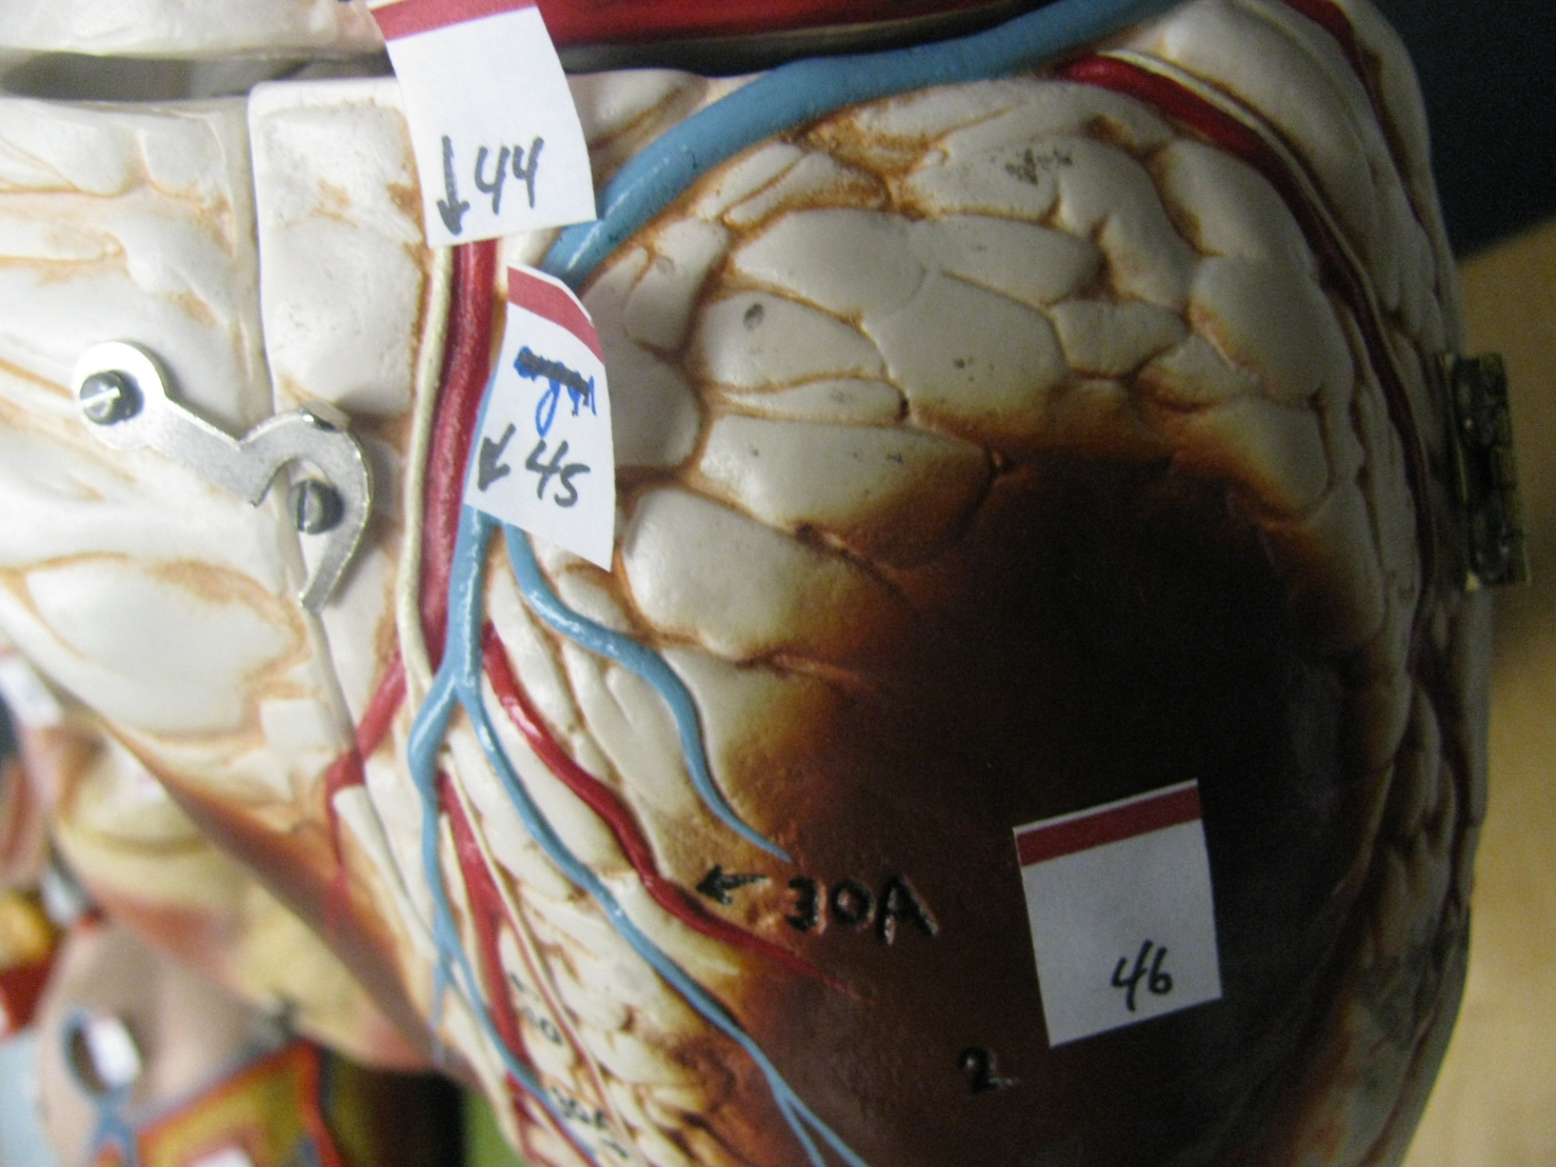

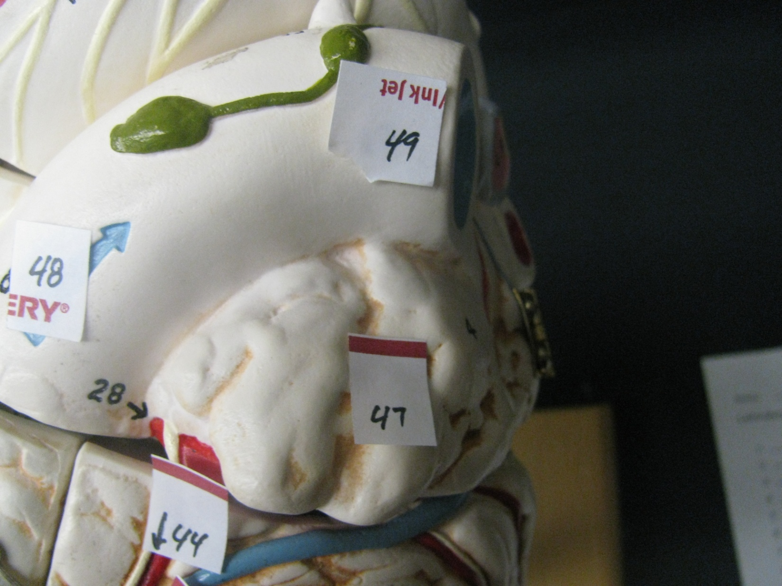

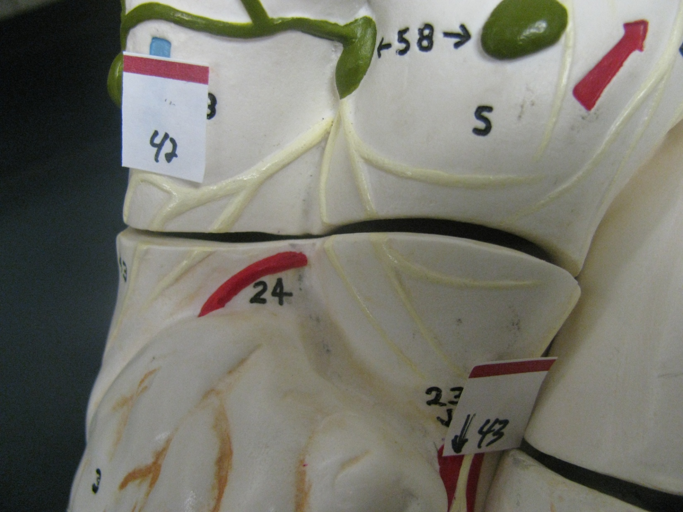

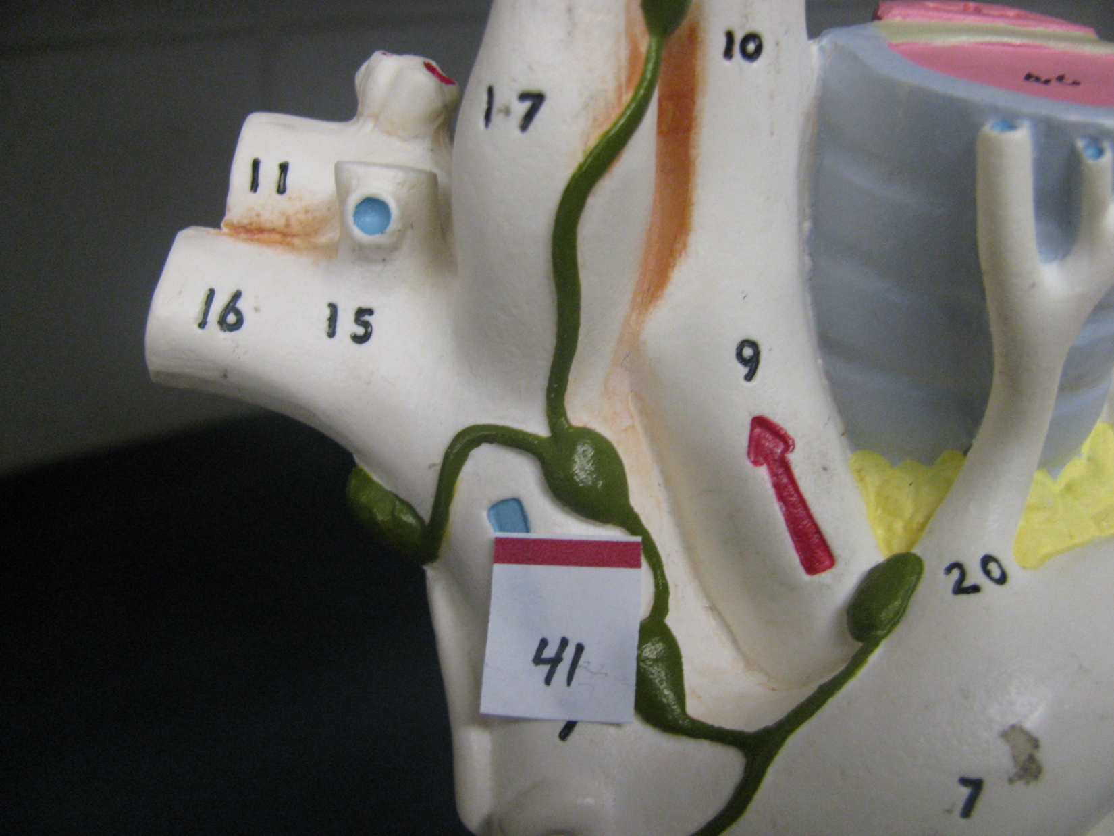

- Thyroid Cartilage
- Cricoid Cartilage
- Trachea
- Left Primary Bronchi
- Secondary Bronchi
- Tertiary Bronchi
- Bronchioles
- Rt. Superior Lobe
- Rt. Middle Lobe
- Rt. Inferior Lobe
- Left Superior Lobe
- Left Inferior Lobe
- Diaphragm
- Sphenoidal Sinus
- Nasal Septum
- Inferior Nasal Meatus
- Hard Palate
- Maxillae
- Epiglottis
- Thyroid Cartilage
- Cricoid Cartilage
- Trachea
- Frontal Sinus
- Inferior Nasal Concha
- Palatine Bone
- Nasal Cartilage
- Vomer
- Rt. Atrium
- Aorta
- Rt. Pulmonary V
- Left Atrium
- Inferior Vena Cava
- Right Ventricle
- Right Atrium
- Right Brachiocephalic V
- Brachiocephalic A
- Left Brachiocephalic V
- Aorta
- Pulmonary Trunk
- Left Atrium
- Right Brachiocephalic V
- Superior Vena Cava
- Right Coronary A
- Anterior Interventricular A
- Great Cardiac V
- Left Ventricle
- Left Atrium
- Pulmonary Trunk
- Left Pulmonary A

