Unit Design
Aaka Surti
Briana Kennett
Karianne Szlufik
Leslie Williams

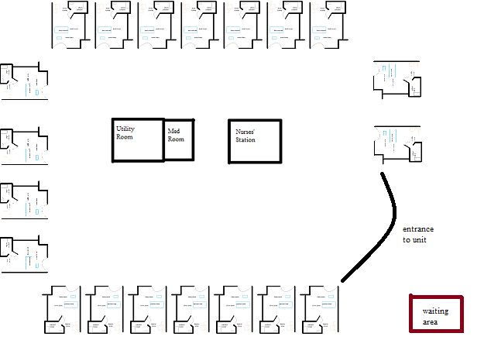 Our postpartum “mother-baby” unit is design with families in mind. The 20 all-private suites are located on our 6th floor. Our postpartum unit features the utmost in privacy, comfort, and convenience. Our unit features mother-baby couplet care, which enables mother and baby to be cared for in the same room. This feature helps promote a richer bonding experience and provides more educational opportunities. Each room includes sleeper chairs, a bassinet, private shower, and satellite television.

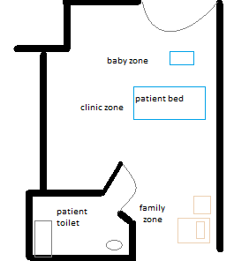Room magnified

