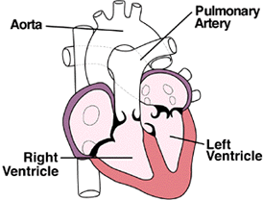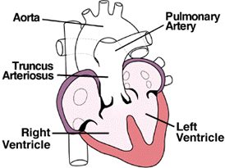
Normal v truncus arteriosus
(heartpoint.com)

(From LPCH) Medical management based on:
- child's age, overall health, and medical history
- extent of the condition
- child's tolerance for specific medications, procedures, or therapies
- expectations for the course of the condition
- opinion or preference
Truncus arteriosus must be treated by surgical repair of the defects. However, medical support may be necessary until the best time for the operation to take place. Treatment may include:
- medical management
Many children will eventually need to take medications to help the heart and lungs work better. Medication that may be prescribed includes the following:
  - digoxin
  - diuretics
  - ACE inhibitors
- adequate nutrition
Infants may become tired when feeding, and may not be able to eat enough calories to gain weight. Options that can be used to ensure baby will have adequate nutrition include:
  - high-calorie formula or breast milk
  - supplemental tube feedings
- surgical repair
Surgery is usually performed after the infant is 2 weeks old, but before the blood vessels in the lungs are overwhelmed by extra blood flow and become diseased.
The operation is performed under general anesthesia, and involves the following:
  - The pulmonary arteries are detached from the common artery (truncus arteriosus) and connected to the right ventricle using a homograft (a section of pulmonary artery with its valves intact from a tissue donor). Occasionally, a conduit (a small tube containing a valve) is used instead of a homograft (human tissue valve).
  - The ventricular septal defect is closed with a patch.

Postoperative care:
Children will spend time in the intensive care unit (ICU) after a truncus repair.
While in the ICU, special equipment will be used to help him/her recover, and may include the following:
- ventilator
- intravenous (IV) catheters
- arterial line
- nasogastric (NG) tube
- urinary catheter
- chest tube
- heart monitor
Nursing Interventions include a full assessment of the child (and assistive equipment) and pain management:
Assess the surgical wound
Assess vital signs
Assess arterial line/IV sites
Assess placement of/place NG tube
Assess I&O
Assess chest tube & drainage
Assess pain consistently and frequently
Provide prescribed pharmacologic relief
Referral to child life for distraction/entertainment

Bibliography
Heart Point. (1997, November). Truncus Arteriosus. Retrieved October 9, 2011, from Heart Point: http://heartpoint.com/congtruncus.html
Lucile Packard Children's Hospital. (2011). Truncus Arteriosus. Retrieved October 9, 2011, from Lucile Packard Children's Hospital: http://www.lpch.org/DiseaseHealthInfo/HealthLibrary/cardiac/truncus.html

