Toni….The Food Blaster in your header should have been in all caps
50/50

Food Blaster
Tori L. Knierim
Lakeview College of Nursing
Nursing Informatics
July 9, 2012

Food Blaster
According to Olsen-Roper, Call, Leishman, Ratcliffe, Mandleco, Dyches, and Marshall (2009), “nurses, diabetes educators and parents should provide developmentally appropriate information about diabetes care and management” (p. 1705). Type 1 diabetes, formally known as juvenile diabetes, effects 5% of children and young adults in the United States (American Diabetes Association (ADA), 2012). It is characterized by a metabolic disorder in which the body is unable to convert glucose into energy because the beta cells within the pancreas do not produce a sufficient amount of insulin (ADA, 2012). Type 1 diabetes generally occurs in children and young adolescents, so early education is extremely important (Olsen-Roper et al., 2009). One topic of diabetes education that is extremely important is nutrition.
I have decided to create an App that is designed for school-age children (6-12 years old) that educates them on proper nutrition for type 1 diabetes. It will be available for Apple users, Windows users, Droid users, Kindle users, and Blackberry users. One will need an internet connection to download the App, but will be able to play it offline once it has been downloaded. The background/layout for the App will be a kitchen will lots of different food scattered about. Different foods include cereals, donuts, chicken, fish, cheeseburgers, lemonade, candy bars, chips, apples, carrots, etc. Depending on whether the child is using a computer or touch screen tablet, s/he will use his/her mouse/finger to touch/click on the different food options. If the food is a healthy option, it will light up green, make a dinging noise, and be “blasted” or disappear. Unhealthy options will turn red, make a buzzer noise, and remain on the screen. The App will have different levels that are timed as well. Easier levels allow for more time, and harder levels have less time. Furthermore, each level will have a determined number of foods that must be blasted. The beginning levels will start with five foods to be blasted, and each level higher up will require an additional number of food to be blasted within the allotted time frame. Different food options will appear on the different levels so that a wide variety of food options are being presented and learned, and the foods will get more challenging as the levels increase as well. A lower level may have one ingredient foods, such as lettuce, potatoes, spinach, or rice. Higher levels will have more complex foods with multiple ingredients, so they child will have to think about all of the ingredients involved.
This App is intended to be fun and educational. It is designed for a younger target audience, but could also be enjoyed by an older adolescent as well. Food Blaster is designed in a way that children can learn which foods are good options for them and which foods are bad options for them by playing an entertaining App. The App is also designed to be challenging in order to engage the children and keep their attention. A very rough example of what this App might look like is below. 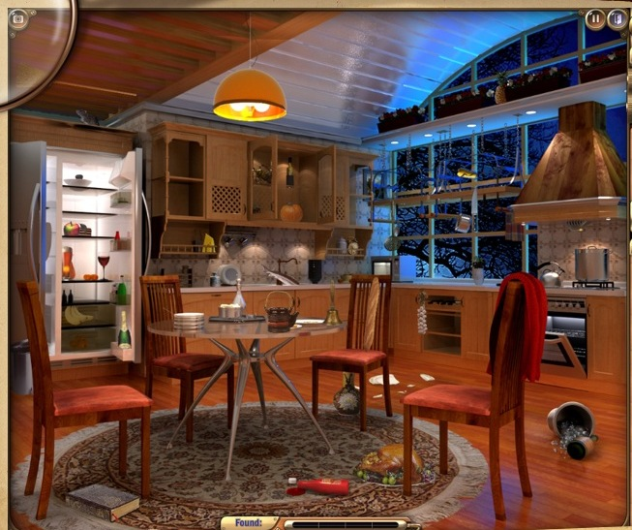 (Game Insight, 2011)
This picture was taken on my iPad. It is a picture of a game that I like to play called Mystery Manor: Hidden Adventure, and I loosely modeled Food Blaster off of it. The app Mystery Manor has many more rooms than just a kitchen, and the gamer looks for lots more items than just food, but it is similar in its concept. Mystery Manor is a fun game that I like to play, so why wouldn’t a school-age child find a somewhat similar game interesting? Food Blaster combines the enjoyment of a game like Mystery Manor with the education that can be learned from a lecture or discussion. Kids will learn a lot from Food Blaster because they will have fun while playing it and want to play it more and more. Food Blaster could be the springboard for other educational diabetes related Apps as well.

References
American Diabetes Association. (2012). Diabetes basics. Retrieved from http://www.diabetes
.org/diabetes-basics/type-1/
Game Insight. (2011). Mystery manor: Hidden adventure [iPad app].
Olsen-Roper, S., Call, A., Leishman, J., Ratcliffe, C., Mandleco, B., Dyches, T., & Marshall, E.
(2009). Type 1 diabetes: Children and adolescents’ knowledge and questions. Journal of Advanced Nursing, 65(8), 1705-1714. doi: 10.1111/j.1365-2648.2009.05033.x

