Blood flow thorough heart
- Cardiovascular system circulates blood via pulmonary circulaton (right heart) and systemic circulatory system (left heart)
- Arteries thick–walled, transports blood containing oxygen and nutrients from heart to tissues of body.
- Venules and veins are responsible for returning blood to the heart after cellular exchange of oxygen, nutrients, and metabolic waste products. Veins are readily distended, permitting large volumes of blood to accumulate (low pressure).
Anatomic structures and physiologic function of the heart and peripheral circulation
- Hollow muscular organ located in the center of the thorax.
- 3 layers: Endocardium (Inner layer), Myocardium (middle layer), and Epicardium (outer layer). The heart is encased in a thin fibrous sac= pericardium. Base is the upper portion of the heart and the apex or the point of maximal impulse is the lower portion.
- Coronary arteries originating from the aorta supply the heart and receive must of the blood during diastole when the aortic valve close.
- Blood flow=Superior and inferior vena cava>right atrium>tricuspid valve>right ventricle>pulmonary arteries>lungs>pulmonary veins>left atrium>mitral valve>left ventricle>aortic valve to systemic circulation.
Patient preparation and related nursing implications for common tests and procedures FOR WHAT????
Dysrhythmias:
- Identification of arrhythmias-Disorders of the electrical impulses w/in the heart that cause disturbances of heart rate. S/S related to hemodynamic effect they cause decrease in cardiac output. Some arrhythmias increase the risk of clot formation w/in the chambers of the heart.
  - Assessment: Hx, signs of decreased cardiac output, coexisting conditions, meds, signs of fluid retention (neck vein distention, crackles and wheezes, edema) Pt may state “Feels like my heart jumping out of the chest or in my throat.
  - Interventions: Monitorin and managing the arrhythmia, minimizing anxiety, and teaching self-care.
  - Treatment: Cardioversion used to treat tachyarrhythmias by delivering an electrical current that depolarizes a critical mass of myocardial cells (sinus node is able to recapture its role as the heart’s pacemaker). Synchronized w/ pt’s electrical events. Defibrillation: Used in emergency situations as the treatment of choice for ventricular fibrillation and pulseless VT. Implantable cardioverter defibrillator (ICD) is a device that detects and terminated life-threatening episodes of tachycardia or fibrillation. Used for pts who have survived sudden cardiac death syndrome usually caused by ventricular fibrillation. Respond to a rate exceeds a predetermined level and a change in the isoelectric line segments. Primary complication is surgery-related infection Pacemakers: is an electronic device that delivers electrical stimulation to the heart to regulate the heart rate when a patient has a slower-than-normal heart rate or conduction disturbance. May be used to control some tachyarrhythmias or to treat advanced heart failure. Complications: #1 dislodgment of pacing electrode, local infection, bleeding and hematoma, hemothorax, ventricular ectopy and tachycardia, movement or dislocation of lead placed. Electrophysiology (EP) study-invasive procedure used to evaluate and treat significan arrthymias and for pts w/ symptoms that suggest an arrthymia that has gone undetected and undiagnosed. Others uses: identify the impulse formation and propagation via the cardiac electrical conduction system, assess function of SA and AV nodal areas, identify location &mechanism of dysrhythmogenic foci, assess effects of antiarrhythimic meds, & treat certain arrhythmias via destruction of causative cells (ablation). Cardiac conduction surgery- Atrial tachycardias and ventricular tachycardias that do not respond to meds and are not suitable for antitachycardia. Maze procedure is an open heart surgical procedure for refractory atrial fibrillation. Destroy cells that are the cause or central conduction route of a tachyarrhythmia.
  - Sinus Bradycardia-occurs when the sinus node creates an impulse at a slower-than-normal rate. Cause: lower metabolic needs, vagal stimulation, meds (calcium channel blockers, amiodarone, beta blockers), increased intracranial pressure, & MI.
    - No symptoms. ECG characteristics: Rate <60 BPM, Rhythm=regular, P-wave=Present before each QRS and consistent in size and shape. PR interval=Normal ORS duration: Normal
    - Bradycardias that cause serious s/s (altered mental status, ongoing chest pain, hypotension, or shock) require immediate treatment. Treatment includes transcutaneous pacing and atropine (1.5 mgIV Bolus every 3-5 mins MAX dosage=2-3mg). If pacing is unavailable and ineffective a dopamine or epinephrine infusion.
  - Sinus Tachycardia occurs when the sinus node creates an impulse at a faster-than-normal rate.
    - Cause: Physiologic or psychological stress (acute blood loss, anemia, shock, hypervolemia, hypovolemia, heart failure, pain, hypermetabolic states, fever exercise, anxiety. Meds: Stimulate the sympathetic response(catecholamines, aminophylline, atropine) & stimulants (alcohol, nicotine, caffeine), & illicit drugs (amphetamines, cocaine, Ecstasy)
    - Does not often cause s/s. Heart rate increase, diastolic filling time decreases. Pt may develop acute pulmonary edema or cardiac ischemia. Rate: >100 BPM Rhythm=regular, P-wave=Present before each QRS and consistent in size and shape. PR interval=Normal ORS duration: Normal
    - Treatment is determined by the severity of s/s. For example: tachycardia caused by blood loss would be treated w/ IV fluid replacement and blood transfusion.
  - Atrial arrhythmias
    - Premature Atrial Complex- A single ECG complex that occurs when an electrical impulse starts in the atrium before the next normal impulse of the sinus node
      - Causes: Caffeine, alcohol, nicotine, stretched atrial myocardium, anxiety hypokalemia, hypermetabolic states, hypoxemia, or atrial ischemia, injury, and infarction
      - Assessment: Pt may say “My heart skipped a beat.” Rate= depends on underlying rhythm. Rhythm=irregular. Size and shape associated with premature beat. PR interval=>0.12 seconds but shorter than the sinus generated PR.
      - Nursing Management: If infrequent no treatment is necessary. Frequent (>6/min) sign of worsening condition.
  - Atrial Flutter-occurs in the atrium and creates impulses at a rapid but regular atrial rate between 220-250 Xs/min.
    - Causes: CAD, hypertension, mitral valve disease, hyperthyroidism, chroniclung disease, cor pulmonale (right heart failure), & cardio myopathy. Increases pt risk of developing atrial fibrillation.
    - S/S: Fatigue, lightheadedness, chest pain, SOB, and low B/P. Chances of mural (wall) emboli forming increases). Rate=Atrial rate (220-250 BPM) Ventricle rate (75-150 BMP), Rhythm=usually regular but may be irregular due to AV conduction change. P wave= flutter waves “sawtooth”
    - Nursing management: Unstable urgent electrical cardioversion is needed. Adenosine 6mg (Adenocard-slows conduction time via AV node) may be admin. rapidly via IV push. S/S nausea, headache, facial flushing, & SOB. Cardiac affects include bradycardia, hypotension, & sinus arrest. If initial dose ineffective w/in 1-2 mins. 12mg may be ordered. If lasting for longer than 48 hrs anticoagulation may be used before cardioversion.
      - IA-Moderate depression of depolarization; prolongs repolarization=Quinidine (Quinaglute, Quinidex, Cardioquin) preocainamide (Pronestyl). Treats and prevents atrial and ventricular arrthythmias=disopyramide (Norpace). IB-Minimal depression of depolarization; shortened repolarization=Lidocaine (Xylocaine). Treats ventricular arrhythimas=Tocainide (Tonocard). IC Marked depression of depolarization; little effect on repolarization Flecainide (Tambocor). Treats atrial and ventricular arrhythmias. II Decreases automaticity and conduction=Atenolol (Tenormin). Treats atrial and ventricular arrhythmias=lol*Bisoprolol/HCTZ(Ziac, Zebeta), metroprolol, propranolol. III Prolongs repolarization=amidarone. Treats atrial and ventricular arrhythmias especially in pt’s w/ ventricular dysfunction=dofetilide (Tikosyn) & Ibutilide (Corvert) &Sotalol (Betapace). IV Blocks calcium channel=Verapamil (Calan, Isoptin). Treats atrial arrhythmias =Diltiazem & Bepridil.
Hypertension:
- Prehypertension: 139/80- 89 mm Hg
- Hypertension: 140/ 90 mm Hg
- Hypertension can be further classified into as stage 1 or stage 2
  - Stage 1: 140-159/ 90- 99 mm Hg
  - Stage 2: 160/ 100 mm Hg or greater
  - Diagnosis is determined by two or more reading measurements taken during two or more different times
Pathophysiology
- For hypertension to develop there must be a change in one or more factors affecting peripheral vascular resistance (PVR) or cardiac output
  - Peripheral vascular resistance: r/t the diameter of the blood vessels and the viscosity of the blood
    - thicker blood or smaller radius of blood vessels = higher resistance
    - larger diameter of blood vessels or thinner blood = lower PVR
  - Cardiac output: vol. of blood being pumped by the heart per min.
Diff b/n primary/ secondary
- Primary Hypertension: high BP from an unidentified cause
  - Also given the names: essential or idiopathic hypertension
  - More common than secondary hypertension in 2009 95% of pts. diagnosed w/ hypertension was is in the form of primary hypertension
- Secondary Hypertension: high BP to secondary to an identified cause
  - Possible causes narrowing of renal arteries or renal stenosis, renal disease, medications, and pregnancy
Risk Factors/ general info
- Hypertension increases w/ age
  - Aging causes structural changes and functional changes in the heart and blood vessels ( atherosclerosis and decreased elasticity of major blood vessels, increased wall stiffness)
- Systolic hypertension is the most common form of hypertension
- Hypertension is more common in men than women, until menopause
- Obesity common risk factor
  - BMI > 30
- Hypertension is a risk factor for the development of atherosclerotic heart disease, often coexists w/ dyslipidemia and diabetes mellitus
  - Dyslipidemia: elevated LDL cholesterol or low HDL cholesterol or a total elevated total cholesterol
- Oral contraceptives can cause a small increase in systolic and diastolic BP
- Smoking does NOT cause high BP but if they have hypertension and smoke it increases their risk of dying from heart disease or related disorders
Signs/ symptoms
- SOB
- Alteration in speech
- Vision
- Angina pain
- Impaired balance
- Epistaxis ( nosebleeds)
- Headache
- Dizziness
- Nocturia
Assessment
- Typically no symptoms, physical examination may only reveal an elevated BP
- The nurse should assess for signs and symptoms of target organ damage
- The nurse should also ask about personal, social, or financial factors and about medication usage
Best practice for taking BP
- *Inflate the cuff to palpate the brachial artery until the pulse is obliterated, deflate the cuff, add 30 mm Hg to the palpated pressure, and then measure the BP*
- Instruct the pt to avoid smoking or drinking caffeine 30 min. prior
- Make sure the cuff size is correct
  - Too small of a cuff= too high of a reading
  - Too large of a cuff = too low of a reading
- Position the pts. arm at level of the heart
- Palpate the systolic pressure before auscultating
- Ask the pt to sit quietly
- When releasing the pressure let out about 2 mm Hg per sec.
- Make sure to document the location of the site it taken at
  - Especially important when assessing for orthostatic changes
- Inform the pt of the BP value and what it means, emphasize the need for periodic reassessment, and encourage the pts. who measure BP at home to keep a written log
  - This engages the pt in the teaching process and correlation of diet, medication adherence w/ BP
Treatment
- Net goal is a BP < 140/90 mm Hg and > 130/ 80 mm Hg for those w/ diabetes or chronic kidney disease
- Self-management should be encourage which includes self BP monitoring, pt should be given information on healthy lifestyle changes
- Life style changes include: weight reduction, DASH diet, reduction of Na, physical activity, moderation of alcohol consumption
- Educate the pt it takes 2 to 3 months for taste buds to adapt to changes in salt intake
- Teach pt how to read food labels and to look for foods that contain less 400 mg of Na per serving
- It is important to assess the pts. beliefs about hypertension
- Prehypertension
      - Want to prevent or delay the onset of hypertension
      - Lifestyle modification: dietary changes and exercise
    - Stage 1
      - Pharmacologic therapy and lifestyle changes
      - Should be monitored every month until their BP goal is met, and every 3 months to 6 months thereafter
- Stage 2 hypertension w/ other complicating conditions
  - They need to be seen more frequently
Drug interaction/ Herbals
- Herbals or Over the counter (OTC) meds. that may increase BP
  - Caffeine
  - Ephedra
  - Oral contraceptives
  - Acetaminophen
  - NSAIDs
Medicine/ non pharmacologic
- The most effective therapy is only effective if the pt. adheres to it and adherence is dependent on the pts. motivation
- Motivation improves if pt has a positive experience and if trust is built, empathy builds trust and is a positive motivator
- Thiazide diuretic are given to those w/ uncomplicated hypertension
- Useful in elderly w/ osteoporosis because they decrease bone breakdown
- Medications can be added or the dose may be increased
  - Advantage of adding a new med. instead of increasing the dose is that the occurrence of side effect may be avoided
  - Most pts. need two or more drugs because hypertension is caused by multiple factors
- For those w/ diabetes, heart failure , or cardiovascular disease an ACE inhibitor or ARB is recommended
  - These drugs protect and preserve renal function and protect the vascular endothelium
- Statins are given to lower cholesterol
- Low-dose-aspirin therapy is indicated once BP is controlled to limit cardiovascular complications

Nursing alerts
“Pulse pressure is the diff. b/n the systolic and diastolic pressure; normally it is 40 mm Hg i.e. 120/80 mm Hg. A widened pulse pressure, over 50 mm Hg is associated w/ increased intracranial pressure, atherosclerosis, aortic insufficiency, and fever.”
“Normally, the BP should vary by no more than 5mm Hg b/n arms. A diff. greater than 10 mm Hg or greater may indicate an arterial obstruction on the side w/ the lower value.”
“Reducing table salt to about 1 teaspoon per day, or 2.4 g of Na, can reduce systolic BP by 2 to 8 mm Hg.”

Peripheral Arterial Disease:
Arthrosclerosis
Signs/ symptoms
Interventions/care
Abdominal Aortic Aneurysm (AAA)
Signs/ symptoms
Risk factors
Preop/Postop care

Complications from Heart Disease:
Pgs. # 424-438
Difference between diastolic and systolic heart failure: pgs. #424-434:
Heart failure is the inability of the heart to pump sufficient blood to meet the needs of the tissues for oxygen and nutrients. In the past, HF was often referred to congestive heart failure (CHF) because many pts. experience pulmonary and peripheral congestion.
Systolic (problem with the contraction of the heart): alteration in ventricular contraction
- Most common
- Characterized by a weakened heart muscle
- EF severely reduced (>55%)
Diastolic (problem with the filling of the heart):
- Characterized by a stiff and noncompliant heart muscle = difficult for the ventricle to fill
- EF normal (55-65%)
Signs /Symptoms: Fluid overload or inadequate tissue perfusion
- SOB
- Edema
- Fatigue
Left-sided vs. right -sided HF:
Left-sided:
- Dyspnea, orthopnea, PND
- Cough
- Pulmonary crackles
- ↓ O2 sat levels
- S3 ventricular gallop
- Oliguria if renal perfusion is diminished
- ↓ perfusion to other systemic organs (advanced failure):
- Sluggish GI motility
- Dizziness, lightheadedness, confusion, restlessness
- Anxiety
- Skin cool and clammy
- ↓ in EF
- Tachycardia and/or weak thread pulse
- Fatigue and activity intolerance
Right-sided heart failure:
- Lower extremity dependent edema (dependent edema is swelling that follows the position of the body):
- Legs and feet
- May progress to thighs, external genitalia, lower trunk, abdomen, sacral edema (in a bed-bound pt.)
- Pitting edema (indentations in the skin remain after even slight compression with the fingertips)
- Hepatomegaly
- Ascites (accumulation of fluid in the peritoneal cavity)
- Anorexia and nausea
- Weight gain due to retention of fluid (gain >2kg or 4.4 lbs. problem)
- Weakness/fatigue from reduced CO and impaired cognition
- Decreased perfusion to other systemic organs (advanced failure)
Neurohormonal compensatory mechanisms resulting from HF:
- Systolic HF = ↓blood volume ejected from the ventricle … baroreceptors activate SNS (sympathetic nervous system) … SNS releases epinephrine & norepinephrine = ↑ HR and contractility … SNs also causes (negative effects) = vasoconstriction of the skin, GI tract, and kidneys …↓CO and vasoconstriction = ↓ renal perfusion = release of rennin by kidneys …
- Renin → angiotensin I + ACE = angiotensin II (potent vasoconstrictor) … ↑ BP & afterload (resistance) … angiotensin II stimulates release of aldosterone from adrenal cortex = Na+ and fluid retention by the renal tubules … = volume overload …
- Angiotensinogen, aldosterone, and other neurohormones = ↑preload + afterload … ↑ stress on ventricular wall … ↑ workload on the heart …
- Heart’s workload ↑ = myocardial muscle fibers ↓ … ↓ contractility = ↓ end-diastolic blood volume (preload) in the ventricles … = stretching the myocardial muscle fibers = ↑ size of ventricle … ↑ ventricle size = ↑stress of ventricular wall = adding to the workload of the heart.
- ↑ workload = ↑ thickness of the heart wall (ventricular hypertrophy) = ventricular remodeling
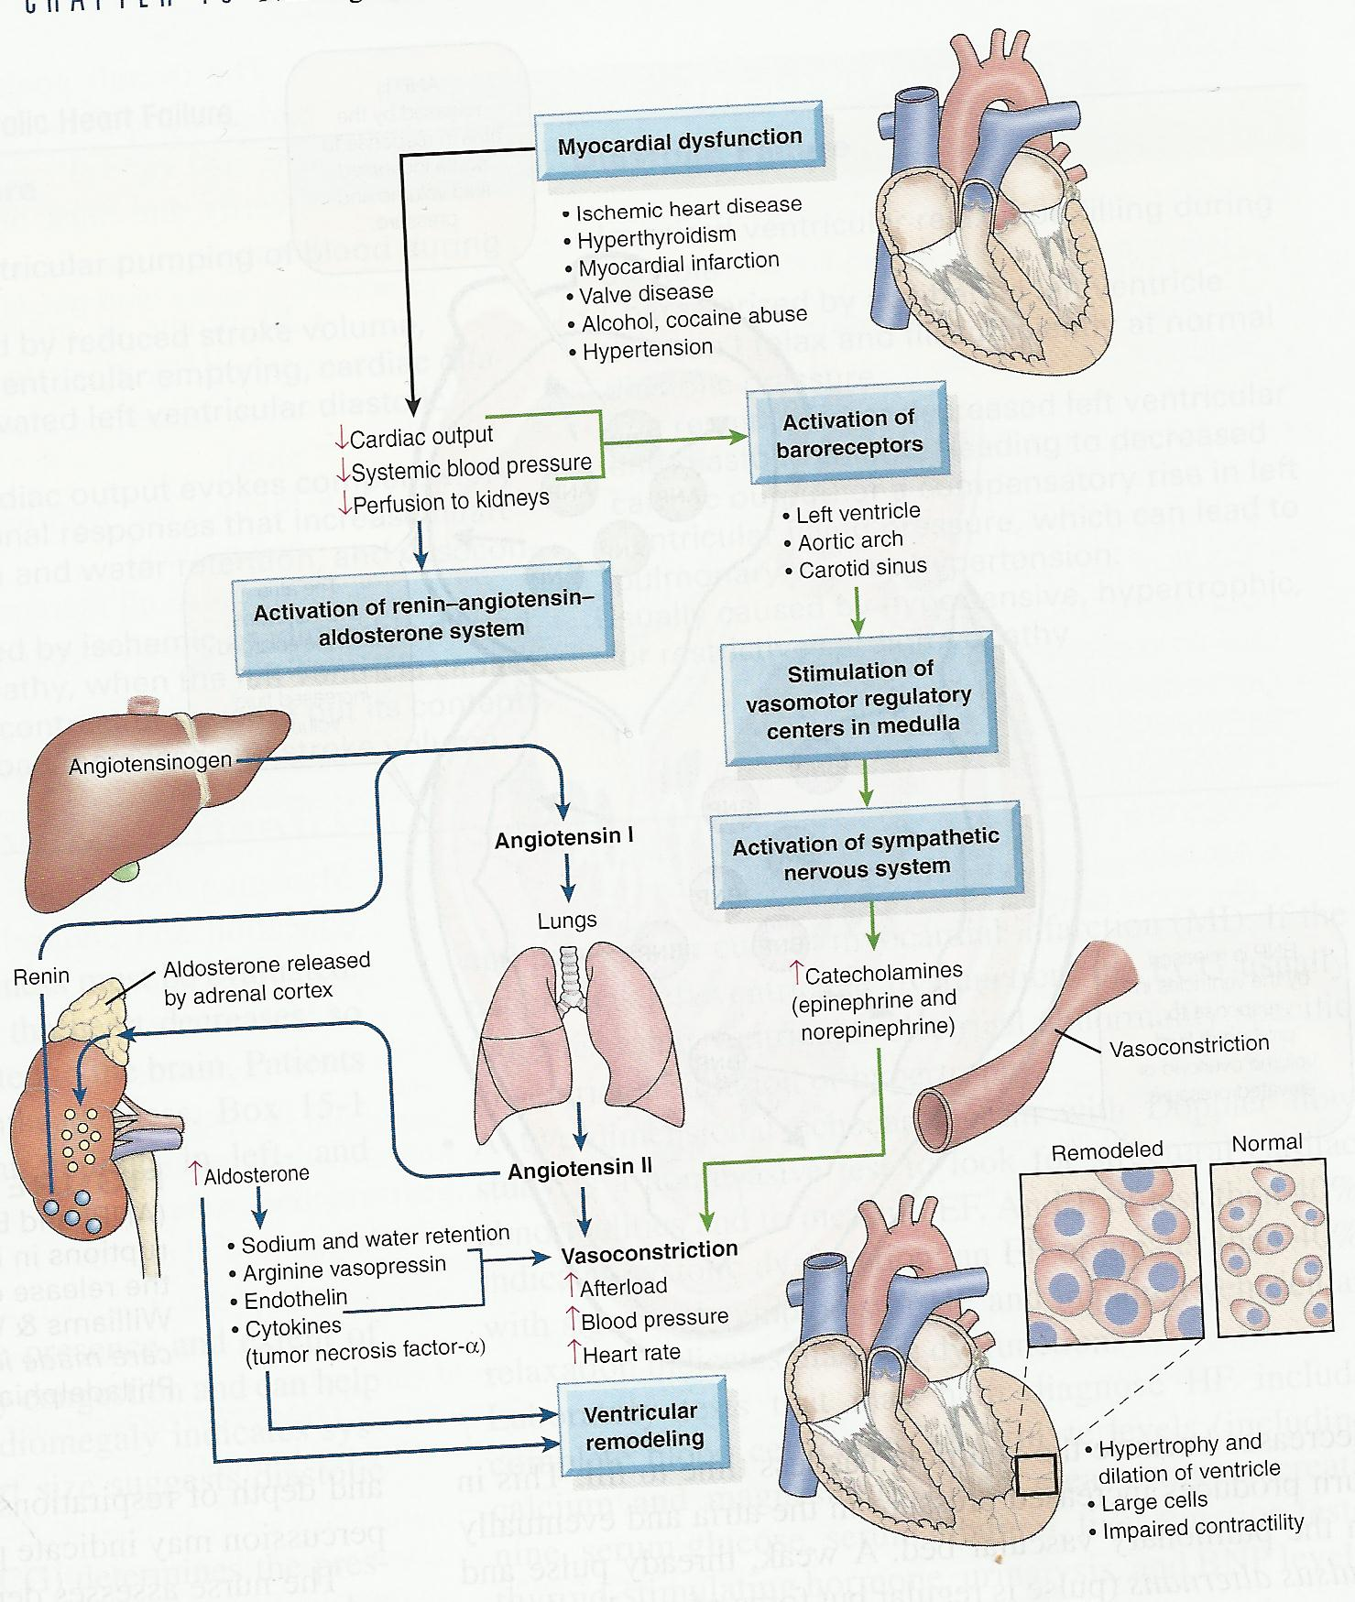
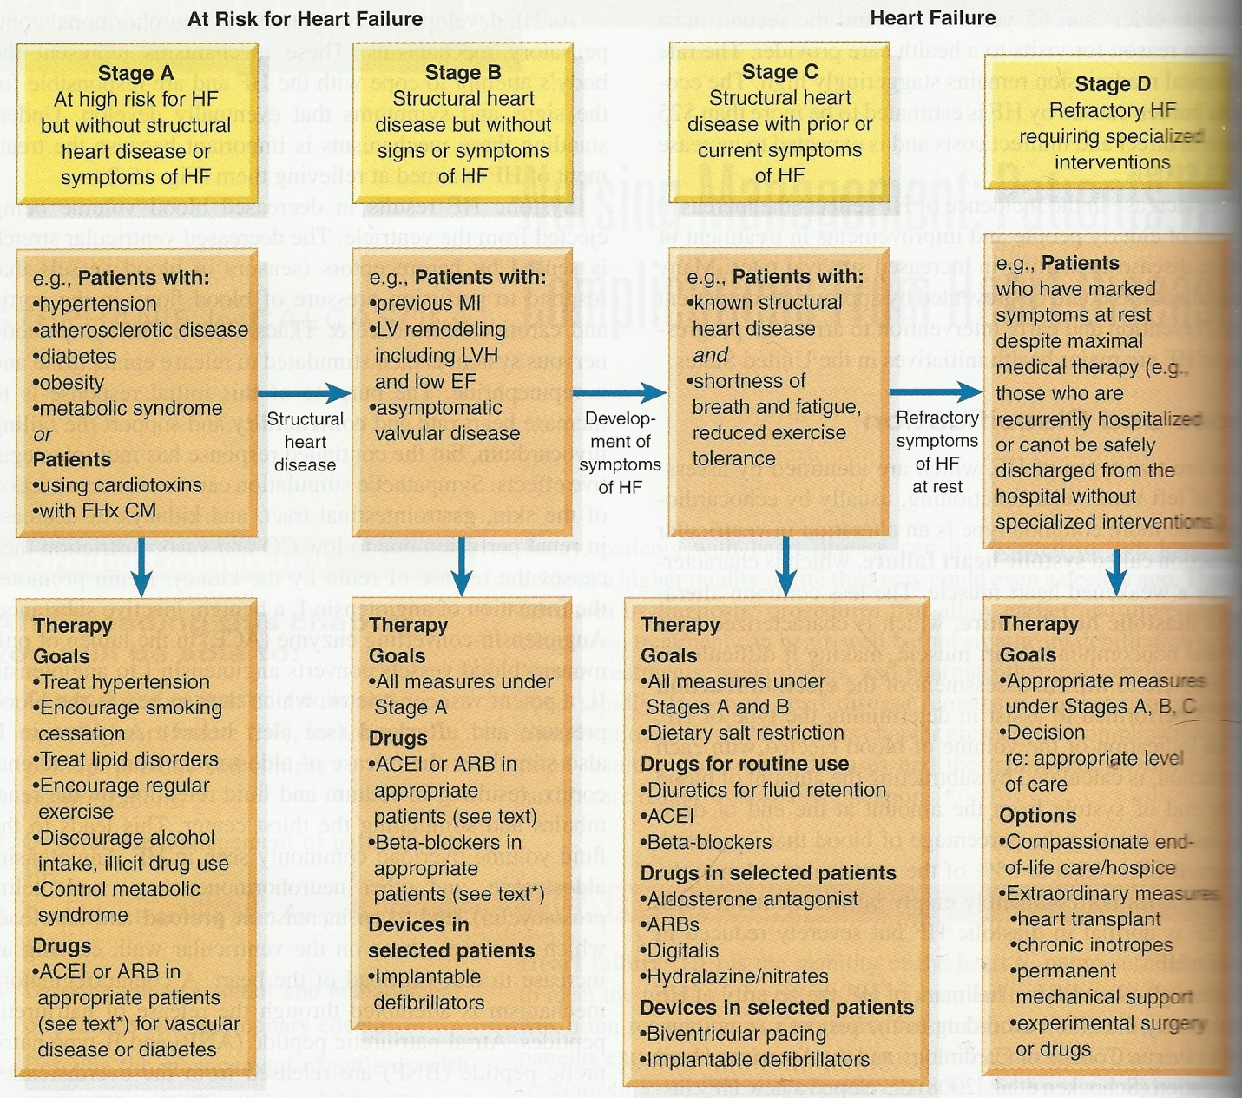
Risk factors:
Major: Minor:
- Age (>65) smoking/ excessive alcohol consumption
- Sex (male) Genetics (Schocken et al., 2008)
- Hypertension high cholesterol (dyslipidemia)
- L. ventricular hypertrophy diabetes
- MI toxins (chemotherapeutic agents)
- Valvular heart disease sleep-disordered breathing
- Obesity chronic kidney disease
Low socioeconomic status
Psychological stress
Sedentary lifestyle

Management of patients with HF:
- Relive pt. symptoms
- Improve fx status and quality of life
- Tx based on type, severity and cause of HF
- Specific objectives include:
- Eliminate/reduce any etiologic contributory factor, especially those that may be reversible
- Reduce the workload on the heart by reducing afterload and preload
- Optimize all therapeutic regimen
- Prevent exacerbations of HF
Lifestyle changes:
- Provide general education and counseling to pt. and family
- Restriction of dietary sodium
- Avoidance of excessive fluid intake
- Alcohol
- Smoking
- Weight reduction when indicated
- Regular exercise
- Pt. will know how to recognize signs and symptoms that need to be reported to the health care professional such as weight gain, ↑ SOB, fatigue, edema
Pharmacologic therapy:
- ACE inhibitors
- Beta blockers
- Diuretics
- Digitalis
Assessment of Pulmonary edema: accumulation of fluid in the lungs (interstitial spaces and the alveoli)
- Can occur acutely or as an exacerbation of HF
- Pt. becomes ↑ restlessness and anxious
- Sudden onset of breathlessness, sense of suffocation, cough that produces large amts. of frothy sputum (may be blood-tinged), cold and moist skin, cyanotic (bluish) nail beds, a weak and rapid pulse, pulmonary rales, expiratory wheezing, and distended neck veins.
- O2 demand ↑ = admin. O2
- **Demands immediate action b/c pt. is literally drowning in secretions**
- Oxygen, diuretics, pharmacologic preload and afterload reduction, and possibly hemodynamic monitoring
- Early rescue with noninvasive mask ventilation and bronchodilator therapy with select beta 2 agonist medications like albuterol.
Management of cardiac arrest: EMERGENCY
- AIRWAY: maintaining an open airway
- BREATHING: providing artificial ventilation by rescue breathing
- CIRCULATION: promoting artificial circulation by external cardiac compression; administering medication therapy (epinephrine for asystole)
- DEFIBRILLATION: shocking with standard defibrillator of automatic external defibrillator (AED) for ventricular tachycardia and ventricular fibrillation.
Medsurg Cardiac

Pericardium- tough, fibrous, double-walled sac that surrounds and protects the heart

Myocardium-muscular wall of the heart. It does the pumping

Endocardium- thin layer of endothelial tissue that lines the inner surface of the heart chambers and valves.

Superior and Inferior vena cava return oxygenated venous blood to the right side of the heart

Chambers of the Heart:
Right Atria
Left Atria
Right Ventricle
Left Ventricle

Valves of the Heart:
*Atrioventricular-
open during diastole(hearts filling)
close during systole (hearts pumping)
Tricuspid-Right side
Mitral- Left side
*Semilunar-open during systole (pumping phase)
Pulmonic-right
Aortic-left
Systole- allow blood to be ejected from the heart

Flow of Blood:
Inferior & Superior Vena Cava
Right Atrium
Tricuspid Valve
Right Ventrical
Pulmonary Valve
Pulmonary Artery
LUNGS
Pulmonary Veins (O2 rich blood)
Left Atrium
Mitral Valve
Left Ventricle
Aortic Valve
Aorta
Body

Cardiac Cycle of Heart:

Cardiac Cycle: rhythmic movement of blood through the heart
Systole: Blood is pumped from the ventricles and fills the pulmonary and
systemic arteries 1/3 of the cardiac cycle
occurs because ventricular pressure is higher than atria

DIASTOLE-
Ventricles are relaxed, fill 2/3 of cardiac cycle
AV valves (tricuspid & mitral) are open
Pressure in atria is higher than that in the Ventricles so blood
pours rapidly into the ventricles.
This is called early or protodiastolic filling

SYSTOLE:
Blood is pumped from the ventricles and fills the pulmonary &
systemic arteries; fills 1/3 of cardiac cycle
Ventricle pressure is higher than that in the atria, so the
mitral and tricuspid valves close
AV valves closing contribute to the first heart sound and
signals the beginning of systole
AV valves close because they prevent any regurgitation of
blood back up into the atria during contraction

- The same events are happening in the right side as they are in the left. However, pressures in the right side of the heart are much lower than those of the left side because less energy is needed to pump blood to its destination (pulmonary Circulation)

Heart Sounds

S1-closure of AV valves, signals systole, loudest at apex
S2- closure of the semilunar valves, signals end of systole, loudest at the base

REMEMBER THE PHRASE…. moRe to the Right heart, Less to the Left

S3- diastole, silent event, occurs when ventricules are resistant to filling
during the early rapid filling phase

S4- occurs at end of diastole, at presystole, when ventricle is resistant to
filling, atria contract and push blood into a noncompliant ventricle. This creates vibrations.

Murmurs:
Murmur- Gentle blowing, swooshing, sound that can be heard on the chest well.
Conditions of a murmur include:
- Velocity of blood increases (flow murmur) ex: exercise
- Viscosity of blood decreases ex: anemia
- Structural defects in valves (narrowed valve, incompetent valve) or unusual openings occur in the chambers (dilated chamber, wall defect)

Characteristics of Sound
- Frequency (pitch)
  - High pitched or low pitched
- Intensity (loudness)
  - Loud or soft
- Duration-
  - Very short for heart sounds; silent periods are loner
- Timing
  - Systole or diastole

Pumping Ability
CO = SV x R
Cardiac Output = Volume of blood in systole (Stroke Volume) x beats per
minute (rate)

Preload- venous return that builds during diastole. It is the length to which
the ventricular muscle is stretched at the end of diastole just before
contraction

Examples: Hypervolemia (increased blood volume)
Cardiogenic Shock (BP drops, volume decreases)

Afterload- opposing prssure the ventricle must generate to open the aortic
valve against the higher aortic pressure. It is resistance against which the
ventricle must pump its blood.

Examples: Aortic Stenosis (Vessle Shrinks)
Inferior Vena Cava Obstruction (Pressure is increasing)

Carotid Artery Pulse
Jugular Venous Pulse and Pressure

Subjective Data- Health History Questions to ask
Chest pain?
Any tightness in the chest area?
Dyspnea- Any shortness of breath?
Orthopnea- how many pillows do you use when you sleep?
Cough- Do you have a cough?
Fatigue- Do you tire easily?
Cyanosis or pallor- facial skin ever look blue or ashen?
Diaphorisis- sweating
Tachycardia- fast heart rate
Edema- Any swelling in your feet or legs?
Nocturia- do you awake at night with an urgent need to urinate?
Cardiac history- Past history of hypertension elevated cholesterol or
triglycerides, heart murmur, congenital heart disease, rheumatic fever
or unexplained joint paints as a child or young, recurrent tonsillitis, anemia?
Family Cardiac History- any family history of hypertension, obesity, diabetes, coronary artery disease (CAD), sudden death at younger age?
Personal habits (cardiac risk factors)-

Objective Data- The Physical Exam
Preparation:
Position and draping
Room preparation
Follow order
Equipment needed:
Marking pen
Small centimeter ruler
Stethoscope with diaphragm and bell end piece
Alcohol swab
Physical Exam
To evaluate carotid arteries, the person can be sitting up.
Palpate & auscultate for bruit
To assess jugular veins and Precordium, the person should be
supine with the head and chest slightly elevated. Inspect
the anterior chest, Palpate the APICAL PULSE, palpate
across the preordium
Always Stand on the right side of the patient
When performing a regional cardiovascular assessment, use
this order:
- pulse and BP
- Extremities
- Neck vessels
- Precordium
Purpose of this order is to begin observations peripherally and move in toward the heart.

REMEMBER AUSCULTORY AREAS: APE TO MAN
Aortic, pulmonic, earbs, tricuspid, mitral

Difference between S3 & Split S2
Sound Location Resp. variation pitch
S3 apex or L does not vary in lower
Lower sternal timing w/
Border respirations

Split S2 base varies in timing with stays
Respirations same

Abnormal Findings Congenital Heart Defects
- Patent ductus arteriosus (PDA)
  - Persistence of channel joining left pulmonary artery to aorta
    - Normally occurs in the fetus and closes within hours upon birth
- Atrial Septal Defect (ASD)
  - Causes large increase in pulmonary blood flow
    - Abnormal opening in the atrial septum
- Ventricular Septal Defect (VSD)
  - Size and position vary
    - Abnormal opening in septum btwn the ventricles (subaortic area)
- Tetralogy of Fallot
  - Shunts a lot of venous blood directly into aorta away from pulmonary system, so blood never gets oxygenated
    - 4 components:
      - right ventricular outflow stenosis
      - VSD
      - Right ventricular hypertrophy
      - Overriding aorta
- Coarctation of the Aorta
  - Severe narrowing of descending aorta
    - Occurs at junction of the ductus arteriosus and the aortic arch. Results in increased work load on left ventricle

Murmurs Due to Valvular Defects:

Aortic Stenosis- Calcification of aortic valve cusps restricts forward
flow of blood during systole; LV hypertrophy develops

Data:
S:fatigue, dizziness, fainting, anginal pain,
O: Pallor, slow radial pulse, low BP, apical pulse is
Towards the left, Thrill in systole
Murmur: loud, harsh, midsystolic,
Crescendo-decrescendo, loudest at second right
Inter-space, radiates widely to side of neck

Pulmonic Stenosis: calcification of pulmonic valve restricts forward
flow to blood

Data:
S: -
O: thrill in systole at second and third left inter-space,
ejection click present after S1, diminished S2, usually
with wide split, S4 common with RV hypertrophy

Murmur: systolic, medium pitch, coarse, crescendo-
decrescendo (diamond shape), best heard at second left
inter-space, radiates to left and neck

Mitral Regurgitation- stream of blood regurgitates back into LA
during systole through incompetent mitral valve. In diastole, blood passes back into LV again along with new flow; results in LV dilation and hypertrophy

Tricuspid Regurgitation: backflow of blood through incompetent
tricuspid valve into RA

Mitral Stenosis- Calcified mitral valve will not open right, impedes
forward flow of blood into LV during diastole. Results in LA enlarged
and LA pressure increased

Tricuspid Stenosis- Calcification of tricuspid valve impedes forward
flow into RV during diastole. Diminished arterial pulse

- Myasthenia gravis – autoimmune process in which antibodies attack nicotinic m receptors on skeletal muscle = characterized by fluctuating muscle weakness and predisposition to rapid fatigue
TX = cholinesterase inhibitors (increase muscle strength)
Excessive muscarinic response
Undermed. = difficulty swallowing (ptosis)
Overmed. = excessive salvation and other muscarinic responses
Myasthenic crisis - ↑neostigmine
Cholinergic crisis – chol. Drug
Extreme muscle weakness or frank paralysis and signs of excessive muscarinic stimulation
TX = breathe for them and atropine
Medications – Neostigmine (Prostigmin) –
Muscarinic receptors – identical to muscarinic agonist response
Therapeutic dose - ↑ force of contraction in skeletal muscle (CNS = mild stimulation)
Toxic - ↓ force of contraction (CNS = depress the CNS)
- Beta blocker to tx migraines (in book): notes week 3 pg. #10 = propranolol??
It is not known how beta-blockers prevent migraine headaches. It may be by decreasing prostaglandin production, though it also may be through their effect on serotonin or a direct effect on arteries. The beta-blockers used in preventing migraine headaches include propranolol (Inderal), atenolol (Tenormin), metoprolol (Lopressor, Lopressor LA, Toprol XL), nadolol (Corgard), and timolol (Blocadren).

- Dopamine –
- ↑cardiac output
- ↑ renal perfusion
- ↑ myocardial contractility with heart failure (also… will ↑ O2 demand = be careful)
Adv. effects:
- Tachycardia, dysrhythmias, angina pain, necrosis w/ extravasation
Drug interactions:
- MAOI, TCA, diuretics
*antidote = Regetine
Dobutamine – Heart failure (CHF) - ↑ cardiac contractibility
- Beta 1 activation = only indication is for heart failure
Adv. effects =
- Tachycardia = ↑ HR = chest pain
- Key concepts = adrenergic and non-adrenergic
Predominant effects of alpha and beta receptors
- Drugs that interact w/epinephrine. Good lord there’s 243of them! But I think she’s looking for :
OTC cold meds
Herbal (ephedra/ma hung)

- b/c the first pass by the liver would metabolize it so that the body wouldn’t be able to absorb it
- Atropine – muscarinic antagonist (anticholinergic drug)
- ↑HR
- ↓ secretions (dry SLUD)
- Smooth muscle relaxation
- Causes mydriasis (eye)
- CNS excitation
Uses:
- Pre-anesthetic medication
- Disorders of the eye
- Bradycardia muscarinic agonist (cholergic) poisoning **antidote**
Adv. effects:
- Dry SLUD
- Tachycardia
- Asthma (thickening or drying secretions)
- ↑ intraocular pressure
**antidote for anticholinergic drugs = Physostigmine salicylate**
Drug interactions:
- Avoid combining with other drugs capable of causing muscarinic blockade:
Antihistamines
Antipsychotics
TCAs
Phenothiazine
- Drug of choice if a pt. is in shock or bleeding = epinephrine?
- Drug of choice for heart failure =
Dobutamine – Heart failure (CHF) - ↑ cardiac contractibility
- Beta 1 activation = only indication is for heart failure
Adv. effects =
- Tachycardia = ↑ HR = chest pain
- Muscarinic agonists: reasons to give these meds
- Medications used to increase smooth muscle strength = cholinesterase inhibitors
- BPH meds: Alpha blockers work by relaxing the smooth muscle tissue in your prostate and at the opening to your bladder. When this muscle tissue relaxes, it is easier for your urine to flow. This may help if you have difficulty starting to urinate and a weak urine stream. Alpha blockers can start working within two to three days, and may relieve your urinary symptoms in about two to three weeks. However, these medications do not stop your prostate gland from continuing to enlarge.

- Sympathetic: fight or flight –
- Regulation of cardiovascular system
- Regulate body temp.
- Implementation of fight or flight reaction:
- ↑HR &BP
- Shunting blood away from the skin and viscera (organs other than heart, lungs, brain)
- Dilating the bronchi = breathe
- Dilating the pupils = see
- Mobilizing stored energy (breakdown glycogen →glucose)
- ↑HR + BP + vasoconstrict = ↑ cardiac output
Parasympathetic: rest and digest –
- **Stimulate the vagus nerve = ↓HR
- ↑ gastric secretions = drooling
- Emptying the bladder / bowel
- Constricting of the pupil
- Contracting bronchial smooth muscle (contraindicated in pts. with asthma)
- Symptoms of anticholinergic overdose:
Produces exaggerated effects:
- Hyperthermia, Mydriasis, Paralytic ileus
- Delirium, tachycardia, urinary retention
- Seizures, coma, respiratory arrest
**antidote = Physostigmine salicylate (IV slowly)**
Activated charcoal
Diazepam
Ice bags, cooling blankets ( ↓ fever)
- Acetylcholine receptor – how this neurotransmitter affects muscles …book – sick and ambulate?
- Neostigmine (Prostigmin) – antidote for non-depolarized skeletal muscle relaxants used in surgery (Tubocurarine)
Mech. of action: pg #314
↓ the inactivation of acetylcholine in the synapse by the enzyme acetylcholinesterase. Acetylcholine can then accumulate in the synapse and enhance the activation of postsynaptic muscarinic as well as nicotinic receptors = ↑ skeletal muscle tone and strength.
- Beta blockers – most important assessments of pts. on beta blockers is (cardiac functioning?)
- Nicotinic receptors = promotes contraction of skeletal muscle
- Nicotinic receptors are located in motor nerves & skeletal muscle.
Muscarinic receptors are located in most internal organs.
- Epinephrine –
- Delay absorption of local anesthetic
- Control superficial bleeding
- ↑ BP
- Mydriasis during ophthalmologic procedures
- Overcome AV block
- Restore cardiac fx in arrest
- Bronchial dilation in asthma
- Tx of choice for anaphylactic chock
- Alpha and beta receptors:
Alpha 1 – constrict blood vessels
Alpha 2 – negative feedback to stop neurotransmitter release
Beta 1 – speed and strengthen heart → cardiac stimulation = ↑HR & contractibility
Beta 2 – bronchodilation
- Refer to #14
- Mydriasis – adrenergic meds and glaucoma (in book)
- Refer to # 14
- Muscarinic 1 & 2:
Notes week 3 pg. #3 = slow heart, stimulate GI, vasodilate
26-32. This is the same question-I am assuming that she is trying to tell us that the “primary intervention in addressing the pt.s B/P” ?????Antidote or Dopamine?????

33. Robinul (Glycopyrrolate)- Antisecretory/Antispasmodic is an older Anticholinergic drug used for gastro intestinal disorders, but with newer drugs w/fewer side effects Anticholinergic drugs are infrequently prescribed today.
Bethanechol (Urecholine)-is a synthetic derivative of choline, this drug produces smooth muscle contractions so it should not be used in obstructive conditions of the urinary/GI tracts.
Catapres (Clonidine)-inhibits the release of norepinephrine in the brain, thereby decreasing the effects of SNS stimulation throughout the body.

Angina-Condition marked by severe pain in the chest, often also spreading to the shoulders, arms, and neck, caused by an inadequate blood supply to the heart.
Pericarditis-Inflammation of the pericardium

Pulmonary embolism-A blockage of the main artery of the lung or one of its branches by a substance that has travelled from elsewhere in the body through the bloodstream. ...

Aortic dissection-A tear in the wall of the aorta that causes blood to flow between the layers of the wall of the aorta and force the layers apart. aortic dissection is a medical emergency and can quickly lead to death, even with optimal treatment. ...

Gastroesophageal reflux disease-Gastroesophageal reflux disease gastro-oesophageal reflux disease gastric reflux disease, or acid reflux disease is defined as chronic symptoms or mucosal damage produced by the abnormal reflux in the oesophagus.

Symptoms:
Heart attack
A sudden and sometimes fatal occurrence of coronary thrombosis, typically resulting in the death of part of a heart muscle.

Angina
Condition marked by severe pain in the chest, often also spreading to the shoulders, arms, and neck, caused by an inadequate blood supply to the heart.

Gastroesophageal reflux disease
Gastroesophageal reflux disease gastro-oesophageal reflux disease gastric reflux disease, or acid reflux disease is defined as chronic symptoms or mucosal damage produced by the abnormal reflux in the esophagus.

Pericarditis
Inflammation of the pericardium

Pulmonary embolism
A blockage of the main artery of the lung or one of its branches.

