My PowerPoint slide could look like this… if you can add the US picture below that would great.

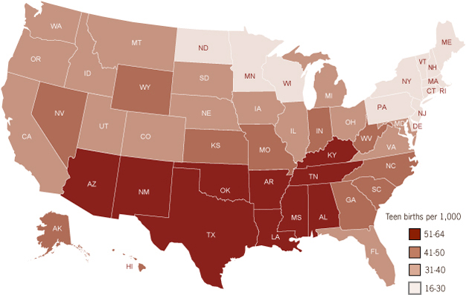
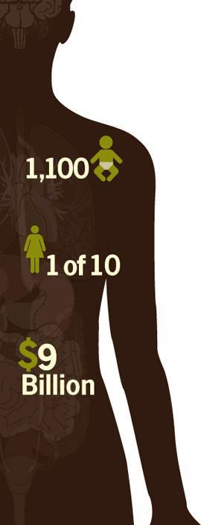
ggg
STATISTICS
- Teen births in U.S.
- Taxpayer Costs
- America ranked 2nd
- Possible hold on life
- Birth rates by race/ethnicity
- Positive outlook
1 of 10 new mothers is a teen (CDC, 2011).

About 1,100 teen girls give birth every day. That’s almost 46 child births an hour (CDC, 2011).

Teen childbearing costs US taxpayers more than $9 billion each year (CDC, 2011).

- More than 400,000 teen girls, aged 15-19 years, give birth each year in the US (CDC, 2011).
- State comparison: Teen birth rates per 1,000 girls aged 15-19 years, 2009 (CDC, 2011).
- Compared to other developed countries, the US is ranked 2nd among teen births rates. Coming in at first place is Bulgaria and Switzerland had the lowest birth rate (CDC, 2011).
- About 50% of teen mothers get a High School diploma by the age of 22.
- Teen pregnancy can definitely put a hold on life, but that’s not always the case.
- Birth rate by race/ethnicity: African Americas are the highest, then Hispanic, and then whites (CDC, 2011).
- Overall, the rate of teen girls having children has dropped about 40% over the last 20 years. This is great news, but there is still much work to do because teen pregnancy has such a huge impact on the future of America's children (CDC, 2011).

Reference
Preventing Teen Pregnancy in the US. (2011, April 5). In Centers for Disease Control and Prevention. Retrieved September 23, 2012, from USA.gov website: http://www.cdc.gov/VitalSigns/TeenPregnancy/

Just some other graphs to support data. They don’t need to go in the PowerPoint.
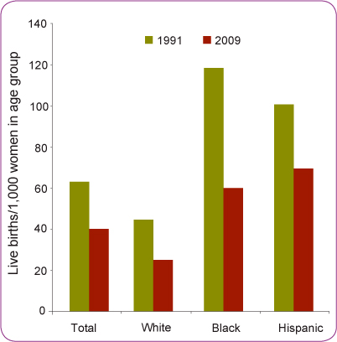
US Birth Rates for Teens 15-19 Years by Race/Ethnicity, 1991 and 2009

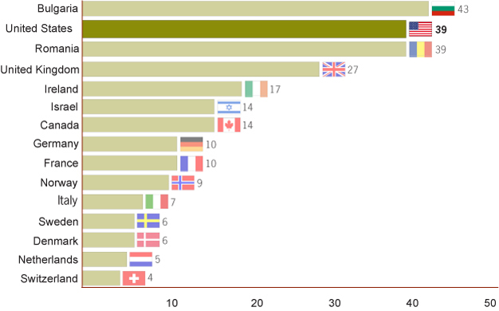
Teen birth rates internationally, per 1,000 girls aged 15-19 years, 2008 and 2009

