LATENT TB Treatment:
People with latent TB do not show symptoms and cannot spread the disease to others, however these people should still be treated to prevent the disease from becoming active.
Because there is less bacteria, treatment is easier. Four regimens are approved for the treatment of latent TB:
Drugs | Duration | Interval | Minimum doses
Isoniazid | 9 months | Daily | 270
Isoniazid | 9 months | Twice weekly* | 76
Isoniazid | 6 months | Daily | 180
Isoniazid | 6 months | Twice weekly* | 52
Isoniazid and Rifapentine | 3 months | Once weekly* | 12
Rifampin | 4 months | Daily | 120
*Use Directly Observed Therapy (DOT)

Which regimen that will work best for you should be discussed with your doctor. It can depend on many things such as your overall health, the strength of your immune system, and how diligent you are about taking your medications!
It is important to report any signs and symptoms of adverse drug reactions to their health care provider, including
-Unexplained anorexia, nausea or vomiting, dark urine*, or icterus
-Persistent paresthesia of hands or feet
-Persistent weakness, fatigue, fever, or abdominal tenderness
-Easy bruising or bleeding
**If you are taking RIF or RPT that y will notice a normal orange discoloration of body fluids, including urine and tears. Contact lenses may be permanently stained

Active TB treatment:
TB becomes active when the immune system cannot stop the bacteria from growing. Once it is active it is known as TB disease and can make a person sick.
The first-line anti-TB agents that form the core of treatment regimens include:
-isoniazid (INH)
-rifampin (RIF)
-ethambutol (EMB)
-pyrazinamide (PZA)

Regimens for treating TB disease have an initial phase of 2 months, followed by a choice of several options for the continuation phase of either 4 or 7 months for a total of 6 to 9 months for treatment.
-The 4-month continuation phase should be used in the large majority of patients.
-The 7-month continuation phase is recommended only for three groups: patients with cavitary pulmonary tuberculosis caused by drug-susceptible organisms and whose sputum culture obtained at the time of completion of 2 months of treatment is positive; patients whose initial phase of treatment did not include PZA; and patients being treated with once weekly INH and rifapentine and whose sputum culture obtained at the time of completion of the initial phase is positive.
It is VERY important to take your TB drugs. Finishing the medication and taking it exactly prescribed is imperative to making sure the you do not become sick again and to make sure your body does not become resistant to the drugs you are taking!

Drug Resistant TB treatment:
Drug-resistant TB is caused by TB bacteria that are resistant to at least one first-line anti-TB drug. Multidrug-resistant TB is resistant to more than one anti-TB drug and at least isoniazid (INH) and rifampin (RIF).
Treating and curing drug-resistant TB is complicated. Inappropriate management can have life-threatening results. Drug-resistant TB should be managed by or in close consultation with an expert in the disease.
Drug resistance is proven by drug-susceptibility testing. However, since this testing can take weeks, treatment should be started with an empirical treatment regimen based on expert advice as soon as drug-resistant TB disease is suspected. When the testing results are known, the treatment regimen should be adjusted according to the results. Patients should be monitored closely throughout treatment. Directly observed therapy (DOT) always should be used in the treatment of drug-resistant TB to ensure adherence.

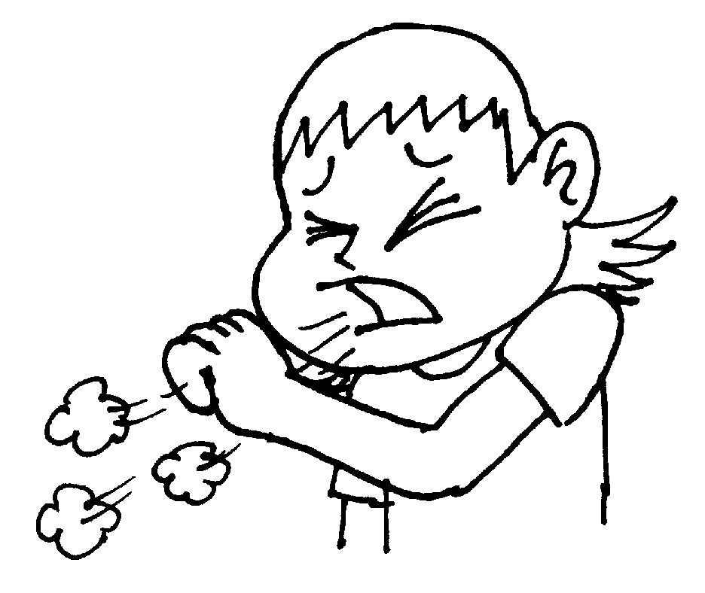

Three populations who are most likely to contract the TB virus are:
-those working in a heathcare setting
-those who travel frequently
-those who live in close quarters (prisons, military camps, homeless shelters)

Ways to prevent contracting the disease include:
- avoid being in close quarters with those who have the disease
- practice airborne precautions including wearing a mask and covering your cough
- getting a tuberculosis skin test (TST) once a year
- practice good hygiene and clean areas daily which may have exposure to TB

If you think you have been exposed to someone with TB disease, contact your health care provider or local health department to see if you should be tested for TB. Be sure to tell the doctor or nurse when you spent time with someone who has TB disease.

