 Low-molecular-weight heparin injections vs. Sequential Compression Devices, Which is best 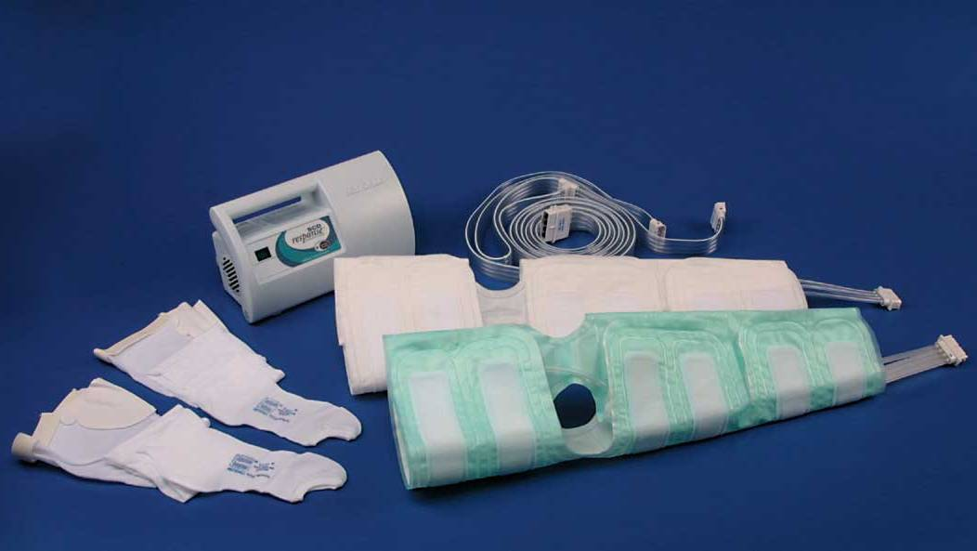
Kendallhq.com
Aboutlawsuits.com
Tenika McMillan, RN
Lakeview College of Nursing, Danville, IL

Article 1 Article 2 Article 3 Article 4
Methods
A literature search was done using the following: CINAHL, Cochrane, PubMed, Google scholar, using keywords “DVT prevention”, “SCD”, “surgical patient
complications” and “PE”. Four articles were chosen based on these criteria.
Background
Surgical patients are amongst the highest population to develop DVT’s (deep vein thrombosis) and PE's (pulmonary emboli); having an understanding of patients at risk for DVT's in addition to using appropriate prophylaxis will improve patient outcomes.

Agnelli, G. (1998). Post discharge prophylaxis for venous thromboembolism among high-risk surgery patients. Vascular Medicine 3: 51-56
Nutescu, E. (2007) Assessing, preventing, and treating venous thromboembolism: Evidence-based approaches. Symposium Vol.64
Summerfield, D. (2006). Decreasing the incidence of deep vein thrombosis through the use of prophylaxis. AORN Journal. Vol 84, No. 4
Egger, M. Elliott, G. Gardner, R. Hopkins, J. Mosen, D. Mundorff, M. Patterson, R. (2004) The Effect of a Computerized Reminder System on the Prevention of Postoperative Venous Thromboembolism. Chest 125:1635-1641
Article Citation

Research

Research

Research

Research
Type of Article

Case controlled study

Case Report
Case controlled study

Case controlled study

Level of Evidence

.
Deep vein thrombosis (DVT) and pulmonary embolism (PE) affect between 200,000 and 600,000 Americans each year. Of those patients who develop a PE, 60,000 to 200,000 will die.
The most serious acute complication of DVT is PE. Long-term complications after DVT include recurrent DVT, post-thrombotic syndrome, persistent edema, pain, purpura, dermatitis, pruritus, cellulitis, ulceration, and death.
Deep vein thrombosis is a common complication after elective major surgery. Without prophylaxis, approximately 25% of patients who undergo general surgical procedures and approximately 50% of patients who undergo hip replacement acquire deep vein thrombi that are detected by venography.
Venous thrombolism is the most common cause of preventable in-hospital postoperative morbidity and mortality.
Conclusion
After reviewing the research gathered, it is clear that all hospitalized patients are at risk for developing DVT’s mostly due to immobility. Surgical patient are at higher risk depending on the extensiveness of surgery. DVT prevention is essential for all patients. The research proved that both low-molecular-weight heparins and SCD’s decrease the risk of developing DVT’s with other interventions, such as early ambulation and adequate fluid intake. In many cases both types of interventions are used on surgical patients; the exception of be a patient who is not hemodynamically stable, suffer from anticoagulation disorders, and patients allergic to or have a negative reactions to low-molecular-weight heparins.
PICOT
P: adult Surgical Patient
I: DVT prophylaxis
C: subcutaneous heparin vs. sequential compression devices
O: identify which intervention will show a decrease in the number of DVT’s
T: post-op period (length of hospitalization)
A medical /surgical nurse is interested in researching patient outcomes associated with using low-molecular-weight heparin vs. SCD’s when preventing post-op DVT’s.

Background

.

Long-term complications of deep vein thrombosis (DVT), assessment of risk for venous thromboembolism (VTE) in medical and surgical patients, recommendations in evidence-based guidelines for VTE prophylaxis in surgical and medical patients and the treatment of VTE, and a new alternative for VTE prophylaxis and treatment are discussed.
Every year, thousands of patients develop deep vein thrombosis (DVT) after undergoing surgery. Deep vein thromboses that result in pulmonary embolisms (PEs) are believed to be one of the most frequently occurring, preventable killers of hospitalized patients.
The aim of this article is to identify if the use of a computerized reminder system on the prevention of postoperative DVT to help improve patient outcomes.
The role of pharmacological prophylaxis against venous thromboembolism in high-risk surgical patients is straightforward during hospitalization but controversial after hospital discharge.
Purpose

Article identifies major surgery patients and some medical patients are at risk for developing VTE. Article also found that there is limited research to support the outcomes of the use of intermittent pneumatic compression stockings (IPC) and devices are expensive. Article also supports the use of low-molecular-weight heparin.
The incidence of postoperative deep vein thrombosis (DVT) can be reduced with pharmacological prophylaxis.
Computerized reminder systems combined with altered care procedures increase the rate of prophylaxis against venous thromboembolism without decreasing the rate of symptomatic venous thromboembolism when the baseline rate of prophylaxis is high.
Article identified mechanical DVT and chemical prophylaxis to be the most commonly used treatment amongst surgical patients.
Key Findings

Purpose
To compare the benefits of using low-molecular-weight heparin vs. the use of sequential compression devices for better patient outcomes.

The article revealed similar risk factors and promoted the use of both mechanical DVT and chemical prophylaxis.
The use of low-molecular-weight heparin showed in significant decrease in the development of DVT’s; also showed an increase in the risk for bleeding.
This article supports the use of technology to identify patients at risk and remind staff to prevent interventions.
Article identifies risk factors associated with development of DVT’s and treatment options.
Clinical Relevance

