MED SURG TEST #2:
CHAPTER 51: NURSING ASSESSMENT: INTEGUMENTARY FUNCTION:
EXPLAIN THE STRUCTURES OF THE SKIN:
Epidermis: outer barrier of the skin. Continuously dividing cells covered by dead cells that contain large amounts of Keratin.
- Repel pathogens
- Prevent excessive fluid loss
Dermis: makes up the largest portion of the skin. Made up of blood, lymph vessels, nerves, sweat/sebaceous glands, and hair roots.
- Strength
- Structure
Made up of two layers:
- Papillary: Located directly below the epidermis. Made up of fibroblast cells capable of producing one form of collagen, a component of connective tissue.
- Reticular: lies beneath the papillary layer. Produces collagen and elastic bundles.
Cellulitis: an infection of the dermis that spreads rapidly within the skin and sebaceous structures. Usually caused by staphylococci or streptococci and presents with redness, warmth, swelling, and tenderness.
Hypodermis (subcutaneous): inner-most layer of the skin. Primarily adipose tissue.
- Provides a cushion between the skin layers, muscles, and bones
- Promotes skin mobility
- Molds body contours
- Insulates the body – regulates temp.
Fat deposits are distributed according to a person’s:
- Gender (<male, >female
- Eating habits
FUNCTIONS OF THE SKIN:
- Protection: against invasion of bacterial and viral pathogens as well as other foreign matter. Thickened layer on the palms and soles protects against the effects of the constant trauma that occurs in these areas. Stratum corneum (outer layer) provides the most protection against fluid loss to maintain a homeostatic environment and penetration of environmental factors such as chemicals, insect bites, and microbes.
- Sensation: receptor endings of nerves in the skin allow the body to constantly monitor the conditions of the immediate environment.
- Temperature
- Pain
- Light touch
- Pressure (heavy touch)
- Fluid balance: stratum corneum (outer-most layer) has the capacity to absorb water, thereby preventing an excess loss of water and electrolytes from the internal body and retaining moisture in the subcutaneous tissues.
- Thermoregulation: body continuously produces heat as a result of the metabolism of food, which produces energy. This heat is dissipated primarily through the skin.
Normal conditions: metabolic heat production is balanced with heat loss.
- Vitamin synthesis: exposure to UV light = convert substances necessary for synthesizing Vit D.
- Immune response function: Langerhans cells (specialized cells in the sin): facilitate the uptake of IgE- associated allergens. This action plays a vital role in the pathogenesis of atopic dermatitis and other allergic diseases (asthma, allergic rhinitis) local inflammation pushes out foreign materials.
NORMAL AGING PROCESS OF THE SKIN AND SKIN CHANGES COMMON IN ELDERLY PTS.:
Risk factors that increase skin problems:
- Excessive Sun exposure
- Systemic disease
- Poor nutrition
- Medications (antihistamines, antibiotics, diuretics) photosynthesizing and ↑ damage from the sun
Outcomes: increasingly vulnerable to injury and certain diseases.
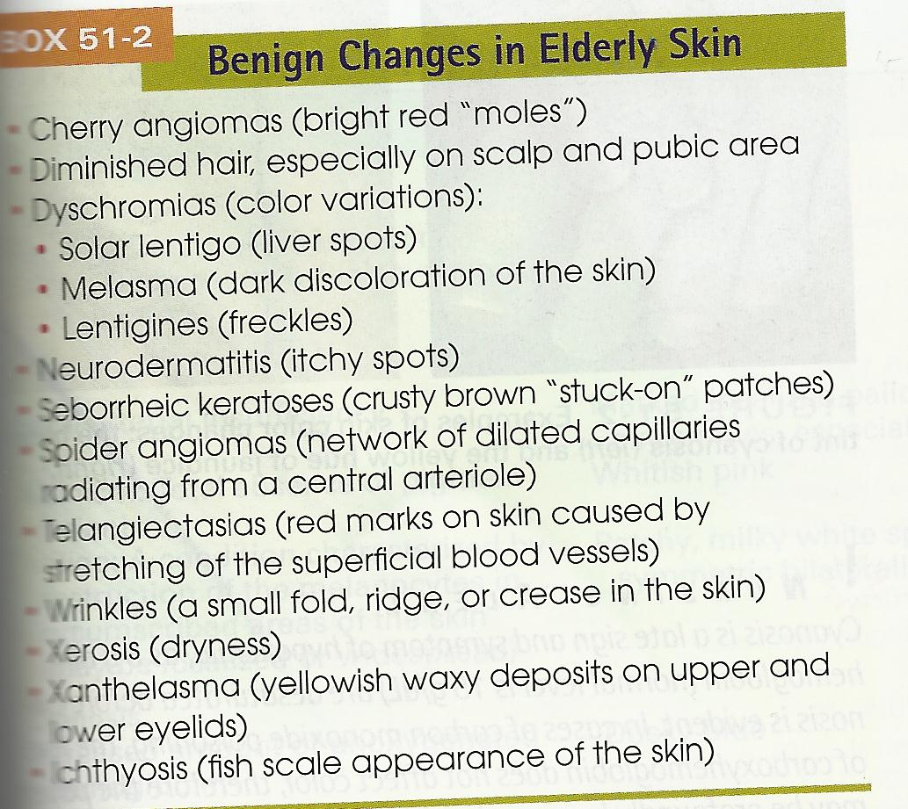

Pruritus (itching): Elderly pts. are more likely to develop pruritus as a result of dry skin and systemic illness, occult malignancy, and taking multiple medications…
PRESSURE ULCERS AND PREVENTATIVE PRACTICES (PG. # 1353):
Pressure ulcers: the breakdown of the skin due to prolonged pressure, friction, and shear forces, and insufficient blood supply, usually at bony prominences. Susceptible areas include:
- Sacrum
- Coccygeal
- Ischial tuberosities (especially pts. who sit for extended periods of time)
- Greater trochanter
- Heel
- Knee
- Malleolus
- Medial condyle of the tibia
- Fibular head
- Scapula
- Elbow
Clinical manifestations:
- (#1 sign ) erythema (redness of the skin) – normally resolves in < 1 hour
- Tissue ischemia or anoxia – the cutaneous tissue becomes broken or destroyed, leading to progressive destruction and necrosis of underlying soft tissue = pressure ulcer
Assessment:
- Pts. mobility
- Sensory perception
- Cognitive abilities
- Tissue perfusion
- Nutritional status
- Friction and shear forces
- Sources of moisture on the skin
- Age and skin condition
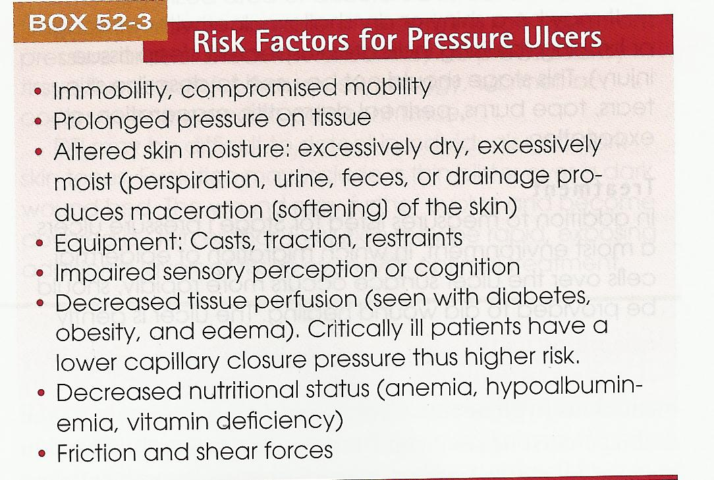
If a pressure ulcer is noted… the nurse documents:
- Size
- Location
- Uses a grading system to determine the severity
Stage I (indicates “at risk” pts.):
  - Intact with non-blanched erythema of a localized area.
  - The area may be painful, firm, soft, and warmer or cooler in temperature.
Tx: remove pressure to allow for increased tissue perfusion
- Nutrition, fluid, and electrolyte balance are maintained
- Friction and shear reduced
- Moisture to the skin is avoided
Stage II (partial thickness):
- Loss of dermis present as a shallow open ulcer
- Red-pink wound bed
- Without slough
- Intact or open/ruptured serum-filled blister
- May be shiny or dry shallow ulcer w/o slough or bruising
Tx: in addition to measures listed in stage I:
- A moist environment should be provided – migration of epidermal cells over the ulcer’s surface occur more rapidly = aid wound healing
- Gently cleanse ulcer with sterile saline solution.
- Semipermeable occlusive dressing, hydrocolloid wafers, or wet saline dressings – provide moist environment for healing and minimize the loss of fluids and proteins from the body
Stage III (full thickness tissue loss):
- Subcutaneous fat may be visible but bone, tendon, or muscle are NOT exposed
- Slough may be present, but does not obscure the depth of the tissue
- May include undermining and tunneling.
Tx: stage III and IV pressure ulcers are characterized by extensive tissue damage… in addition to the measures listed for stage I: advanced, draining, necrotic pressure ulcers must be:
Cleaned (debrided) to create an area that will heal, necrotic, devitalized tissue favors bacterial growth, delays granulation, and inhibits healing…
- Must administer analgesia (pain med) during wound cleaning and dressing change
- Debridement: wet-to-damp dressing changes
- Mechanical flushing of necrotic and infective exudate
- Application of prescribed enzyme preparations that dissolve necrotic tissue
- Surgical dissection – if an eschar covers the ulcer, it is removed surgically to ensure a clean, vitalized wound.
- Exudate may be absorbed by dressings or special hydrophobic powders, beads, or gels.
- Cultures – obtained to guide the selection of antibiotic therapy
- Topical ointment – to promote granulation after the ulcer is cleaned
- Protect new granulation from infection from drying, re-infection, and damage
- Objective evaluation should be done to ensure tx is effective:
(Measurement of the size and depth, inspection for granulation tissue)
Stage IV (full-thickness tissue loss with exposed bone, tendon, or muscle).
- Slough or eschar may be present
- Often include undermining and tunneling
- Depth often varies by location
- Can extend into muscle and/or supporting structures (fascia, tendon, or joint capsule) making osteomyelitis possible
- Exposed bone or tendon is visible or directly palpable
Tx: see stage III tx in addition:
- Surgical intervention may be necessary when the ulcer is:
- Extensive
- complications exist
- The ulcer does not respond to tx.
- Surgical procedures include:
- Debridement
- Incision and drainage
- Bone resection
- Skin grafting
Osteomyelitis (common complication of IV pressure ulcers): chapter 41
Unstageable (full-thickness tissue loss, ulcer covered by slough and/or eschar):
- Slough – yellow, grey, tan, green or brown
- Eschar – tan, brown or black
- Until enough slough or eschar is removed to expose the base of the wound, the true depth, and therefore stage, cannot be determined.
BURNS:
Assessment of burns: type, depth, skin involvement:
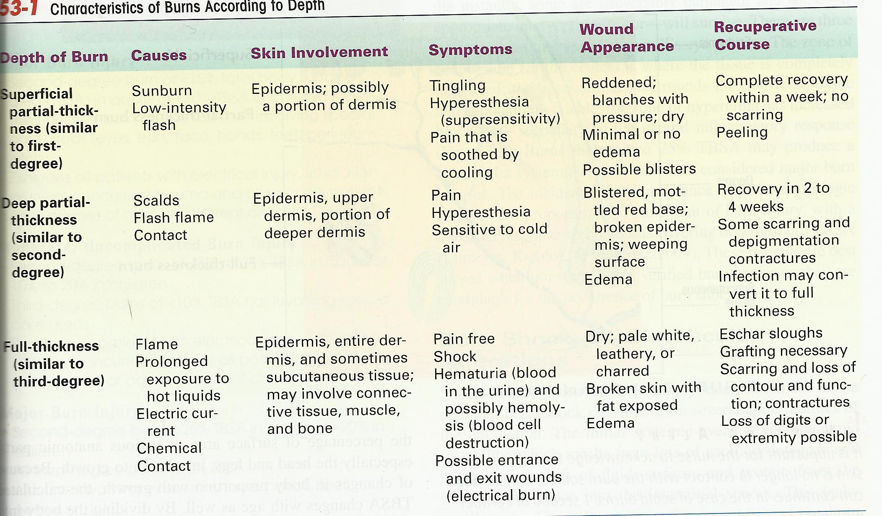

Emergent, Acute and rehabilitation Care of burn patient:
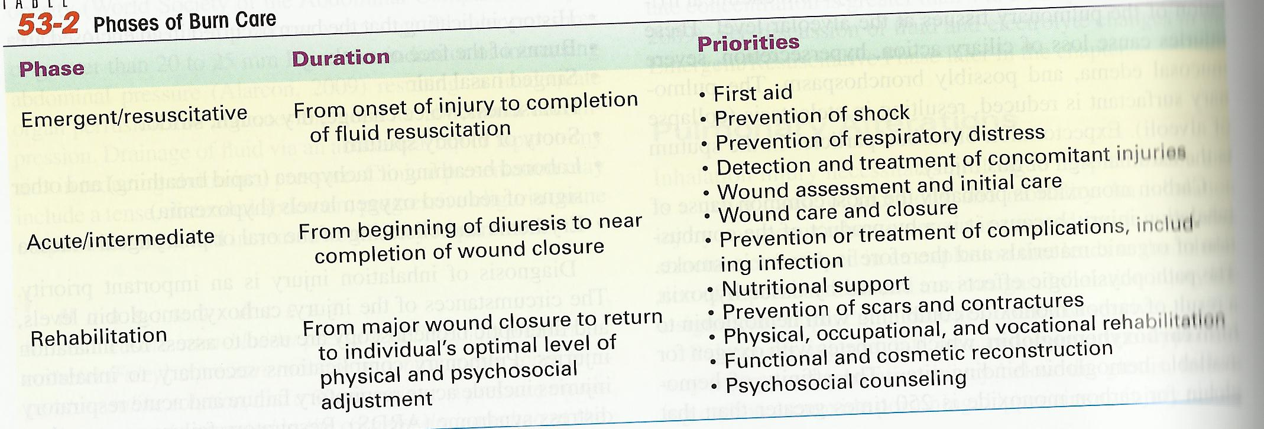
Complications of burns:
- Burn shock: cardiovascular alterations – shock = oxygen does not meet tissue demand.
- Develops from several abnormalities of the circulation:
- Hemodynamic instability – loss of capillary integrity and a subsequent shift of fluid, sodium, and protein from the intravascular space → interstitial spaces.
- ↑ cell permeability
- Progressive edema develops in unburned tissue and organs = hypoperfusion and hypovolemic shock
- Fluid loss ↑ and vascular volume ↓ = the CO (cardiac output) and BP ↓
- ↑ peripheral vascular resistance (2ndary to edema), ↓ blood volume, ↓CO
- Fluid and electrolyte alterations:
- Greatest amount loss = 24-36 hours
- Lactated ringers (LR) soln. is the preferred IV fluid for burn resuscitation – b/c sodium (130 mEq/L) and potassium (4 mEq/L) concentrations are similar to normal intravascular levels. LR also contains lactate (28 mEq/L) which can be converted by the liver to bicarbonate (the blood buffer) the aid in correcting the metabolic acidosis frequently seen in burn shock.
- Abdominal compartment syndrome (fluid shifts into abdomen)
= ↓CO, ↓BP, ↓ urine output, also …
Compresses the inferior vena cava = restricts blood flow & perfusion to abdominal organs… further compromising renal, hepatic, and visceral organ fx…
tx = abdominal decompression – drainage of fluid via tap or laparotomy = ↓pressure
- Massive systemic edema – constricting effect similar to compartment syndrome b/c the burnt skin does not yield to the edema = surgical incision into the eschar to relieve
- Circulating blood volume ↓: severe capillary leak w/ variations of serum sodium levels in response to fluid resuscitation- usually ↓Na , immediately after burn = ↑K (cell destruction) then shift to ↓K with fluid shifts, lactic acidosis b/c hypovolemia & hypoperfusion
- Pulmonary alterations: inhalation injury from superheated air and noxious gas
- Fall into 2 categories:
- Upper airway injury – results from direct heat and edema. Mechanical obstruction of the upper airway.
Tx: nasotracheal, endotracheal intubation, or tracheotomy. Emergency tracheotomy may be necessary is edema is present.
- Injury below the glottis (CO2 poisoning) – results directly from chemical irritation of the pulmonary tissues at the alveolar level. = loss of ciliary action, hypersecretion, severe mucosal edema, and possibly bronchospasm.
The pulmonary surfactant is ↓ = atelectasis (collapse of alveoli)
CO2 = tissue hypoxia b/c CO2 + hemoglobin = carboxyhemoglobin (competes with O2 for available hemoglobin- binding sites).
Tx: intubation & mechanical ventilation

- Renal alterations: as a result of ↓ blood volume
- Destruction of RBC = free hemoglobin in the urine
- Muscle damage = myoglobin released from muscle cells and excreted by kidneys
- Inadequate blood flow in kidneys = hemoglobin & myoglobin occlude the renal tubules, resulting in acute tubular necrosis and renal failure
Tx: adequate fluid volume – restores renal blood flow = ↑ glomerular filtration rate and urine volume. Monitor BUN, creatinine, and urinary output to eval. renal fx.

- Immunologic alterations: diminishes resistance to infection
- Loss of skin integrity = abnormal inflammatory factors:
Impairment of the production and release of macrophages & granulocytes from the bone marrow = immunosuppression = ↑↑ risk for sepsis!!

- Thermoregulatory alterations: loss of skin = inability to regulate body temp.
- ↓ temp (early hours after injury) … then hypermetabolism resets core temp = pt. becomes hyperthermic for most of the post-burn period (even w/o infection)

- Gastrointestinal alterations: 2 potential complications may occur:
- Paralytic ileus (absence of intestinal peristalsis): resulting from burn trauma.
- Gastric distention & nausea may lead to vomiting unless gastric decompression is initiated.
- Curling’s ulcer (gastric or duodenal erosion): gastric bleeding secondary to massive physiologic stress may be signaled by occult blood in the stool, regurgitation of “coffee ground” material from the stomach, or bloody vomitus.

MALE REPRODUCTION:

BPH- enlargement of the prostate gland that obstructs the out flow of urine.
- Couse of BPH is uncertain
- Treatment- alpha-adrenergic blockers and 5-alpha-reducase inhibitors
- Multiple surgical options also exist

Prostate cancer- rarely produces symptoms in early stages
- Screening – digital rectal examination, and prostate-specific antigen
- Treatments – include surgery, radiation, and hormonal treatments, and hormonal treatments

Surgeries for BPH and prostate cancer
- Transurethral resection of prostate
- Suprapubic prostatectomy
- Retropubic prostatectomy
- Transurethral incision of the prostate

Testicular cancer – most common cancer in young men: highly treatable and curable
- Symptoms appear gradually with a mass or lump on the testicle and painless enlargement of the testes
- Treatment is orchiectomy (removal of the testes_ and/or radiation

Peritoneal Dialysis – goal = remove toxic substances and metabolic wastes and to reestablish normal fluid and electrolyte balance
- Pts. who can’t do hemodialysis or have a transplant can benefit from this
- Can be done on an outpatient basis
- Pts. with diabetes, severe hypertension, cardio disease and older patients are likely candidates for this.
- Slower than hemodialysis so it takes longer
- Fluid is introduced into the peritoneal cavity by a peritoneal catheter.
- Complications = peritonitis, leakage, and bleeding

