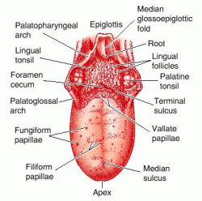
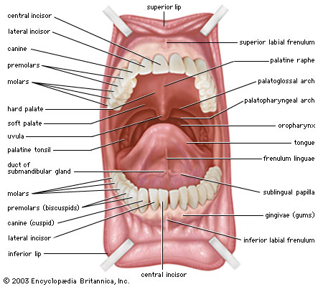
- Tonsils
  - Normal- the same pink as the oral mucosa. The surface has indentations or crypts. In some people the crypts collect small plugs of whitish cellular debris. This does not indicate infection. However, there should be no exudates on the tonsils. Normal tonsils are 1+ or 2+
    - Grading scale
      - 1+ Visible
      - 2+ Halfway between tonsillar pillars and uvula
      - 3+ Touching the uvula
      - 4+ Touching each other
  - Abnormal-tonsils are bright red, swollen, and may have exudates or large white spots. A white membrane covering the tonsils may also indicate infection. Tonsils are enlarged to 2+, 3+, or 4+ with an acute infection
- Nose
  - Inspect external nose and then nasal cavity. Test patency of nostrils. The sense of smell, mediated by cranial nerve I, is usually not tested in a routine exam. Observe nasal septum. A deviated septum is common and not significant unless air flow is obstructed. Inspect turbinates. The superior turbinate will not be in view but the middle and inferior turbinates are. They are also quite vascular and tender if touched.
  - Nasal mucosa is normally red in color with a smooth moist surface. Normally turbinates are the same light red color as the nasal mucosa.
  - Abnormal
    - Nasal mucosa is swollen and right red with an upper respiratory infection or rhinitis.
    - Discharge is common with rhinitis and sinusitis, varying from watery and copious to thick, purulent, an green-yellow
    - Which chronic allergy, mucosa looks swollen, boggy, pale, and gray
    - Epistaxis commonly comes from the anterior septum.
    - A deviated septum looks like a hump or shelf in one nasal cavity.
    - Perforation is seen as a spot of light from penlight shining in other naris and occurs with cocaine use.
    - Polyps in the turbinate are smooth, pale gray, avascular, mobile, and nontender.
- Barriers to infant tooth development and health
  - Discolored teeth appear yellow or yellow-brown with infants taking tetracycline or whose mothers took the drug during pregnancy. Teeth may also appear green or black with excessive iron ingestion, this reverses when the iron is stopped
  - Malocculusion-upper or lower dental arches are out of alignment. Anklyoglossia-short lingual frenulum, can limit protrusion and impair speech. Trauma may indicate child abuse from forced feeding of bottle or spoon
  - A high-arched palate is usually normal in the newborn, but a very narrow or high arch also occurs with Turner’s Syndrome, Ehlers-Danlos syndrome, Marfan’s syndrome, an Treacher Collin syndrome, or develops in the mouth-breather in chronic allergie.
  - With neonate, palpate for integrity of palate and to assess sucking reflex.
  - Cleft lips are the most common congenital deformities of the head and neck. Early treatment preserves the functions of speech and language formation and deglutition (swallowing)
- Structure of the abdomen location of the organs
Right Upper Quadrant  Liver, gall bladder, duodenum, head of pancreas, right kidney and adrenal, hepatic flexure of colon, part of ascending and transverse colon | Left Upper Quadrant  Stomach, spleen, left lobe of liver, body of pancreas, left kidney an adrenal, splenic flexure of colon, part of transverse and descending colon
Right Lower Quadrant  Cecum, appendix, right ovary and tube, right ureter, right spermatic cord | Left Lower Quadrant  Part of descending colon, sigmoid colon, left ovary and tube, left ureter, left spermatic cord

