A STROKE is an EMERGENCY!
Every Minute Counts so act F.A.S.T!
Face: Does one side of the face droop?
- Ask the person to smile.
Arms: Is one arm weak or numb?
- Ask the person to raise both arms. Does one arm drift downward?
Speech: Is speech slurred?
- Ask the person to repeat a simple sentence. Is the sentence repeated correctly?
Time: If the person shows any of these symptoms, CALL 911 or get to the hospital IMEMDIATELY!
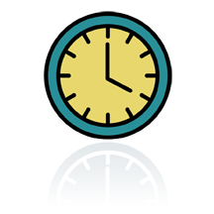


F. A. S. T.

