Community: the whole body of the people living in a city, district, country, etc.
(Webster’s Concise, 2005)

Community (defined). 2005. Webster’s Concise: English dictionary.
pp. 44. New Lanark, ML. Geddes & Grossest

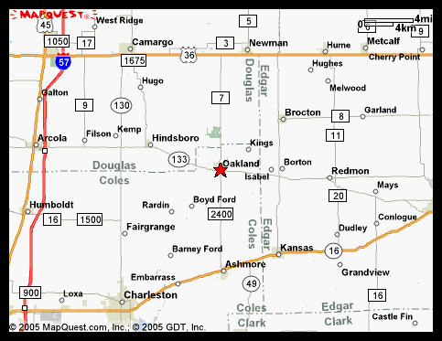
(mapquest.com)

Map of Oakland, IL. Retrieved March 12, 2011. from
http:www.mapquest.com/oaklandIL

