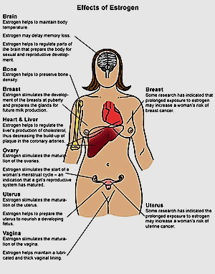Reproductive Study Guide
Hormone replacement - Estrogen only vs added progesterone, adverse effects, nursing implication
(Lehne: benefits 726-727t, discontinue 730-731, drugs 731-732, inappropriate 730, recommendations 729-730, risks 726-729; all 726-729)
- Benefits postmenopausal are suppression of menopausal symptoms and osteoporosis prevention; equine estrogen from pregnant mare urine
- Nausea most common side effect
- Two basic regimens of HRT: estrogen alone and estrogen with progesterone. Purpose of estrogen is compensation for estrogen lost from menopause. Progesterone counteracts adverse effects unopposed estrogen has on endometrium. Women who no longer have a uterus do not need progesterone.
- EPT – estrogen + progesterone (not ET) can protect against colon cancer
- Known risks of EPT: CHD; stroke, thromboembolic events, breast cancer and dementia; MI; DVT; Gallbladder disease; urinary incontinence
- Benefits of EPT: suppression of vasomotor symptoms; preservation of urogenital integrity; preservation of bone mineral density and prevention of osteoporosis fractures; decreased colon cancer risk
- Known risks of ET – estrogen therapy (safer than EPT): stroke, DVT, pulmonary embolism, ovarian cancer, uterine cancer, gallbladder disease, urinary incontinence
- Benefits of ET: suppression of vasomotor symptoms; preservation of urogenital integrity; preservation of bone mineral density and prevention of osteoporosis fractures
- Hormone replacement Therapy Approved Indications (3):
- Treatment of moderate to severe vasomotor symptoms of menopause-2-3yrs treatment
- Treatment of moderate to severe vulvar and vaginal atrophy of menopause-2-3yrs treatment; consider topical
- Prevention of postmenopausal osteoporosis- Lifelong- used only after exhausting other options
- Inappropriate use: Attempted prevention of heart disease and dementia- no evidence of cardiovasculare dementia protection : There IS evidence of cardiovascular and dementia harm
- Discontinuing HRT: when reducing dosage to stop treatment progesterone must remain the same or estrogen may stimulate endometrial growth and endometrial hyperplasia
- Nursing Implication of HRT:
- Baseline data: assess breast exam; pelvic exam; lipid profile, mammography, BP; if used for vasomotor symptoms, menopause verified with FSH level
- Identifying High Risk Patients: contraindicated for pt with estrogen dependatn cancers, undiagnosed vaginal bleed, active thrombophlebitis or thrombolytic disorders, or history of estrogen-associated thrombophlebitis; contraindicated during pregnancy
- Administration: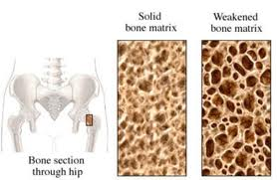
- Routes: oral; IV; transdermal and intravaginal
- Transdermal Patch: Apply to clean , dry, intact skin on ab or trunk (not breasts or waistline) by pressing firmly for 30 seconds; if patch falls off reapply same or new if necessary; remove old and replace once or twice weekly per product specs; rotate site so same is not used more than once a week
- Transdermal emulsion: apply each morning to top or both thighs and back of both calves
- Transdermal gel: once daily after showering to one arm from shoulder to wrist
- Transdermal spray: 1,2, or 3 sprays once daily to inner forearm, let dry at least 2 minutes before dressing and 30 minutes before washing
- Intravaginal cream: apply high into vagina, at bedtime, use applicator
- Intravaginal ring: insert ring as deeply as possible into vaginal vault, leave for 3 months then removed and replaced if indicated
- Ongoing Evaluations and Interventions: yearly breast and pelvic exam; minimize adverse by informing pt nausea reduced by taking estrogen with food and dosing at night; Endometrial hyperplasia and cancer: instruct provider notification if persistent or recurrent vaginal bleeding develops; Breast cancer: to minimize risks instruct pt to perform monthly self-breast exams, yearly by healthcare prof, and periodic mammograms; Ovarian cancer: advise pt to undergo periodic evaluation for ovarian cancer; Cardiovascular effects: reduce risk by advising pt to avoid smoke, regular exercise, decrease sat fats, treat hypertension, diabetes and high cholesterol

Theraputic uses of estrogen, adverse effects (Lehne: 719-721, action 720, admin 721, adverse 720-721, implications 733-734; 750-751)
Uses: Menopausal hormone
Replacement Therapy (most common)
Female Hypogonadism: In absence of ovarian estrogens, pubertal transformation doesn’t happen. Causes of estrogen defficiendy: primary ovarian failure, hypopituitarism, bilateral oopherectomey (removal of both ovaries), and Turner’s syndrome (genetic disorder impairing gonadal function). Puberty may be induced for girls with insufficient estrogen with admin of exogenous estrogens. Treatment promotes breast development, maturation of reproductive organs, and development of pubic and axillary hair. To stimulate normal patterns, low dose therapy for a year is followed by cyclic administration in higher doses.
Acne: Oral contraceptives help control acne. Treatment is limited to at least 15 yrs old desiring contraception.
Adverse Effects: Principal concerns- endometrial hyperplasia, endometrial cancer, breast cancer, cardiovascular effects. Other adverse are more of a nuisance.
Endometrial Hyperplasia and Carcinoma: associated with use of estrogens alone; concurrent use of progesterone greatly reduces cancer risk by antagonizing endometrial proliferation and reversing hyperplasia; during first 3-6 mos breakthrough bleeding is benign; if breakthrough bleeding persists or occurs after prolonged therapy evaluation of endometrial carcinoma is needed
Breast Cancer: estrogen use can cause breast cancer in postmenopausal women using estrogen without progesterone
Ovarian Cancer: Therapy with estrogen alone in postmenopausal women.
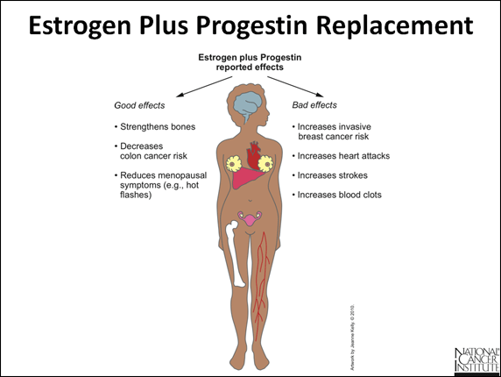Cardiovascular effects: Postmenopausal women using either estrogen alone or combined with progesterone are at increased risk for pulmonary embolism, venous thromboembolism (VTE); and stroke. Estrogen alone increases risk of MI.; Premenopausal women combo estrogen/ progesterone oral contraceptives increase risk of VTE
Nausea: Most common side effect; reduced with continued use; rarely severe; minimized when admin with food, initiate therapy at low doses, topical formulation when appropriate
Other Adverse: Gallbladder disease, jaundice, headache, chloasma (patchy brown facial pigmentation)
FSH, LH – ovulation, determination of menopause (Lehne: FSH719; LH 719)
- 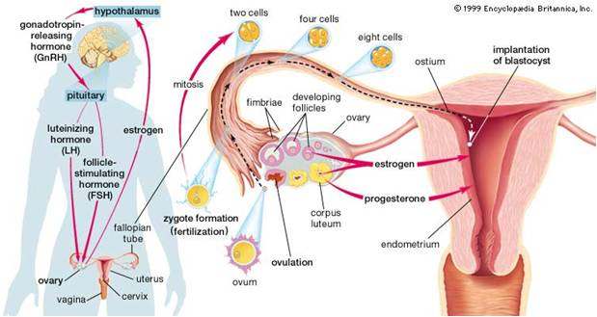FSH (follicle stimulating hormone): During first half of cycle, FSH acts on the developing ovarian follicles, causing maturation and secretion of estrogens. Resultant rise of estrogen exerts negative feedback on pituitary suppressing further FSH release.
- LH (luteinizing Hormone): At midcycle, Lh levels rise abruptly. Lh surge causes dominant follicle to swell abruptly,, burst to release ovum to abdominal cavity. Following ovulation, the ruptured follicle becomes a corpus luteum and under the influence of LH, begins to secrete progesterone.
- Determination of Menopause:
- Need 2 tests during different times of cycle
Women past menopause: | 19.3-100.6 IU/L
- Many conditions can change FSH levels. Your doctor will discuss any significant abnormal results with you in relation to your symptoms and past health.
- High values
- High FSH values in a woman may mean:
Loss of ovarian function before age 40 (ovarian failure).
Menopause has occurred. http://women.webmd.com/follicle-stimulating-hormone?page=2
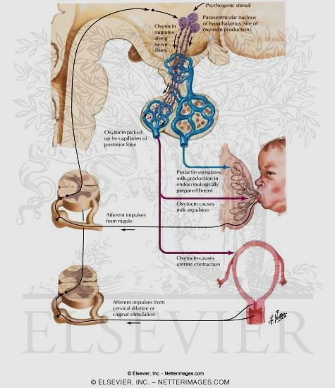Oxytocin – uses, adverse effects, administration, desired contraction patterns (Lehne 763-765)
- Promotes uterine contraction (2) stimulates milk during breastfeeding; produced in hypothalamus and stored in posterior pituitary;
- Primary use: Induction of labor near term
- Promotes renal retention of water;
- Contraindications: Improper use is hazardous; Uterine rupture may occur especially high in cases of cephalopelvic disproportion, fetal malpresentation, placental abnormalities, umbilical prolapse, previous uterine surgery and fetal distress; active genital herpes; 5 or more pregnancies (para) carries high incidence of uterine rupture
- Adverse: large doses have antidiuretic effect; rare in doses used to induce labor;
- Also used postpartum to increase uterine contractions and control bleeding or hemorrhage
- * ideal contraction are once every 2-3 minutes lasting 45 – 60 seconds

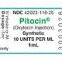Pitosin (Lehne:763-764t) ) (Lehne 763, 764t)
- Use: induction of labor beyond term (42 weeks) and in pregnancy in which early vaginal delivery is likely to decrease morbidity and mortality for mother or infant;
- Contraindications: induction should not be done if fetal lungs have not matured, or if cervix is not ripe. If fetal lungs are still immature, maturation should be hastened with a glucocorticoid. If cervix is not ripe, ripening should be induced mechanically or by membrane stripping.
- Adverse: water intoxication although at doses used to induce labor, water intoxication is rare. Dose and admin: induction of labor admin by IV; dilute solutions (eg. 10 milliunits/mL) infused at rate no more than 1-2 milliunits/min; infusion rate gradually increased (by increments of 1-2 milliunits/min every 30 to 60 minutes until uterine contractions; during infusion constant supervision is 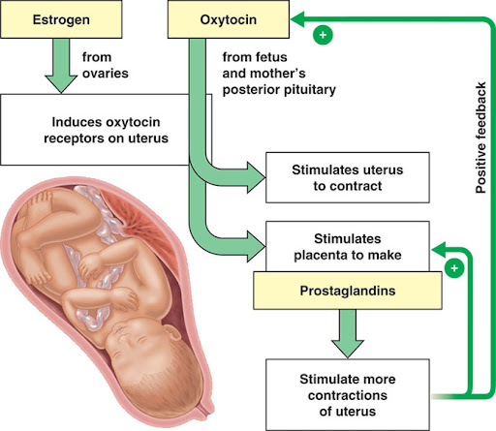required. Mother should be monitored for blood pressure, pulse rate and uterine contractility (frequency, duration and intensity). The fetus must be monitored for heart rate and rhythm. If significant fetal or maternal distress occurs, the infusion should be stopped and contractions will diminish rapidly.
- Complications that usually require interruption of the infusion are: (1) elevation of resting uterine pressure above 15-20mm Hg, (2) contractions persisting for more than one minute, (3) contractions occurring more often than every 2-3 minutes and (4) pronounced alteration in fetal heart rate or rhythm. Additional Therapeutic Uses: Augmentation of labor: In dysfunctional labor must be used judiciously. Dosage regulated with special care necessary. Usually not used to promote labor in progress because intensification of contraction force uterine rupture or trauma may be inflicted.
- Postpartum Use: IM or IV following placental delivery to control bleeding or hemorrhage and increase uterine tone. Abortion: Second trimester for incomplete abortion but is NOT method of choice. NOTE: You will see info about oxytocin/pitosin again in OB. Also information about meds for lung maturation in utero (bethamethazone).

Terbutaline (beta2 agonist– uses, side effects, topolitic agent, admin, s/e discontinuing use (Lehne: andrenergic agonist; asthma896-897; pharm 158, implications in asthma 904-905; preterm labor 761, 763t) (ATI 411,412)
- Use: to delay preterm labor although FDA has not approved for this use; Admin IV or SubQ for up to 48 hrs
- Adverse: maternal- pulmonary edema, tachycardia, palpations, chest pain, myocardial ischemia, hypotension, tremors, hypokalemia, hyperglycemia
- MOA: Selectively activate beta 2 receptors in bronchial smooth muscle causing bronchodilation when used for asthma; selectively activates beta2-adrenergic receptors resulting in uterine smooth muscle relaxation
- Uses: IV or subq used up to 48 hrs to delay preterm delivery
- S/E: Tachycardia, palpations, chest pain- monitor these beta1 side effects; Intervene based on tolerance and physiological impact; Tremors, anxiety, headache- monitor for these beta2 skeletal muscle stimulant side effects which decline with continued use
- Admin: IV or Subq due to high first pass effect of oral admin; monitor injection site for infiltration if subq
- oral meds frequently prescribed for home use
- monitor FHR; uterine contractions; maternal pulse, blood pressure, respiratory rate, lung sounds and daily weight
- limit fluid intake to 1,500- 2,400ml/24hrs
- Notify provider if contractions persist or increase in frequency
- Interactions: Concurrent use of adrenergic agonists can cause additive effects- monitor client for additive adrenergic effects (tachycardia, tremors)
- Concurrent use of beta blockers can blunt effects of terbutaline-monitor pt for negation of effects
- Contra/Cautions: Greater than 34 weeks gestation (risks outweigh benefits); acute fetal distress; severe pregnancy induced hypertension or eclampsia; vaginal bleeding; cervical dilation greater than 6cm
- S/E discontinuing: Withhold/ discontinue med and contact provider for reports of chest pain, maternal heart rate greater than 120/min, or presence of tachycardia rhythms
Tocolytic Medications: Magnesium Sulfate
- Tocolytic agent: A medication that can inhibit labor, slow down or halt the contractions of the uterus. Tocolytic agents are widely used today to treat premature labor and permit pregnancy to proceed and so permit the fetus to gain in size and maturity before being born.
- MOA: Central nervous system depressant tocolytic agent to relax smooth muscle of uterus causing fewer maternal and fetal side effects than other tocolytic agents; also prescribed for pregnancy induced hypertension; depresses central nervous system thus decreasing CNS irritability
- Use: IV to suppress preterm labor
- IV also used to manage pregnancy induced hypertension or preeclampsia
- Slow magnesium tablets may be prescribed once preterm labor has been suppressed
- Complications:
- Lethary, weakness, blurred vision, headaches- assess baseline before beginning medication; implement safety procedures; diarrhea- monitor serum magnesium levels; monitor I&O and watch for dehydration;
- Nausea and vomit- ice chips and antiemetic meds as prescribed;
- depression of deep tendon reflexes- monitor deep tendon reflexes every 2 hr.;
- decreased urinary output- monitor urinary output every 2 hr.;
- decrease in respiratory rate- monitor vital signs per hospital protocol; cardiac arrest-CPR
- Contra/cautions: greater than 34 weeks gestation (risks outweigh benefits)
- Acute fetal distress; vag bleed; cervical dilation greater than 6cm
- Interactions: no significant interactions
- Admin: Monitor closely; discontinue medication immediately if pulmonary edema develops and notify provider; monitor for magnesium sulfate toxicity and discontinue of any of the following adverse effects, which include loss of deep tendon reflexes, urinary output less than 25-30ml/hr, respiratory depression less than 12/min, pulmonary edema, and/or chest pain; Calcium gluconate should be immediately available to admin as an antidote for mag sulfate toxicity
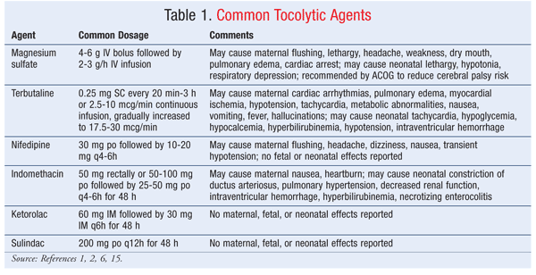

PCOS – pol cystic ovarian syndrome (Lehne: 753)
- combined endocrine metabolism disorder characterized by androgen excess and insulin resistance. Symptoms: irregular periods, anovulation, infertility, acne, and hirsutism. 50% are obese. PCOS increases risk for diabetes, cardiovascular disease and cancer of the ovaries and endometrium. Presence of cysts not required for positive diagnosis. PCOS is the most common endocrine order of young women affecting 5-10% of women of reproductive age.
- Treated with lifestyle changes and drugs. Goal: restore regular menstruation and 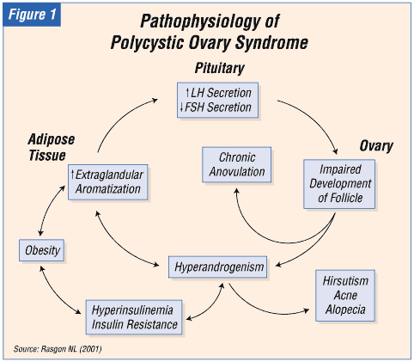ovulation, reverse hyperandrogenism (eliminating hirsutism and acne), decrease long term risks of diabetes, cancer and heart disease.
- Treatment options:
- Weight loss: reduce insulin and androgen levels, improve insulin sensitivity, restore menstruation and ovulation, increase pregnancy rates
- Clomiphene: first line drug for inducing ovulation, used alone or in combination with metformin
- Metformin: drug for type 2 diabetes, increases insulin sensitivity and decreases insulin levels, indirectly lowers androgen levels, improves glucose tolerance, ovulation and pregnancy rates
- Glitazones- rosiglitazone and pioglitazone act like metformin increasing insuling sensitivity and decreasing insulin and androgen levels; can harm fetus- do not use in pregnancy
- Oral contraceptives- restore regular periods reducing acne and hirusitism
- Spironolactone- antiadrenergic actions decreasing hirusitism and acne- can harm fetus; do not use during pregnancy
- Normal ovarian cysts from: http://www.mayoclinic.com/health/ovarian-cysts/DS00129/DSECTION=symptoms
- Most ovarian cysts start during the normal function of your menstrual cycle. These are known as functional cysts. Other types of cysts are much less common.
- Most cysts don't cause any symptoms and go away on their own. A large ovarian cyst can cause abdominal discomfort. If a large cyst presses on your bladder, you may feel 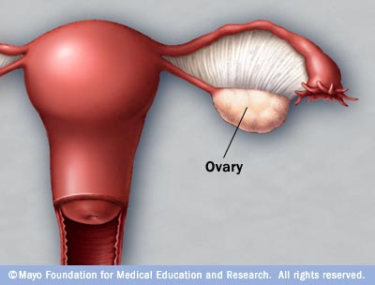the need to urinate more frequently because bladder capacity is reduced.
- The symptoms of ovarian cysts, if present, may include:
- Menstrual irregularities
- Pelvic pain — a constant or intermittent dull ache that may radiate to your lower back and thighs
- Pelvic pain shortly before your period begins or just before it ends
- Pelvic pain during intercourse (dyspareunia)
- Pain during bowel movements or pressure on your bowels
- Nausea, vomiting or breast tenderness similar to that experienced during pregnancy
- Fullness or heaviness in your abdomen
- Pressure on your rectum or bladder that causes a need to urinate more frequently or difficulty emptying your bladder completely
- When to see a doctor
Seek immediate medical attention if you have:
- Sudden, severe abdominal or pelvic pain
- Pain accompanied by fever or vomiting
- S/S -those of shock, such as cold, clammy skin, rapid breathing, and lightheadedness or weakness — indicate an emergency and mean that you need to see a doctor right away.
- Functional cysts
- 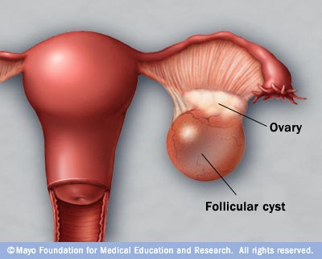Your ovaries normally grow cyst-like structures called follicles each month. Follicles produce the hormones estrogen and progesterone and release an egg when you ovulate. Sometimes a normal monthly follicle just keeps growing. When that happens, it becomes known as a functional cyst. There are two types of functional cysts:
- Follicular cyst. Around the midpoint of your menstrual cycle, an egg bursts out of its follicle and begins its journey down the fallopian tube in search of sperm and fertilization. A follicular cyst begins when something goes wrong and the follicle doesn't rupture or release its egg. Instead it grows and turns into a cyst.
- Corpus luteum cyst. When a follicle does release its egg, the ruptured follicle begins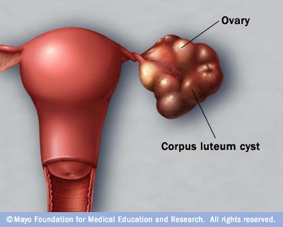 producing large quantities of estrogen and progesterone in preparation for conception. This changed follicle is now called the corpus luteum. Sometimes, however, the escape opening of the egg seals off and fluid accumulates inside the follicle, causing the corpus luteum to expand into a cyst.
- The fertility drug clomiphene (Clomid, Serophene), which is used to induce ovulation, increases the risk of a corpus luteum cyst developing after ovulation. These cysts don't prevent or threaten a resulting pregnancy.
- Functional cysts are usually harmless, rarely cause pain, and often disappear on their own within two or three menstrual cycles.
- Other cysts
- Some types of cysts are not related to the normal function of your menstrual cycle. These cysts include:
- Dermoid cysts. These cysts may contain tissue such as hair, skin or teeth because they form from cells that produce human eggs. They are rarely cancerous.
- Cystadenomas. These cysts develop from ovarian tissue and may be filled with a watery liquid or a mucous material.
- Endometriomas. These cysts develop as a result of endometriosis, a condition in which uterine endometrial cells grow outside your uterus. Some of that tissue may attach to your ovary and form a growth.
- Dermoid cysts and cystadenomas can become large, causing the ovary to move out of its usual position in the pelvis. This increases the chance of painful twisting of your ovary, called ovarian torsion
- Some women develop less common types of cysts that may not produce symptoms, but that your doctor may find during a pelvic examination. Cystic ovarian masses that develop after menopause may be cancerous (malignant). These factors make regular pelvic examinations important.
- Infrequent complications associated with ovarian cysts include:
- Ovarian torsion. Cysts that become large may cause the ovary to move out of its usual position in the pelvis. This increases the chance of painful twisting of your ovary, called ovarian torsion.
- Rupture. A cyst that ruptures may cause severe pain and lead to internal bleeding.

Thelarche Etymology: Gk, thele, nipple, archaios, beginning
- The beginning of female pubertal breast development, normally occurring between 9 and 13 years of age.
- Thelarche occurs before puberty at the beginning of the phase of rapid growth.
- Premature thelarche is precocious breast development in a female without other evidence of sexual maturation
Everything covered on the menstrual cycle chart as discussed in class (Lehne: 718-719)
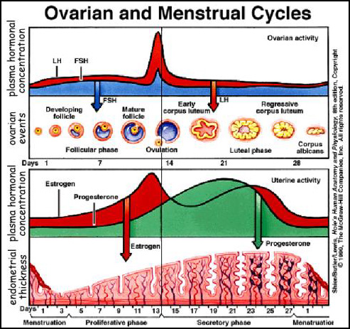
- Follicular phase- first half; Second half- luteal phase; one full cycle typically 28 days
- Ovarian events: Ovary: (1) several ovarian follicles ripen (2) one ripe follicle ruptures, causing ovulation (3) ruptured follicle evolves into corpus luteum (4) if fertilization does not occur, corpus luteum atrophies
- Parallel events of uterus: (1) while follicles ripen, endometrium prepares increasing thickness and vascularity (2) following ovulation uterus continues by increasing secretory activity (3) if nidation fails, endometrium breaks down causing menses
- Nidation- The implantation of the early embryo in the uterine mucosa.
- Roles of estrogen and progesterone: during follicular phase, estrogens are secreted by maturing ovarian follicles causing proliferation of endometrium; Midcycle one follicle ruptures evolving into corpus luteum which produces estrogens and progesterone influencing the second half of the cycle. When corpus luteum atrophies at end of cycle, production of estrogen and progesterone declines causing endometrium to break down.
- Note: spike of progesterone during last half of cycle (luteum phase) maintains endometrium for implantation; will stay high if implantation occurs; progesterone sometimes used to prevent early miscarriage
- Roles of Pituitary Hormones: 2 anterior hormones: FSN (follicle stimulating hormone & LH- luteinizing hormone play central roles in menstrual cycle; precisely timed alterations of secretion of FSH & LH coordinate structural and secretory change occurin throughout menstral cycle
- FSH: during first half of cycle acts on developing ovarian follicles causing maturation and secretion of hormones; rise in estrogen provides negative feedback on pituitary suppressing further FSH release
- 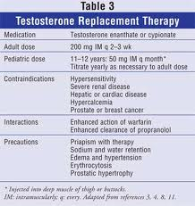LH: midcycle LH surge causes dominant follicle to swell rapidly, burst and release ovum to abdominal cavity; following ovulation ruptured follicle become corpus luteum which when influenced by LH begins to secrete progesterone
Testosterone – administration and adverse effects, uses, adverse, monitoring adverse with what bloodwork? (Lehne: Summary 771t; 769-770; androgens 771t-774; implications 776; uses in men 772; uses in women 772-773; sex 772-773
Class: Androgens
Purpose: development of sex traits in men and development of sperm; increase in skeletal muscle; increase in synthesis of erythropoietin
Therapeutic Uses: Treat hypogonadism in males; delayed puberty in boys; androgen replacement for testicular failure; post-menopausal breast cancer
Admin: IM, transdermal; implantable pellets, buccal tablets
Adverse/ complications:
- 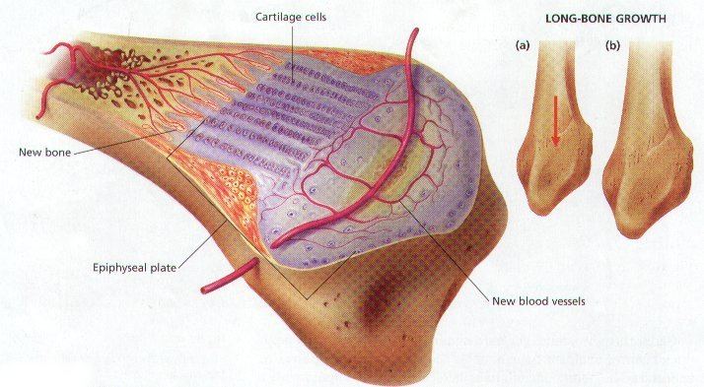Adrenergic effects: for women these meds may cause irregularity or cessation of menses, hirsutism, weight gain, acne, lowering of voice, growth of clitoris, vaginitis and baldness; Boys or men: meds may cause acne, priapism, increased facial and body hair, penile enlargement Interventions: advise of possibilities, advise women to report occurrences. Med may be discontinued to prevent permanent change
- Epiphyseal closure- permanent closure of epiphysis in boys may reduce height Intervention: Monitor epiphysis with X-rays
- Cholestatic hepatitis/ Jaundice: Monitor liver enzymes and jaundice signs (yellowing of sclera and skin)
- Hypercholesteremia- meds decrease HDL and increase LDL- monitor cholesterol; adjust diet
- Increase growth of prostate cancer- do not give to prostate cancer patients; monitor for prostate cancer
- Polycythemia- monitor hemoglobin and hematocrit
- Edema from salt and water retention- advise pt monitor weight and swelling and report to provider if occurs; med may be discontinued
- High abuse potential
Contra/Cautions: pregnancy risk category X; Contraindicated in men with prostate or breast cancer; pt with hypercalcemia; older adults; caution in pt with HF, hypertension, cardiac, renal or liver disease
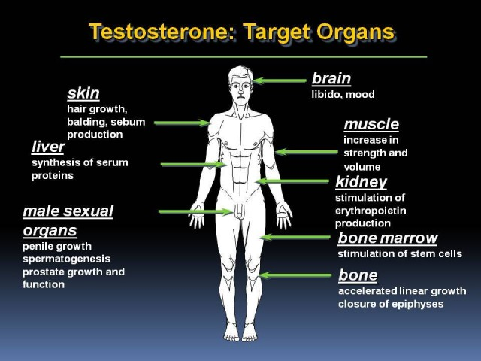Interactions:
- Androgens may alter effects of anticoagulants- monitor PT and INR
- Androgens may alter effects of insulins and antidiabetic agents- monitor glucose and adjust dosages
- Concurrent use of androgens and hepatoxic medications may increase risk of hepatoxicity- monitor liver enzymes
Contraceptive patch – limitations of use (body weight)
- Among women who weighed 90kg (198 lbs) or more, the pregnancy rate was significantly higher, suggesting the patch may not be appropriate for women in this weight group.
- The most common adverse effects are breast discomfort, headache, local, irritation, nausea, and menstrual cramps.
Prolactin
- Produced by the anterior pituitary.
- Principal function is stimulation of milk production.
- Under the influence of dopamine released from the hypothalamus, release of prolactin by the pituitary is suppressed. When release of dopamine declines, release of prolactin is allowed to increase.
- Excessive secretion of prolactin produces adverse effects in males and females.
  - Women- amenorrhea, galactorrhea (excessive milk flow), and infertility.
  - Men- Libido and potency are reduced.
  - Causes- pituitary adenoma, injury to the hypothalamus, and certain drugs (eg, antipsychotic drugs, estrogen)

Depo-provera – administration, effects on bones, risks
*Suppresses endometrium.
- Progesterone only. Lacks estrogen risks and benefits.
- Administer deep IM every 12 wks. Initiate between day 1-5 of the menses. Takes effect in 24 hrs.
- Adverse Effects
  - Unexpected bleeding (Should develop amenorrhea but this does not happen for everyone. Pt needs to know this is possible.) Injection cannot be reversed.
  - Bone loss over time (after 2-5 years)
  - Hair loss
  - Weight gain
  - Headaches
  - Depression
- Three mechanisms are involved:
  - Suppresion of ovulation
  - Thickening of the cervical mucus
  - Alteration of the endometrium such that implantation is unlikely
- D/C of injection return of fertility is delayed. Average delay is 9 months.
Gardasil injection – what does it prevent? Pt education 6, 11, 16, & 18
- Prevention of Cervical Cancer.
- Recommended for 9-26 year old pts.
- Prevents subtypes 16 & 18 (2 most common to be associated w/ cervical cancer) and 6 & 11 (cause genital wartts)
- 3 vaccines over 6 month period.
* If pts were already exposed to HPV, given this injection may cause a reoccurrence of HPV.
Lichen sclerosis *Some condition of the vulva that causes chronic itching. Biopsy shows tissue change.
- Skin disorder is common in women after menopause.
- The condition can make the opening of the vagina smaller so that sexual intercourse becomes painful.
Atrophic vaginitis
- Atrophic vaginitis is vaginal dryness due to thinning tissue and decreased lubrication.
- Atrophic vaginitis is caused by a decrease in estrogen. Estrogen levels normally drop after menopause.
- Estrogen is very important in keeping the tissues of the vagina lubricated and healthy. Normally, the lining of the vagina makes a clear, lubricating fluid. This fluid makes sexual intercourse more comfortable and helps decrease vaginal irritation.Thinning or shrinking of the vaginal tissue causes dryness and inflammation.
- The following may also cause estrogen levels to drop and lead to atrophic vaginitis:
- Medications or hormones used to decrease estrogen levels in women, as part of the treatment for breast cancer, endometriosis, fibroids, or infertility
- Radiation treatment to the pelvic area or chemotherapy
- Severe stress, depression, or rigorous exercise
- Atrophic vaginitis may occur in younger women who have had surgery to remove their ovaries. Some women develop the condition immediately after childbirth or while breastfeeding, since estrogen levels are lower at these times.
- The vagina can also become further irritated from soaps, laundry detergents, lotions, perfumes, or douches. Certain medications, smoking, tampons, and condoms may also cause or worsen vaginal dryness. For more information on these causes of vaginitis, see: Vulvovaginitis.
- S/S
- Burning on urination
- Light bleeding after intercourse
- Painful sexual intercourse causing a loss in sexual interest
- Slight vaginal discharge
- Vaginal soreness, including itching or burning sensations
Adrenal gland and puberty
- Adrenal gland is the principle organ. It becomes hyperplasic, enlarged and work more> secreting androgens= breast development.
- Begin w/ thelarche (breast development) in females
- Adrenarche- Adrenal glands work more.
- Gonadarche- End of puberty. Genitalia is ready for reproduction.
- Early puberty (Precocious puberty) in girls linked to obesity. Increased levels of leptin (a hormone secreted from adipose tissue) regulates appetite.
Testicular torsion – risks to pt
- A twisting of the testicles and the spermatic cord. The torsion causes decreased blood flow to the testes, essential strangling them of oxygen and nutrients. Occurs in boys age 10 and older. May occur in fetal development or after a baby is born.
- Comes from incomplete attachment of the testes w/in the scrotum>allowing the testes to be more movable and cause twisting.
- S/S: Acute pain, swelling, bruising in newborns, firmness in newborns, redness, high-lying testicles, nausea and vomiting, and loss of cremasteric reflex.
Tamoxifen – uses and contraindications * SERMS (selective estrogen receptor modulators)
- Commonly prescribed drug for breast cancer. Reducing the development of breast cancer in healthy women at risk.
- Blocks estrogen receptors in some tissues and activates them in others. Receptor activation leads to other beneficial effects (increased bone mineral density, reduction of LDL cholesterol, and elevation of HDL cholesterol).
- MOA:
  - Blocks estrogen receptors on breast cancer cells and prevents receptor activation by estradiol, the principle endogenous estrogen
- Has 2 treatment applications:
  - Therapy to suppress growth of residual cancer cells following therapy.
  - Treatment of metastatic disease
- Contraindications
  - Good for women ages 40-59 except for those who are at risk for thrombosis and for women who still have a uterus.
  - Women ages 60 and above this medication is not recommended because they have the highest risk for complications from the med.
- Adverse Effects
  - Hot flushes
  - Fluid retention
  - Vaginal discharge
  - Nausea
  - Vomiting
  - Menstrual irregularities
(Biggest Concern)-Endometrial cancer- Med act as an estrogen agonist at receptors in the uterus, causing proliferation of endometrial tissue= result in endometrial hyperplasia>endometrial cancer.
Leuprolide – use in prostate cancer
- Indicated for advanced carcinoma of the prostate
- May be administered daily ( Sub Q), monthly (IM), every 3 months (IM), or once a year (implant)
- MOA: provides palliation by suppressing androgen production in the testes. Sometimes referred to chemical castration because it decreases testosterone so much.
- Androgen receptor blocker can help with leuprolide by preventing cancer cells from undergoing increased stimulation during the intial phase & can block the effects of adrenal androgens
- Adverse effects – generally well tolerated. Hot flushes are the most common effect. Loss of testerone can cause impotence and loss of libido, and reducation of muscle mass and increase adipose mass. Bone loss, osteoporosis and fractures can occur – take calcium and vitamin D. bone pain and urinary obstruction may be cause by prostate cancer.

Insulin glargine
  - Long duration (at least 24 hrs)
    - Indicated for once/day subQ administration to treat adults and children w/ type 1 diabetes and adults w/ type 2 diabetes
    - Injection should be made at bedtime.
    - The med differs from natural human insulin by 3 amino acids because of these modifications the med has low solubility at physiologic pH.
    - When injected subQ it forms microprecipitates that slowly dissolve and thereby releases the med. in small amounts over and extended time.
    - Achieves blood levels that are relatively steady over 24 hrs= less risk of hypoglycemia or hyperglycemia.
    - Should not be mixed w/ other insulins and should never be given IV.

Insulin lispro
  - Long duration (at least 24 hrs)
    - Indicated for once/day subQ administration to treat adults and children w/ type 1 diabetes and adults w/ type 2 diabetes
    - Injection should be made at bedtime.
    - The med differs from natural human insulin by 3 amino acids because of these modifications the med has low solubility at physiologic pH.
    - When injected subQ it forms microprecipitates that slowly dissolve and thereby releases the med. in small amounts over and extended time.
    - Achieves blood levels that are relatively steady over 24 hrs= less risk of hypoglycemia or hyperglycemia.
    - Should not be mixed w/ other insulins and should never be given IV.

Sulfonylureas – adverse effects
- 1st generation-Tolbutamide (Orinase), Chlorpropamide (Diabinese)
- 2nd generation- Glipizide (Glucotrol, Glucotrol XL), Glyburide (DiaBeta, Micronase), Glimepiride (Amaryl)
- Sulfonylureas (prodrug-Tolbutamide, Glipizide) promote insulin release from the pancreas.
  - MOA:Increase the function of the pancreatic beta cells. Binds w/ and thereby block ATP-sensitive potassium channels in the cell membrane. Taken w/ food just prior to the meal. Can cause severe hypoglycemia. 1st generation are the worst. 2nd generations are more potent and therefore are given in low dosage and they have less drug-drug interactions
  - Therapeutic Use: Ineffective in pts w/ type 1 diabetes due to the pancreatic islets incapable of insulin synthesis. For pt w/ type 2 diabetes. Med should only be employed if blood glucose cannot be lowered by a program of caloric restriction and exercise.
  - Adverse Effects: Hypoglycemia ( requiring infusion of dextrose) Most likely in pts w/ kidney or liver dysfunction. S/S are fatigue, excessive hunger, profuse sweating, and palpitatons. Cardiovascular toxicity
  - Med should not be given during pregnancy nor women who are nursing
  - Contraindicated in the treatment of diabetic ketoacidosis.
  - Drug-Drug Interactions- Alcohol (pt may have disulfram-like reaction (flushing, palpitation, and nausea. Drugs that can intensify hypoglycemic. Beta-Adrenergic Blocking Agents (suppressing insulin release.)
  - Nursing Evaluation:
    - Glucose levels of 90 to 130 mg/dL preprandial and <180 mg/dL poatprandial
    - HgA1c<7%
    - Normotensive (<130/80mm Hg)
    - Cholestrol levels w/in normal range.

Glitazones – when not to use
Thiazolidinediones “Glitazones” (Rosiglitazone-Avandia)
*Work like sulfonureas but have less hypoglycemia. Increase Aldosterone which can accelerate heart failure in pts w/ heart disease. May have link to bladder cancer.
  - Increase cellular response to insulin by decreasing insulin resistance.
  - Therapeutic Uses: Control blood glucose levels in pts w/ type 2 diabetes mellitus. Used in conjunction w/ diet & exercise life-style changes.
  - Side Effects:
    - Fluid Retention
    - Elevations of LDL cholesterol.
    - Hepatotoxicity
  - Contraindications:
    - Use is ineffective in pts with type 1 diabetes mellitus.
    - Pts w/ severe heart failure
    - Use cautiously in pts w/ mild heart failure due to fluid retention effects.
  - Drug-Drug Interactions:
    - Gemfibrozil (Lopid)- Concurrent use resultsin inhibition of rosiglitazone metabolism, which leads to an increase for hypoglycemia.
    - Insulin-Increase risk for hypoglycemia w/ concurrent use.
  - Interventions
    - Encourage pt to consistently exercise and to follow appropriate dietary guidelines.
    - Encourage pt to maintain a log glucose levels and to note patterns that impact glucose levels.
  - Nursing Evaluation:
    - Glucose levels of 90 to 130 mg/dL preprandial and <180 mg/dL poatprandial
    - HgA1c<7%
    - Normotensive (<130/80mm Hg)
    - Cholestrol levels w/in normal range.

Vitamin D administration – therapeutic uses
- Composed of two compunds. Vitamin D3 – what is produced in humans and vitamin D2 – occurs in plants. Both forms are OTC
- Vitamin D is an important regulator of calcium and phosphorus homeostasis. Vitamin D increases blood levels of both elements primarily by increasing their absorption from the intestine and promoting their mobilization from bone. Vitamin D also reduces renal execretion of calcium and phosphate.
- Vitamin D is obtained through the diet and exposure to sunlight.
- Vitamin D defficent is below 50 nmol/l
- Insufficient is 50 – 80
- Above 80 is recommended
- Administered orally- bile is needed- if no bile then has to administered IM
- Toxicity – more common in children. S/S – fatigue,nausea, vomiting, and constipation. Constant hypercalcemia can cause kidney malfunction – polyuria, nocturia, and proteinuria. Large amounts can cause osteoporosis.
- USES – rickets, osteomalacia, and hypoparathyroidism.

Alendronate – uses, administration, pt teaching. When to discontinue
- Most commonly used biophaste, and is the prototype for the family
- Approved for postmenopausal osteoporosis, male osteoporosis, glucocorticoid-induced osteoporosis, and paget’s disease of the bone. Oral bioavailabily is poor. Although alendtonate is usually safe, esophageal ulceration has occurred in some patients.
- MOA: suppresses the reabsorbtion of the bone by decreasing the number and the activity of osteoclasts.
- ADVERSE EFFECTS: generally well tolerate, but can cause esophagitis-sometimes resulting in ulceration, It is CONTRAINDICATED in pts with esophageal disorders. This drug can also cause muscle pain, ocular inflammation and osteonecrosis of the jaew
- Should be taken in the morning on an empty stomach. No food, INCLUDING orange juice and coffee should be consumed for AT LEAST 30 mins. To AVOID ESOPHAGITIS- Take with a full glass of water, reamin upright for at least 30 minutes nad avoid chewing or sucking on the tablets

Zoledronate – iv administration
- USES & ACTIONS: it is an bisphosphate approved for hypercalcemia of malignancy (HCM), postmenopausal osteoporosis, and pagets disease of the bone. It undergoes incorporation in the bone, where it remains for years. When osteoclasts ingest the drug it inhibits there activity and prevents bone reabsorbtion. Has benefits with pts with HCM because this drug has a faster onset, longer duration, and shorter infusion (15 mins). In Osteoporosis the pt. only has to have a single dose once a year.
- Adverse effects – Most common is fever followed by nausea, constipation, dyspenea, ab pain, and bone and joint pain. Also can reduce levels of calcium, phosphorus, and magnesium. Also can be associated with bone injury most common is bisphosphonate- related osteonecrosis of the jaw – common after dentist surgeries. Renal/kidney damage can also occur.
- Administration – infusion 15 minutes or longer. Cant get a second dose for at least 7 days and only if kidney function is adequate.

Menstral hormones do what (chart)
Who should avoid oral contraceptives?
Screening prior to use of oral contraceptives

