PrepU Quick Start for Students
Logging in and using PrepU is easy. The program involves two codes: Access Code and Class Code.

If you have any questions about the registration process, call Technical Support at 1-800-468-1128 or send an e-mail to techsupp@lww.com  OR

Also our Student Video is available for reinforcement:

http://www.brainshark.com/lww/vu?pi=zFRzcUcp1zO0Oz0&

Register Using Your Access Code
1. To login to PrepU, you need an account on thePoint: http://thepoint.lww.com. If you already have an account on thePoint, click on the Return User Button to log on and skip to step 3 below.

2. If you need to create an account on thePoint, click on the New User button (above) and follow the instructions by entering your access code and building an account.
3. When you are logged in to your account on thePoint, be sure you are in the My Content tab. If you have not yet activated your PrepU access code, click on the Add a new title to My Content box to the right of the screen and follow the instructions.


4. The new PrepU title should be in your My Content tab. Click on the Student Resources link under the PrepU icon that corresponds to your new PrepU title. The site platform will appear in a new window.
5. Click on the Student Resources tab. Select the PrepU icon that corresponds to your new PrepU title. The site platform will appear in a new window.
6. Once you are in the Student Resources associated with your PrepU title (as shown on the next page), click on the link “Access PrepU for [your PrepU title].”

7. You have now entered PrepU.

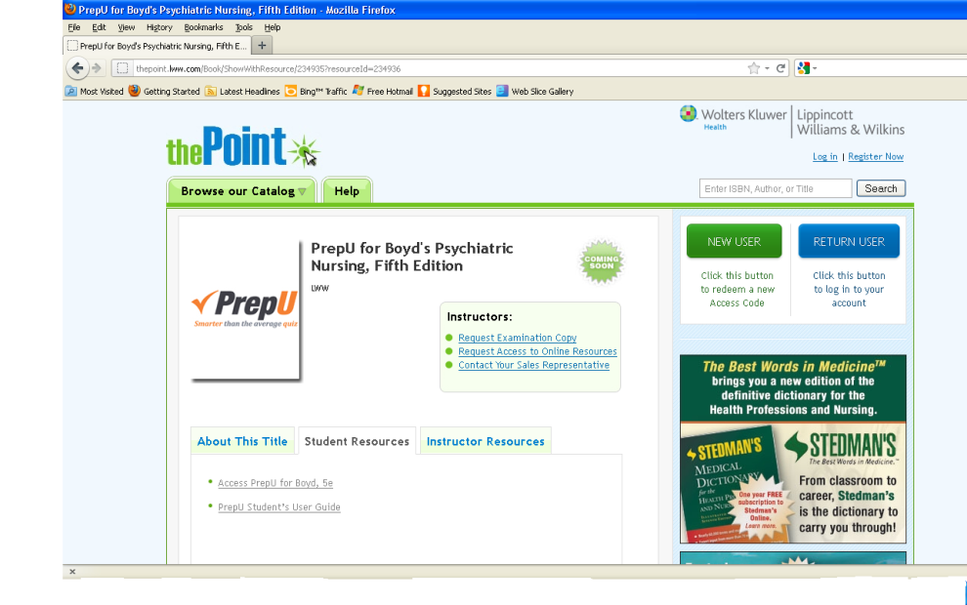
(The PrepU title here is just an example and may or may not match yours.)

*NOTE: You need to register with your Access Code ONLY ONCE and you will have continual access to your PrepU title from http://thepoint.lww.com.

Joining a Class Using Your Class Code

Each Class Code is unique and associated with a specific course. By joining a class via a Class Code, your instructor can assign you quizzes in PrepU. You need to receive your Class Code from your instructor. Once you have your Class Code:

- Click on “My Classes” at the top of the PrepU home page. Enter the Class Code, which is

Shepherd6231

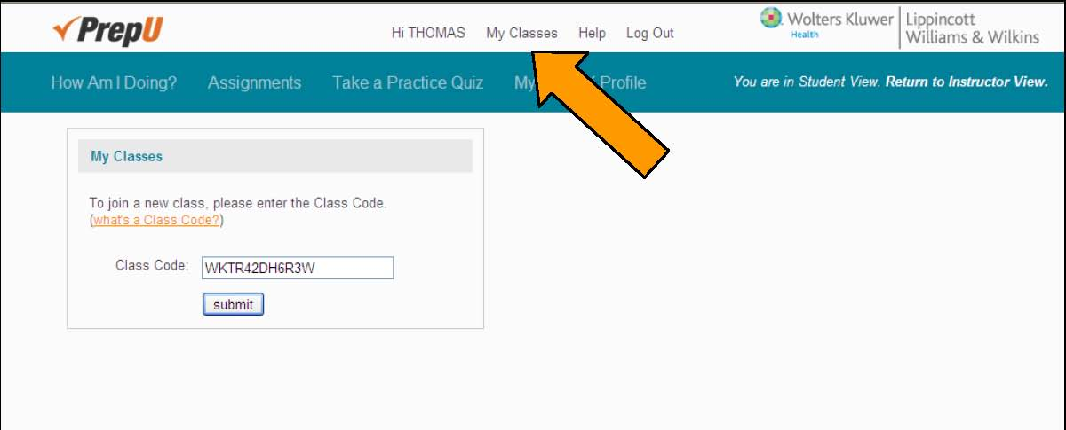

- Click Submit.

- You are now enrolled in that class!

