Preventions

Abstinance

Contraceptives
-birth control
- condoms
-plan b
Teenage pregnancy educational programs
Media
-commercials
- Advertisments

youtube video: http://www.youtube.com/watch?v=RqTGvJT-fFo

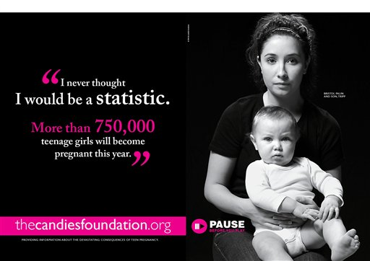

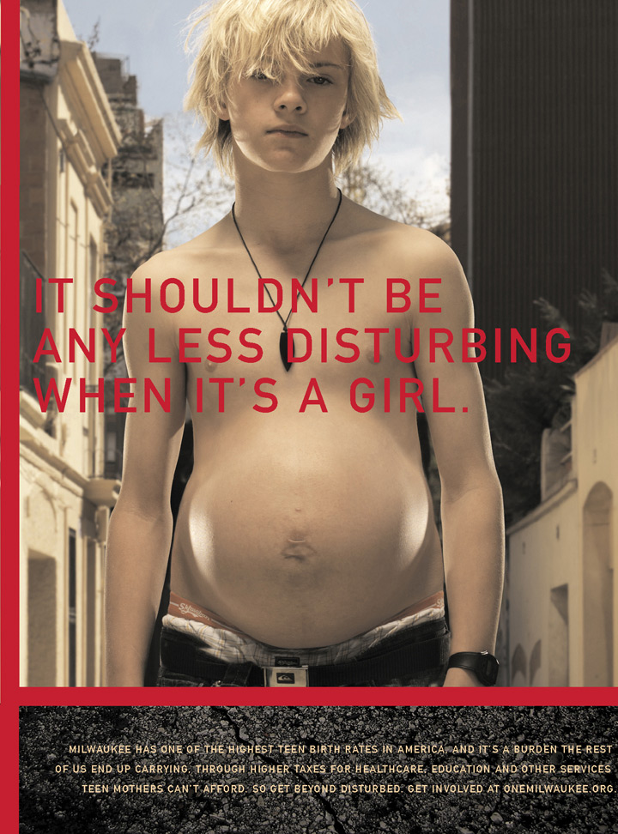

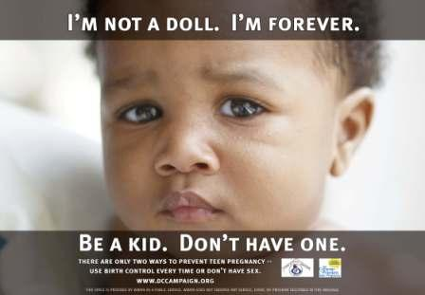

http://www.cdc.gov/teenpregnancy/PreventTeenPreg.htm

http://www.allpsychologycareers.com/topics/teenage-pregnancy-prevention.html

http://www.eiu.edu/herc/sexualhealth.php

