Placental abruption, the premature separation of the placenta from the uterus during pregnancy, is a significant contributor to both maternal and fetal mortality and accounts for approximately 12% of all perinatal deaths.18 Placental abruption has been discussed as a potential consequence of IPV19; however, empirical evidence linking the two is sparse. Common risk factors for placental abruption include advanced maternal age, hypertension, trauma, and maternal substance use. Some of these risk factors are also either directly or indirectly associated with IPV. For example, violence and assault (e.g., blunt force to the abdomen) by a partner is the second leading cause of pregnancy trauma and represents22% of all pregnancy trauma cases.20 IPV victims also report higher tobacco, alcohol, and illicit drug use,10,14 which may stem from increased levels of stress and fear associated withvictimization.9 El Kady et al.13 reported a significant link between IPV and placental abruption among nearly 5 million women identified through maternal discharge records in California between 1990 and 1999. To date, however, no study has empirically linked IPV to placental abruption after statistically controlling for other known biological risk factors for placental abruption. The current study examines factors associated with reporting IPV during prenatal care and the extent to which IPV and other risk factors (i.e., tobacco, alcohol, and drug use; preeclampsia; and gestational diabetes) are associated with pregnancy trauma and placental abruption. We examined pregnancy trauma and placental abruption, which, with few exceptions, have not been previously explored thoroughly in the literature on IPV. Our findings indicate that IPV is a large, significant, and independent predictor of pregnancy trauma and placental abruption. Indeed, controlling for both socio-demographic and health-related variables, women who reported IPV during prenatal care had more than 30 times the odds of a clinical diagnosis of pregnancy trauma and approximately 5 times the odds of experiencing placental abruption compared with women who did not report IPV. The current study supports previous research linking IPV to pregnancy trauma. 20 Previous work by El Kady et al.13 found an association between IPV and placental abruption in a population-based study; our study substantiates these earlier findings in an in-depth empirical analysis that controls. To date, very little is known about the etiology of placental abruption.14 Placental abruption is relatively infrequent, occurring in about 6.5/1000 births, but is a significant contributor to both fetal and maternal mortality.16,17 For example, perinatal mortality occurs in about 119/1000 births with placental abruption vs. 8.2/1000 among all other births.21 The high fetal mortality associated with placental abruption is due primarily to its strong association with preterm delivery. Maternal outcomes caused by placental abruption include significant blood loss, disseminated intravascular coagulopathy, and renal failure.22 (Effects of intimate partner violence, 2010).

Premature separation of the placenta occurs in only 1% of all pregnancies, yet it is an important cause of stillbirth, preterm delivery, early neonatal death and even maternal death. 1 Placental abruption accounts for 20–25% of antepartum haemorrhages. The perinatal mortality rate varies between 2% and 67%, depending on gestational age, fetal weight, and the degree of abruption. In this retrospective case-control study, we found carrier-ship of FVL, prior recurrent fetal loss, and first degree heritage of thrombosis to be significant risk factors for developing placental abruption. Other conditions known to have an increased risk of placental abruption were at similar risk as usually reported (ie smokers, intrauterine growth restriction, pre-eclampsia, and chronic hypertension). We confirmed the recent report stating an increased risk for women with first-degree heritage of venous thromboembolism. 12 In addition, we found prior repeated fetal loss as a significant risk factor for placental abruption, which is in accordance with a prior recent report. 13 also reported a high prevalence of combined thrombophilic defects in women with stillbirth. 8 In addition, our data support the established risk factors related to placental abruption. Also, the predominance of male fetal gender is in agreement with that in study by Kramer et al. 1 We conclude that FVL is a significant risk factor for placental abruption and that several anamnestic factors such as thrombosis heredity and prior recurrent fetal loss might be used to identify cases at higher risk for late pregnancy haemorrhage or premature contractions. Frequency of selected thrombophilias in women with placental abruption, 2007).

Management of abruption may require rapid operative delivery to prevent neonatal morbidity and mortality. Risk factors for placental abruption: Chronic hypertension, Multiparity, Preeclampsia, Previous abruption, Short umbilical cord, Sudden decompression of an overdistended uterus, Thrombophilias; Tobacco, cocaine, or methamphetamine use; Trauma: blunt abdominal or sudden deceleration; Unexplained elevated maternal alpha fetoprotein level; Uterine fibroids. (Late Pregnancy Bleeding, 2007)
Placental abruption is the separation of the placenta from the uterine wall before delivery. Abruption is the most common cause of serious vaginal bleeding, occurring in 1 percent of pregnancies. Neonatal death occurs in 10 to 30 percent of cases.8 Approximately 50 percent of placental abruptions occur before 36 weeks’ gestation, resulting in adverse outcomes secondary to prematurity.29 The incidence of abruption increased between 1979 and 2001, possibly as a result of rising rates of hypertension and stimulant abuse and increased diagnosis by ultrasonography.9 Risk factors associated with abruption include tobacco or cocaine Placental abruption typically manifests as vaginal bleeding, uterine tenderness or back pain, and evidence of fetal distress. Preterm labor, growth restriction, and intrauterine fetal death also may occur.30 The fundus often is tender to palpation, and pain occurs between contractions. Bleeding may be completely or partially concealed or may be bright, dark, or intermixed with amniotic fluid. Disseminated intravascular coagulation may result from the release of thromboplastin into the maternal circulation with placental separation. This occurs in about 10 percent of abruptions and is more common with fetal death. A chronic form of abruption may manifest as recurrent vaginal bleeding with episodic pain and contractions. (Late Pregnancy Bleeding, 2007)
Management: Because the unpredictable nature of abruption does not allow for controlled trials, management remains empiric. A Cochrane review found no randomized controlled trials assessing interventions for placental abruption that met inclusion criteria. Initial management includes rapid stabilization of maternal cardiopulmonary status and assessment of fetal well-being. Delay can be fatal to the fetus; 30 percent of perinatal deaths in one case series occurred within two hours of admission. Definitive management should never be delayed for ultrasound confirmation because ultrasonography is not reliable in diagnosing abruption (Figure 5). Acute blood clots and the placenta are hyperechoic on ultranography and difficult to distinguish from one another. Maternal stabilization requires serial evaluation of the hematocrit and coagulation studies to determine whether disseminated intravascular coagulation is present. Tocolysis generally is contraindicated except in mild abruption before 34 weeks’ gestation, when it may be used to allow administration of corticosteroids. A nonreassuring fetal heart tracing necessitates rapid, usually cesarean, delivery. A decision-to-delivery interval of 20 minutes or less resulted in improved neonatal outcomes in a case control study of severe abruption. Occasionally, abruption occurs during the second stage, and an operative vaginal delivery may be attempted. When fetal death occurs secondary to abruption, vaginal delivery should be the goal.37 Serial ultrasonography and antepartum surveillance in the third trimester are appropriate for women with chronic abruption because of the potential for uteroplacental insufficiency. (Late Pregnancy Bleeding, 2007)
Prevention: The incidence of placental abruption may be decreased by cessation of tobacco, cocaine, or amphetamine use, and appropriate care for hypertensive disorders of pregnancy. One trial demonstrated a reduction in the incidence of abruption with intrapartum treatment of preeclampsia using magnesium sulfate. (Late Pregnancy Bleeding, 2007)

The risk of recurrence of placental abruption in the same woman was higher after severe than mild placental abruption. After mild placental abruption, there was no increased recurrence between sisters. However, after severe placental abruption, there was a two-fold recurrence risk between sisters. The estimated heritability of severe placental abruption was 16%. Neither increased recurrence from sisters to partners of their full brothers nor from brothers’ partners to their sisters or brothers’ partners was observed. The present study revealed an aggregation in families of severe placental abruption, while mild placental abruption tended to recur to a lesser extent in the same woman and did not recur between sisters. The recurrence between sisters after severe placental abruption may be caused by persistent risk factors such as genes associated with placental abruption, while recurrence between sisters of mild placental abruption may be more incidental. The present study supports a hypothesis that placental abruption is an aetiologically heterogeneous disorder that occurs in at least two separate subsets, one clinically severe and another more mild. In future studies, it may be important to study different subtypes separately to examine whether they have different genetic or environmental risk determinants, either the subtypes analysed in the present study or clinical degrees of severity previously described. This is from a population-based study based on records of pregnancies from the Medical Birth Registry of Norway; 377 902 sisters with 767 395 pregnancies, 168 142 families incorporating 2–10 sisters, and 346 385 brothers with 717 604 pregnancies in their partners were identified. (Occurrence of placental abruption in relatives, 2009)

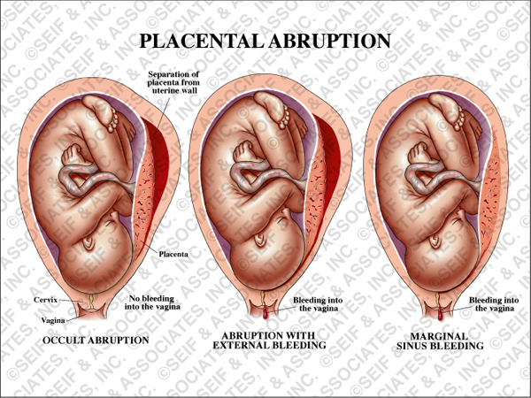
http://www.seifmedgraphics.com/placental_abruption.htm

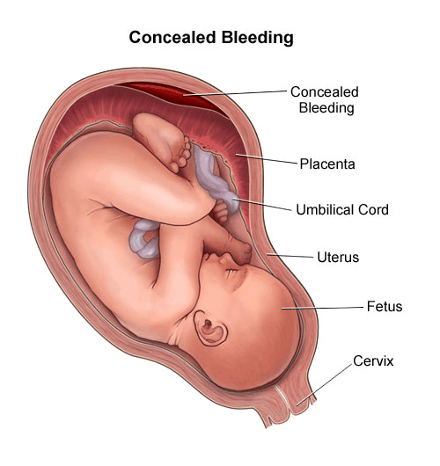
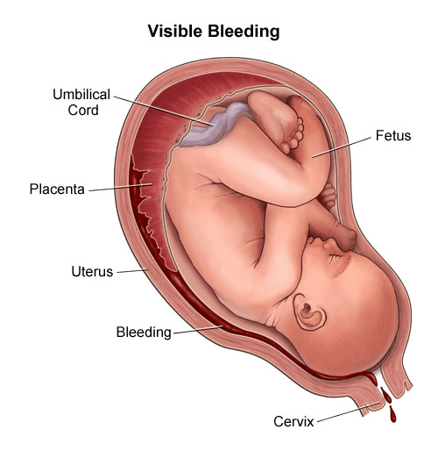
- Grade 1 - small amount of vaginal bleeding and some uterine contractions, no signs of fetal distress or low blood pressure in the mother.
- Grade 2 - mild to moderate amount of bleeding, uterine contractions, the fetal heart rate may shows signs of distress.
- Grade 3 - moderate to severe bleeding or concealed (hidden) bleeding, uterine contractions that do not relax (called tetany), abdominal pain, low blood pressure, fetal death.
Sometimes placental abruption is not diagnosed until after delivery, when an area of clotted blood is found behind the placenta.
http://www.chop.edu/healthinfo/bleeding-in-pregnancy-placenta-previa-placental-abruption.html

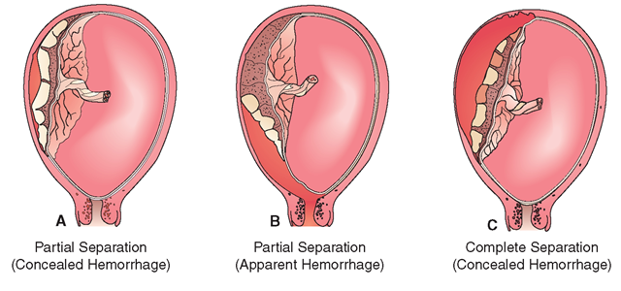
http://what-when-how.com/nursing/high-risk-pregnancy-and-childbirth-maternal-and-newborn-nursing-part-3/

