Nursing Theorists
Patricia Benner
Benner’s theory focuses on the acquisition of knowledge over a period of time as well as the “know-how” in nursing practice.
Based on the Dreyfus model of skill acquisition, Benner developed the following:
Stage | Skill Acquisition
Novice | The nurse has no background or experience in the situation. Expert nurses outside of their specific specialty can be viewed as a novice in any given situation, although this stage is generally referring to the student nurse.
Advanced Beginner | During this stage, the nurse has had some exposure to similar situations and can demonstrate marginally acceptable skills and may require some coaching from a mentor. This nurse can often grasp the concepts. This is a rule and task oriented stage. Nurses in this stage are often focused on their abilities and less on patient needs and responses.
Competent | During this stage, the nurse is more deliberate and conscious of the patient needs. In this stage, nurses become more consistent, predict outcomes, and work on time management. It is the most critical stage in clinical learning as this stage is reflective of the ability to process information and know what elements of a situation warrant action which elements can be ignored.
Proficient | The nurse views situations holistically. Intuition becomes a new component of nursing care as the nurse becomes more comfortable with knowledge, skills, and situations. During this stage, the nurse exudes confidence and is more involved with the patient and family.
Expert | At this stage, the nurse is more aware of intuition and the ability to predict the range of a given situation without losing time to process information in an analytical format. Nurses can recognize patterns earlier based on previous experiences and often times have difficulty articulating a methodical process by which they provided care in a given situation because it becomes internalized.
(Tomey & Alligood, 2006)
This can be useful when evaluating student clinical performance.

Jean Watson—Theory of Caring
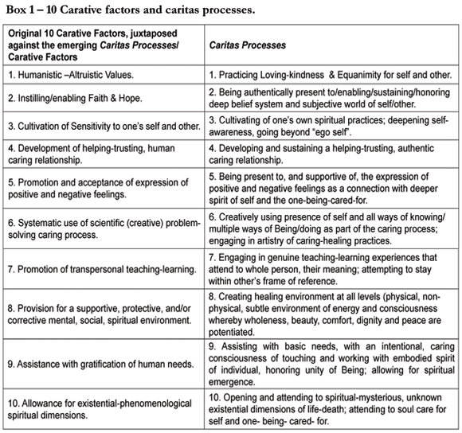
Retrieved from:
http://www.scielo.br/scielo.php?pid=S0104-07072007000100016&script=sci_arttext

Nola Pender—Health Promotion Model
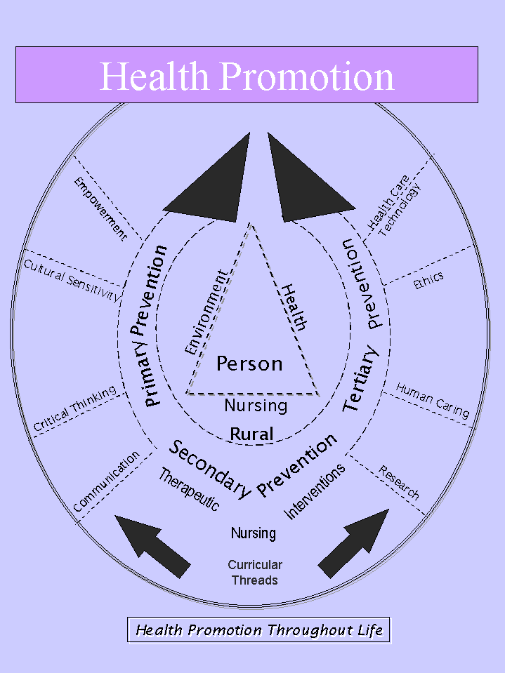
Retrieved from:
http://chhs.georgiasouthern.edu/nursing/?link=overview/overview_about&sm=0

Sister Calista Roy—Adaptation Model
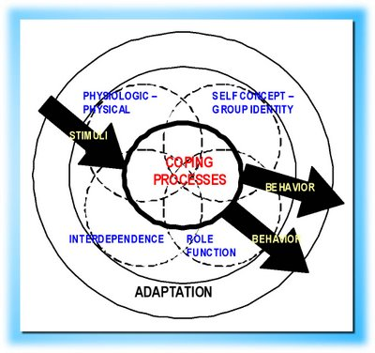
Retrieved from:
http://nursingtheories.blogspot.com/2008/07/sister-callista-roy-adaptation-theory.html

Ida Orlando—Nursing Process Theory
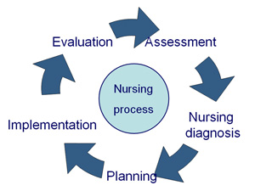
Retrieved from:
http://nurseslabs.com/nursing-nursing-related-theories-theorists-an-ultimate-guide/
Madeliene Leininger—Transcultural Nursing
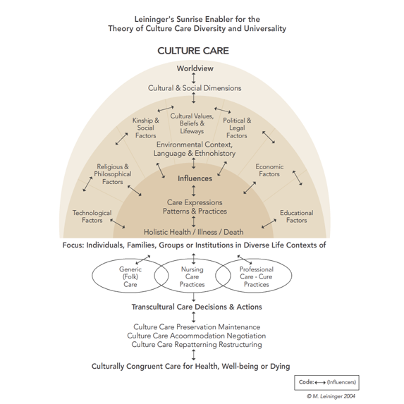
Retrieved from:
http://media.capella.edu/CourseMedia/MS6006/CulturalCompetencePractice/interactive_ts.html

