Prevent age-associated diseases
Improve self-concept and confidence
Alleviate symptoms associated with depression

Exercise can…
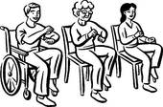
Reduce of symptoms of anxiety
Improve social skills

Reduce blood pressure and lower cholesterol
Decrease Risk of Falling
Increase independent mobility
Make your bones stronger
Promote weight loss

