Prevent age-associated diseases
Improve self-concept and confidence
Alleviate symptoms associated with depression

Exercise can…
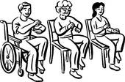
Reduce of symptoms of anxiety
Improve social skills

