14/15

Case Study
Khoa Dang Nguyen
Lakeview College of Nursing
N309 Gerontology
April 21, 2012

Case Study
- According to the American Cancer Society (2011), “the goal of hospice is to help patients live their last days as alert and pain-free as possible. Hospice care tries to manage symptoms so that a person’s last days may be spent with dignity and quality, surrounded by their love ones” (American Cancer Society, 2011, p. 2.). In a hospice care facility, nurses and staff members do not treat the patients’ illness or cure their illnesses. Instead, hospice care focuses on the well-being of the patient and provides an environment that is comfortable and free of stress. In other word, hospice care is place for elders who want to live with the best quality of life with their remaining of time while having family members around.
- According to the American Cancer Society (2011), “Hospice care is used when you can no longer be helped by curative treatment, and you are expected to live about 6 months or less if the illness runs its usual course. You, your family, and your doctor decide together when hospice cares should begin” (American Cancer Society, 2011, p. 4). After all the medical treatment has failed to cure the patients’ illness, the doctor and the patient usually began to discuss the option of hospice care. Patients who usually enter a hospice care program have a remaining life time of several months.
- According to the American Cancer Society (2011), “In most cases, an interdisciplinary health care team manages hospice care. This means that many interacting disciplines work together. Doctors, nurses, social workers, counselors, home health aides, clergy, therapists, and trained volunteers care for you and your family. Each of these people offers support based on their special areas of expertise” (American Cancer Society, 2011, p. 5). By having multiple professionals working on the patients, the patients would be adequately cared for. With everyone having their special skills, the patient will have the best quality of life with their remaining time.
- According to American Cancer Society (2011), “The doctor must re-certify the patient at the beginning of each benefit period (2 periods of 90 days each, then an unlimited number of 60-day periods). The patient signs a statement that says he or she understands the nature of the illness and of hospice care, and that he or she wants to be admitted to hospice. By signing the statement, the patient declines Medicare Part A and instead chooses the Medicare hospice benefit for all care related to his or her cancer. The patient can still receive Medicare benefits for other illnesses (American Cancer Society, 2011, p. 6)
According to American Cancer Society (2011), “Most states have a Medicaid hospice benefit, which is patterned after the Medicare hospice benefit. Most private insurance companies include hospice care as a benefit. If insurance coverage is not available or is not enough to cover all costs, the patient and the family can hire hospice providers and pay for services out of pocket. Some hospices provide services without charge if a patient has limited or no financial resources” (American Cancer Society, 2011, p. 6).
- 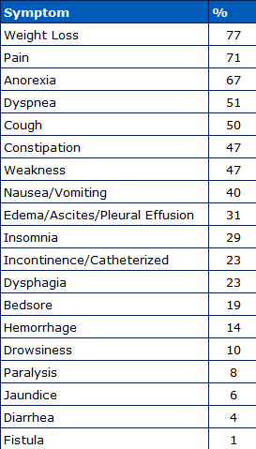 Table from Hospice Education Institute, 1985
- Reassure Jane that the primary goal of the hospice care is to help patient live their last days as alert and pain-free as possible. Explain to Jane that there will be nurses who will make sure that Jane spend her the rest of her life with her love ones around her to make her feel safe and comfortable. Elaborate about how the care team will have 24 hours a day, 7 days a week observation making sure she is happy and stress free.
- Tell the family that it is not true. Explain to the family that if Jane’s health gets better and the illness goes into remission, the family can take Jane out of the hospice program and place her in a rehabilitation center where the doctor can begin treating her. Also, I would mention that the family may also bring Jane back into hospice care if they wish. Lastly, I would restate the purpose of hospice care is to ensure quality of life and making her lasts days the best days of her life.
- A patient who is alert and oriented is the one who makes the decision to accept or decline hospice services. In this case, Jane is the person who will be making the decision whether or not to accept hospice care. In the case if the patient is not alert and is not able to make decision for themselves, then the family or the power of attorney is the one who makes the decision for the patient since they know what is best for their love one.
Reference
American Cancer Society. 2011. Hospice care. Retrieved from http://www.cancer.org/acs/groups/cid/documents/webcontent/002868-pdf.pdf
Kaye, P. 1985. Principles of symptom control. Hospice Education Institute. Retrieved from: http://www.hospiceworld.org/book/principles_of_symptom_control.htm

