- Hemodynamics – the physical factors that govern blood flow
  - Pressure-force exerted on liquid. Blood flow depends on the difference between pressures in the arterial and venous vessels supplying the organ. Fluid moves from the arterial side of the capillaries (greater pressure), to the venous side (lesser pressure)
  - Resistance- opposition to force. Most opposition to blood flow is provided by the diameter and length of the blood vessels. Changes in blood flow through an organ result from changes in the vascular resistance within the organ= increased resistance leads to decreased blood flow
- Anatomy and Physiology of the Heart
  - Superior Vena Cava-Right atrium-right ventricle- pulmonary arteries- Lungs-pulmonary veins-left atrium-left ventricle-Body
  - 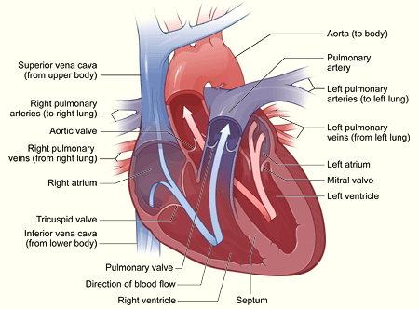
  - Five stages of the cardiac cycle
    - Atrial systole- opening of mitral and tricuspid valves and ventricular filling from atria. The ventricle fill rapidly in early diastole and again in late diastole when atria contract
    - Ventricular systole. Contraction pushes AV valves shut.
    - When ventricular pressure reaches that of the pulmonary artery and aorta, the semilunar value open and ventricular ejection occurs. Intraventricular pressure and ventricular volume decrease rapidly
    - Aortic valve closes with ventricular relaxation and decreased ventricular pressure
    - Mitral valve opens and passive ventricular filling occurs when left ventricular pressure decrease
    - Diastole-ventricular filling; relaxation
    - Systole- contraction that propels blood from ventricles into circulation.
- Atrial Kick- the last contraction that the atrium makes as it sends the blood into the ventricle. As it makes this last contraction, the ventricle takes over and draws in the blood. This allows the ventricle to fill with blood.
- Circulatory Conduction
  - SA node-pacemaker of the heart. Located at the junction of the right atrium and superior vena cava, just above the tricuspid valve. Normal electrical impulses come from here.
  - Then the impulse travels to the AV node, bundle of HIS, bundle branches, Purkinje fibers
  - Arteries- higher pressure, more muscular. Arteriole- regulatory valves. Capillaries-sight of most exchange. Venules- collect blood from capillaries. Veins-Lower pressure, more distendable
- Cancer-Risk Factors
    - Genetics, sedentary lifestyle, obesity,
    - Diet-tobacco, alcohol, high fat, red meat, processed meats, high carbs, vitamin deficiencies.
    - Radiation, exposure to chemicals, air pollution
- Concepts of Drug Therapy
  - Pharmacotherapeutic- prevent, treat diseases. Prevent pregnancy
  - Clinical pharmacology-study of how drugs intact with humans
  - No drug completely safe. Nurse is the last line of defense against medication errors.
  - 6 right- drug, patient, dose, route, time, documentation
  - Selectivity- works on target organ with little systemic adverse effects. The more specific, the les side effects
  - “empty stomach”- one hour before or two hours after a meal
  - Ideal drug- effective, safe, selective, predictable…

