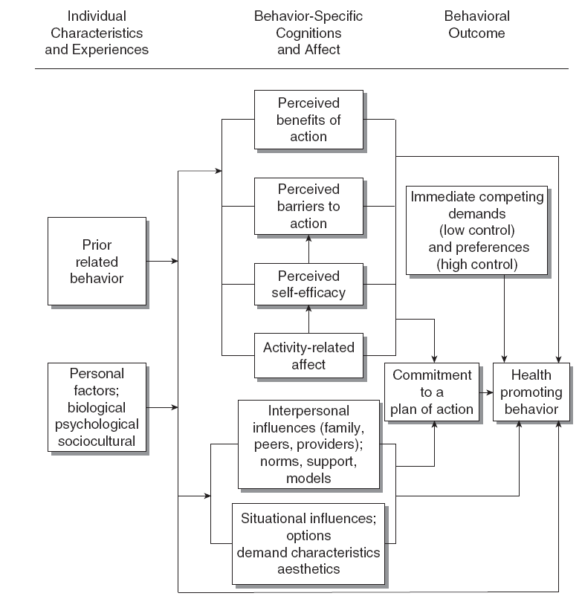
Health Promotion Model

(Sitzman & Eichelberger, 2004)
Hey you can add the 1st page to the PowerPoint. I thought it would be easier to see on the powerpoint instead of drawing it out on a poster board.
This is the only slide I will need --- I’m just going to have note cards and explain each box of the model.

The model came from:
Sitzman, K., Eichelberger, L. (2004) Understanding the work of nurse theorists: A creative beginning. Sudbury, MA: Jones & Bartlett.

