Health History
Holly Robson
Lakeview College of Nursing
Health Assessment
February 20, 2011

Health History
Date of History:
January 29th, 2011
Biographical Data:
Patient is a 54 year old female born in Chicago Illinois. She is married to A.R. and they currently reside in a retirement community. She is a collection specialist with Chase Bank. She is a non denominational Christian.
Source of History:
Patient herself, who seems reliable
Reason for Seeking Care:
“Throat closes up every time perfume or fragrance is present” for past 3 years.
History of Present Illness:
Starting in December of 2007 the throat closes up and skin breaks out in hives every time a person wearing a fragrance comes by. Skin starts to get burning feeling and breathing becomes very difficult. Sometimes difficulty of breathing become severe and patient needs to be escorted out of the room. Condition is only present when fragrances are around and lasts only as long as the fragrance does, hives subside a few minutes later. First noted at Christmas in 2007 when relative came near wearing a strong fragrance. Patient believes she may have a fragrance allergy. Has not done anything besides leaving the room to try and relieve symptoms.
Past History:
Patient’s general state of health has been good. Had chickenpox as a child and got mono twice as a teenager. As an adult has been illness free besides the occasional cold. Has no mental illness or history of mental health issues. Suffered broken leg as result of car accident at age of 29, no other accidents or injuries. Had dental surgery as a teen to remove wisdom teeth. No other surgeries or hospitalizations. Pregnancies: Grav 5, term 3, preterm 0, ab 2, living 3. No immunizations as a child that are remembered. Currently gets yearly flu shot. Last physical exam 2005. Known cat allergy that causes itchy eyes. Not currently on any medication.
Current Health Status:
Patient is currently not on any medications. Takes a woman’s daily multivitamin and drinks an herbal tea to boost her immune system. Has no known medication allergy. Eats a well balanced diet and exercises twice weekly and takes dog for mile long walks nightly. Has trouble sleeping at night about once a week. Does not smoke or use other substances. Has 3 glasses of wine a week.
Family History:
Patient has family history of heart disease from her father and paternal grandfather. History of diabetes with maternal grandfather. Patient has no history in family of asthma, hypertension, bronchitis, stroke, kidney disease, arthritis, anemia, headaches, mental illness, seizure disorders, or tuberculosis. Patient’s father was an alcoholic and had died in 1995 lung cancer; he smoked for 50 years. Mother is 76 and is in excellent health. Patients maternal grandfather died of heart failure and unsure of other grandparents. Patient has one brother and he has brain cancer. All three kids are alive and healthy, one daughter is anemic.

Family Genogram:
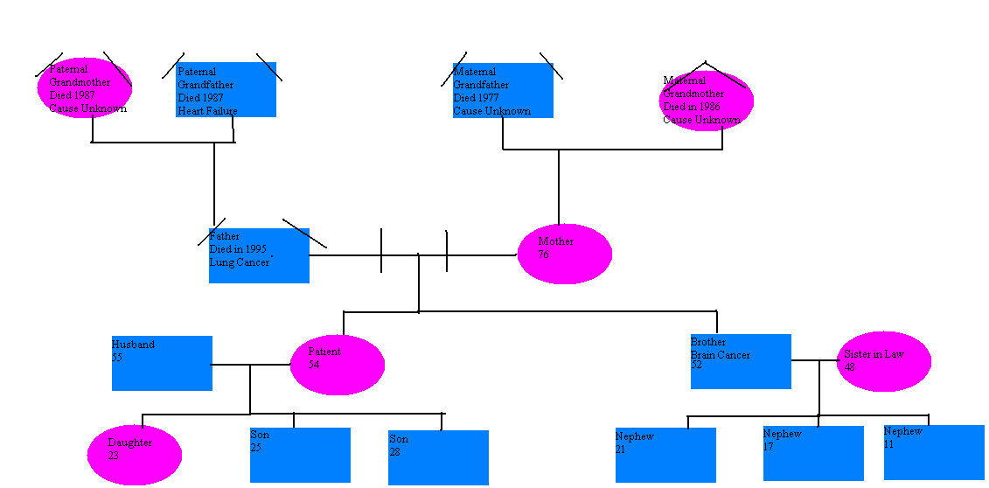
Psychosocial History:
Patient has good home situation with husband. One child lives out of state while two youngest are away at in state schools. Daily life over 24 hour period: Wakes up at 5:00 PM and gets ready for work. At 7:30 she drives to her job as a collections specialist where she sits behind a desk until 5:00. From there she drives home, reads the paper, makes dinner, watches the news, takes the dog for a walk and goes to bed around 10:00. Patient states often times she falls asleep in the chair watching the news and moves to bed when her husband gets home around 11:00. Patient states her greatest life experiences have been the birth of her children and are what inspired her to start eating and living as healthy as possible. Religious beliefs are not relevant in care as her reliegion does not put any restrictions on medical treatment. Patient outlook on present is bad because she is no longer able to go most places in public such as church or movies in fear that her throat will close due to fragrances. She states she no longer goes over to friends houses and cannot dine out with her husband any more, one of her favorite things to do, because every where she goes there seems to be scented candle or fragrance in the air. She is however hopeful about future and feels good that doctors will find a way to manage her symptoms.
Review of Systems
- General Overall Health State: Present weight 164, no current gains or losses. No fatigue, weakness or malaise, fever, or chills. Has been experiencing sweats and night sweats but is currently going through menopause.
- Skin: Presence of Rosacea on face since her mid 30’s. No presence ofcurrent pigment or color change and no change in moles. Skin on face has been drier than usual in recent years. No bruising rashes or lesions.
- Hair: No presence of changes in hair color or texture. No change in nail color, shape or brittleness either. Patient goes tanning twice during the winter months and frequently sun bathes in the summer. Applies lotion to skin daily.
- Head: Does experience frequent mild headaches, but is not unusual for patient to get them. Has never had a severe head injury. Does get occasional dizziness when standing up too quickly.
- Eyes: Patient has no change in difficulty with vision, decreased acuity, bluring or blind spots. No eye pain, double vision, redness or swelling. Patient does experience watering and discharge when going outside in the winter more recently with the winter weather. No presence of cateracts or glaucoma. Patient wears glasses. Has had vision and glaucoma check within the last five years.
- Ears: Patient has no presence of earaches, infections, discharge or tinnitus. Patient does have presence of dizziness when standing up quickly. Patient has no hearing loss and states that ears are cleaned at least once a week with a cotton swab.

