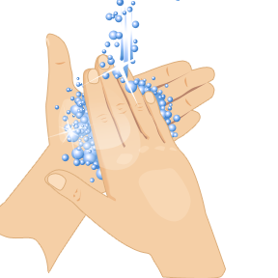
HAND HYGIENE

- The importance of hand washing
- Keeping hands clean through improved hand hygiene is one of the most important steps we can take to avoid getting sick and spreading germs to others. Many diseases and conditions are spread by not washing hands with soap and clean, running water. If clean, running water is not accessible, as is common in many parts of the world, use soap and available water. If soap and water are unavailable, use an alcohol-based hand sanitizer that contains at least 60% alcohol to clean hands.

- The proper way to wash your hands

- Wet your hands with clean, running water (warm or cold) and apply soap.
- Rub your hands together to make a lather and scrub them well; be sure to scrub the backs of your hands, between your fingers, and under your nails.
- Continue rubbing your hands for at least 20 seconds. Need a timer? Hum the "Happy Birthday" song from beginning to end twice.
- Rinse your hands well under running water.
- Dry your hands using a clean towel or air dry them.

