Health assessment final study guide:
32. Changes in breasts with pregnancy (pg#386):
Start during the second month, and are an early sign of pregnancy for most women
• Stimulates the expansion of the ductal system and supporting fatty tissues as well as development of the true secretory alveoli =
o Breasts enlarge = feel more nodular
o Nipples are larger, darker, and more erectile
o The areolae become larger and grow darker brown as pregnancy progresses
o The tubercles become more prominent
o A venous pattern is prominent over the skin’s surface
• After the 4th month:
o Colostrum may be expressed (thick, yellow fluid that is the precursor for milk, containing the same amt. of protein and lactose but practically no fat … also… rich with antibodies that protect the newborn against infection)
o Produce colostrum for the first few days after delivery, milk production begins 1-3 days postpartum.
33. Auscultation technique when listening to lungs (pg#433):
The anterior chest- breath sounds:
• Auscultate the lungs fields over the anterior chest from the apices in the supraclavicular areas down to the 6th rib.
• Progress from side to side as you move downward, and listen to one full respiration in each location.
• Use the sequence indicated for percussion:

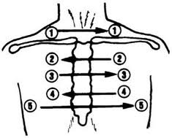
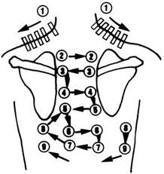

Wheezes vs. rhonchi vs. rales (pg# :
Bronchophony vs. whispered pectoriloquy (see table 18-7 on pg#446):
Bronchophony: ask the person to repeat 99 while you listen with the stethoscope over the chest wall; listen especially if you suspect pathology
Normal = voice transmission is soft, muffled, and indistinct; you can hear sound through the stethoscope but cannot distinguish what is being said.
Abnormal = pathology that increases lung density will enhance transmission of voice sounds; so you auscultate a clear 99. The words are more distinct than normal, and sound close to your ear.
whispered pectoriloquy: ask the person to whisper a phrase like “apple pie” or “baseball” as you auscultate
Normal = faint, muffled, and almost inaudible.
Abnormal = with only small amounts of consolidation, the whispered voice is transmitted very clearly and distinctly, although still somewhat faint; it sounds as if the person is whispering right into your stethoscope.
How to assess carotid arteries in an older adult (pg#465 & 471):
For patients middle age or older who show symptoms or signs of cardiovascular disease:
- Auscultate each carotid artery for the presence of a bruit (blowing, swishing sound indicating blood flow turbulence; normally none is present)
- Avoid compressing the artery because this could create an artificial bruit, and it could compromise circulation if the carotid artery is already narrowed by atherosclerosis.
- Ask the person to take a deep breath, exhale, and hold it briefly while you listen so that tracheal breath sounds do not mask or mimic a carotid artery bruit.
S1, S2, S3, S4 heart sounds- where heard in cardiac cycle (pg#477-478 & 490):
S1: signals the beginning of systole.Heard loudest at the apex, 1st heart sound caused by closure of AV valves,
**S2: heard loudest at the base, closure of the semilunar valve, second heart sound cannot find occurrence
S3: (ventricular gallop: occurs with heart failure and volume overload): occurs in early- mid diastole during the rapid filling phase.
S4: (atrial gallop: occurs with CAD): occurs when the atria contract in late diastole.

