Legacy Project: Marcia Smith
Gwena Zike
October 24, 2010
Lakeview College of Nursing

On July 3, 1951 Alonzo and Mary (Everett) Reardon started their own family with the birth of their daughter Marcia Kay. Mary gave birth to Marcia in the basement of a doctor’s office in Effingham, Illinois. The local hospital, St. Anthony’s, had burnt in April of 1949 and the new hospital had not yet been constructed. Two hours after being born Marcia, along with her parents returned home to their apartment in Effingham, Illinois. Marcia was a few months old when the family made the move to Mattoon, Illinois.
Marcia was not an only child for long and over the years she became a big sister to siblings Dennis, Steve, Rhonda, and half-sister Angie. Marcia has fond memories of school especially when thinking about her second grade teacher Mrs. Day. Mrs. Day was a kind hearted woman and took an interest in young Marcia and made her feel special. Marcia was influenced greatly by her Aunt Betty who was kind and compassionate. Aunt Betty took Marcia under her wing and taught her many things including how to cook.
In high school Marcia’s favorite subject was history, especially the history of the Civil War. Marcia is a petite lady and when asked about whether she participated in sports she laughed and replied, “No I was always too short”. Marcia’s first date was to a high school dance with a classmate when she was 16 years old. She proudly admits to being a Beatles fan while in high school but her musical tastes now include hit rock music from the 80’s and even Lady Gaga. Her favorite clothing fad was granny dresses like those worn by the cast of “Little House on the Prairie”.
On June 22, 1969 Marcia became a mother. To this day she isn’t sure about many of the events surrounding her labor and subsequent delivery. She agrees that this fact may be contributed to both mental block and the use of gas during labor. Marcia woke up from a post-partum gas fueled nap and was surprised to see a nurse on the right side of her bed holding a baby and a nurse on the left side of the bed holding a baby. Congratulations Marcia, you have twins! Marcia named her daughter Lori and her son Brad. The twins were born three weeks early and had no health problems.
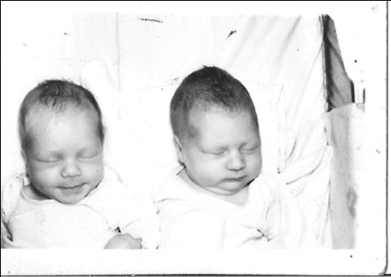
Figure 1. Brad and Lori
Prior to the birth of her twins Marcia worked for the Embarrass River Basin agency and the Mayor’s office. She was a receptionist and did clerical work at this job until two days before she gave birth. She made approximately $1 an hour at this job. After a short post-partum recovery period Marcia began working at the General Electric plant in Mattoon, Illinois. She lived in a small apartment with the twins and kept busy between working and caring for two infants. On March 6, 1970 Marcia married Curt Betty a Specialist in the United States Army. In the fall of 1971 the Betty family found two things looming in the horizon, the upcoming birth of their child and Curt’s deployment overseas. Curt’s concerned grandmother wrote a compelling letter to then President Richard Nixon who changed Specialist Betty’s orders so that he would not have to leave his pregnant wife and family. They welcomed Sean into their lives on November 1, 1971. After Sean’s birth the Betty family moved to Denver, Colorado for a while and then returned home to good old Mattoon, Illinois.
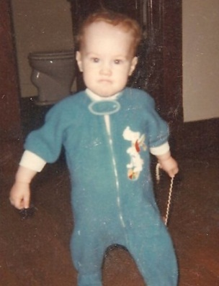
Figure 2. Sean
Marcia and Curt divorced in 1981. She and Curt have remained friends. Marcia opened her home to her ailing father Alonzo and cared for him in her home for eleven years. There was no second thought to having him stay with her and she enjoyed the time that they spent together. The saddest experience in Marcia’s life was when her father passed away. She recalls her dad’s favorite quote as “100 years from now no one will ever know the difference”.
In 1988 Marcia was introduced to a handsome co-worker by a mutual friend. She readily admits to being attracted to his kindness. The fact that he is extremely handsome didn’t hurt either. They hit it off instantly and on December 22, 1988 in Paducah, Kentucky Marcia became Mrs. Michael Smith. To this day Marcia still refers to Mike as the best gift she has ever received. The biggest scare Marcia has ever gone through was when Mike was diagnosed with colon cancer. Marcia’s favorite story about Mike is related to his first colonoscopy and let’s just says Mike plus versed makes for an interesting combo. Close family and friends will know exactly what this means. Marcia lists two of her happiest moments in life as when they found out that Mike’s colon cancer hadn’t spread and later when Mike was declared cancer free.
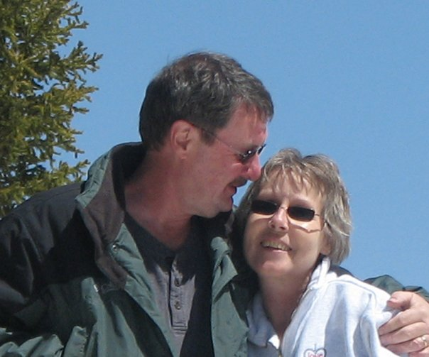
Figure 3. Mike and Marcia

The one historical event that most changed Marcia’s her life was the first Iraqi war. During this war not one but both of her sons were in harm’s way. Brad served in the Army and Sean in the Navy. They both returned home safe and sound and that is something that both Mike and Marcia are extremely grateful of.
Marcia received her degree in business management at Lake Land College at 41 years of age. She did so well at Lake Land that she graduated with honors. Marcia believes that the computer and the World Wide Web rank as the two major technological advances that have affected her life the most.
In the mid 90’s Marcia sought out medical help to determine what was causing her chronic pain. It took seven years and a myriad of tests and treatments such as basal ganglia blocks, nerve conduction studies, barium enema x-ray’s, CT scans, EEG’s, and physical therapy. After going through that all her physician asked the staff nurse to tell Marcia there was nothing else they could do for her. This left Marcia frustrated. Her frustration soon turned to humiliation when she started experiencing tremors. Marcia put off having the tremor checked out for two years and then her general practitioner referred her to a different physician. This physician tried numerous medications that made it difficult for Marcia to eat and left her very emotional. During the diagnostic process this new physician sent her home to drink a bottle of wine to see if that would rule out essential tremors. The wine made the tremors worse and this made a very frustrated Marcia even more upset. Finally, though she had a diagnosis, Parkinson’s disease. Marcia took it upon herself to seek out an expert and she hit the jackpot with Dr. Roger Elble. A visit to Dr. Elble included a two hour session of tests and assessments and he agreed with the diagnosis of Parkinson’s. Dr. Elble changed Marcia’s medications and this was the turning point in her life. While the diagnosis was not one that she would have wished for it did provide her with an idea of what was going on with her body.
Life with Parkinson’s disease is hard to imagine when you aren’t the one going through with it. Marcia gave permission to share an excerpt from an email regarding what it is like for her in the mornings. “I can tell you that no one wants to be here when I get out of bed each morning. My hands are claws and Mike has to get water and put the pills in my mouth, then lay me back down gently. Or I will go PLOP! Throughout the day no one can see the pain, its more pain that I ever thought I would live with for the rest of my stinking life. It makes my face very ugly and I look angry. It is the PAIN!”
Marcia is quick to say that she isn’t Parkinson’s disease. She is a person with Parkinson’s disease but it does not define her. She volunteers and is the current leader of a local group for those diagnosed with as well as those affected by Parkinson’s. In addition to her work with the group she also visits nursing homes with her beloved canine companions Spanky and Lucy. The visits to the nursing home were hard for Marcia at first but seeing the joy that she, Spanky, and Lucy bring to others has been a rewarding experience. Marcia and Mike are both animal lovers and failed foster dog parents. Earlier this year they fostered a sweet geriatric canine and the decision was made to fail as foster parents and officially adopt the old girl. This sweet dog came to know true love like she had never known before. While their time with her was short it was surely the best care this dog had received in her entire life.

Figure 4. Princess Lucy and Spanky ready to go visit nursing home residents.
Prior to her diagnosis Marcia really didn’t have any hobbies. After her diagnosis she was bitten by the art bug. She now paints and takes photographs. Her work is beautiful and one of her favorite paintings took home awards for best in show and the people’s choice award at a local art contest. She often takes a picture of a scene and goes later and reproduces the image on canvas. Marcia shares her love of art with her granddaughter Kaylee and with a young neighbor girl. She has spent time with both young ladies talking about and working on art projects. They have also accompanied her on trips to the local animal shelter to photograph animals that are up for adoption.
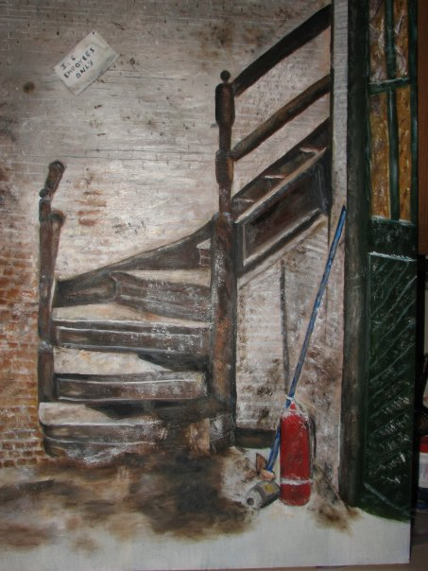
Figure 5. Marcia’s award winning painting.
Marcia and Mike have a combined hobby of photographing storms. They have taken some magnificent photographs together. When a storm is looming in the horizon you can be sure that Mike and Marcia are smiling in anticipation of the lightning show that they are sure to witness. Mike works part-time as an EMT at Mitchell-Jerdan’s in Mattoon. Marcia has enjoyed spending some ride time with him and is fascinated with the world of pre-hospital care.

Figure 6. Lightning picture taken by Mike and Marcia.
When asked about any regret’s in life Marcia’s life she smiles and regrets not being able to pursue a second career as an EMT due to her Parkinson’s. She also regrets not being a better parent but truly believes that she has done the best job that she could. Mike and Marcia share a brood of four children. Marcia’s three children listed above and Mike’s son Todd. The have been blessed with nine beautiful grandchildren and two sweet little great-granddaughter’s.
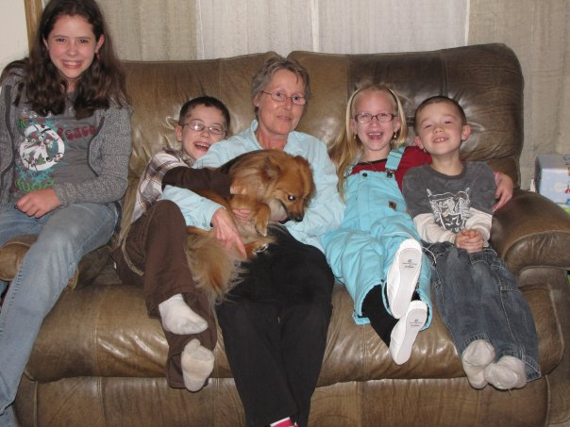
Figure 7. Marcia with several of her grandchildren.
Marcia is proud of the fact that she is still walking and lives an active life. She intends on staying active and living life to its fullest. One of her greatest fears is ending up in the nursing home and her hope for the future is to remain independent. Marcia’s life is a testament of love, unselfishness, and determination. 

