Complications from Heart Disease:
Pgs. # 424-438
Difference between diastolic and systolic heart failure: pgs. #424-434:
Heart failure is the inability of the heart to pump sufficient blood to meet the needs of the tissues for oxygen and nutrients. In the past, HF was often referred to congestive heart failure (CHF) because many pts. experience pulmonary and peripheral congestion.
Systolic (problem with the contraction of the heart): alteration in ventricular contraction
- Most common
- Characterized by a weakened heart muscle
- EF severely reduced (>55%)
Diastolic (problem with the filling of the heart):
- Characterized by a stiff and noncompliant heart muscle = difficult for the ventricle to fill
- EF normal (55-65%)
Signs /Symptoms: Fluid overload or inadequate tissue perfusion
- SOB
- Edema
- Fatigue
Left-sided vs. right -sided HF:
Left-sided:
- Dyspnea, orthopnea, PND
- Cough
- Pulmonary crackles
- ↓ O2 sat levels
- S3 ventricular gallop
- Oliguria if renal perfusion is diminished
- ↓ perfusion to other systemic organs (advanced failure):
- Sluggish GI motility
- Dizziness, lightheadedness, confusion, restlessness
- Anxiety
- Skin cool and clammy
- ↓ in EF
- Tachycardia and/or weak thread pulse
- Fatigue and activity intolerance
Right-sided heart failure:
- Lower extremity dependent edema (dependent edema is swelling that follows the position of the body):
- Legs and feet
- May progress to thighs, external genitalia, lower trunk, abdomen, sacral edema (in a bed-bound pt.)
- Pitting edema (indentations in the skin remain after even slight compression with the fingertips)
- Hepatomegaly
- Ascites (accumulation of fluid in the peritoneal cavity)
- Anorexia and nausea
- Weight gain due to retention of fluid (gain >2kg or 4.4 lbs. problem)
- Weakness/fatigue from reduced CO and impaired cognition
- Decreased perfusion to other systemic organs (advanced failure)
Neurohormonal compensatory mechanisms resulting from HF:
- Systolic HF = ↓blood volume ejected from the ventricle … baroreceptors activate SNS (sympathetic nervous system) … SNS releases epinephrine & norepinephrine = ↑ HR and contractility … SNs also causes (negative effects) = vasoconstriction of the skin, GI tract, and kidneys …↓CO and vasoconstriction = ↓ renal perfusion = release of rennin by kidneys …
- Renin → angiotensin I + ACE = angiotensin II (potent vasoconstrictor) … ↑ BP & afterload (resistance) … angiotensin II stimulates release of aldosterone from adrenal cortex = Na+ and fluid retention by the renal tubules … = volume overload …
- Angiotensinogen, aldosterone, and other neurohormones = ↑preload + afterload … ↑ stress on ventricular wall … ↑ workload on the heart …
- Heart’s workload ↑ = myocardial muscle fibers ↓ … ↓ contractility = ↓ end-diastolic blood volume (preload) in the ventricles … = stretching the myocardial muscle fibers = ↑ size of ventricle … ↑ ventricle size = ↑stress of ventricular wall = adding to the workload of the heart.
- ↑ workload = ↑ thickness of the heart wall (ventricular hypertrophy) = ventricular remodeling
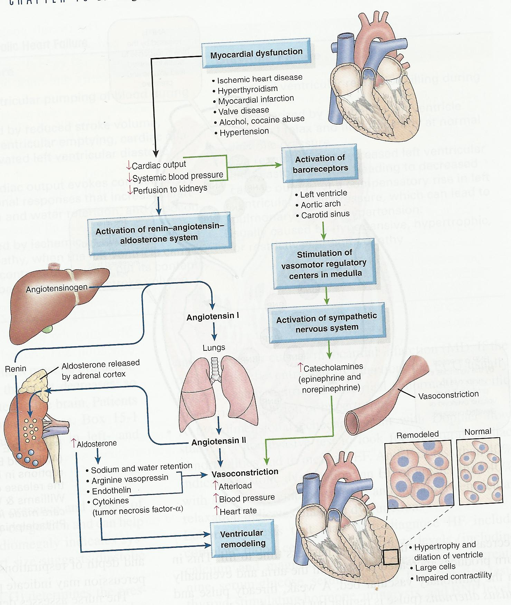
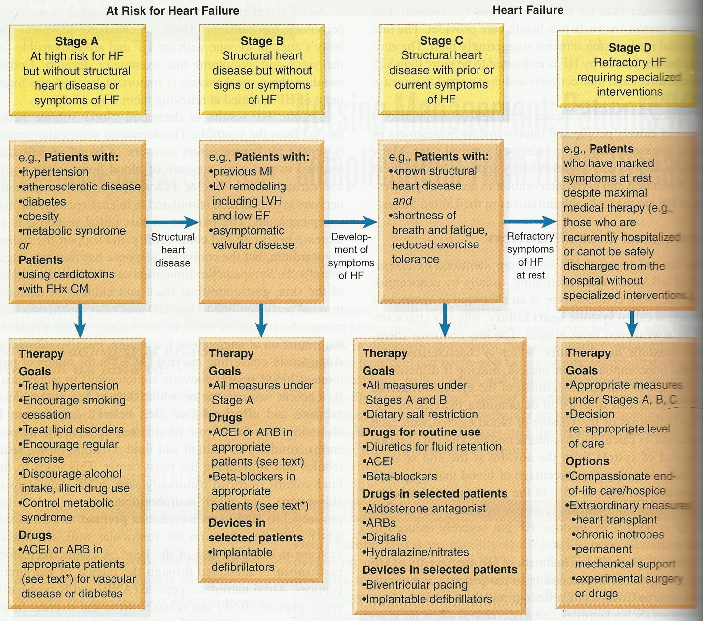
Risk factors:
Major: Minor:
- Age (>65) smoking/ excessive alcohol consumption
- Sex (male) Genetics (Schocken et al., 2008)
- Hypertension high cholesterol (dyslipidemia)
- L. ventricular hypertrophy diabetes
- MI toxins (chemotherapeutic agents)
- Valvular heart disease sleep-disordered breathing
- Obesity chronic kidney disease
Low socioeconomic status
Psychological stress
Sedentary lifestyle

Management of patients with HF:
- Relive pt. symptoms
- Improve fx status and quality of life
- Tx based on type, severity and cause of HF
- Specific objectives include:
- Eliminate/reduce any etiologic contributory factor, especially those that may be reversible
- Reduce the workload on the heart by reducing afterload and preload
- Optimize all therapeutic regimen
- Prevent exacerbations of HF
Lifestyle changes:
- Provide general education and counseling to pt. and family
- Restriction of dietary sodium
- Avoidance of excessive fluid intake
- Alcohol
- Smoking
- Weight reduction when indicated
- Regular exercise
- Pt. will know how to recognize signs and symptoms that need to be reported to the health care professional such as weight gain, ↑ SOB, fatigue, edema
Pharmacologic therapy:
- ACE inhibitors
- Beta blockers
- Diuretics
- Digitalis
Assessment of Pulmonary edema: accumulation of fluid in the lungs (interstitial spaces and the alveoli)
- Can occur acutely or as an exacerbation of HF
- Pt. becomes ↑ restlessness and anxious
- Sudden onset of breathlessness, sense of suffocation, cough that produces large amts. of frothy sputum (may be blood-tinged), cold and moist skin, cyanotic (bluish) nail beds, a weak and rapid pulse, pulmonary rales, expiratory wheezing, and distended neck veins.
- O2 demand ↑ = admin. O2
- **Demands immediate action b/c pt. is literally drowning in secretions**
- Oxygen, diuretics, pharmacologic preload and afterload reduction, and possibly hemodynamic monitoring
- Early rescue with noninvasive mask ventilation and bronchodilator therapy with select beta 2 agonist medications like albuterol.
Management of cardiac arrest: EMERGENCY
- AIRWAY: maintaining an open airway
- BREATHING: providing artificial ventilation by rescue breathing
- CIRCULATION: promoting artificial circulation by external cardiac compression; administering medication therapy (epinephrine for asystole)
- DEFIBRILLATION: shocking with standard defibrillator of automatic external defibrillator (AED) for ventricular tachycardia and ventricular fibrillation.

