a. Define community-boundaries
is a city in Coles County, in the Charleston-Mattoon metro area. (epidunk.com)
Land area of 0.82 sq miles (Illinois.hometownlocator.com)
Water area of 0.04 sq miles (Illinois.hometownlocator.com)
Density 1,125.8 people per sq mi (Illinois.hometownlocator.com)
b. Include a map of the area
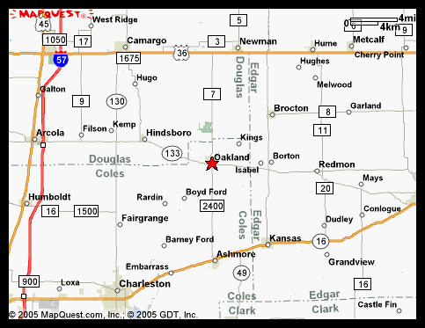
Mapquest.com
c. Include general identifying data, such as location in relation to larger areas.
Oakland is:
About 180miles (3hrs) south of Chicago, IL (maps.yahoo.com)
About 158 miles (2.5hrs) Southeast of St. Louis, MO (maps.yahoo.com)
Locally:
About 60 miles Southwest of Danville, IL (maps.yahoo.com)
About 47 miles South of Champaign, IL (maps.yahoo.com)
References

Profile for Oakland, IL. Retrieved March 8, 2011 from
http: www.epodunk.com/cgi-bin/genInfo.php?IocIndex

Oakland, IL. Retrieved March 8, 2011 from
http: www.illinois.hometownlocator.com/il/coles/oakland.cfm

Oakland, IL. Retrieved March 8, 2011 from
http: www.maps.yahoo.com/oakland

