Community Assessment Project
RN404 Community Health Nursing
Tenika Mcmillian, Alicia Northen, Sheila Roth, and Lori A.Turner,
Lakeview College of Nursing

Community Assessment Project RN404 Community Health Nursing
This windshield survey was conducted multiple times during different times of the day. During assessing the homes in this town, it was noted most of the homes were approximately the same age with similar styles. Most styles were Ranch with occasional Cape Cod or Bungalow styles. All homes appeared to be older but well kept. It was noted the homes on the south side of route 133 were more run down and had more mobile homes with less upkeep. It appeared to be where the low socioeconomically class lived. Most homes had moderately sized yards and were not spaced real close together. In general, the neighborhoods were status quo. No new developments occurring and rare abandoned homes.
The center of the town had a square that is an open grassy area. The square is where some local businesses are located. During business hours, many people are seen frequenting the established businesses. During the evening hours, no one was noted to be around the square. The north side of the square has the Christian Church and one block north of this church is the Methodist Church. Two Baptist Churches are located outside of town. One church is located south west of town; the other church is north of town. To the east, there is an insurance company, a furniture store, a beauty and barber shop, and a bank. To the south of the town square, there is a building that has been rebuilt that the community uses for social activities and gatherings. It is the Columbia Building. It can be rented for social gatherings. There is a newspaper building, the Noodle Company, a bank, a variety store that sells paint, T-shirts, sweat shirts that can have the school mascot applied, flowers, movie rentals, jewelry, and other nik naks. There are also empty buildings along this side of the square. To the east, there is a small restaurant and a farm implement store. A few block further east, a modern funeral home is noted, a lumber yard and a Crop Production business is noted. Within a block west of the square, there is a library, a senior citizen building that provides meals to seniors and meals on wheels, and a grocery store. Just south of the library, there is an independent living facility called the Oaks Manor. It is a small apartment like complex that houses 13 small apartments for seniors. To the east of the square, there is an antique store, the food pantry, a used clothing store, and another restaurant. The North West side of town includes a swimming pool and a golf course. The town does not have health care or dental care available. The nearest hospital is to the east approximately 18 miles.
The town is divided by route 133 that runs east and west. There is the county road the locals refer to as the Oakland/Ashmore road that runs south of route 133. Walnut Street runs north out of town just west of the square. These roads are in good shape and transportation was noted in private vehicles in and out of town. No public transportation is available in this community. Route 133 divides the town into north and south, the Oakland/Ashmore road and Walnut Street divides the town into east and west. There are two gas stations on the south east of the town. One gas station is Casey’s General Store that sells food and a few grocery items. The other gas station provides mechanical repairs for automobiles. Just south of route 133 is the fire house, the ambulance garage, a car wash, laundry mat, and a vehicle body shop. The town appears to be thriving.
Occasionally noted were older adults walking early in the morning before work hours. No children were observed playing ball, bike riding or any other physical activities.
The school is located on the north east side of town. North of the school is the town park. The town also has a small lake just north of the park. No one was observed visiting the park or lake.
The general race appears to be dominantly white. One Hispanic child, two Asian children and one African American child noted. Parents / guardians of these children are white.
Because there was minimal physical activity noted throughout the town, the risk for obesity is prevalent in this town. Several people were interviewed and many voiced the concern of increased childhood obesity as well as the adults due to limited activities in the community. One interview was with the school nurse, Vivian Hudson. Vivian is taking an active role in the community to help address this risk. Some of the activities she has organized are the community 5k race and 1k walk having open gym for physical activities, and encouraging family walk night. She has also been instrumental in changing meals and snacks the school is offering such as placing a salad bar in the cafeteria for lunches.

FIGURE 1. Prevalence of obesity among children and adolescents, by age group --- United States, 1963--2008
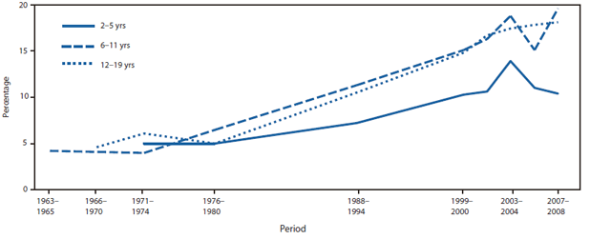
Alternate Text: The figure above shows the prevalence of obesity among children and adolescents, by age group, in the United States during 1963-2008. In the United States, childhood obesity affects approximately 12.5 million children and teens (17% of that population). Changes in obesity prevalence from the 1960s show a rapid increase in the 1980s and 1990s, when obesity prevalence among children and teens tripled from nearly 5% to approximately 15%.

FIGURE 2. Prevalence of obesity among children and adolescents, by sex, age group, and race/ethnicity --- United States, 2007--2008
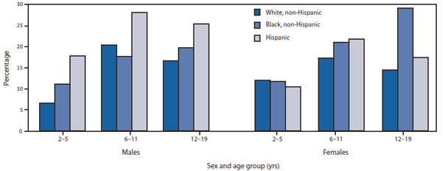
http://www.cdc.gov/mmwr/preview/mmwrhtml/mm6002a2.htm?s_cid=mm6002a2_w
References
zzzzzzz ======Reference placeholder, don't delete====== zzzzzz

